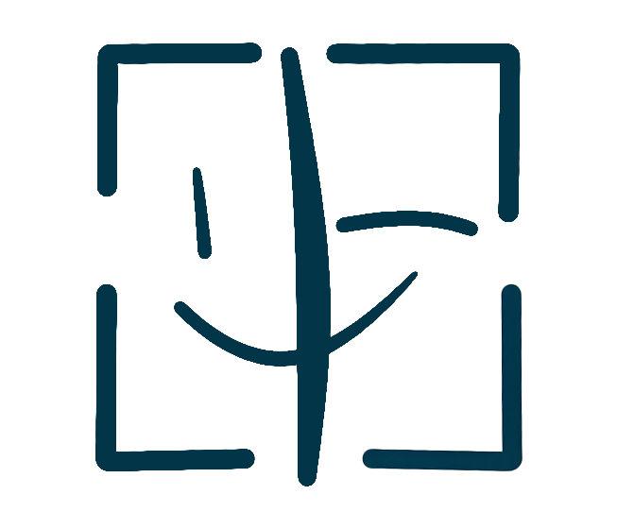
PortraitPay AI

PORTRAITPAY AI CONTRACT GUIDE
Overview and Signing Instructions
LICENSE TYPE: All Contract Types | FEE RANGE: See Individual Contracts

PARTIES TO THIS AGREEMENT
Complete the fields below. Both parties must fill in their information.
PARTY A (Portrait Owner) | PARTY B (Authorized User)
Full Legal Name: _________________________ | Full Legal Name / Company: _________________________
Email Address: _________________________ | Email Address: _________________________
Mailing Address: _________________________ | Company / Organization: _________________________
Phone Number: _________________________ | Phone Number: _________________________

ABOUT PORTRAITPAY AI
PortraitPay AI is a blockchain-based portrait rights management platform. Every portrait is stored on-chain with an immutable timestamp, creating a legally recognized certificate of ownership. When you sign a digital licensing contract through PortraitPay AI, the agreement is recorded on the blockchain and stored on IPFS, providing tamper-proof evidence of the licensing relationship.
FOUR CONTRACT TYPES AVAILABLE
PortraitPay AI offers four specialized digital human licensing contracts, each designed for a different use case:
1. STANDARD (Non-Exclusive): For general commercial and personal use. Fee range: USD 100 - 10,000. Platform fee: 1%.
2. EXCLUSIVE: For situations requiring sole rights. Fee range: USD 500 - 50,000. Includes complimentary legal consultation through our partner lawyer network.
3. ENDORSEMENT: For brand ambassador and celebrity endorsement relationships. Fee range: USD 1,000 - 100,000. Includes face verification at mint time.
4. FILM ADAPTATION: For film, television, and content production use. Fee range: USD 5,000 - 500,000. Includes smart contract auto-split revenue sharing.
HOW TO SIGN A CONTRACT
Step 1 — Register: Create a free account at portraitpayai.com and complete your profile.
Step 2 — Upload Portrait: Upload a clear, high-resolution portrait photo. The system will generate a 128-dimensional face vector stored in our database and a SHA-256 hash recorded on the Base blockchain.
Step 3 — Select Contract Type: Choose the contract type that matches your intended use. Each contract clearly states the license scope, fee range, and permitted uses.
Step 4 — Face Verification: For Endorsement and Film Adaptation contracts, face verification is required at mint time to ensure authenticity.
Step 5 — Digital Signing: Both parties review the contract terms and sign digitally through the PortraitPay AI platform.
Step 6 — Payment: The Licensee pays the agreed fee. PortraitPay AI deducts the 1% platform fee and transfers the remainder to the Licensor within 5 business days.
IMPORTANT LEGAL NOTES
All contracts are governed by the laws of the State of California, USA. Disputes fall under the exclusive jurisdiction of Los Angeles County courts.
Face verification at mint time ensures that the person signing is the legitimate owner of the portrait. This creates a strong chain of evidence if disputes ever arise.
All contract data is stored on IPFS (InterPlanetary File System) with a content hash recorded on the Base blockchain. This provides legal-grade evidence that can be used in court proceedings.
PortraitPay AI charges a flat 1% platform fee on all transactions. No hidden fees. No recurring charges.
DISPUTE RESOLUTION
If a dispute arises under any PortraitPay AI contract, both parties agree to first attempt resolution through our partner lawyer network mediation process. If mediation fails, disputes shall be submitted to binding arbitration in Los Angeles County, California, under the rules of the American Arbitration Association.
PROHIBITED USES
The Licensed Portrait may NOT be used for any of the following purposes:
☐ PortraitPay AI contracts do not grant indefinite perpetual rights
☐ All contracts have a defined term — please check each contract for duration
☐ PortraitPay AI reserves the right to terminate accounts that violate the prohibited use provisions
☐ Misuse of the platform for illegal purposes will be reported to authorities
SIGNATURES
By signing below, both parties agree to all terms and conditions set forth in this Agreement.
Party A Signature: ___________________________________ | Party B Signature: ___________________________________
Party A Print Name: ___________________________________ | Party B Print Name: ___________________________________
Party A Date: ___________________________________ | Party B Date: ___________________________________

portraitpayai.com

