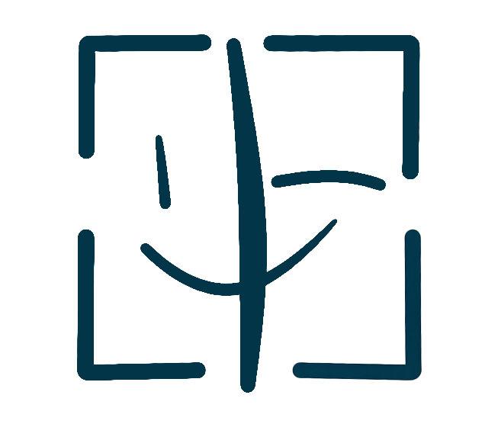
PortraitPay AI
STANDARD LICENSE AGREEMENT
Non-Exclusive Portrait Licensing Contract
LICENSE TYPE: Standard (Non-Exclusive) | FEE RANGE: USD 100 - 10,000

PARTIES TO THIS AGREEMENT
Complete the fields below. Both parties must fill in their information.
LICENSOR (Portrait Owner) | LICENSEE (Authorized User)
Full Legal Name: _________________________ | Full Legal Name / Company: _________________________
Email Address: _________________________ | Email Address: _________________________
Mailing Address: _________________________ | Company / Organization: _________________________
Phone Number: _________________________ | Phone Number: _________________________

1. GRANT OF LICENSE
The Licensor hereby grants to the Licensee a non-exclusive, non-transferable license to use the Licensor's digital portrait ("Licensed Portrait") for the purposes described in this Agreement. This license is limited to the specific uses selected by the Licensee during the digital signing process on the PortraitPay AI platform at https://portraitpayai.com/.
2. LICENSE SCOPE AND PERMITTED USES
Subject to the terms of this Agreement, the Licensee is authorized to use the Licensed Portrait solely for: advertising, marketing, and promotional materials; product packaging and labeling; social media content; digital and print publications; and other uses as agreed in writing.
3. TERRITORY AND DURATION
This license is granted for a period of one (1) year from the date of digital execution unless earlier terminated. The territory is worldwide (global) unless otherwise specified.
License Start Date: ____________________________
License End Date: ____________________________
Territory: ____________________________
4. CONSIDERATION AND PAYMENT
The Licensee shall pay the Licensor a one-time licensing fee as agreed during the digital signing process. PortraitPay AI will process the payment and transfer the net proceeds (after deducting the 1% platform fee) to the Licensor within five (5) business days of receipt.
Agreed License Fee (USD): ____________________________
Payment Method: ____________________________
5. REPRESENTATIONS AND WARRANTIES
The Licensor represents and warrants that: (a) the Licensor is the sole and exclusive owner of the Licensed Portrait and has full authority to grant this license; (b) the Licensed Portrait does not infringe upon any third-party intellectual property rights; (c) the Licensor has obtained all necessary consents for the creation and use of the Licensed Portrait.
6. LIMITATION OF LIABILITY
To the maximum extent permitted by applicable law, neither party shall be liable for any indirect, incidental, consequential, special, or exemplary damages arising out of or in connection with this Agreement. The total aggregate liability of either party shall not exceed the total license fees paid hereunder.
7. GOVERNING LAW
This Agreement shall be governed by and construed in accordance with the laws of the State of California, United States of America, without regard to its conflict of law provisions. Any disputes shall be subject to the exclusive jurisdiction of the courts located in Los Angeles County, California.
8. ENTIRE AGREEMENT AND AMENDMENTS
This Agreement constitutes the entire agreement between the parties with respect to the subject matter hereof. Any amendment or modification must be in writing and signed by both parties or executed digitally through the PortraitPay AI platform.
9. TERMINATION
Either party may terminate this Agreement upon thirty (30) days written notice. Upon termination, the Licensee must cease all use of the Licensed Portrait and remove all copies from circulation within five (5) business days. PortraitPay AI reserves the right to terminate this Agreement immediately for any material breach.
PROHIBITED USES
The Licensed Portrait may NOT be used for any of the following purposes:
☐ Adult, pornographic, or sexually explicit content
☐ Political, extremist, or propaganda content
☐ Violent, gory, or graphic content
☐ Hateful, discriminatory, or defamatory content
☐ Fraudulent, scam, or deceptive content
☐ Sale of weapons or dangerous goods
☐ Illegal activities or unlawful purposes
SIGNATURES
By signing below, both parties agree to all terms and conditions set forth in this Agreement.
Licensor Signature: ___________________________________ | Licensee Signature: ___________________________________
Licensor Print Name: ___________________________________ | Licensee Print Name: ___________________________________
Licensor Date: ___________________________________ | Licensee Date: ___________________________________

This template was generated by PortraitPay AI
portraitpayai.com

