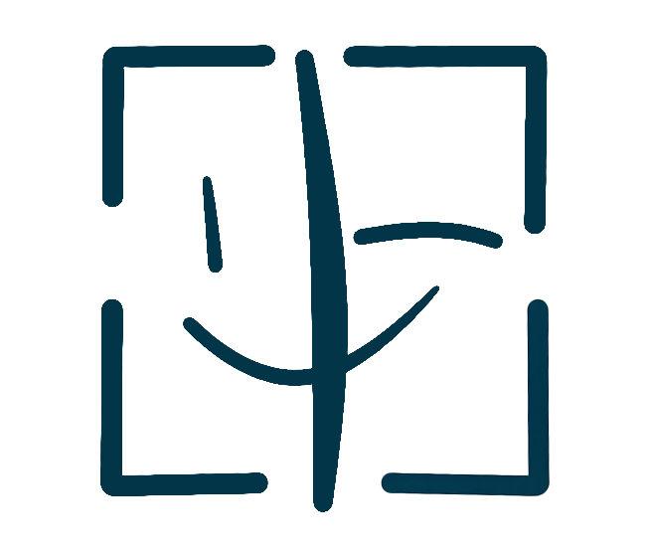
PortraitPay AI

EXCLUSIVE LICENSE AGREEMENT
Exclusive Portrait Licensing Contract
LICENSE TYPE: Exclusive | FEE RANGE: USD 500 - 50,000

PARTIES TO THIS AGREEMENT
Complete the fields below. Both parties must fill in their information.
LICENSOR (Portrait Owner) | LICENSEE (Authorized User)
Full Legal Name: _________________________ | Full Legal Name / Company: _________________________
Email Address: _________________________ | Email Address: _________________________
Mailing Address: _________________________ | Company / Organization: _________________________
Phone Number: _________________________ | Phone Number: _________________________

1. GRANT OF EXCLUSIVE LICENSE
The Licensor hereby grants to the Licensee an exclusive, non-transferable license to use the Licensor's digital portrait ("Licensed Portrait"). During the term of this Agreement, the Licensor shall not grant any other license to any third party for the Licensed Portrait, and agrees to cease all independent use of the Licensed Portrait worldwide.
2. EXCLUSIVITY TERMS
This exclusive license grants the Licensee sole rights to use, reproduce, distribute, publicly display, and create derivative works from the Licensed Portrait. The Licensor acknowledges that the exclusivity premium is reflected in the fee range above. Any use by the Licensor themselves during the license term is strictly prohibited.
3. DURATION AND TERRITORY
This exclusive license is granted for a period of one (1) to five (5) years from the date of digital execution, as agreed by both parties. The territory is worldwide unless otherwise specified in Appendix A.
License Start Date: ____________________________
License End Date: ____________________________
Exclusivity Term (Years): ____________________________
Territory: ____________________________
4. CONSIDERATION AND PAYMENT
The Licensee shall pay the Licensor an exclusivity premium fee as agreed during the digital signing process. PortraitPay AI will process the payment and transfer the net proceeds (after deducting the 1% platform fee) to the Licensor within five (5) business days of receipt.
Agreed License Fee (USD): ____________________________
Payment Method: ____________________________
5. REPRESENTATIONS AND WARRANTIES
The Licensor represents and warrants that: (a) the Licensor is the sole and exclusive owner of the Licensed Portrait; (b) the Licensed Portrait does not infringe upon any third-party intellectual property rights; (c) the Licensor has obtained all necessary consents and model releases; (d) the Licensor will not negotiate any conflicting license during the term of this Agreement.
6. INFRINGEMENT ASSISTANCE
PortraitPay AI will assist in monitoring and enforcing this exclusive license against third-party infringement. The Licensor is entitled to complimentary legal consultation for any infringement case related to this Agreement through PortraitPay AI's partner lawyer network.
7. LIMITATION OF LIABILITY
To the maximum extent permitted by applicable law, neither party shall be liable for any indirect, incidental, or consequential damages. The total aggregate liability shall not exceed the total license fees paid under this Agreement.
8. GOVERNING LAW
This Agreement shall be governed by the laws of the State of California, USA. Disputes shall be subject to the exclusive jurisdiction of the courts of Los Angeles County, California.
9. TERMINATION
Termination may occur upon mutual written agreement or if either party materially breaches this Agreement and fails to cure within thirty (30) days of notice. Upon termination, all exclusive rights revert to the Licensor and the Licensee must cease all use immediately.
PROHIBITED USES
The Licensed Portrait may NOT be used for any of the following purposes:
☐ Use by the Licensor themselves during the exclusivity term
☐ Any sublicensing or transfer of this exclusive license
☐ Adult, pornographic, or sexually explicit content
☐ Political, extremist, or propaganda content
☐ Violent, gory, or graphic content
☐ Hateful, discriminatory, or defamatory content
☐ Fraudulent, scam, or deceptive content
☐ Illegal activities or unlawful purposes
SIGNATURES
By signing below, both parties agree to all terms and conditions set forth in this Agreement.
Licensor Signature: ___________________________________ | Licensee Signature: ___________________________________
Licensor Print Name: ___________________________________ | Licensee Print Name: ___________________________________
Licensor Date: ___________________________________ | Licensee Date: ___________________________________

This template was generated by PortraitPay AI
portraitpayai.com

