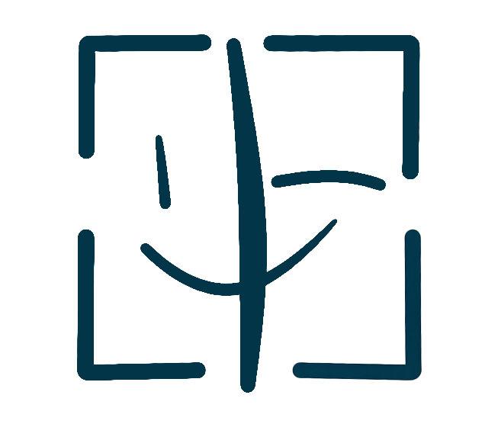
PortraitPay AI

FILM ADAPTATION LICENSE AGREEMENT
Content Adaptation Portrait Licensing Contract
LICENSE TYPE: Film / Content Adaptation | FEE RANGE: USD 5,000 - 500,000

PARTIES TO THIS AGREEMENT
Complete the fields below. Both parties must fill in their information.
LICENSOR (Portrait Owner) | PRODUCER (Content User)
Full Legal Name / Stage Name: _________________________ | Production Company Name: _________________________
Email Address: _________________________ | Contact Email: _________________________
Mailing Address: _________________________ | Production Address: _________________________
Phone Number: _________________________ | Project Title: _________________________

1. GRANT OF ADAPTATION LICENSE
The Licensor hereby grants the Producer a non-exclusive license to use the Licensor's digital portrait ("Licensed Portrait") in connection with the production, distribution, promotion, and exploitation of a film, television, or digital content project ("the Project"). This license includes the right to reproduce, distribute, publicly display, and create derivative works incorporating the Licensed Portrait.
2. PROJECT SCOPE
The Producer is authorized to use the Licensed Portrait in: film trailers and theatrical posters; television broadcast and streaming promotion; digital advertising campaigns; merchandise and packaging related to the Project; press and media materials. Face verification at mint time is required to ensure authenticity of the Licensed Portrait.
Project Title: ____________________________
Project Type (Film/TV/Web): ____________________________
License Start Date: ____________________________
License End Date: ____________________________
Distribution Territory: ____________________________
Exhibition Platform(s): ____________________________
3. REVENUE SHARING
In consideration for the license granted herein, the Producer shall pay the Licensor a combination of an upfront advance against royalties and an ongoing revenue share based on the Project's commercial performance. Revenue splits are defined in Appendix A. PortraitPay AI will process payments through its smart contract system, automatically distributing net proceeds after deducting the 1% platform fee.
Advance Payment (USD): ____________________________
Royalty Rate (%): ____________________________
Revenue Reporting Frequency: ____________________________
4. LAWYER REVIEW REQUIREMENT
Due to the complexity and value of film adaptation licenses, both parties acknowledge that this Agreement has been reviewed or may be reviewed by a qualified attorney prior to execution. PortraitPay AI can facilitate the connection to its partner lawyer network for both parties.
5. CREDIT AND ATTRIBUTION
The Producer agrees to provide appropriate credit to the Licensor in all credits and attribution materials for the Project, in the form: "Portrait courtesy of [Full Legal Name] — PortraitPay AI". The form and placement of credit shall be agreed upon in writing before the Project's public release.
6. REPRESENTATIONS AND WARRANTIES
The Licensor represents and warrants that: (a) the Licensed Portrait is original and the Licensor has full authority to grant this license; (b) the Licensed Portrait does not infringe any third-party intellectual property or privacy rights; (c) the Licensor has obtained all necessary model releases. The Producer represents that the Project will comply with all applicable laws and regulations.
7. GOVERNING LAW
This Agreement shall be governed by the laws of the State of California, USA. Any disputes shall be subject to the exclusive jurisdiction of the courts of Los Angeles County, California.
8. TERMINATION
Either party may terminate upon sixty (60) days written notice. Upon termination, the Producer must cease all new use of the Licensed Portrait and remove all existing uses from circulation within thirty (30) days, except for materials already distributed and for which recall is commercially impractical.
PROHIBITED USES
The Licensed Portrait may NOT be used for any of the following purposes:
☐ Use in content that is pornographic, obscene, or defamatory
☐ Use in connection with illegal products, services, or activities
☐ Association with political extremist or hate group content
☐ Modification of the Licensed Portrait beyond agreed adaptation scope
☐ Transfer of this license to a third party without written consent
☐ Use in competing film or content projects during the license term
SIGNATURES
By signing below, both parties agree to all terms and conditions set forth in this Agreement.
Licensor Signature: ___________________________________ | Producer Signature: ___________________________________
Licensor Print Name: ___________________________________ | Producer Print Name: ___________________________________
Licensor Date: ___________________________________ | Producer Date: ___________________________________

This template was generated by PortraitPay AI
portraitpayai.com

