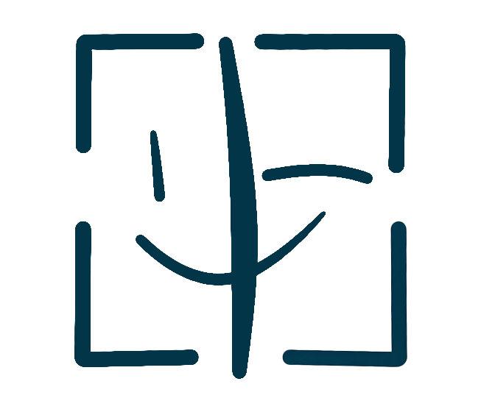
PortraitPay AI
CONSENT PASSPORT
AI Use Authorization Statement

PARTIES TO THIS AGREEMENT
Complete the fields below. Both parties must fill in their information.
LICENSOR (Portrait Owner) | LICENSEE (Authorized User)
Full Legal Name: _________________________ | Full Legal Name / Company: _________________________
Email Address: _________________________ | Email Address: _________________________
Mailing Address: _________________________ | Company / Organization: _________________________
Phone Number: _________________________ | Phone Number: _________________________

I, , hereby authorize the use of my likeness (photograph, voice, and visual appearance) by AI systems under the following terms:

✅ I ALLOW the following AI use: [Describe what you permit — e.g., video generation, voice cloning, digital avatar, etc.]
─────────────────────────────────────────────────────────────────────────────────────
─────────────────────────────────────────────────────────────────────────────────────
─────────────────────────────────────────────────────────────────────────────────────

❌ I DO NOT allow the following AI use: [Describe what you prohibit — e.g., adult content, political use, impersonation, etc.]

─────────────────────────────────────────────────────────────────────────────────────
─────────────────────────────────────────────────────────────────────────────────────
─────────────────────────────────────────────────────────────────────────────────────

📧 For usage inquiries, contact: [Email / Phone / Social Media Handle]

Additional terms or conditions:
[Any other rules — e.g., require written approval, watermark, credit, etc.]

SIGNATURES
By signing below, both parties agree to all terms and conditions set forth in this Agreement.
Party A Signature: ___________________________________ | Party B Signature: ___________________________________
Party A Print Name: ___________________________________ | Party B Print Name: ___________________________________
Party A Date: ___________________________________ | Party B Date: ___________________________________

This statement does not constitute a legal contract. It serves as a clear, verifiable record of my consent preferences for AI systems and parties seeking to use my likeness.

This template was generated by PortraitPay AI
portraitpayai.com

