

**Faculty of Computing and Information Systems**

Program: BSC. Computing Science

Level: 500

Lecturer: Dr. Dominic Louis

Course Title: Real World Project

Course ID: GTU206CDE

**GROUP TWO MEMBERS**

Shaibu Zidane – 050919048

Jedidiah Ingram – 050919014

Richmond Oberko – 050919048

Samuel Owusu – 050919007

Emmanuel Frimpong Asante – 050919002

Benjamin Azure – d 050919035

**GROUP REFLECTIVE REPORT**

**GROUP REPORT**

On Monday 5th July 2021, Shaibu Zidane suggested that we bring in ideas that we can work on in relation to the app or website. He made it clear that any idea proposed will be thoroughly evaluated and possibly chosen. We all decided to think about an idea we can work on that will not only be okay for each of our schedules, but one we all had experience on. Our group was made up of six members, Shaibu Zidane, Jedidiah Ingram, Richmond Oberko, Samuel Owusu, and Emmanuel Frimpong. Richmond suggested that we create a machine that checks on the attendance of staff, particularly a fingerprint machine, but since that did not fall in line with our general objectives, he later withdrew the comment. The day after, Wednesday 7th July, Emmanuel then suggested we create a Doctor’s Appointment Booking System, to which he had knowledge on its whole design format, including the use of HTML, SQL and other programming languages as his main skill. Shaibu requested for a Zoom meeting on Thursday but due to the unavailability of majority members, particularly Jedidiah, Benjamin, Emmanuel and Samuel, the meeting could not come on.

A key issue was our scheduling for meetings online and the unavailability or satisfactory contribution of some members. Such attitude isn’t surprise to encounter but was criticized and rebuked. The only issue that was at its apex was some members’ inability to meet up with the group physically with the reason being that others are employees and distanced as well. Emmanuel emphasised a lot on how the system would work and gave us details into how it would be reducing the workload of secretaries. Richmond was very available in the group and offered to partake in presentations and other activities. Jedidiah Ingram later suggested an emergency locator app and explained the detail. Jedidiah’s idea wasn’t absorbed due to the complexity and the limited time. The idea also did not fall in the criteria of a website but an app, so it was also downvoted. It was later decided that Samuel would be our group leader, he worked on the Group Proposal that would be presented on Monday 9th August, and Benjamin reviewed it to check for some mistakes (***fig 1***).

Jedidiah suggested we work on a UI/UX design to use in presentation to give full experience of what we want to achieve in the case where it looks different (***fig 2a, 2b***), Shaibu and Jedidiah worked on its outlook, but Shaibu was able to add wireframes and made it more interactive with the design sent him by Jedidiah of how it should mimic. Shaibu did well by updating us every step of the way (***fig 3a, 3b***). Our GitHub Identification and Emails were shared with Emmanuel so he could add us as contributors to the repository on Wednesday 1st September, making it private (***fig 4***). While Jedidiah worked on the front end of the page (***fig 5***), Emmanuel had completed all the listed requirements for the Backend (***fig 6a, 6b***). The remaining was the websites front end that he would add to his backend. Zidane completed most of the UI/UX design by Thursday 9th September but made a statement that a few adjustments had to be made before sharing the video with us. The group had a zoom meeting on Monday 13th September, but not all members were available, Jedidiah submitted the front-end codes to Emmanuel to be reviewed and linked to the backend, and on that note, majority of our tasks could be crossed off our bucket list (***fig 7***). Jedidiah also offered to help the group members with their Individual reflective reports, using the Group report as an additional experience. On Friday 17th September, Benjamin Azure went to make clarifications about the self & peer evaluation. After a week went by, on Thursday 23rd September, Jedidiah indicated that each individual in the group prints their self & peer evaluation reports and fill them, he also asked that the group members talk about the power point. Jedidiah made a suggestion to Emmanuel to add all the files to one folder to be sent to Dr. Dominic Louis after he has finished with the Power Point. He then requested that all group members meet up in the school to work on the presentation. Certain amends were made on the presentation and its format (***fig 8***), by 12:57 AM on Saturday 25th September. Finally, all clarifications on the Website & Documentation were achieved by all members present except two who were absent due to emergency. On Sunday 26th September, Benjamin worked with Jedidiah to get powerpoing presentation completed.

Group 2’s report, website and PowerPoint were ready for submission on Monday 27th September, 2021.

**FIGURE 1: PROPOSAL LOOK …………………………………………………………………………………….**

**GROUP TWO**

Shaibu Zidane – 050919048

Jedidiah Ingram – 050919014

Richmond Oberko – 050919048

Samuel Owusu – 050919007

Emmanuel Frimpong Asante – 050919002

Benjamin Azure – d 050919035

**FIGURE 2a: UI/UX HARDCOPY LOOK…………………………………………………………………………………**

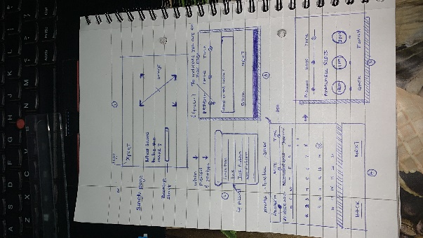

**FIGURE 2b: UI/UX SOFTCOPY LOOK…………………………………………………………………………………**

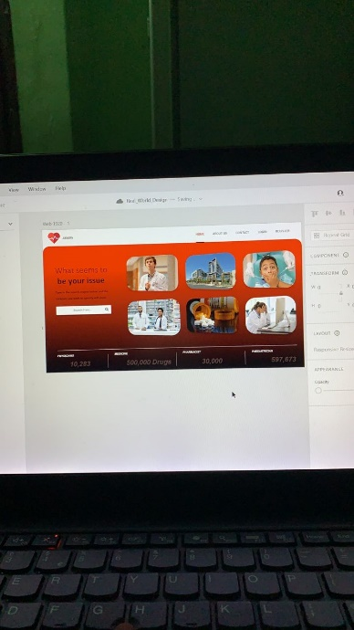

**FIGURE 3a: UI/UX SHAIBU ………………………………………………………………………………………….**

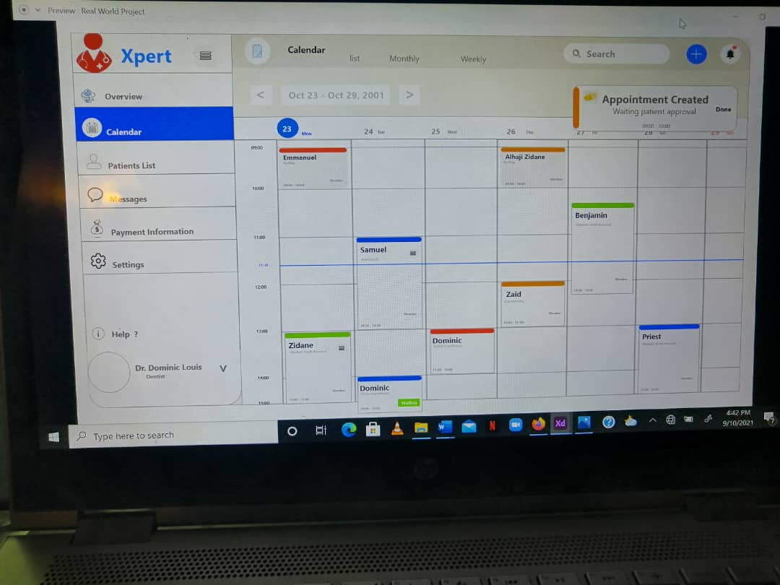

**FIGURE 3b: UI/UX SHAIBU ………………………………………………………………………………………….**

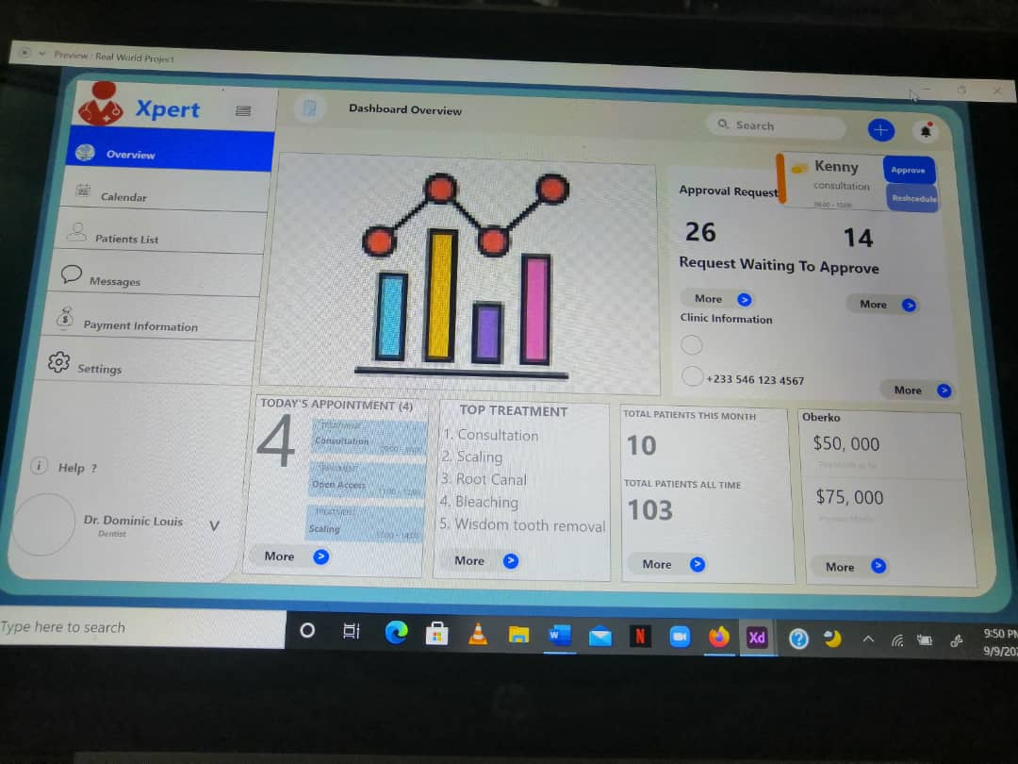

**FIGURE 4: REPOSITORY …………………………………………………………………………………………………**

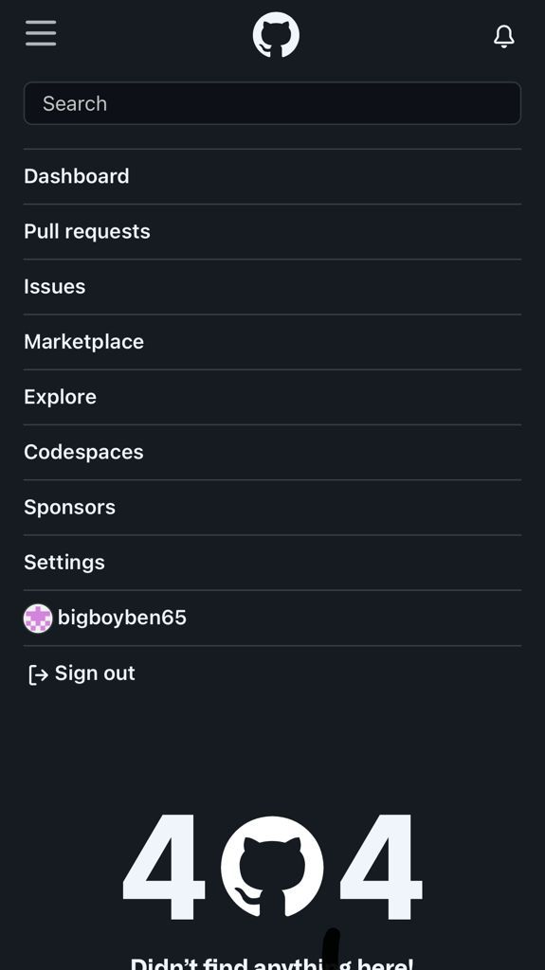

**FIGURE 5: FRONT END ………………………………………………………………………………………………….**

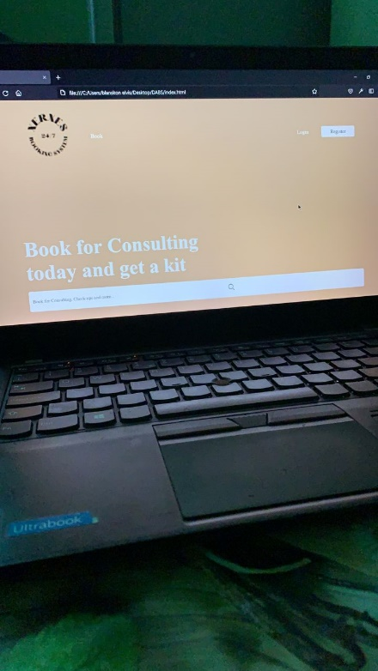

**FIGURE 6a: BACKEND ………………………………………………………………………………………………………**

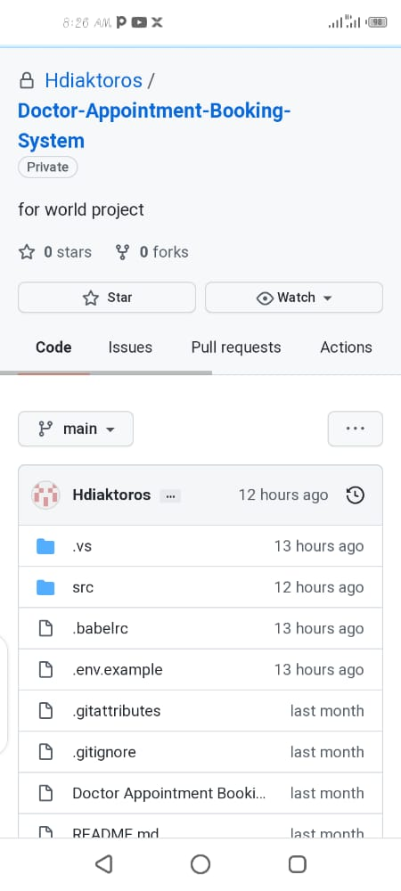

**FIGURE 6b: BACKEND ………………………………………………………………………………………………………**

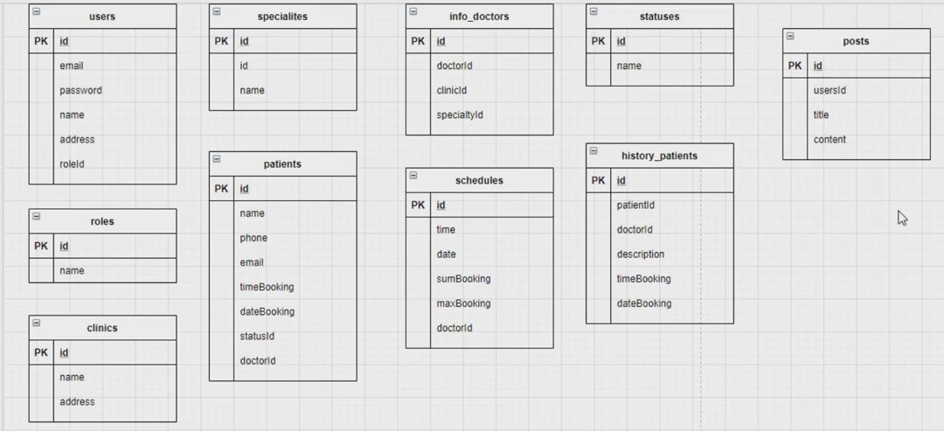

**FIGURE 7: BUCKET LIST ………………………………………………………………………………………………………**

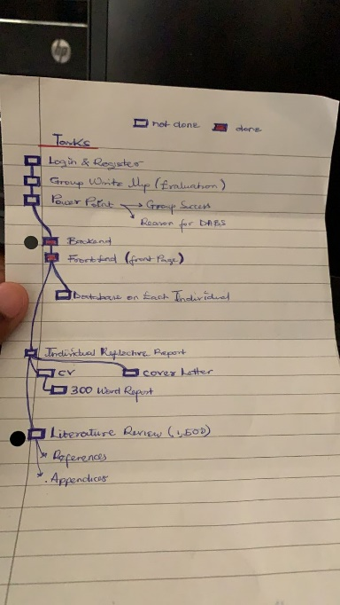

**FIGURE 8: POWER POINT FORMAT ………………………………………………………………………………………**

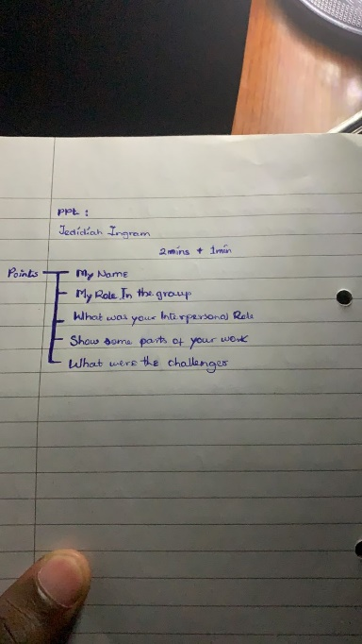

Productivity was in-between, execution of ideas and group participation and tolerance was at an all-time high. Communication between group members was also high and constant check-ups on each group member was made, self & peer evaluation was accurate & not biased, it however varied from time as some member’s productivity rather spiked up while others declined in small amounts. Each members ideas were respected, considered, and analysed before and actions could be made.