sudo service mysqld start;

--Create table Applicant

Create table Applicant(Appid int,MobileNo varchar(10) ,Appname varchar(100),DocType varchar(20),InsDt Date,InsBy varchar(50) )

Row format delimited fields terminated by "," stored as textfile ;

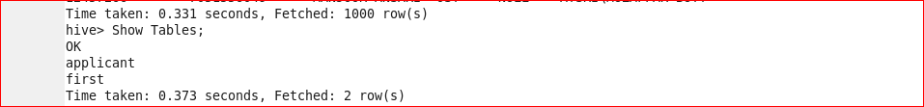

Load data local inpath '/home/acadgild/Dowloads/Sample.csv' Into Table Applicant ;

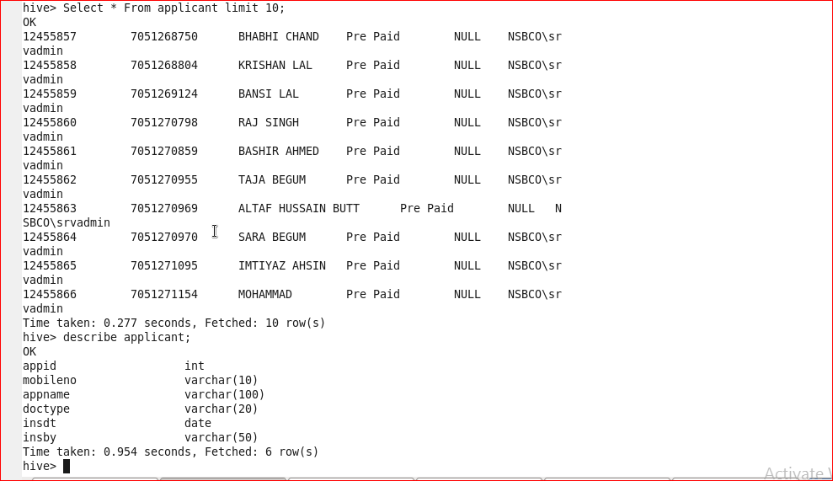

Select * from Applicant ;

Create table Applicant_Seq (Appid int,MobileNo varchar(10) ,Appname varchar(100),DocType varchar(20),InsDt Date,InsBy varchar(50) )

Row format delimited fields terminated by "," stored as SequenceFile ;

describe applicant;

appid int

mobileno varchar(10)

appname varchar(100)

doctype varchar(20)

insdt date

insby varchar(50)

Insert Overwrite Table applicant_seq

Select appid,mobileno,appname,doctype,insdt,insby From applicant;

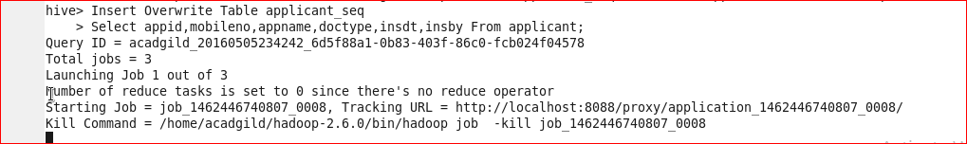

Create table Applicant_RcFile (Appid int,MobileNo varchar(10) ,Appname varchar(100),DocType varchar(20),InsDt Date,InsBy varchar(50) )

Row format delimited fields terminated by "," stored as RcFile ;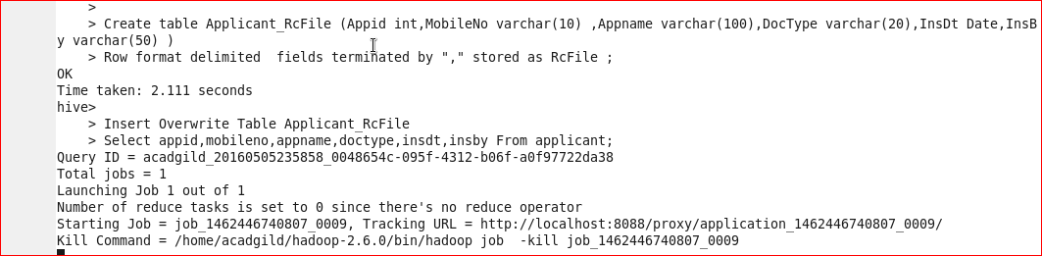

Insert Overwrite Table Applicant_RcFile

Select appid,mobileno,appname,doctype,insdt,insby From applicant;

Create table Applicant_ORCFile (Appid int,MobileNo varchar(10) ,Appname varchar(100),DocType varchar(20),InsDt Date,InsBy varchar(50) )

Row format delimited fields terminated by "," stored as ORC ;

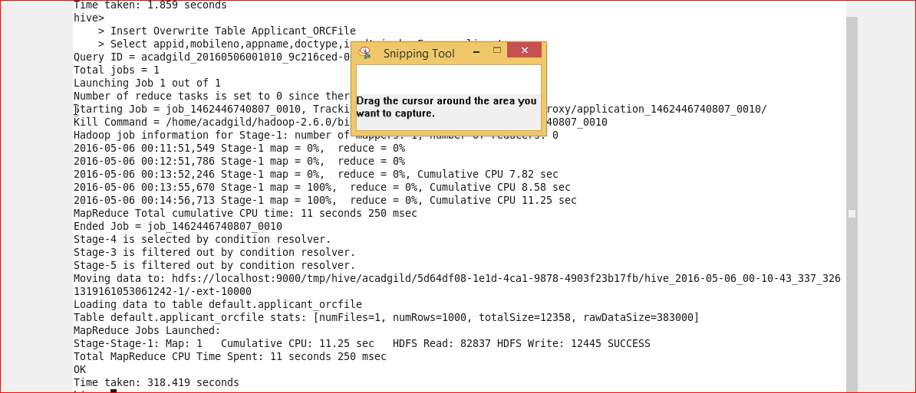

Insert Overwrite Table Applicant_ORCFile

Select appid,mobileno,appname,doctype,insdt,insby From applicant;