**Harshal** **Dhruve**

**Salary Management System**

DBMS Individual Project

Queries

1. **To join department id from another table to employees table**

**INPUT**:

SELECT employees.employeeid,

employees.firstname,

employees.lastname,

employeedepartment.departmentid

FROM employees

LEFT JOIN employeedepartment

ON employees.employeeid = employeedepartment.employeeid;

**OUTPUT:**

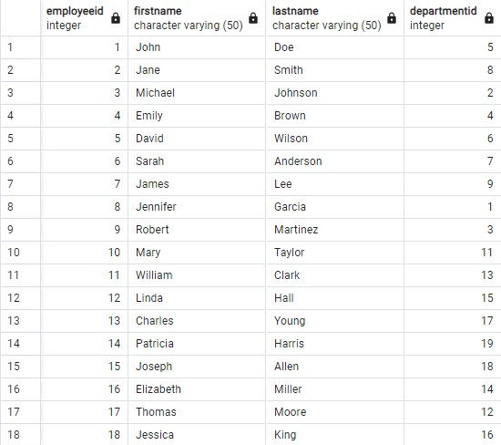

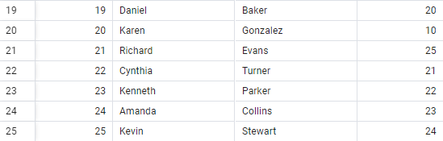

1. **To see department name of employees**

**INPUT:**

SELECT employeedepartment.employeeid, departments.departmentname

FROM employeedepartment, departments

WHERE employeedepartment.departmentid = departments.departmentid

LIMIT 5;

**OUTPUT:**

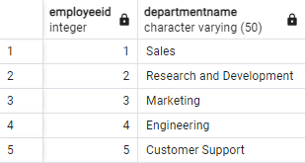

1. **Total Salary expense**

**INPUT:**

SELECT SUM(salaryamount)

AS total_salary_expense

FROM salaries;

**OUTPUT:**



1. **Fetching 5 employees whose salary is greater than 100000**

**INPUT:**

SELECT *

FROM salaries

WHERE salaryamount > 100000

LIMIT 5;

**OUTPUT:**

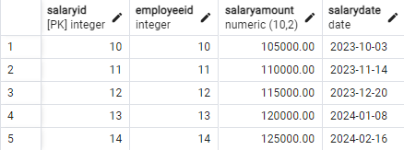

1. **Highest salary out of all employees**

**INPUT:**

SELECT MAX(salaryamount)

AS highest_salary

FROM salaries;

**OUTPUT:**



1. **Top 10 highest paid employees**

**INPUT:**

SELECT *

FROM salaries

ORDER BY salaryamount DESC

LIMIT 10;

**OUTPUT:**

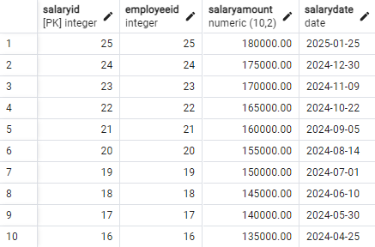

1. **Employees who joined after ‘2023-10-01’**

**INPUT:**

SELECT *

FROM employees

WHERE hiredate < '2023-10-01';

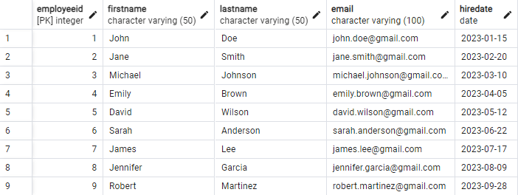**OUTPUT:**

1. **Getting the one employee who earns highest avg salary**

**INPUT:**

SELECT employeeid, AVG(salaryamount) AS average_salary

FROM salaries

GROUP BY employeeid

ORDER BY average_salary DESC

LIMIT 1;

**OUTPUT:**



1. **Fetching 1 employee with the lowest bonus(salary)**

**INPUT:**

SELECT employeeid, MIN(salaryamount) AS lowest_bonus

FROM salaries

GROUP BY employeeid

ORDER BY employeeid

LIMIT 1;

**OUTPUT:**

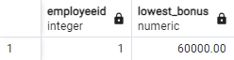

1. **Total salary expense between ‘2021-01-01’ and ‘2024-01-01’**

**INPUT:**

SELECT SUM(salaryamount) AS salary_expense

FROM salaries

WHERE salarydate BETWEEN '2023-01-01' AND '2024-01-01';



1. **Top 5 highest earning employees and the date on which their salary is paid**

**INPUT:**

SELECT * FROM salaries

ORDER BY salaryamount DESC

LIMIT 5;

**OUTPUT:**

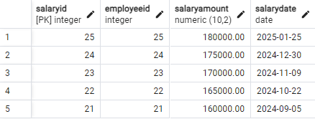

1. **Average salary paid**

**INPUT:**

SELECT AVG(salaryamount) AS average_salary

FROM salaries;

**OUTPUT:**

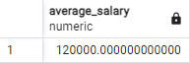

1. **Fetching employee name and their respective salary in ascending salary**

**INPUT:**

SELECT e.firstname, s.salaryamount

FROM employees AS e

JOIN salaries AS s ON e.employeeid = s.employeeid

LIMIT 10;

**OUTPUT:**

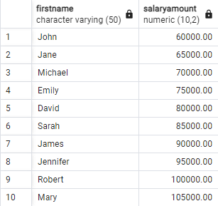

1. **Fetching the first name of employees and the maximum salary they can earn**

**INPUT:**

SELECT e.firstname,e.employeeid,s.salaryamount

FROM employees AS e , salaries AS s

WHERE salaryamount = (SELECT MAX(salaryamount) FROM salaries AS s)

LIMIT 10;

**OUTPUT:**

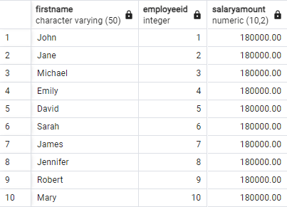

1. **Joining employeedepartment table with employee table**

**INPUT:**

SELECT *

FROM employees

LEFT JOIN employeedepartment

ON employeedepartment.employeeid = employees.employeeid

LIMIT 10;

**OUTPUT:**

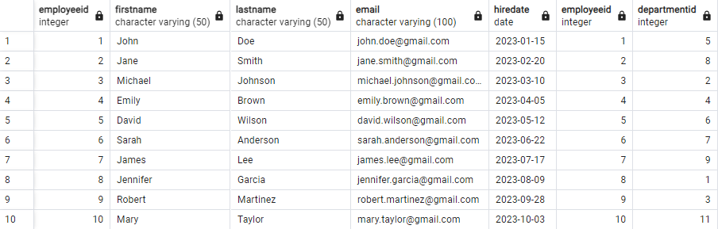

1. **Employees whose salary is between 75000 and 100000**

**INPUT:**

SELECT e.firstname,s.salaryamount

FROM employees AS e, salaries AS s

WHERE s.salaryamount BETWEEN '75000' AND '100000'

AND e.employeeid = s.employeeid;

**OUTPUT:**

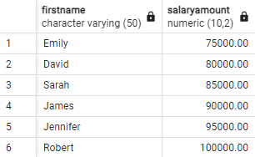

1. **Employees whose name start with ‘J’**

**INPUT:**

SELECT *

FROM employees

WHERE firstname LIKE'J%';

**OUTPUT:**

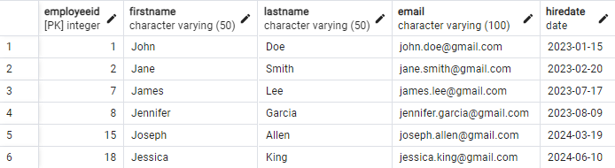

1. **Find the employees with the most recent hire date**

**INPUT:**

SELECT *

FROM employees

ORDER BY hiredate DESC

LIMIT 1;



1. **Find if any two or more employees are hired on the same date**

**INPUT:**

SELECT hiredate, employeeid AS employee_ids

FROM employees

GROUP BY employees.employeeid

HAVING COUNT(*) > 1;

**OUTPUT:**



(No output as no two or more employees were hired on the same date)

1. **Find employees that were hired before today(06-10-2023)**

**INPUT:**

SELECT * FROM employees

WHERE CURRENT_DATE>hiredate

**OUTPUT:**

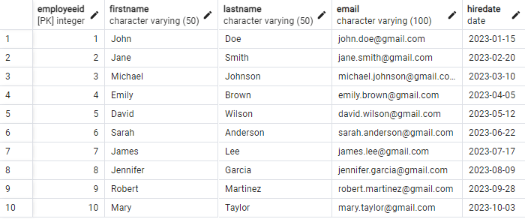

1. **Highest earner of the company**

**INPUT:**

SELECT e.employeeid, e.firstname, e.lastname, salaries.salaryamount

FROM employees AS e, salaries

WHERE e.employeeid = salaries.employeeid

ORDER BY salaryamount DESC

LIMIT 1;

**OUTPUT:**



1. **List employees in alphabetical order by last name**

**INPUT:**

SELECT *

FROM employees

ORDER BY lastname

LIMIT 10;

**OUTPUT:**

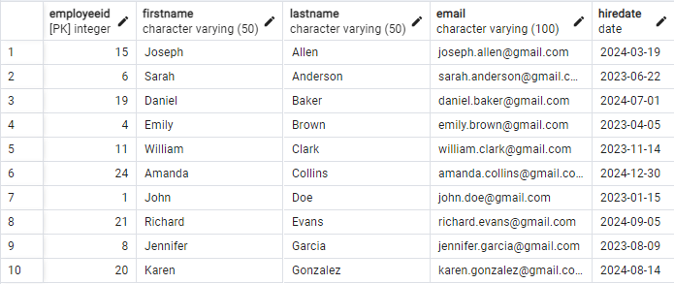

1. **List employees who earn more than the average salary**

**INPUT:**

SELECT *

FROM salaries

WHERE salaryamount > (SELECT AVG(salaryamount) FROM salaries);

**OUTPUT:**

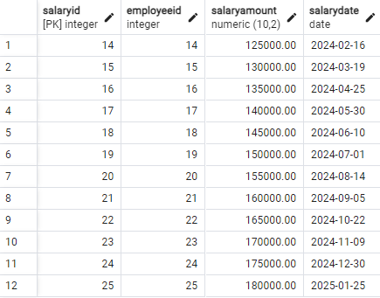

1. **Count number of employees whose first name start with ‘J’**

**INPUT:**

SELECT COUNT(*) AS number_of_emp

FROM employees

WHERE firstname LIKE 'J%';

**OUTPUT:**



1. **Employees that have joined in the month of July**

**INPUT:**

SELECT *

FROM employees

WHERE extract(month from hiredate) = 07;

**OUTPUT:**

