北京邮电大学计算机学院2021-2022学年第一学期

软件工程专业《Java 程序设计》-期末课程作业

|  |  |
| --- | --- |
| 班级： 姓名： 学号： | |
| 注意事项 | 一、学生必须独立完成本作业。  二、**任何雷同或者有抄袭嫌疑的作业，会导致提交者的总评成绩为0分**。  三、学生可以通过阅读、查找纸质资料或者网上电子资料解答题目。但是，不允许**【抄袭】**  四、请保留作业题目，删除【作业解答】中不必要的文字或者标题，保持作业回答干净整洁  五、作业必须以PDF格式提交。作业文件命名：**学号-姓名.pdf** |

评分标准

1. 输出结果和工程项目截图，截图应清晰，大小合适：10%；
2. 实现程序的基本要求：70%；
3. 代码有必要的注释，符合javadoc规范：10%；
4. 代码结构清晰、缩进合理；文档干净整洁；作业文档中的代码字体大小合理规整，代码有语法加亮：10%；

【**特别强调**】任何抄袭或者疑似抄袭的代码，都将导致你的作业被二次复审。请保存好自己的作业，不要给任何人参考。

Question 1（30 points）

Design a class named **Person** and its two subclasses named ***Student*** and ***Employee***. Make ***Staff*** subclass of ***Employee***. A person has a name, address, phone number, and e-mail address. A student has a class status (fresh-man, sophomore, junior, or senior). Define the status as a constant. An employee has an office, and salary. A staff member has a title. Override the toString() method in each class to display the class name and the person's name.

Write a test program that creates a ***Person***, ***Student***, ***Employee***, and ***Staff***. Store the four objects in a ***Person array*** and invokes their toString() methods by the array element references.

Question 2 (30 points)

Write a program with following instructions:

1) Write a client program with TCP socket, which sends a String object which contains "Hello World!" to the server and then quit. Be aware of using exception handling. No thread needed.

2) Write a multi-threaded server program with TCP socket. The server listens on port 8000. When a client connects to the server, the server creates a new thread to serve the client. In the thread, the program receives the String object and save the object in a file named "string.dat". Be aware, when multiple threads write to the same file, these threads need to be synchronized to avoid errors.

Question 3 (30 points)

Write a program to simulate following situation in a simple Pub-Sub messaging system.

a) A message is represented by an integer. At most N (N >= 1) messages can be stored in the Buffer at any time.

b) As long as there is an empty space in the Buffer, the Publisher repeats generating a message, putting the message into the Buffer, and notifying possible waiting Subscriber.

c) The Subscriber repeats consuming a message as long as there is a message in the Buffer. After consuming a message, the Subscriber will notify possible waiting Publisher, and sleeping for a random period.

d) Buffer class has two methods named as putMessage() and getMessage(), which can be invoked by Publisher or Subscriber to put a message into the Buffer or get a message out of the Buffer.

e) Define three classes: Publisher, Subscriber, and Buffer. Publisher and Subscriber are running as Threads.

f) The Publisher has to wait if there is no empty space in the Buffer. The Subscriber has to wait if there is no product in the Buffer

Question 4 (10 points)

You may choose to finish both or either of the following requests and you will get the corresponding scores.

1. Based on Question 3, design a GUI to demonstrate the Pub/Sub messaging system (5 points).
2. Based on 1), implementing Publisher, Subscriber and the Buffer as separate applications. The Publisher connects to the Buffer with TCP socket. Also, the Subscriber connects to the Buffer with TCP Socket. GUI is needed and maybe you need to design 3 GUI applications (5 points).

CAUTION: Post all your codes for this question here, maybe including some code snippets from question 3.

The GUI examples for 1) may be as follows:

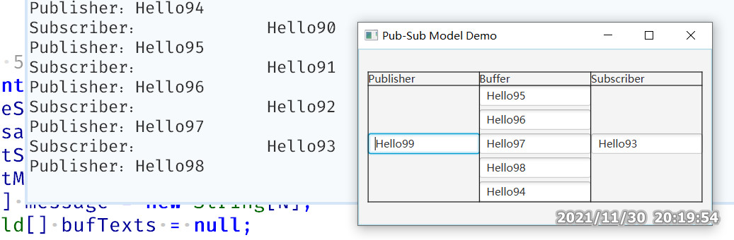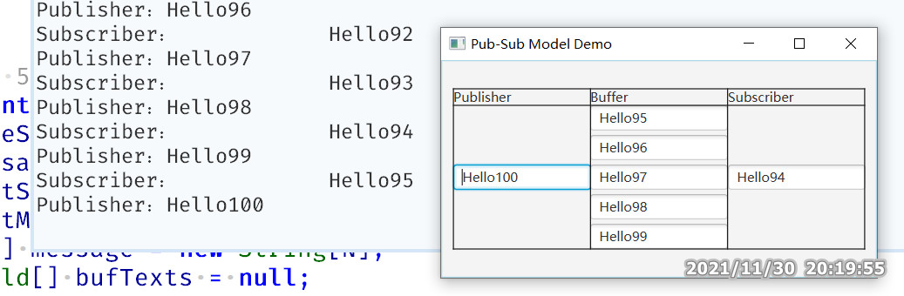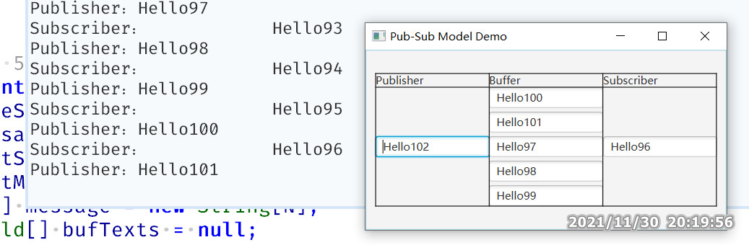

*Note: the timestamps at the bottom-right corner do not belong to the GUI.*

作业解答

# 题目1

## 输出结果截图

## 工程项目截图

IDE中工程项目截图，显示项目文件

## xxx.java

|  |
| --- |
| package xxx;  public class Q1 {  public static void main(String args[]) {  }  } |

## xxx.java

（请将上面的标题改为你的源代码文件名）

代码请使用正文样式。中文可使用宋体或者微软雅黑，英文使用等宽字体 (例如Consolas)。

代码应保持缩进

代码应保持IDE中的加亮

在Eclipse中拷贝代码，在本文档中【带格式粘贴】，随后调整代码字体大小、行间距等。

|  |
| --- |
| package xxx;  public class Q1 {  public static void main(String args[]) {  }  } |

# 题目2

## 输出结果截图

## 工程项目截图

## xxx.java

|  |
| --- |
| package xxx;  public class Q1 {  public static void main(String args[]) {  }  } |

## xxx.java

|  |
| --- |
| package xxx;  public class Q1 {  public static void main(String args[]) {  }  } |

# 题目3

本题目无需程序运行输出结果截图

## 工程项目截图

## xxx.java

|  |
| --- |
| package xxx;  public class Q1 {  public static void main(String args[]) {  }  } |

## xxx.java

|  |
| --- |
| package xxx;  public class Q1 {  public static void main(String args[]) {  }  } |

# 题目4.1 （第四题第1问）

本题目无需程序运行输出结果截图

## 工程项目截图

## xxx.java

|  |
| --- |
| package xxx;  public class Q1 {  public static void main(String args[]) {  }  } |

# 题目4.2（第四题第2问）

本题目无需程序运行输出结果截图

## 工程项目截图

## xxx.java

|  |
| --- |
| package xxx;  public class Q1 {  public static void main(String args[]) {  }  } |

## xxx.java

|  |
| --- |
| package xxx;  public class Q1 {  public static void main(String args[]) {  }  } |

## xxx.java

|  |
| --- |
| package xxx;  public class Q1 {  public static void main(String args[]) {  }  } |