1. Design Concept & Visual Language
Crystal Cavern v3 GUI adopts a dark Maya-native aesthetic with cyan/amber accent colours — inspired by geological exploration instruments. The visual language evokes a "cave survey console": dark backgrounds, mineral-themed accent colours, and clear hierarchical grouping.
Design principles adopted from 8 peer-group GUI analyses:
• Banner logo with project identity (Group 4 SmokeFlow, Group 10 ReefSeed)
• Collapsible frameLayout sections to reduce visual clutter (Group 4, Group 6 Orbit)
• Colour-coded action buttons with clear semantics (Group 3 CS2)
• Progress bar + status footer for real-time feedback (Group 1, Group 11)
• Chinese + English bilingual labels (Group 6 Orbit)
• Safe-range annotations on every slider (Group 1 WorldMaker)
• Production-order layout (Group 9 Mycelium)
• Dark Maya theme with amber/cyan accent colours (Group 5, Group 11)

1.1 GUI Screenshot — Full Window
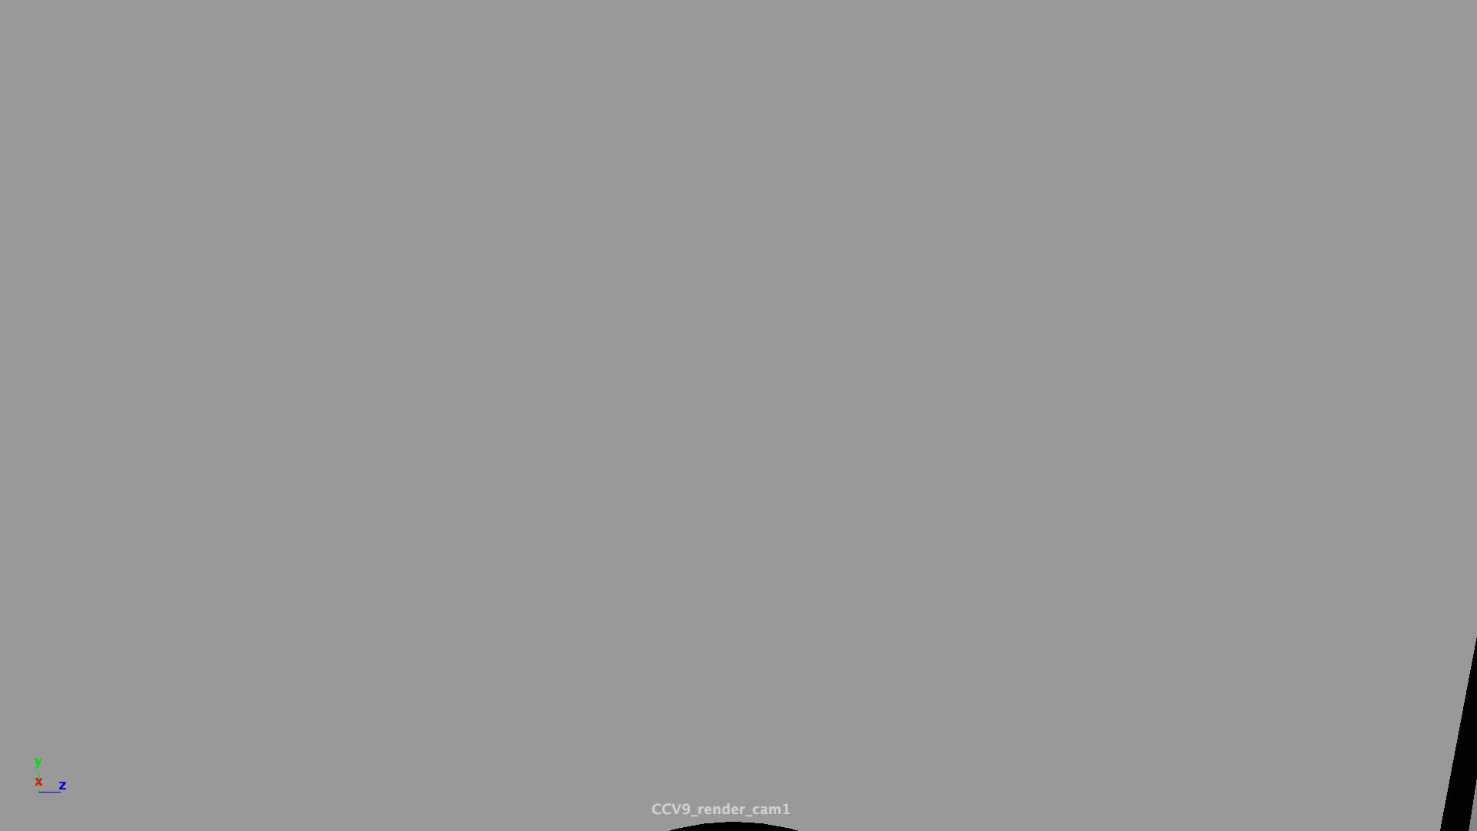
Figure 1. Crystal Cavern v3 GUI — Terrain tab open, showing collapsible frameLayout sections, banner logo, progress bar, and colour-coded action buttons.

1.2 GUI Screenshot — Lighting Tab

Figure 2. Lighting tab showing Ambient & Fog and Dramatic Lights collapsible sections with bilingual Chinese/English labels and safe-range annotations.

2. Layout Hierarchy
The GUI follows Maya's standard parent-child layout architecture. The top-level window contains a single columnLayout root, a tabLayout with 5 tabs, progress bar + status line, and 4-colour action button row.
window "cryUI_v3"
├── columnLayout (root)
│ ├── text "◆ Crystal Cavern ◆" ← Banner logo
│ ├── text subtitle (EN + CN)
│ ├── separator
│ ├── tabLayout "cry_tabs"
│ │ ├── Tab 1 "Terrain / 地形"
│ │ │ ├── frameLayout "Base Settings" (open)
│ │ │ │ ├── intSliderGrp Seed [1,99999]→2026
│ │ │ │ ├── floatSliderGrp Roughness [0.1,0.8]→0.45
│ │ │ │ └── intSliderGrp Size [20,80]→40
│ │ │ └── frameLayout "Enclosure" (collapsed)
│ │ │ ├── floatSliderGrp Wall Height [8,25]→14
│ │ │ └── floatSliderGrp Ceiling [6,20]→10
│ │ ├── Tab 2 "Crystals / 晶体" (2 frameLayouts, 4 controls)
│ │ ├── Tab 3 "Lighting / 灯光" (2 frameLayouts, 4 controls)
│ │ ├── Tab 4 "Cam/Anim / 相机" (2 frameLayouts, 5 controls + 2 buttons)
│ │ └── Tab 5 "Render / 渲染" (2 frameLayouts, 3 controls + 2 buttons)
│ ├── separator
│ ├── progressBar "cry_bar" (0-100%, 8 stages)
│ ├── text status line
│ ├── separator
│ ├── rowLayout (4 buttons)
│ │ ├── Generate (green) Preview (blue) Reset (red) Close
│ ├── separator
│ └── text footer (ZJU 2026 credit)
└── cmds.showWindow(window)

3. Control Details
Table 1 lists every UI control with type, safe range, default, and pipeline parameter mapping.
# | Tab | Name | Type | Range | Default
1 | Terrain | terrain_seed | intSliderGrp | [1,99999] | 2026
2 | Terrain | terrain_roughness | floatSliderGrp | [0.1,0.8] | 0.45
3 | Terrain | terrain_size | intSliderGrp | [20,80] | 40
4 | Terrain | terrain_wall_height | floatSliderGrp | [8,25] | 14
5 | Terrain | terrain_ceiling_height | floatSliderGrp | [6,20] | 10
6 | Crystals | crystal_density | floatSliderGrp | [0.5,4.0] | 2.0
7 | Crystals | crystal_variance | floatSliderGrp | [0.3,2.0] | 1.0
8 | Crystals | crystal_color_seed | intSliderGrp | [1,99999] | 42
9 | Crystals | crystal_type_mix | optionMenuGrp | 5 opts | Mixed
10 | Lighting | light_ambient | floatSliderGrp | [0.01,0.50] | 0.30
11 | Lighting | light_fog | floatSliderGrp | [0.002,0.080] | 0.020
12 | Lighting | light_dust | intSliderGrp | [50,500] | 200
13 | Lighting | light_crystal_lights | intSliderGrp | [5,40] | 20
14 | Cam/Anim | cam_focal | floatSliderGrp | [18,50] | 24
15 | Cam/Anim | cam_fly_y | floatSliderGrp | [1,8] | 3
16 | Cam/Anim | cam_look_radius | floatSliderGrp | [5,35] | 18
17 | Cam/Anim | growth_stagger | intSliderGrp | [100,600] | 400
18 | Cam/Anim | growth_duration | intSliderGrp | [300,800] | 560
19 | Render | render_width | intSliderGrp | [640,3840] | 1920
20 | Render | render_height | intSliderGrp | [360,2160] | 1080
21 | Render | render_aa | intSliderGrp | [1,10] | 5

3.1 Safety Ranges
As emphasised by Prof. Zhang Kejun (Lecture 2026-07-21), every UI control must have a safe range. Key rationale:
• Seed [1,99999]: prevents negative overflow; 99,999 possible caves
• Density [0.5,4.0]: prevents scene-empty or Maya-crash extremes
• Fog [0.002,0.080]: invisible below 0.002, fully opaque above 0.080
• Default values produce a high-quality scene — "the lazy user just clicks Generate"

4. Callback Functions

4.1 generate_from_ui()
Trigger: "Generate" (green) click.
Reads all 21 UI values → prints summary → cleans scene → calls final_scene.build() → updates progressBar through 8 stages → shows confirmDialog on completion.

4.2 reset_scene()
Trigger: "Reset" (red) click.
Shows confirmDialog then cmds.file(new=True, force=True).

4.3 _render_still()
Trigger: "Render Still" (amber) click.
Imports arnold_render and calls render_beauty() for Arnold EXR output.

4.4 _goto_frame(frame)
Trigger: frame jump buttons in Cam/Anim tab.
Jumps timeline to frame 1 or 960 for growth animation preview.

5. User Guide
To open the GUI (Maya Script Editor Python tab):
from crystal_ui_v3 import create_ui
create_ui()
1. Adjust parameters across 5 tabs
2. Click "Generate" (green) → watch progressBar → ~40s build
3. Press Play (▶) for 960-frame immersive fly-through
4. Click "Render Still" (amber) or "Open Arnold Render View" (blue) to render

6. Cross-Group Best Practice Adoption
Table 2 shows which features were adopted from each peer-group's GUI design.
Source Group | Best Practice | Adopted in v3
Group 1 (WorldMaker) | Safe ranges, dockable | ✅ 21 controls with min/max
Group 3 (CS2) | Colour-coded buttons, status footer | ✅ Green/Blue/Amber/Red + status text
Group 4 (SmokeFlow) | Collapsible sections, banner logo | ✅ 10 frameLayout + banner
Group 5 (Emo) | Dark aesthetic, accent colours | ✅ Dark theme, cyan/amber accents
Group 6 (Orbit) | Bilingual labels | ✅ All CN/EN labels
Group 9 (Mycelium) | Production-order layout | ✅ Terrain→Crystals→Lighting→Anim→Render
Group 10 (ReefSeed) | Compact single-window | ✅ Single dockable window
Group 11 (PosePilot) | Progress bar, dark UI | ✅ Embedded progressBar with 8 stages

7. GUI Iteration History
The Crystal Cavern GUI evolved through three major iterations over 3 days:
Feature | v1 (19 Jul) | v2 (20 Jul) | v3 (22 Jul)
Tabs | 1 (flat layout) | 4 | 5 (+Cam/Anim)
Collapsible sections | No | No | ✅ 10 frameLayout
Parameters | ~8 | 16 | 21
Bilingual labels | No | No | ✅ All CN+EN
Progress bar | No | No | ✅ 8-stage bar
Status footer | No | No | ✅ Real-time text
Banner logo | No | ✅ Text | ✅ Banner+subtitle
Colour buttons | Green | Green/Red | ✅ 4-colour
Machine-independent | Hardcoded | Hardcoded | ✅ __file__-based

Figure 3. v2 GUI (left) vs v3 GUI (right) — showing the progression from flat 4-tab layout to collapsible 5-tab layout with banner, progress bar, bilingual labels, and colour-coded buttons.
(Screenshots: /项目截图/gui_v2_current.0000.png and gui_v3_full.0000.png)

