**Program Structure**

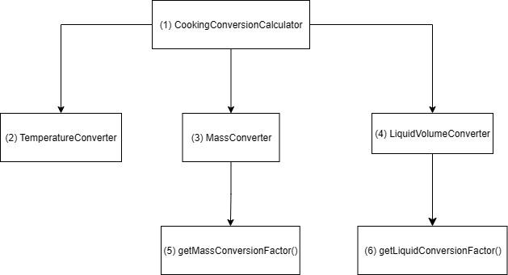

**Top-down Integration**

| Unit under test | Input | List of Stubs/Drivers | Stub’s return value | Expected results | Actual results | Pass/Fail/No run |
| --- | --- | --- | --- | --- | --- | --- |
| 1 | Choice: temperature | 2, 3, 4 | 2 -> 30  3 -> 5  4 -> 5 | 30 | 30 | Pass |
| 1 | Choice: mass | 2, 3, 4 | 2 -> 30  3 -> 5  4 -> 5 | 5 | 5 | Pass |
| 1 | Choice: liquid | 2, 3, 4 | 2 -> 30  3 -> 5  4 -> 5 | 5 | 5 | Pass |
| 2 | Value: 32  choice: temperature  fromUnit: fahrenheit  toUnit: celsius |  |  | 0 | 0 | Pass |
| 2 | Value: 0  Choice: temperature fromUnit: celsius toUnit: fahrenheit |  |  | 32 | 0 | Fail |
| 3 | Value: 1  Expected: 10 | 5 | 5 -> 10 | 1 | 10 | Pass |
| 5 | value: 1  choice: mass  fromUnit: cup  toUnit: gram |  |  | 125 | 125 | Pass |
| 5 | value: 1  choice: mass  fromUnit: tablespoon  toUnit: gram |  |  | 8 | 8 | Pass |
| 5 | value: 1  choice: mass  fromUnit: teaspoon  toUnit: gram |  |  | 3 | 3 | Pass |
| 5 | value: 1  choice: mass  fromUnit: oz  toUnit: gram |  |  | 28.349 | 28.349 | Pass |
| 5 | value: 1  choice: mass  fromUnit: pound  toUnit: kilogram |  |  | 0.454 | 0.454 | Pass |
| 5 | value: 1  choice: mass  fromUnit: gram  toUnit: oz |  |  | 0.035 | 0.035 | Pass |
| 5 | value: 1  choice: mass  fromUnit: kilogram  toUnit: pound |  |  | 2.205 | 2.205 | Pass |
| 4 | Value: 1  Expected: 10 | 6 | 6 -> 10 | 1 | 10 | Pass |
| 6 | Value: 1  Choice: liquid  fromUnit: cup  toUnit: ml |  |  | 250 | 250 | Pass |
| 6 | Value: 1  Choice: liquid  fromUnit: cup  toUnit: oz |  |  | 8 | 8 | Pass |
| 6 | Value: 1  Choice: liquid  fromUnit: tablespoon  toUnit: ml |  |  | 15 | 15 | Pass |
| 6 | Value: 1  Choice: liquid  fromUnit: teaspoon  toUnit: ml |  |  | 5 | 5 | Pass |
| 6 | Value: 1  Choice: liquid  fromUnit: oz  toUnit: ml |  |  | 29.574 | 29.574 | Pass |
| 6 | Value: 1  Choice: liquid  fromUnit: pint  toUnit: ml |  |  | 473.176 | 473.176 | Pass |
| 6 | Value: 1  Choice: liquid  fromUnit: quart  toUnit: liter |  |  | 0.946 | 0.946 | Pass |
| 6 | Value: 1  Choice: liquid  fromUnit: ml  toUnit: oz |  |  | 0.034 | 0.034 | Pass |
| 6 | Value: 1  Choice: liquid  fromUnit: liter  toUnit: pint |  |  | 2.113 | 2.113 | Pass |
| 6 | Value: 1  Choice: liquid  fromUnit: liter  toUnit: quart |  |  | 1.057 | 1.057 | Pass |
| 6 | Value: 1  Choice: liquid  fromUnit: liter  toUnit: gallon |  |  | 0.264 | 0.264 | Pass |

**Bottom-up Integration**

| Unit under test | Input | List of Stubs/Drivers | Stub’s return value | Expected results | Actual results | Pass/Fail/No run |
| --- | --- | --- | --- | --- | --- | --- |
| 2 | Value: 32  fromUnit: fahrenheit  toUnit: celsius | 1 |  | 0 | 0 | Pass |
| 1->2 | Value: 0  Choice: temperature  fromUnit: celsius  toUnit: fahrenheit |  |  | 32 | 0 | Fail |
| 5 | fromUnit: cup  toUnit: gram | 3 |  | 125 | 125 | Pass |
| 3->5 | Value: 1  fromUnit:tablespoon  toUnit: gram | 1 |  | 8 | 8 | Pass |
| 1->3->5 | Value: 1  Choice: mass  fromUnit: teaspoon  toUnit: gram |  |  | 3 | 3 | Pass |
| 6 | fromUnit: cup  toUnit: ml | 4 |  | 250 | 250 | Pass |
| 4->6 | Value: 1  fromUnit: cup  toUnit: oz | 1 |  | 8 | 8 | Pass |
| 1->4->6 | Value: 1  Choice: liquid  fromUnit: tablespoon  toUnit: ml |  |  | 15 | 15 | Pass |

| Integration Test | No. of Test Case | Pass | Fail | No run |
| --- | --- | --- | --- | --- |
| Top-Down | 26 | 25 | 1 |  |
| Bottom-Up | 8 | 7 | 1 |  |
| Total | 34 | 32 | 2 |  |