1. //WAP to check whether the two strings are Anagramas or not.

#include<stdio.h>

#include<string.h>

int anagram(char str1[],char str2[])

{

    int count[1000]={0};

    if(strlen(str1)!=strlen(str2))

    {

        return 0;

    }

    for(int i=0;str1[i]!='\0';i++)

    {

        count[(unsigned char)str1[i]]++;

        count[(unsigned char)str2[i]]--;

    }

    for(int i=0;i<1000;i++)

    {

        if(count[i]!=0)

        {

            return 0;

        }

    }

    return 1;

}

int main(){

    char str1[100],str2[100];

    printf("Enter first string: ");

    fgets(str1,sizeof(str1),stdin);

    str1[strcspn(str1,"\n")]='\0';

    printf("Enter second string: ");

    fgets(str2,sizeof(str2),stdin);

    str2[strcspn(str2,"\n")]='\0';

    if(anagram(str1,str2))

    {

        printf("The strings are anagrama.\n");

    }

    else

    {

        printf("The strings are not anagrams.\n");

    }

}

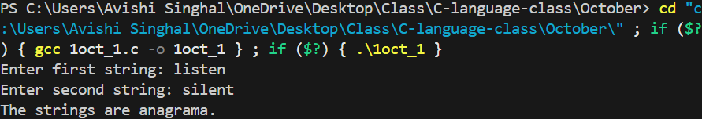

1. //WAP to find the second largest element in an array by passing array to a function.

#include<stdio.h>

int find(int arr[],int size)

{

    int a,b,i;

    if(arr[0]>arr[1])

    {

        a=arr[0];

        b=arr[1];

    }

    else

    {

        a=arr[1];

        b=arr[0];

    }

    for(i=2;i<size;i++)

    {

        if(arr[i]>a)

        {

            b=a;

            a=arr[i];

        }

        else if(arr[i]>b&&arr[i]!=a)

        {

            b=arr[i];

        }

    }

    return b;

}

int main(){

    int arr[100],n,i,ans;

    printf("Enter number of elements: ");

    scanf("%d",&n);

    printf("Enter %d elements: ",n);

    for(i=0;i<n;i++)

    {

        scanf("%d",&arr[i]);

    }

    ans=find(arr,n);

    printf("Second largest element=%d\n",ans);

}

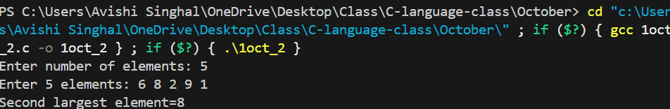

1. //WAP to find sum of digit using recursion.

#include<stdio.h>

int sum(int a)

{

    if(a==0)

    {

        return 0;

    }

    else

    {

        return (a%10)+sum(a/10);

    }

}

int main(){

    int b,ans;

    printf("Enter a number: ");

    scanf("%d",&b);

    ans=sum(b);

    printf("Sum of Digits=%d\n",ans);

}

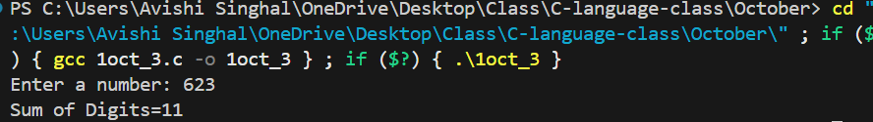

1. //WAP and function to swap two no. using call by refrence.

#include<stdio.h>

void swap(int *a,int *b)

{

    int temp;

    temp=*a;

    *a=*b;

    *b=temp;

}

int main(){

    int c,d;

    printf("Enter first number: ");

    scanf("%d",&c);

    printf("Enter second number: ");

    scanf("%d",&d);

    printf("Before Swapping\n");

    printf("c=%d\nd=%d\n",c,d);

    swap(&c, &d);

    printf("After Swapping\n");

    printf("c=%d\nd=%d\n",c,d);

}

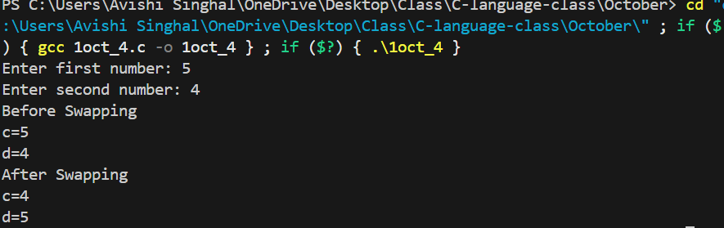

1. //Write a function to sort an array using function.

#include<stdio.h>

void sort(int arr[],int n)

{

    int i,j,temp;

    for(i=0;i<n-1;i++)

    {

        for(j=i+1;j<n;j++)

        {

            if(arr[i]>arr[j])

            {

                temp=arr[i];

                arr[i]=arr[j];

                arr[j]=temp;

            }

        }

    }

}

void display(int arr[],int n)

{

    int i;

    printf("Sorted: ");

    for(i=0;i<n;i++)

    {

        printf("%d",arr[i]);

    }

    printf("\n");

}

int main(){

    int arr[100],n,i;

    printf("Enter number of elements: ");

    scanf("%d",&n);

    printf("Enter %d Elements: ",n);

    for(i=0;i<n;i++)

    {

        scanf("%d",&arr[i]);

    }

    sort(arr,n);

    display(arr,n);

}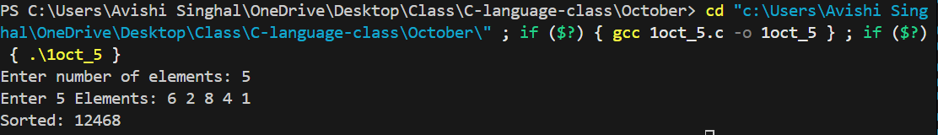

1. //WAP to define structure name student with roll no. , name and marks and write function to input and display student details.

#include<stdio.h>

#include<string.h>

struct Student

{

    int roll_no;

    char name[100];

    float marks;

};

void input(struct Student *s)

{

    printf("Enter Student Roll No.: ");

    scanf("%d",&s->roll_no);

    getchar();

    printf("Enter Student Name: ");

    fgets(s->name,sizeof(s->name),stdin);

    printf("Enter Marks: ");

    scanf("%f",&s->marks);

}

void display(struct Student s)

{

    printf("Roll No.: %d\n",s.roll_no);

    printf("Name: %s\n",s.name);

    printf("Marks: %f\n",s.marks);

}

int main(){

    struct Student s;

    input(&s);

    display(s);

}

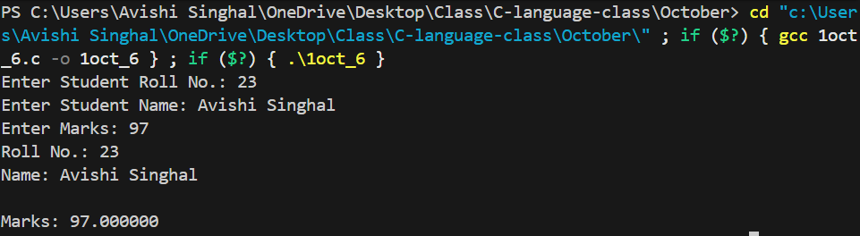

1. //WAP to create a structure employee with ID, name, basic salary, DA, HRA, gross salary and Write a function to calculate salary and display details.

#include<stdio.h>

struct Employee

{

    int id;

    char name[100];

    float basic,da,hra,da_per,hra_per,gross;

};

void input(struct Employee *emp)

{

    printf("Enter Employee ID: ");

    scanf("%d",&emp->id);

    getchar();

    printf("Enter Employee Name: ");

    fgets(emp->name,sizeof(emp->name),stdin);

    printf("Enter Basic Salary: ");

    scanf("%f",&emp->basic);

    printf("Enter DA percentage: ");

    scanf("%f",&emp->da_per);

    printf("Enter HRA Percentage: ");

    scanf("%f",&emp->hra_per);

}

void salary(struct Employee *emp)

{

    emp->da=(emp->da_per/100)*emp->basic;

    emp->hra=(emp->hra_per/100)*emp->basic;

    emp->gross=emp->basic+emp->da+emp->hra;

}

void details(struct Employee emp)

{

    printf("ID: %d\n",emp.id);

    printf("Name: %s\n",emp.name);

    printf("Basic Salary: %f\n",emp.basic);

    printf("DA: %f\n",emp.da);

    printf("HRA: %f\n",emp.hra);

    printf("Gross Salary: %f\n",emp.gross);

}

int main(){

    struct Employee emp;

    input(&emp);

    salary(&emp);

    details(emp);

}

