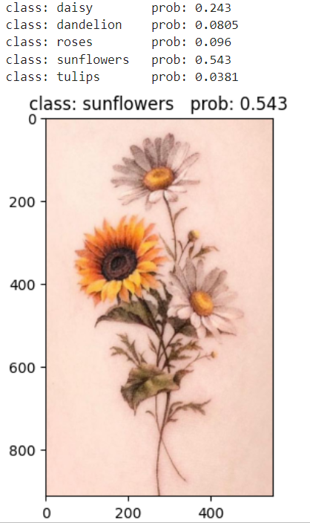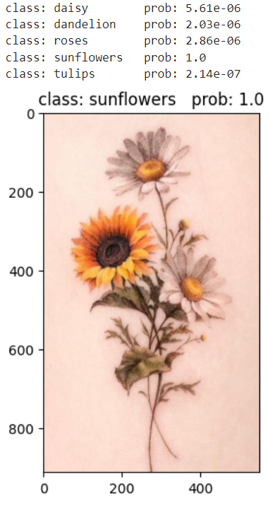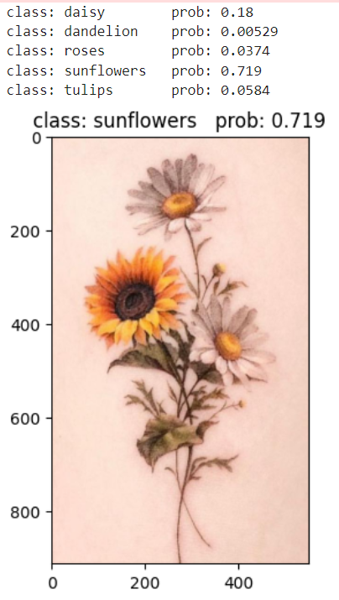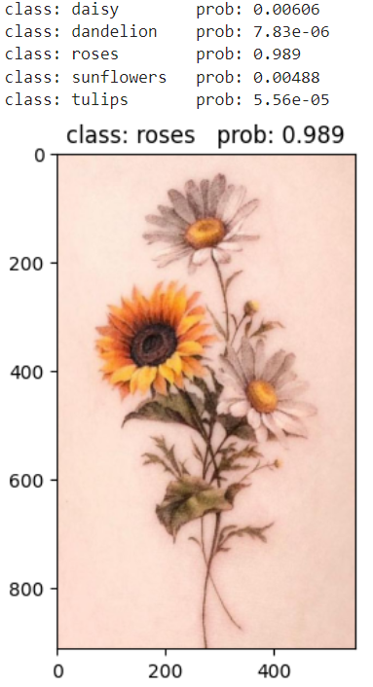

vit_base_patch16_224_in21k vit_base_patch16_224 vit_base_patch32_224 vit_large_patch16_224

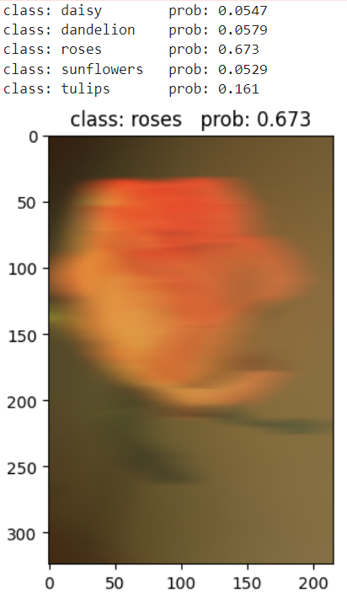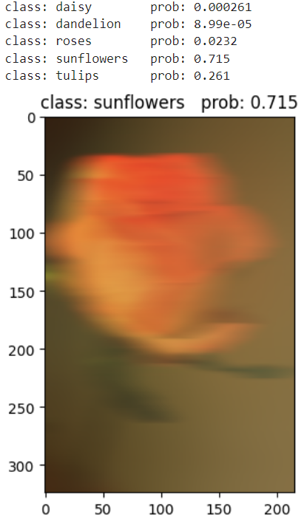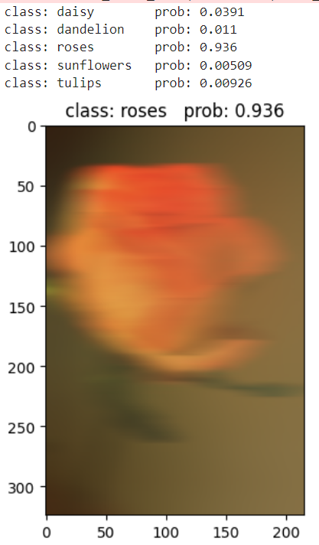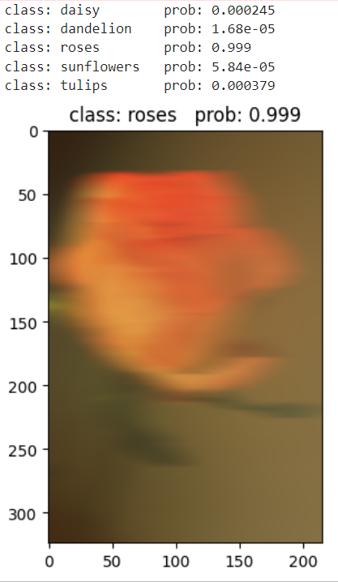

vit_base_patch16_224_in21k vit_base_patch16_224 vit_base_patch32_224 vit_large_patch16_224