**新巴巴运动网 项目第二天**

**传智.上官云**

# 课前回顾

1. 项目介绍 电子商务 互联网项目 外包公司
2. 项目构架 12个项目 父工程 管理版本号 四个服务层Tomcat 并发 检索、静态cms、 后台管理、（用户及购物车、订单）
3. Maven搭建（代码）

# 今天内容

1. SVN搭建
2. 所Jar代 坐标导入
3. 搭建Spring+Mybatis
4. 创建数据库 测试表
5. 测试连接数据库
6. 整合Springmvc
7. 测试
8. 搭建后台管理
9. 品牌管理之列表查询（带条件、分页）

# SVN搭建

## 服务端（保存代码） 有继续用 没有以下（图形化界面） 主机名不能是中文

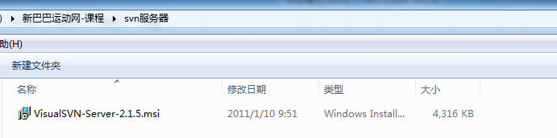

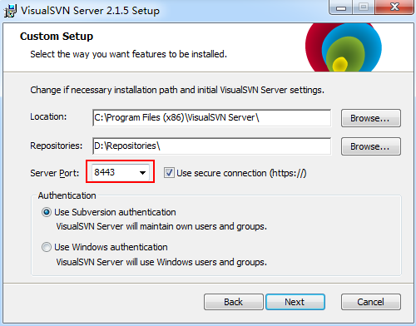

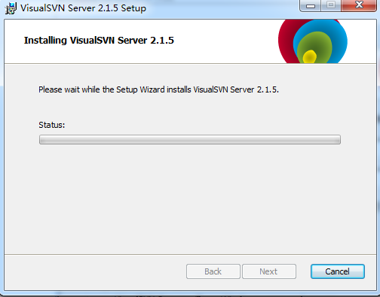

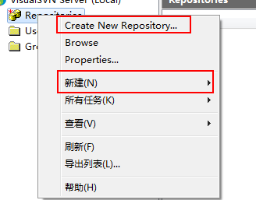

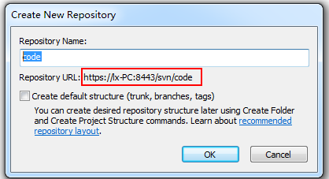

用户

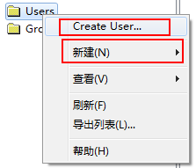

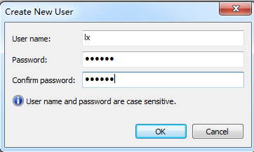

## Eclipse有客户端

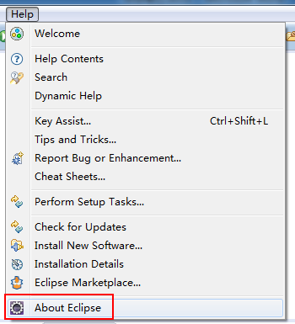

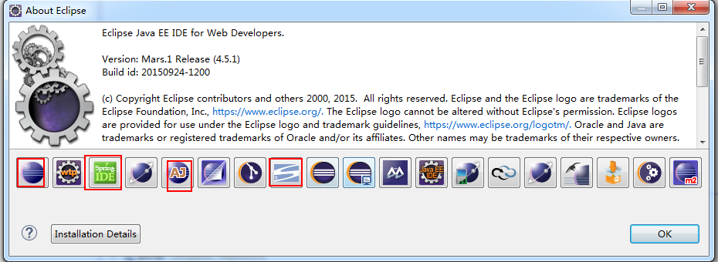

## 提交代码

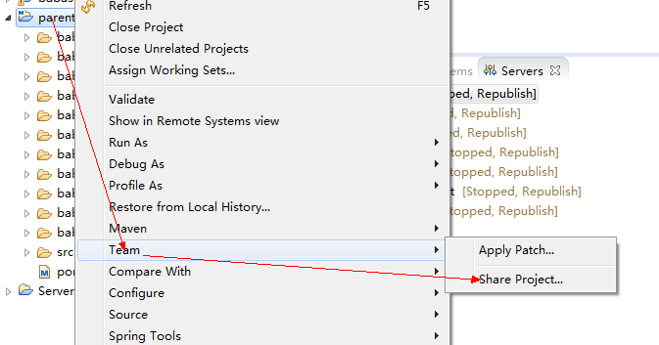

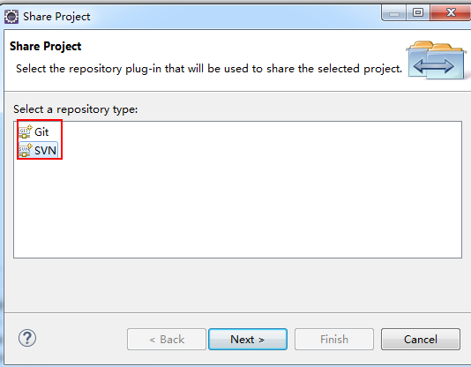

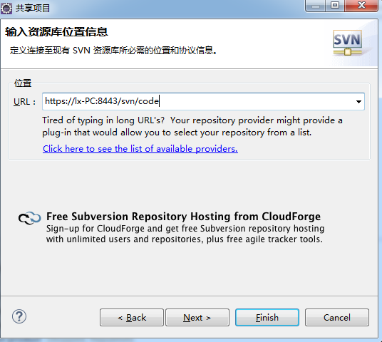

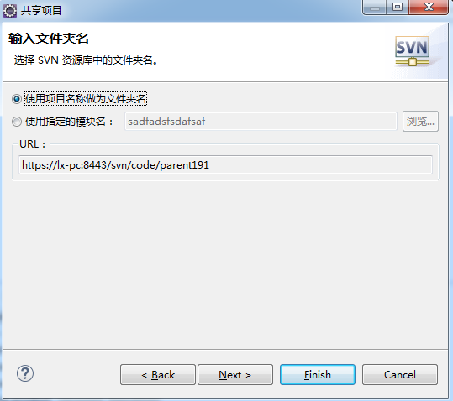

## SVN代码

源代码

项目配置文件、 .classpath .project .settings …..

过滤

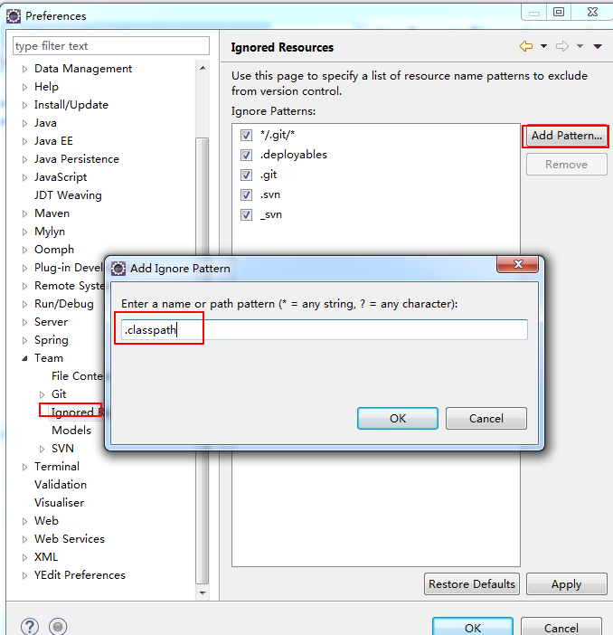

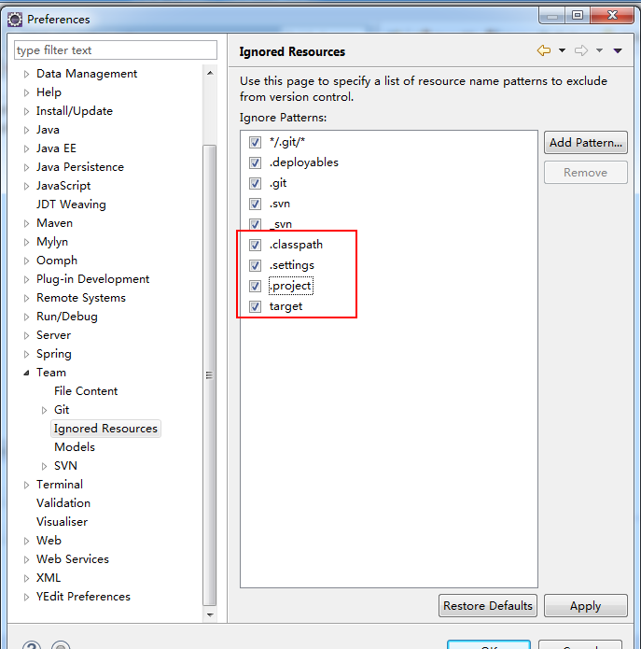

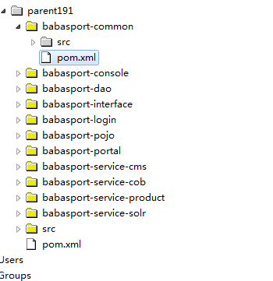

## 代码检出

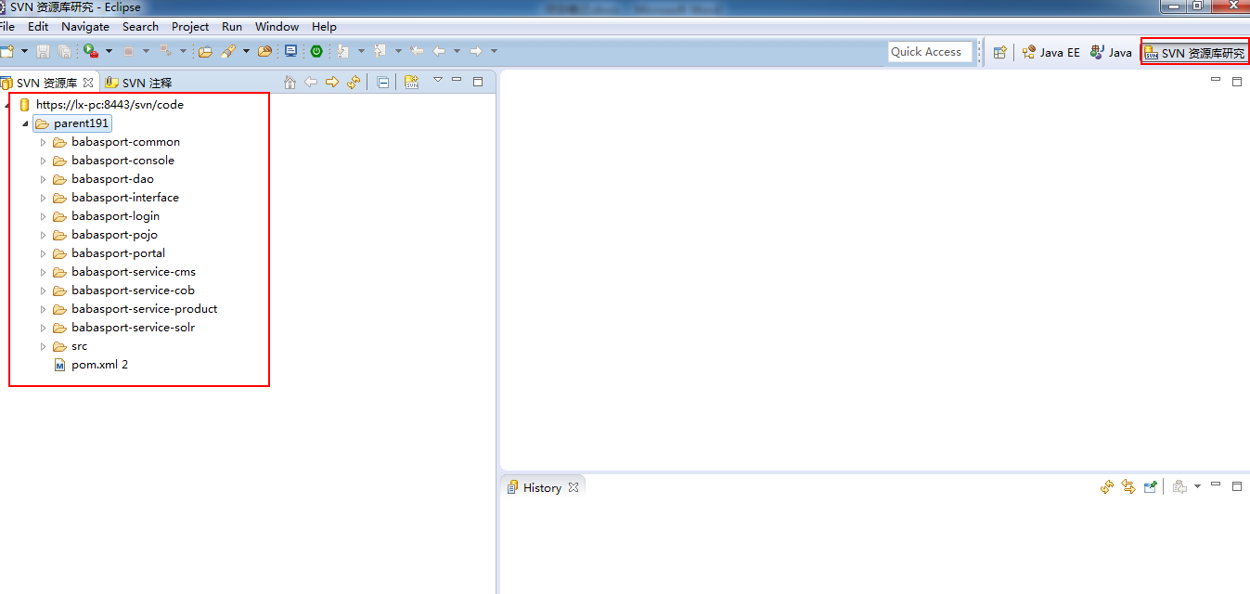

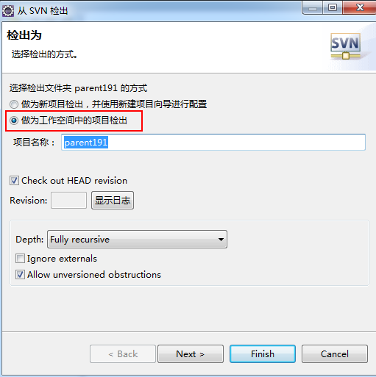

改成Maven工程

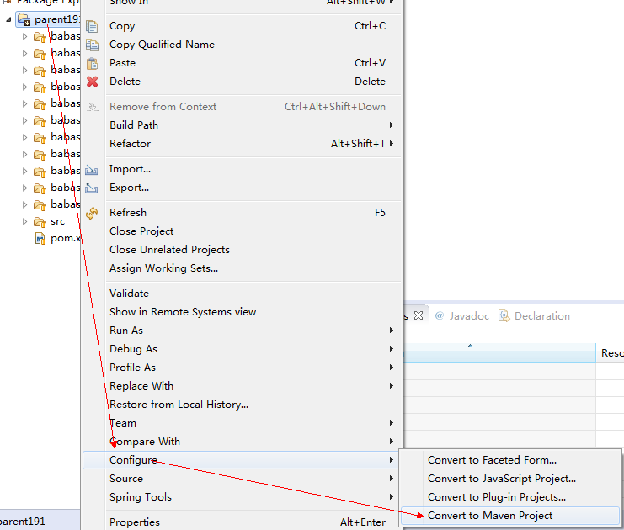

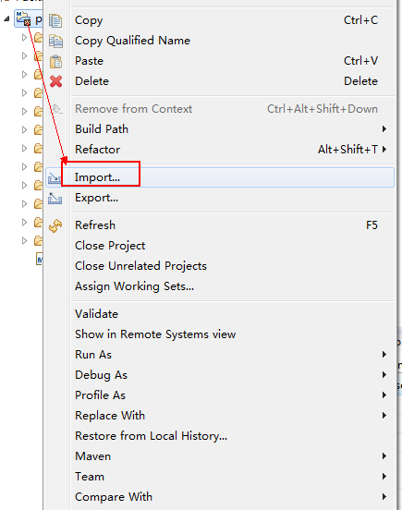

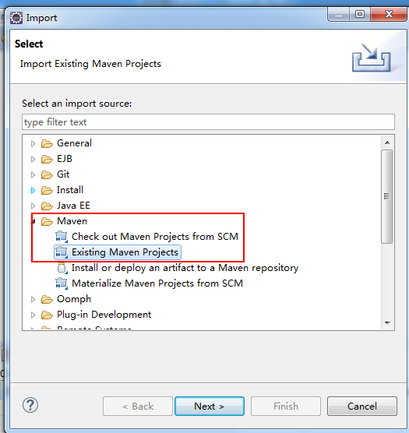

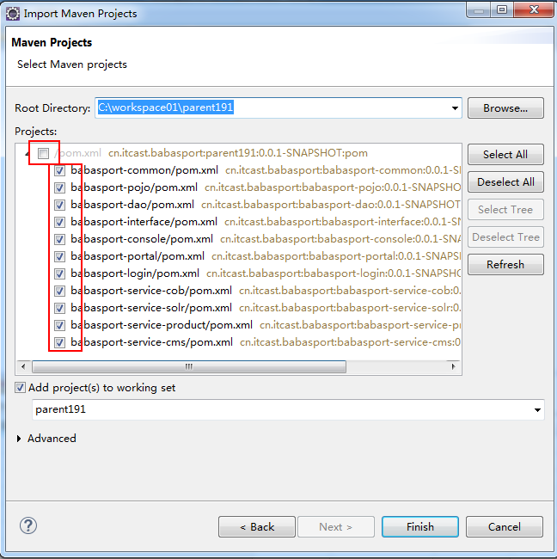

# 所Jar包 坐标导入

Parent191 坐标 gav 版本号 不强制依赖

Common 坐标 ga

Pojo 无 （自定义）

Interface 无

Portal console login 四个service 无

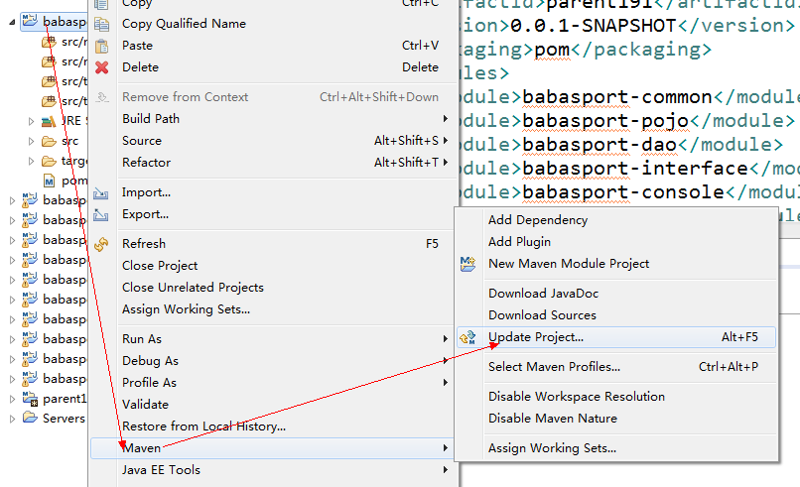

## 更改jdk1.7

|  |
| --- |
| <!-- jdk1.7 -->  <build>  <plugins>  <plugin>  <groupId>org.apache.maven.plugins</groupId>  <artifactId>maven-compiler-plugin</artifactId>  <version>3.2</version>  <configuration>  <source>1.7</source>  <target>1.7</target>  <encoding>UTF-8</encoding>  </configuration>  </plugin>  </plugins>  </build> |

## 父工程中jar坐标

|  |
| --- |
| <!-- 设置统一控制版本 -->  <properties>  <java-version>1.7</java-version>  <junit-version>4.12</junit-version>  <spring.version>4.1.3.RELEASE</spring.version>  <jackson.version>2.4.2</jackson.version>  <mysql-connector-java-version>5.1.8</mysql-connector-java-version>  <org.mybatis-version>3.2.7</org.mybatis-version>  <org.mybatis-spring-version>1.2.2</org.mybatis-spring-version>  <opensymphony-version>2.4.2</opensymphony-version>  <freemarker-version>2.3.18</freemarker-version>  <druid.version>1.0.9</druid.version>  <commons-collections-version>1.0</commons-collections-version>  <commons-fileupload-version>1.2.2</commons-fileupload-version>  <org.apache.commons-version>3.1</org.apache.commons-version>  <commons-codec-version>1.6</commons-codec-version>  <dom4j-version>1.6.1</dom4j-version>  <javax.servlet-version>1.2</javax.servlet-version>  <aspectjweaver-version>1.6.6</aspectjweaver-version>  <slf4j-log4j12-version>1.6.6</slf4j-log4j12-version>  <log4j-version>1.2.16</log4j-version>  <javax.servlet-jsp-version>2.0</javax.servlet-jsp-version>  <cglib-version>2.2.2</cglib-version>  <slf4j-api-version>1.6.6</slf4j-api-version>  <project.build.sourceEncoding>UTF-8</project.build.sourceEncoding>  </properties>    <!-- 依赖管理 版本号 -->  <!-- 设置统一依赖管理、不强行依赖 -->  <dependencyManagement>  <dependencies>  <!-- with junit4.8.2 -->  <dependency>  <groupId>junit</groupId>  <artifactId>junit</artifactId>  <version>${junit-version}</version>  <type>jar</type>  </dependency>  <!-- Spring -->  <dependency>  <groupId>org.springframework</groupId>  <artifactId>spring-context</artifactId>  <version>${spring.version}</version>  </dependency>  <dependency>  <groupId>org.springframework</groupId>  <artifactId>spring-beans</artifactId>  <version>${spring.version}</version>  </dependency>  <dependency>  <groupId>org.springframework</groupId>  <artifactId>spring-webmvc</artifactId>  <version>${spring.version}</version>  </dependency>  <dependency>  <groupId>org.springframework</groupId>  <artifactId>spring-jdbc</artifactId>  <version>${spring.version}</version>  </dependency>  <dependency>  <groupId>org.springframework</groupId>  <artifactId>spring-aspects</artifactId>  <version>${spring.version}</version>  </dependency>  <dependency>  <groupId>org.springframework</groupId>  <artifactId>spring-test</artifactId>  <version>${spring.version}</version>  </dependency>  <dependency>  <groupId>org.springframework</groupId>  <artifactId>spring-context-support</artifactId>  <version>${spring.version}</version>  </dependency>  <dependency>  <groupId>org.springframework</groupId>  <artifactId>spring-jms</artifactId>  <version>${spring.version}</version>  </dependency>  <!-- Jackson Json处理工具包 -->  <dependency>  <groupId>com.fasterxml.jackson.core</groupId>  <artifactId>jackson-databind</artifactId>  <version>${jackson.version}</version>  </dependency>  <!--freemarker -->  <dependency>  <groupId>org.freemarker</groupId>  <artifactId>freemarker</artifactId>  <version>2.3.18</version>  </dependency>  <!-- with mybatis-spring -->  <dependency>  <groupId>org.mybatis</groupId>  <artifactId>mybatis</artifactId>  <version>${org.mybatis-version}</version>  </dependency>  <dependency>  <groupId>org.mybatis</groupId>  <artifactId>mybatis-spring</artifactId>  <version>${org.mybatis-spring-version}</version>  </dependency>  <!-- jdbc driver -->  <dependency>  <groupId>mysql</groupId>  <artifactId>mysql-connector-java</artifactId>  <version>${mysql-connector-java-version}</version>  </dependency>  <!-- 连接池 -->  <dependency>  <groupId>com.alibaba</groupId>  <artifactId>druid</artifactId>  <version>${druid.version}</version>  </dependency>  <!-- apache commons jar -->  <dependency>  <groupId>commons-collections</groupId>  <artifactId>commons-collections</artifactId>  <version>${commons-collections-version}</version>  </dependency>  <dependency>  <groupId>commons-fileupload</groupId>  <artifactId>commons-fileupload</artifactId>  <version>${commons-fileupload-version}</version>  </dependency>  <dependency>  <groupId>org.apache.commons</groupId>  <artifactId>commons-lang3</artifactId>  <version>${org.apache.commons-version}</version>  </dependency>  <dependency>  <groupId>commons-codec</groupId>  <artifactId>commons-codec</artifactId>  <version>${commons-codec-version}</version>  </dependency>  <!-- analyze xml use dom4j -->  <dependency>  <groupId>dom4j</groupId>  <artifactId>dom4j</artifactId>  <version>${dom4j-version}</version>  </dependency>  <!-- jstl标签 -->  <dependency>  <groupId>jstl</groupId>  <artifactId>jstl</artifactId>  <version>1.2</version>  </dependency>  <dependency>  <groupId>taglibs</groupId>  <artifactId>standard</artifactId>  <version>1.1.2</version>  </dependency>  <dependency>  <groupId>org.slf4j</groupId>  <artifactId>slf4j-log4j12</artifactId>  <version>1.6.6</version>  </dependency>  <dependency>  <groupId>log4j</groupId>  <artifactId>log4j</artifactId>  <version>1.2.17</version>  </dependency>  <dependency>  <groupId>org.slf4j</groupId>  <artifactId>slf4j-api</artifactId>  <version>1.6.6</version>  </dependency>  <dependency>  <groupId>javax.activation</groupId>  <artifactId>activation</artifactId>  <version>1.1.1</version>  </dependency>  <dependency>  <groupId>cglib</groupId>  <artifactId>cglib</artifactId>  <version>${cglib-version}</version>  </dependency>  <dependency>  <groupId>net.fckeditor</groupId>  <artifactId>java-core</artifactId>  <version>2.6</version>  </dependency>  <dependency>  <groupId>org.json</groupId>  <artifactId>json</artifactId>  <version>20131018</version>  </dependency>  <!--page -->  <dependency>  <groupId>com.babasport</groupId>  <artifactId>page</artifactId>  <version>1.0</version>  </dependency>  <!-- solrJ -->  <dependency>  <groupId>org.apache.solr</groupId>  <artifactId>solr-solrj</artifactId>  <version>4.10.3</version>  </dependency>  <!-- jedis Java接口 -->  <dependency>  <groupId>redis.clients</groupId>  <artifactId>jedis</artifactId>  <version>2.6.2</version>  <type>jar</type>  </dependency>  <!-- FastDFS client -->  <dependency>  <groupId>fastdfs_client</groupId>  <artifactId>fastdfs_client</artifactId>  <version>1.20</version>  </dependency>  <dependency>  <groupId>org.jboss.netty</groupId>  <artifactId>netty</artifactId>  <version>3.2.5.Final</version>  </dependency>  <dependency>  <groupId>com.alibaba</groupId>  <artifactId>dubbo</artifactId>  <version>2.5.3</version>  </dependency>  <dependency>  <groupId>com.alibaba</groupId>  <artifactId>fastjson</artifactId>  <version>1.1.41</version>  </dependency>  <!-- Zookeeper 用于分布式服务管理 -->  <dependency>  <groupId>com.github.sgroschupf</groupId>  <artifactId>zkclient</artifactId>  <version>0.1</version>  </dependency>  <dependency>  <groupId>org.apache.zookeeper</groupId>  <artifactId>zookeeper</artifactId>  <version>3.4.6</version>  </dependency>  <!-- Zookeeper 用于分布式服务管理 end -->  <!-- Active MQ 开始 -->  <dependency>  <groupId>org.apache.activemq</groupId>  <artifactId>activemq-all</artifactId>  <version>5.8.0</version>  </dependency>  <dependency>  <groupId>org.apache.activemq</groupId>  <artifactId>activemq-pool</artifactId>  <version>5.8.0</version>  </dependency>  <!-- Active MQ 结束 -->  <!-- Tomcat7 servlet-api -->  <dependency>  <groupId>org.apache.tomcat</groupId>  <artifactId>tomcat-jsp-api</artifactId>  <version>7.0.47</version>  <scope>provided</scope>  </dependency>  </dependencies>  </dependencyManagement> |

## Common中jar

|  |
| --- |
| <!-- 依赖管理之后台 -->  <dependencies>  <!-- with junit4.12 -->  <dependency>  <groupId>junit</groupId>  <artifactId>junit</artifactId>  </dependency>  <!-- Spring -->  <dependency>  <groupId>org.springframework</groupId>  <artifactId>spring-context</artifactId>  </dependency>  <dependency>  <groupId>org.springframework</groupId>  <artifactId>spring-beans</artifactId>  </dependency>  <dependency>  <groupId>org.springframework</groupId>  <artifactId>spring-webmvc</artifactId>  </dependency>  <dependency>  <groupId>org.springframework</groupId>  <artifactId>spring-jdbc</artifactId>  </dependency>  <dependency>  <groupId>org.springframework</groupId>  <artifactId>spring-aspects</artifactId>  </dependency>  <dependency>  <groupId>org.springframework</groupId>  <artifactId>spring-test</artifactId>  </dependency>  <dependency>  <groupId>org.springframework</groupId>  <artifactId>spring-context-support</artifactId>  </dependency>  <dependency>  <groupId>org.springframework</groupId>  <artifactId>spring-jms</artifactId>  </dependency>  <!-- Jackson Json处理工具包 -->  <dependency>  <groupId>com.fasterxml.jackson.core</groupId>  <artifactId>jackson-databind</artifactId>  </dependency>  <!--freemarker -->  <dependency>  <groupId>org.freemarker</groupId>  <artifactId>freemarker</artifactId>  </dependency>  <!-- with mybatis-spring -->  <dependency>  <groupId>org.mybatis</groupId>  <artifactId>mybatis</artifactId>  </dependency>  <dependency>  <groupId>org.mybatis</groupId>  <artifactId>mybatis-spring</artifactId>  </dependency>  <!-- jdbc driver -->  <dependency>  <groupId>mysql</groupId>  <artifactId>mysql-connector-java</artifactId>  </dependency>  <!-- 连接池 -->  <dependency>  <groupId>com.alibaba</groupId>  <artifactId>druid</artifactId>  </dependency>  <!-- apache commons jar -->  <dependency>  <groupId>commons-collections</groupId>  <artifactId>commons-collections</artifactId>  </dependency>  <dependency>  <groupId>commons-fileupload</groupId>  <artifactId>commons-fileupload</artifactId>  </dependency>  <dependency>  <groupId>org.apache.commons</groupId>  <artifactId>commons-lang3</artifactId>  </dependency>  <dependency>  <groupId>commons-codec</groupId>  <artifactId>commons-codec</artifactId>  </dependency>  <!-- analyze xml use dom4j -->  <dependency>  <groupId>dom4j</groupId>  <artifactId>dom4j</artifactId>  </dependency>  <!-- jstl标签 -->  <dependency>  <groupId>jstl</groupId>  <artifactId>jstl</artifactId>  </dependency>  <dependency>  <groupId>taglibs</groupId>  <artifactId>standard</artifactId>  </dependency>  <dependency>  <groupId>org.slf4j</groupId>  <artifactId>slf4j-log4j12</artifactId>  </dependency>  <dependency>  <groupId>log4j</groupId>  <artifactId>log4j</artifactId>  </dependency>  <dependency>  <groupId>org.slf4j</groupId>  <artifactId>slf4j-api</artifactId>  </dependency>  <dependency>  <groupId>javax.activation</groupId>  <artifactId>activation</artifactId>  </dependency>  <dependency>  <groupId>cglib</groupId>  <artifactId>cglib</artifactId>  </dependency>  <dependency>  <groupId>net.fckeditor</groupId>  <artifactId>java-core</artifactId>  </dependency>  <dependency>  <groupId>org.json</groupId>  <artifactId>json</artifactId>  </dependency>  <!--page -->  <dependency>  <groupId>com.babasport</groupId>  <artifactId>page</artifactId>  </dependency>  <!-- solrJ -->  <dependency>  <groupId>org.apache.solr</groupId>  <artifactId>solr-solrj</artifactId>  </dependency>  <!-- jedis Java接口 -->  <dependency>  <groupId>redis.clients</groupId>  <artifactId>jedis</artifactId>  </dependency>  <!-- FastDFS client -->  <dependency>  <groupId>fastdfs_client</groupId>  <artifactId>fastdfs_client</artifactId>  </dependency>  <dependency>  <groupId>org.jboss.netty</groupId>  <artifactId>netty</artifactId>  </dependency>  <dependency>  <groupId>com.alibaba</groupId>  <artifactId>dubbo</artifactId>  <exclusions>  <exclusion>  <artifactId>spring</artifactId>  <groupId>org.springframework</groupId>  </exclusion>  </exclusions>  </dependency>  <dependency>  <groupId>com.alibaba</groupId>  <artifactId>fastjson</artifactId>  </dependency>  <!-- Zookeeper 用于分布式服务管理 -->  <dependency>  <groupId>org.apache.zookeeper</groupId>  <artifactId>zookeeper</artifactId>  </dependency>  <dependency>  <groupId>com.github.sgroschupf</groupId>  <artifactId>zkclient</artifactId>  </dependency>  <!-- Zookeeper 用于分布式服务管理 end -->  <!-- Active MQ 开始 -->  <dependency>  <groupId>org.apache.activemq</groupId>  <artifactId>activemq-all</artifactId>  </dependency>  <dependency>  <groupId>org.apache.activemq</groupId>  <artifactId>activemq-pool</artifactId>  </dependency>  <!-- Active MQ 结束 -->  <!-- tomcat7 servlet-api -->  <dependency>  <groupId>org.apache.tomcat</groupId>  <artifactId>tomcat-jsp-api</artifactId>  <scope>provided</scope>  </dependency>  </dependencies> |

# Tomcat jar servlet-api.jar

所有项目中都加入Tomcat7的servlet-api包

Tomcat 7 serlvet-api-3.0.jar

Servlet-api-2.5.jar

Apache servlet-api-3.0.jar

Response request

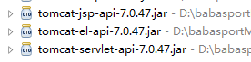

|  |
| --- |
| <!-- tomcat7 servlet-api -->  <dependency>  <groupId>org.apache.tomcat</groupId>  <artifactId>tomcat-jsp-api</artifactId>  <scope>provided</scope>  </dependency> |

# Spring+Mybatis

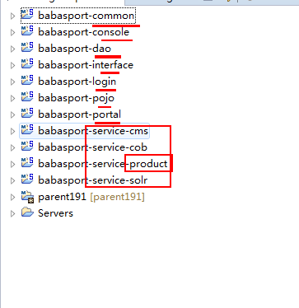

Service-product

## Web.xml

配置监听器

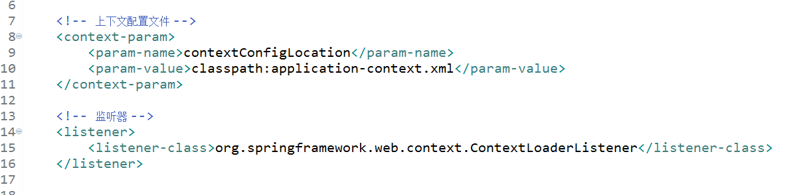

## application-context.xml

|  |
| --- |
| <beans xmlns="http://www.springframework.org/schema/beans"  xmlns:xsi="http://www.w3.org/2001/XMLSchema-instance" xmlns:mvc="http://www.springframework.org/schema/mvc"  xmlns:context="http://www.springframework.org/schema/context"  xmlns:aop="http://www.springframework.org/schema/aop"  xmlns:tx="http://www.springframework.org/schema/tx"  xmlns:task="http://www.springframework.org/schema/task"  xmlns:dubbo="http://code.alibabatech.com/schema/dubbo"  xsi:schemaLocation="http://www.springframework.org/schema/beans  http://www.springframework.org/schema/beans/spring-beans-4.0.xsd  http://www.springframework.org/schema/mvc  http://www.springframework.org/schema/mvc/spring-mvc-4.0.xsd  http://www.springframework.org/schema/context  http://www.springframework.org/schema/context/spring-context-4.0.xsd  http://www.springframework.org/schema/aop  http://www.springframework.org/schema/aop/spring-aop-4.0.xsd  http://www.springframework.org/schema/tx  http://www.springframework.org/schema/tx/spring-tx-4.0.xsd  http://www.springframework.org/schema/task  http://www.springframework.org/schema/task/spring-task-4.0.xsd  http://code.alibabatech.com/schema/dubbo  http://code.alibabatech.com/schema/dubbo/dubbo.xsd">    </beans> |



## 数据源

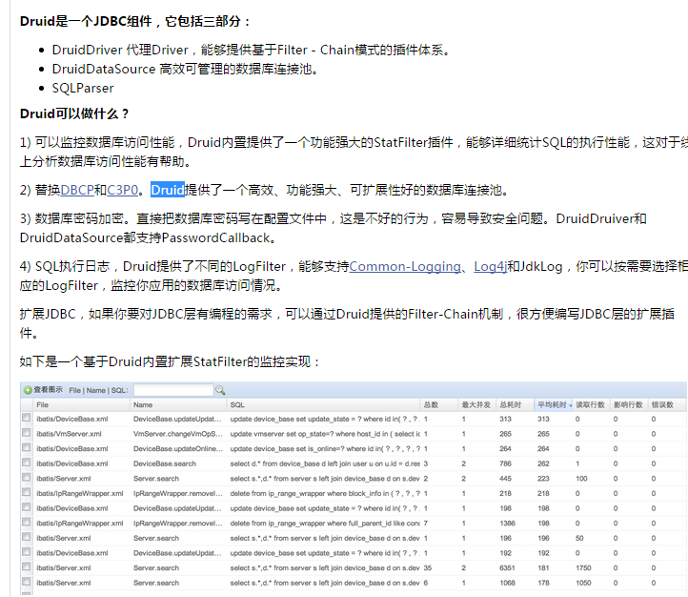

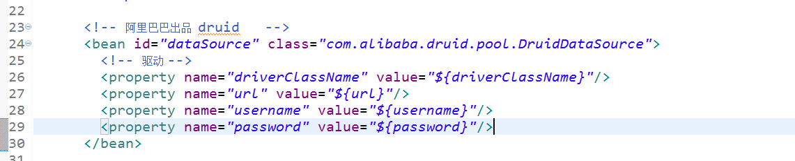

## Jdbc.properties

|  |
| --- |
| driverClassName=com.mysql.jdbc.Driver  url=jdbc:mysql://localhost:3306/babasport?characterEncoding=UTF-8  username=root  password=root |

## 读取配置

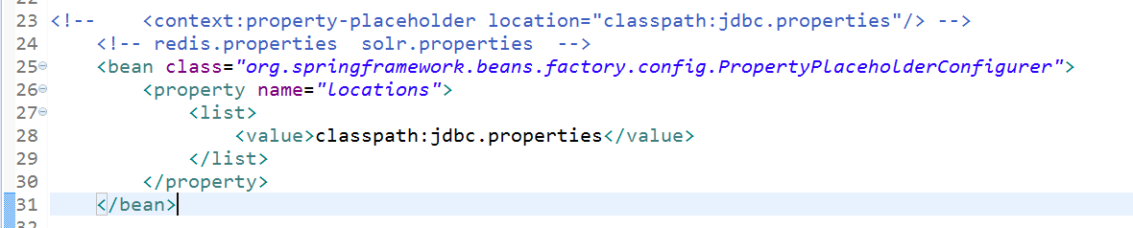

## 扫描



## 事务

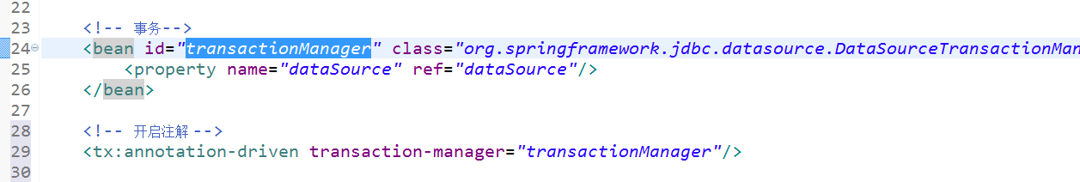

## Mybatis

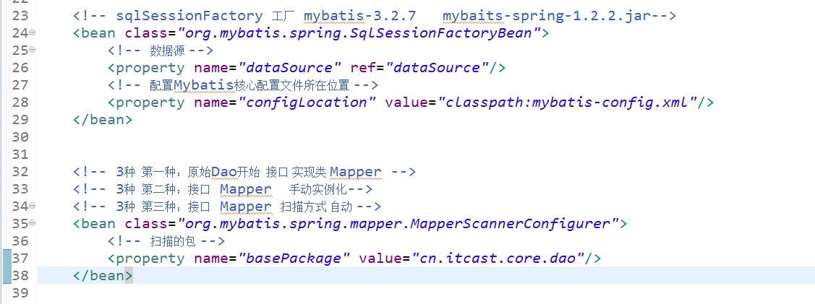

## Mybatis-config.xml

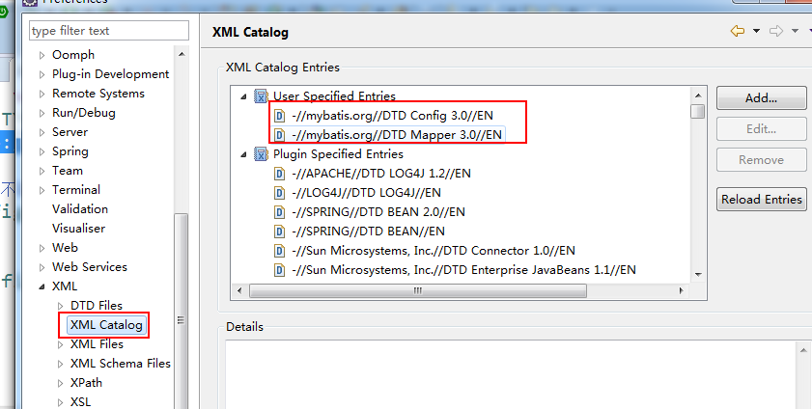

|  |
| --- |
| <?xml version=*"1.0"* encoding=*"UTF-8"* ?>  <!DOCTYPE configuration PUBLIC "-//mybatis.org//DTD Config 3.0//EN"  "http://mybatis.org/dtd/mybatis-3-config.dtd"> |

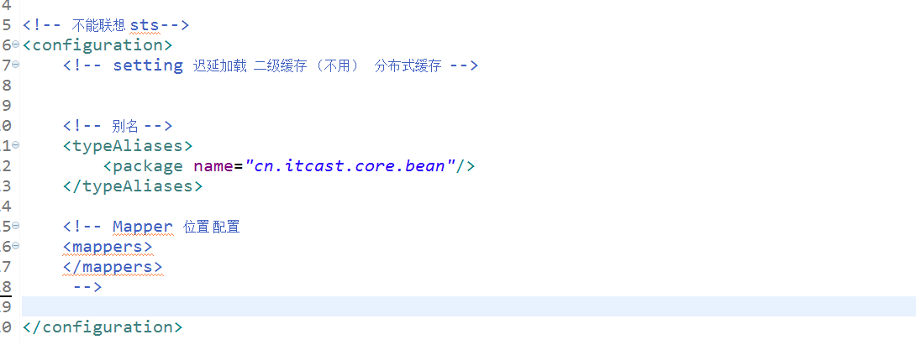

# 测试Spring+Dao+Mysql

## 创建数据库

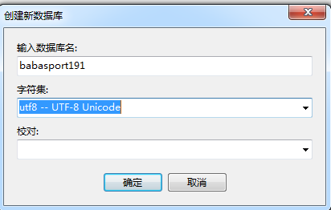

## POJO

## Dao 接口

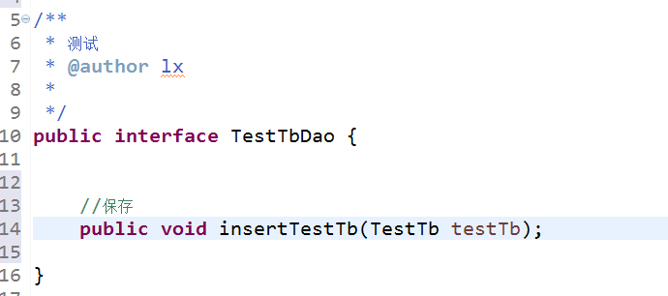

## Mapper.xml

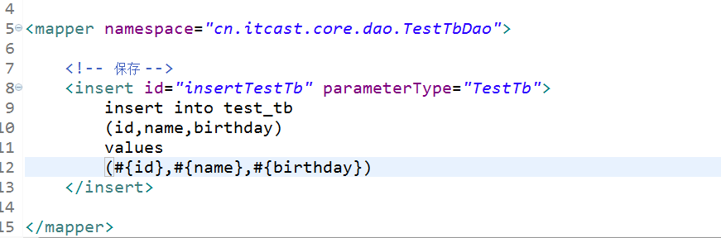

注意： Dao接口及Mapper在同一目录下。并同名

## 测试类 Junit

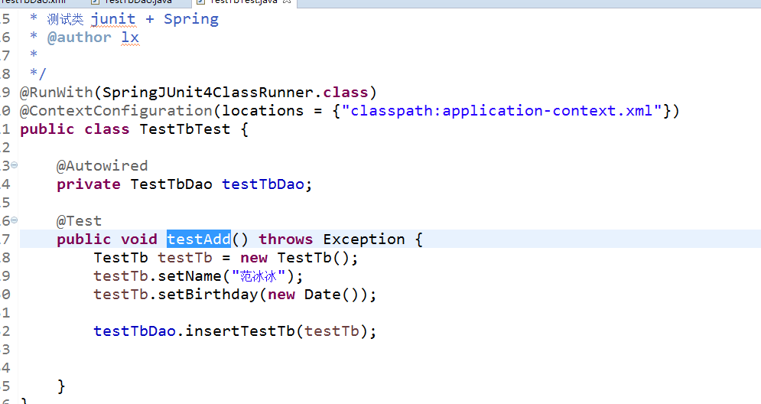

## 测试事务

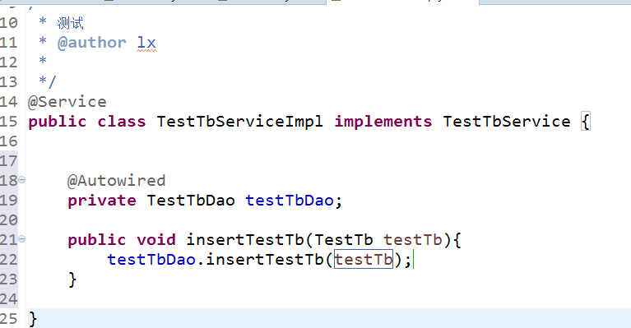

更改成有事务

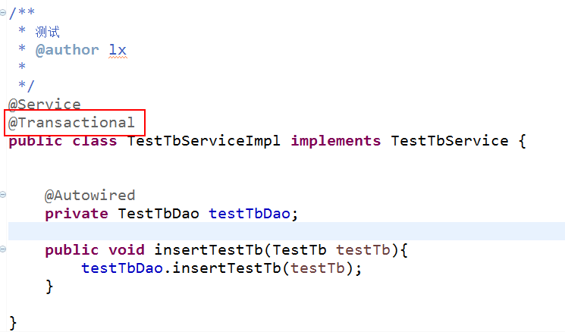

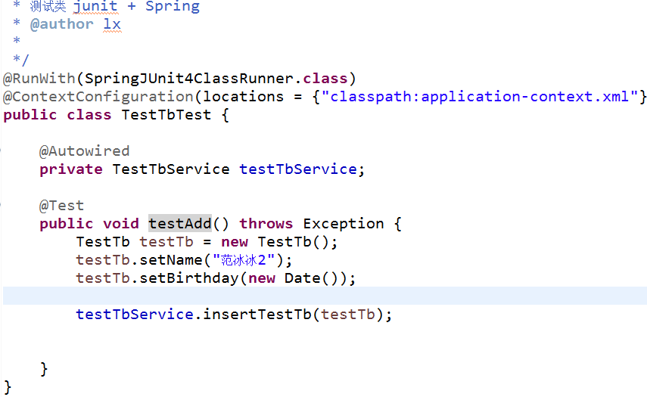

# 整合Springmvc

## Web.xml

配置前端控制器 一个中心

三个基本点

处理器映射器 处理器适配器 视图解释器

扫描

@Controller

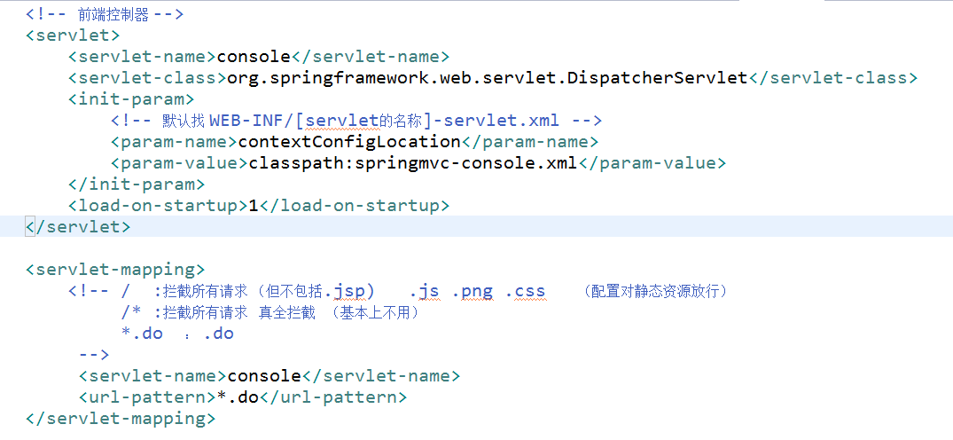

## Springmvc-console.xml

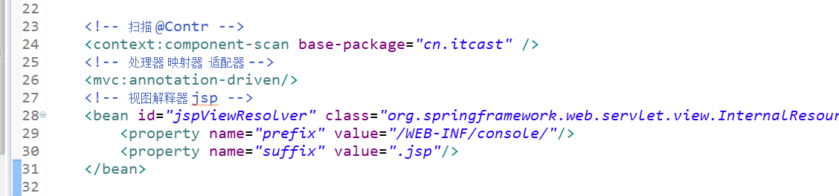

## 测试Springmvc

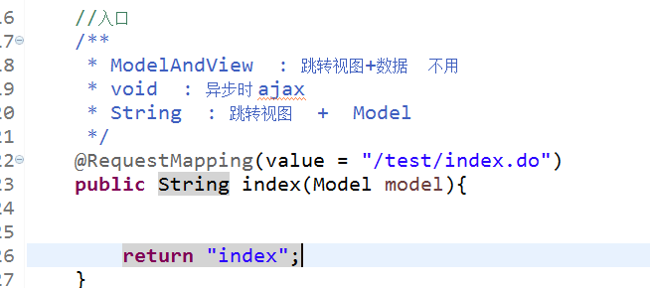

# 整合Dubbo

## 原理

直接连接

Tomcat 8080 服务消费方

Console

Springmvc

Tomcat 服务提供方

Service-product

Spring + mybatis整合

返回值

返地址

请求

中介

1：注册中心

服务提供方

2：Dubbo 提供方

Dubbo-provider.xml

服务消费方

3：Dubbo 消费方

Dubbo的注册中心 官方推荐zookeeper

大数据集群 生态圈

## 搭建Dubbo

### 搭建zookeeper

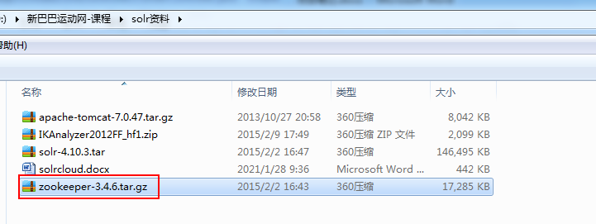

准备Centos-itcast

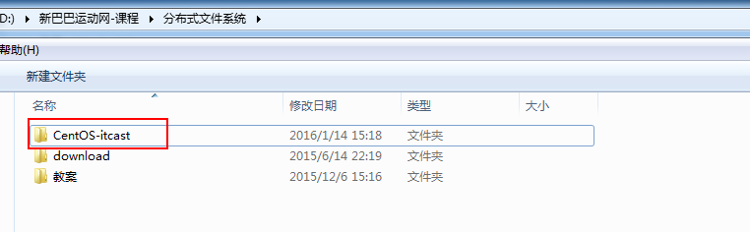

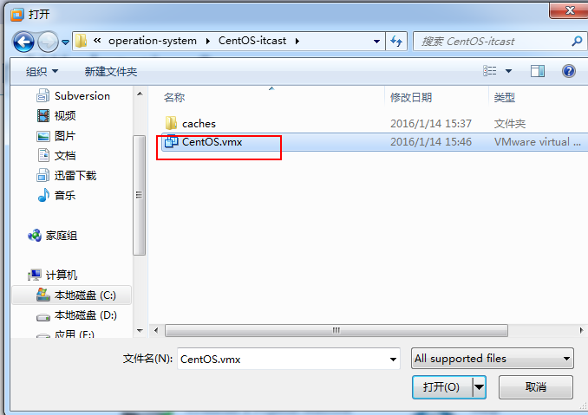

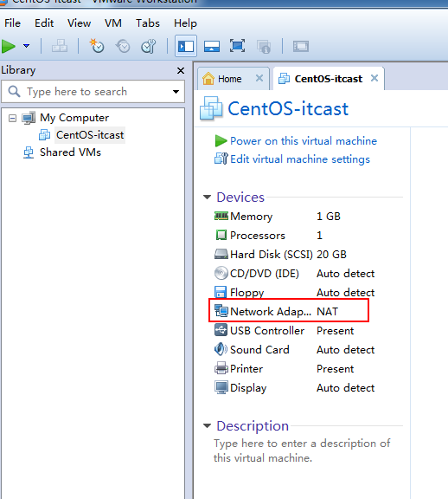

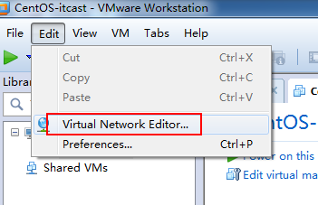

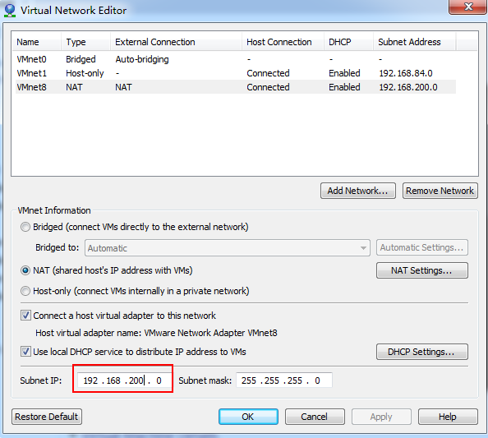

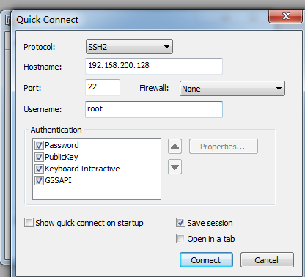

## 安装zookeeper

上传

解压



目录结构

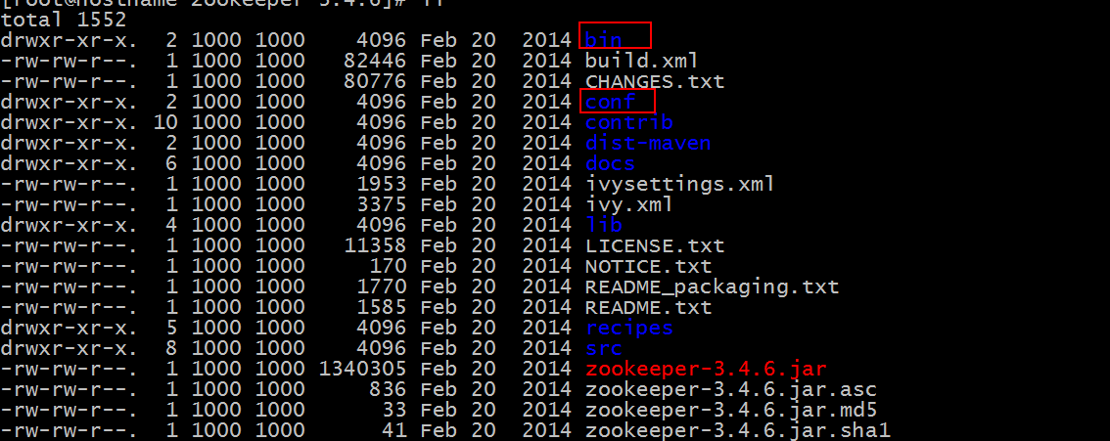

配置配置文件

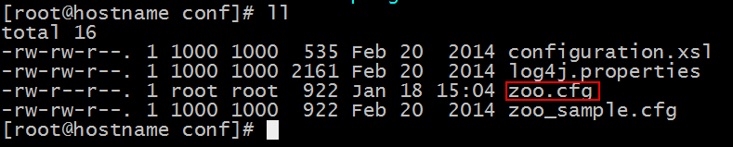

启动

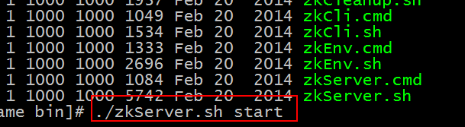

## Dubbo服务提供方

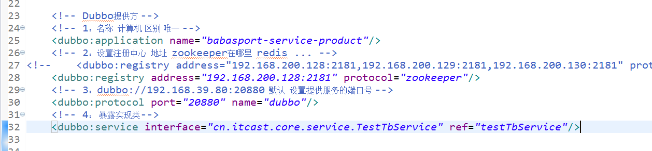

## Dubbo服务消费方

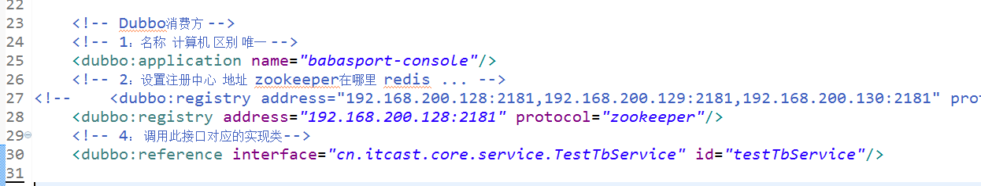

## Log4j

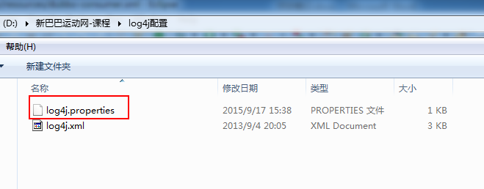

注意事项：

Dubbo消费方及提供方传递的参数必须实现序列化接口

Tomcat