目录

一、 考试服务系统数据库设计 3

1. 用户信息表-表user_info 3

2. 题目信息表-表question_info 4

3. 试卷信息表-表test_paper_info 4

4. 题目分组表-表question_group 5

5. 考试信息表-表test_info 6

6. 考试分组表-表test_group 6

7. 批改试卷信息表-表correct_info 7

二、 考试服务系统接口设计 8

1. 用户接口 : User Controller 8

1.1 学生列表 8

1.2 学生考试列表 9

1.3 教师考试列表 11

1.4 更改个人邮箱 13

2. 考试接口 : Test Controller 14

2.1 新建考试 14

2.2 撤销发布考试 16

2.3 判断是否发布过 17

2.4 试卷信息 18

2.5 教师查看自己发布的考试 20

2.6 发布考试 22

2.7 学生开始考试 23

2.8 提交答案 24

2.9 已提交答案的试卷信息 25

3. 试卷批改接口 : Correct Controller 27

3.1 待批改试卷列表 27

3.2 评分 29

4. 试卷接口 : Test Paper Controller 30

4.1 新建试卷 30

4.2 对试卷增加题目 32

4.3 对试卷删除题目 39

4.4 试卷信息 42

4.5 判断试题添加 44

4.6 试卷库 46

4.7 修改试卷题目分数 49

5. 题目接口 : Question Controller 50

5.1 新建题目 50

5.2 删除题目 52

5.3 单题题目详情 52

5.4 题库 54

5.5 修改题目 56

# 考试服务系统数据库设计

## 用户信息表-表user_info

|  |  |  |  |  |  |
| --- | --- | --- | --- | --- | --- |
| 字段名 | 类型 | 长度 | 是否非空 | 主键 | 注释 |
| id | varchar(64) | 64 | 是 | 是 | 学号/教职工号 |
| role | tinyint unsigned |  | 是 |  | 1为学生/2为教师 |
| create_date | datetime |  | 是 |  | 创建时间 |
| update_date | datetime |  | 是 |  | 修改日期 |
| password | varchar | 100 | 是 |  | 密码 |
| create_by | varchar | 64 | 是 |  | 创建者 |
| remarks | varchar | 255 | 是 |  | 备注信息 |
| del_flag | varchar | 1 | 是 |  | 删除标记 |
| update_by | varchar | 64 | 是 |  | 更新者 |
| is_new_record | tinyint |  | 是 |  | 是否为新记录 |
| name | varchar | 10 | 是 |  | 名字 |
| mail | varchar | 30 | 是 |  | 邮箱 |

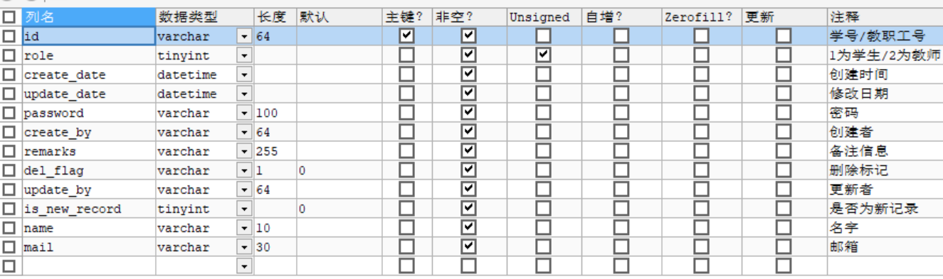

## 题目信息表-表question_info

|  |  |  |  |  |  |
| --- | --- | --- | --- | --- | --- |
| 字段名 | 类型 | 长度 | 是否非空 | 主键 | 注释 |
| id | bigint unsigned |  | 是 | 是 | 问题id |
| create_by | varchar | 64 | 是 |  | 创建人id |
| description | varchar | 100 | 是 |  | 问题描述 |
| picture | varchar | 100 | 是 |  | 相关图片,可为空 |
| create_date | datetime |  | 是 |  | 创建时间 |
| update_date | datetime |  | 是 |  | 修改时间 |
| remarks | varchar | 255 | 是 |  | 备注 |
| del_flag | tinyint |  | 是 |  | 删除标记 |
| update_by | varchar | 64 | 是 |  | 更新者 |
| is_new_record | tinyint |  | 是 |  | 是否为新记录 |

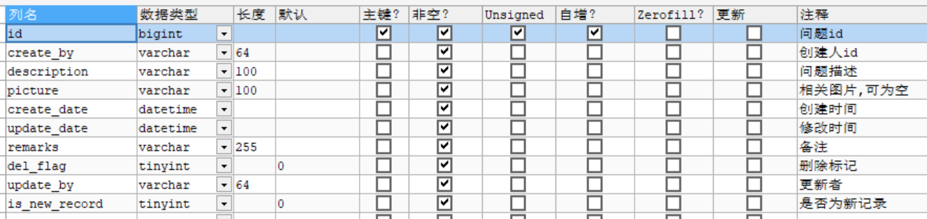

## 试卷信息表-表test_paper_info

|  |  |  |  |  |  |
| --- | --- | --- | --- | --- | --- |
| 字段名 | 类型 | 长度 | 是否非空 | 主键 | 注释 |
| id | bigint unsigned |  | 是 | 是 | 试卷id |
| create_by | varchar | 15 | 是 |  | 创建人id |
| create_date | datetime |  | 是 |  | 创建时间 |
| update_date | datetime |  | 是 |  | 修改时间 |
| paper_name | varchar | 10 | 是 |  | 试卷名称 |
| del_flag | tinyint unsigned |  | 是 |  | 删除标记 |
| is_new_record | tinyint unsigned |  | 是 |  | 是否是新纪录 |
| update_by | varchar | 15 | 是 |  | 更新者id |
| remarks | varchar | 255 | 是 |  | 备注 |

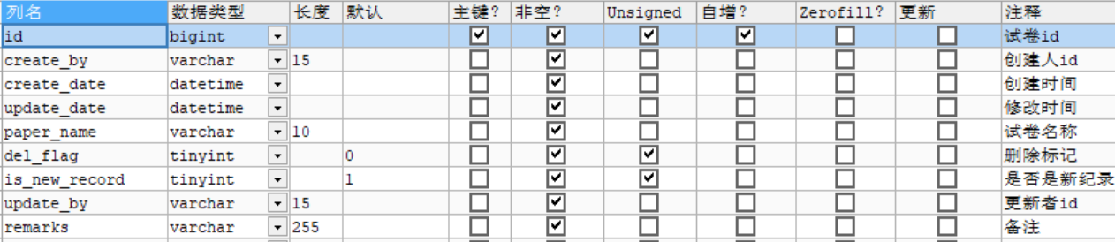

## 题目分组表-表question_group

|  |  |  |  |  |  |
| --- | --- | --- | --- | --- | --- |
| 字段名 | 类型 | 长度 | 是否非空 | 主键 | 注释 |
| id | bigint unsigned |  | 是 | 是 | 记录id |
| paper_id | bigint unsigned |  | 是 |  | 试卷id |
| create_date | datetime |  | 是 |  | 创建时间 |
| update_date | datetime |  | 是 |  | 修改时间 |
| create_by | varchar | 15 | 是 |  | 创建者id |
| del_flag | tinyint unsigned |  | 是 |  | 删除标记 |
| update_by | varchar | 15 | 是 |  | 更新者id |
| question_id | bigint unsigned |  | 是 |  | 题目id |
| score | tinyint unsigned |  | 是 |  | 该题在这份试卷中的分数 |
| is_new_record | tinyint unsigned |  | 是 |  | 是否为新纪录 |

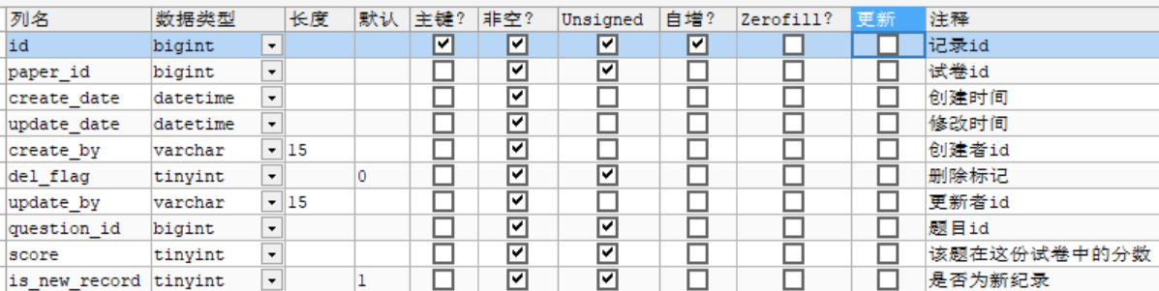

## 考试信息表-表test_info

|  |  |  |  |  |  |
| --- | --- | --- | --- | --- | --- |
| 字段名 | 类型 | 长度 | 是否非空 | 主键 | 注释 |
| id | bigint unsigned |  | 是 | 是 | 考试id |
| paper_id | bigint unsigned |  | 是 |  | 用的试卷id |
| test_name | varchar | 10 | 是 |  | 考试名称 |
| time_limit | int |  | 是 |  | 考试时间限制/min |
| create_date | datetime |  | 是 |  | 创建时间 |
| update_date | datetime |  | 是 |  | 修改时间 |
| create_by | varchar | 15 | 是 |  | 创建人id |
| update_by | varchar | 15 | 是 |  | 更新人id |
| is_new_record | tinyint |  | 是 |  | 是否为新记录 |
| del_flag | tinyint |  | 是 |  | 删除标记 |

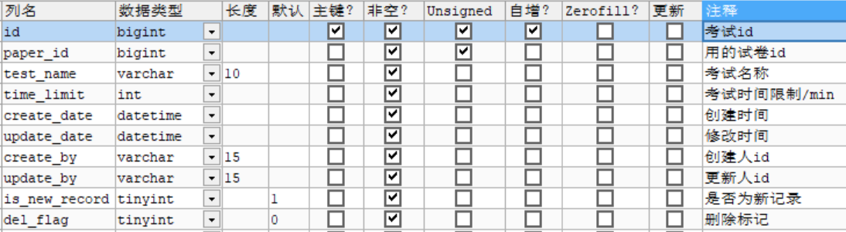

## 考试分组表-表test_group

|  |  |  |  |  |  |
| --- | --- | --- | --- | --- | --- |
| 字段名 | 类型 | 长度 | 是否非空 | 主键 | 注释 |
| id | bigint unsigned |  | 是 | 是 | 记录id |
| test_id | bigint unsigned |  | 是 |  | 考试场次id |
| student_id | varchar | 15 | 是 |  | 学生id |
| create_by | varchar | 15 | 是 |  | 创建者 |
| create_date | datetime |  | 是 |  | 创建时间 |
| update_date | datetime |  | 是 |  | 修改时间 |
| update_by | varchar | 15 | 是 |  | 修改者 |
| del_flag | tinyint |  | 是 |  | 删除标记 |
| is_new_record | tinyint |  | 是 |  | 是否为新纪录 |
| status | varchar | 15 | 是 |  | 状态 |

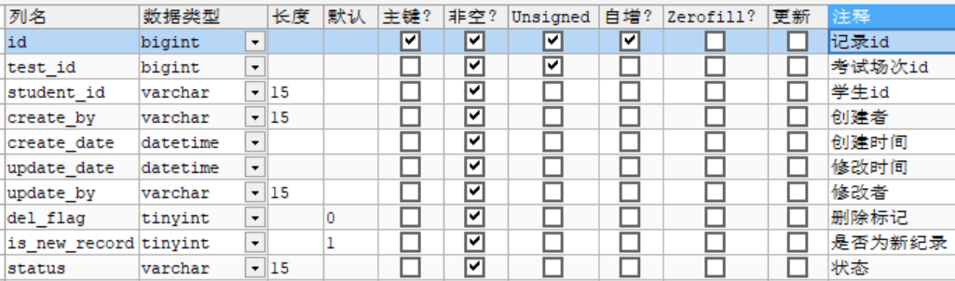

## 批改试卷信息表-表correct_info

|  |  |  |  |  |  |
| --- | --- | --- | --- | --- | --- |
| 字段名 | 类型 | 长度 | 是否非空 | 主键 | 注释 |
| id | bigint unsigned |  | 是 | 是 | 记录id |
| test_group_id | bigint unsigned |  | 是 |  | 考试场次id |
| student_id | varchar | 15 | 是 |  | 学生id |
| score | tinyint unsigned |  | 是 |  | 单题成绩 |
| create_date | datetime |  | 是 |  | 创建时间 |
| update_date | datetime |  | 是 |  | 修改时间 |
| del_flag | tinyint | 1 | 是 |  | 删除标记 |
| is_new_record | tinyint unsigned |  | 是 |  | 是否为新纪录 |
| create_by | varchar | 15 | 是 |  | 创建者 |
| update_by | varchar | 15 | 是 |  | 修改者 |
| answer_picture | varchar | 100 | 是 |  | 答案图片的url |
| correct_flag | tinyint | 1 | 是 |  | 是否批改 |

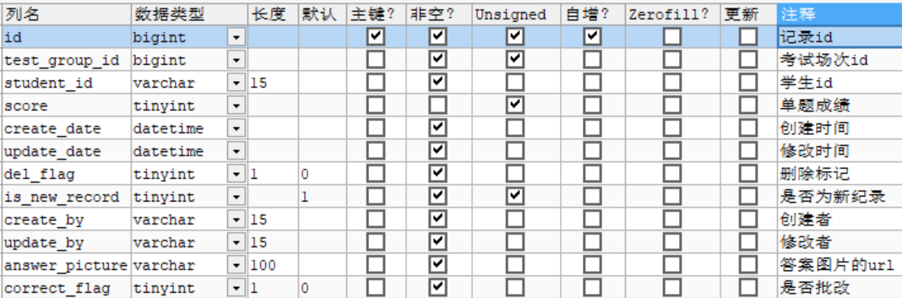

# 考试服务系统接口设计

## [用户接口](http://localhost:98/swagger-ui.html" \l "!/26234330213492021333319953247920219211532550921475) : User Controller

### 学生列表

|  |  |  |  |  |
| --- | --- | --- | --- | --- |
| 学生列表 | | | | |
| 接口描述 | 仅限老师查询学生列表 | | | |
| URL |  | | | |
| 参数名 | 数据类型 | 参数类型 | 是否必填 | 说明 |
| pageNo | int | body | Y | 要获取的页码 |
| **password** | string | header | Y | 密码 |
| pageSize | int | body | Y | 要获得的页面数据数量 |
| **userId** | string | header | Y | 用户id |
| 示例 | | | | |
| 请求参数 |  | | | |
| 返回值 | **{**  "msgCode": 0,  "errMsg": "请求成功.",  "receiptDateTime": "2022-10-28 21:22:06",  "returnDateTime": "2022-10-28 21:22:07",  "requesterId": "未登录",  "page": {  "pageNo": 1,  "pageSize": 5,  "count": 2,  "first": 0,  "last": 0,  "prev": 0,  "next": 0,  "firstPage": false,  "lastPage": false,  "length": 8,  "slider": 1,  "list": [  {  "studentId": "10001",  "name": "李四"  },  {  "studentId": "10002",  "name": "王五"  }  ],  "orderBy": "",  "maxResults": 5,  "firstResult": 0  },  "success": true} | | | |

### 学生考试列表

|  |  |  |  |  |
| --- | --- | --- | --- | --- |
| 学生考试列表 | | | | |
| 接口描述 | 学生所参加的考试列表 | | | |
| URL |  | | | |
| 参数名 | 数据类型 | 参数类型 | 是否必填 | 说明 |
| pageNo | int | body | Y | 要获取的页码 |
| pageSize | int | body | Y | 要获得的页面数据数量 |
| **password** | string | header | Y | 密码 |
| **userId** | string | header | Y | 用户id |
| 示例 | | | | |
| 请求参数 |  | | | |
| 返回值 | {  "msgCode": 0,  "errMsg": "请求成功.",  "receiptDateTime": "2022-10-28 21:26:18",  "returnDateTime": "2022-10-28 21:26:18",  "requesterId": "未登录",  "page": {  "pageNo": 1,  "pageSize": 5,  "count": 3,  "first": 0,  "last": 0,  "prev": 0,  "next": 0,  "firstPage": false,  "lastPage": false,  "length": 8,  "slider": 1,  "list": [  {  "testId": 2,  "testGroupId": 1,  "testName": "大物期中考",  "status": "end"  },  {  "testId": 1,  "testGroupId": 4,  "testName": "大物",  "status": "waitCorrect"  },  {  "testId": 5,  "testGroupId": 5,  "testName": "测试测试测试",  "status": "end"  }  ],  "orderBy": "",  "maxResults": 5,  "firstResult": 0  },  "success": true} | | | |

### 教师考试列表

|  |  |  |  |  |
| --- | --- | --- | --- | --- |
| 教师考试列表 | | | | |
| 接口描述 | 根据id获取相应task | | | |
| URL |  | | | |
| 参数名 | 数据类型 | 参数类型 | 是否必填 | 说明 |
| pageNo | int | body | Y | 要获取的页码 |
| pageSize | int | body | Y | 要获得的页面数据数量 |
| **password** | string | header | Y | 密码 |
| **userId** | string | header | Y | 用户id |
| 示例 | | | | |
| 请求参数 |  | | | |
| 返回值 | {  "msgCode": 0,  "errMsg": "请求成功.",  "receiptDateTime": "2022-10-28 21:28:31",  "returnDateTime": "2022-10-28 21:28:32",  "requesterId": "未登录",  "page": {  "pageNo": 1,  "pageSize": 5,  "count": 5,  "first": 0,  "last": 0,  "prev": 0,  "next": 0,  "firstPage": false,  "lastPage": false,  "length": 8,  "slider": 1,  "list": [  {  "testId": 1,  "testName": "大物",  "timeLimit": 60,  "createDate": "2022-10-08 18:41:39"  },  {  "testId": 2,  "testName": "大物期中考",  "timeLimit": 2,  "createDate": "2022-10-15 11:30:18"  },  {  "testId": 3,  "testName": "测试用的",  "timeLimit": 60,  "createDate": "2022-10-28 10:01:50"  },  {  "testId": 4,  "testName": "测试用的哈哈哈",  "timeLimit": 60,  "createDate": "2022-10-28 10:03:16"  },  {  "testId": 5,  "testName": "测试测试测试",  "timeLimit": 3,  "createDate": "2022-10-28 15:27:47"  }  ],  "orderBy": "",  "maxResults": 5,  "firstResult": 0  },  "success": true} | | | |

### 更改个人邮箱

|  |  |  |  |  |
| --- | --- | --- | --- | --- |
| 更改个人邮箱 | | | | |
| 接口描述 | 学生老师都可以改 | | | |
| URL |  | | | |
| 参数名 | 数据类型 | 参数类型 | 是否必填 | 说明 |
| newMail | string | body | Y | 新邮箱 |
| **password** | string | header | Y | 密码 |
| **userId** | string | header | Y | 用户id |
| 示例 | | | | |
| 请求参数 |  | | | |
| 返回值 | {  "msgCode": 0,  "errMsg": "请求成功.",  "receiptDateTime": "2022-10-28 21:40:55",  "requesterId": "未登录",  "item": {  "userInfo": {  "id": "10000",  "updateBy": "10000",  "updateDate": "2022-10-28 21:40:55",  "delFlag": "0",  "mail": "xxxx@qq.com"  }  },  "success": true}  } | | | |

## [考试接口](http://localhost:98/swagger-ui.html" \l "!/26234330213492021333319953247920219211532550921475) : Test Controller

### 新建考试

|  |  |  |  |  |
| --- | --- | --- | --- | --- |
| 新建考试 | | | | |
| 接口描述 | 仅限教师创建考试 | | | |
| URL |  | | | |
| 参数名 | 数据类型 | 参数类型 | 是否必填 | 说明 |
| paperId | string | body | Y | 选用的试卷id |
| testName | string | body | Y | 考试名称 |
| remarks | string | body | Y | 备注 |
| timeLimit | int | body | Y | 时间限制 |
| **password** | string | header | Y | 密码 |
| **userId** | string | header | Y | 用户id |
| 示例 | | | | |
| 请求参数 |  | | | |
| 返回值 | {  "msgCode": 0,  "errMsg": "请求成功.",  "receiptDateTime": "2022-10-28 21:55:42",  "requesterId": "未登录",  "item": {  "testInfo": {  "remarks": "测试",  "createBy": "10000",  "createDate": "2022-10-28 21:55:42",  "updateBy": "10000",  "updateDate": "2022-10-28 21:55:42",  "delFlag": "0",  "paperId": 1,  "testName": "测试使用啦啦啦",  "timeLimit": 60  }  },  "success": true}  } | | | |

### 撤销发布考试

|  |  |  |  |  |
| --- | --- | --- | --- | --- |
| 撤销发布考试 | | | | |
| 接口描述 | 仅限教师撤销发布考试 | | | |
| URL |  | | | |
| 参数名 | 数据类型 | 参数类型 | 是否必填 | 说明 |
| testGroupId | long | body | Y | 考试组号 |
| **password** | string | header | Y | 密码 |
| **userId** | string | header | Y | 用户id |
| 示例 | | | | |
| 请求参数 |  | | | |
| 返回值 | {  "msgCode": 0,  "receiptDateTime": "2022-10-28 22:08:38",  "requesterId": "未登录",  "item": {},  "success": true}  } | | | |

### 判断是否发布过

|  |  |  |  |  |
| --- | --- | --- | --- | --- |
| 判断是否发布过 | | | | |
| 接口描述 | 选择发布的学生时进行判断（单人） | | | |
| URL |  | | | |
| 参数名 | 数据类型 | 参数类型 | 是否必填 | 说明 |
| testId | long | body | Y | 考试id |
| studentId | string | body | Y | 学生id |
| **password** | string | header | Y | 密码 |
| **userId** | string | header | Y | 用户id |
| 示例 | | | | |
| 请求参数 |  | | | |
| 返回值 | {  "msgCode": 0,  "errMsg": "请求成功.",  "receiptDateTime": "2022-10-29 14:14:24",  "requesterId": "未登录",  "item": {  "isExist": true  },  "success": true  } | | | |

### 试卷信息

|  |  |  |  |  |
| --- | --- | --- | --- | --- |
| 试卷信息 | | | | |
| 接口描述 | 从考试查看试卷，学生老师均可查看，学生可以提交答案 | | | |
| URL |  | | | |
| 参数名 | 数据类型 | 参数类型 | 是否必填 | 说明 |
| testId | long | body | Y | 考试id |
| **password** | string | header | Y | 密码 |
| **userId** | string | header | Y | 用户id |
| 示例 | | | | |
| 请求参数 |  | | | |
| 返回值 | {  "paperId": 1,  "paperName": "大物A第三章",  "remarks": "小测卷",  "questionList": [  {  "questionId": 1,  "description": "1+1等于几",  "picture": "https://bucketofpicture.oss-cn-hangzhou.aliyuncs.com/ae8fcd71b407428cb3102cb9cb93ecfc.png",  "score": 10,  "groupId": 1  },  {  "questionId": 2,  "description": "1+666=?",  "picture": "https://bucketofpicture.oss-cn-hangzhou.aliyuncs.com/34f330e1ff854b0ab9bc937692c7481f.png",  "score": 10,  "groupId": 2  },  {  "questionId": 3,  "description": "2+6=？",  "picture": "https://bucketofpicture.oss-cn-hangzhou.aliyuncs.com/adf13ad5b93c409886cc9c172d16c0d7.png",  "score": 80,  "groupId": 5  },  {  "questionId": 4,  "description": "2+8=？",  "picture": "https://bucketofpicture.oss-cn-hangzhou.aliyuncs.com/c37bb154c0a741b7b69a79860b1c9db4.png",  "score": 20,  "groupId": 6  },  {  "questionId": 5,  "description": "啦啦啦哈哈哈",  "picture": "https://bucketofpicture.oss-cn-hangzhou.aliyuncs.com/cb7070ea5036467d959e5ea63b57d23f.png",  "score": 30,  "groupId": 7  },  {  "questionId": 6,  "description": "哈哈哈lalala",  "picture": "https://bucketofpicture.oss-cn-hangzhou.aliyuncs.com/e1388960b0604303b72770e61f66c253.png",  "score": 40,  "groupId": 8  }  ],  "isTeacher": true} | | | |

### 教师查看自己发布的考试

|  |  |  |  |  |
| --- | --- | --- | --- | --- |
| 教师查看自己发布的考试 | | | | |
| 接口描述 | 仅限教师查看自己发布的考试信息 | | | |
| URL |  | | | |
| 参数名 | 数据类型 | 参数类型 | 是否必填 | 说明 |
| pageNo | Int | body | Y | 要获得的页码 |
| pageSize | int | body | Y | 要获得的页面数据数量 |
| **password** | string | header | Y | 密码 |
| **userId** | string | header | Y | 用户id |
| 示例 | | | | |
| 请求参数 |  | | | |
| 返回值 | {  "msgCode": 0,  "errMsg": "请求成功.",  "receiptDateTime": "2022-10-29 14:24:09",  "returnDateTime": "2022-10-29 14:24:10",  "requesterId": "未登录",  "page": {  "pageNo": 1,  "pageSize": 5,  "count": 4,  "first": 0,  "last": 0,  "prev": 0,  "next": 0,  "firstPage": false,  "lastPage": false,  "length": 8,  "slider": 1,  "list": [  {  "testGroupId": 1,  "testName": "大物期中考",  "stuName": "李四",  "stuId": "10001",  "status": "end"  },  {  "testGroupId": 2,  "testName": "大物期中考",  "stuName": "王五",  "stuId": "10002",  "status": "waitCorrect"  },  {  "testGroupId": 4,  "testName": "大物",  "stuName": "李四",  "stuId": "10001",  "status": "waitCorrect"  },  {  "testGroupId": 5,  "testName": "测试测试测试",  "stuName": "李四",  "stuId": "10001",  "status": "end"  }  ],  "orderBy": "",  "maxResults": 5,  "firstResult": 0  },  "success": true} | | | |

### 发布考试

|  |  |  |  |  |
| --- | --- | --- | --- | --- |
| 发布考试 | | | | |
| 接口描述 | 仅限教师发布考试 | | | |
| URL |  | | | |
| 参数名 | 数据类型 | 参数类型 | 是否必填 | 说明 |
| testId | long | body | Y | 考试id |
| idList | array[string] | body | Y | 学生id数组 |
| **password** | string | header | Y | 密码 |
| **userId** | string | header | Y | 用户id |
| 示例 | | | | |
| 请求参数 |  | | | |
| 返回值 | {  "msgCode": 0,  "receiptDateTime": "2022-10-28 22:08:38",  "requesterId": "未登录",  "item": {},  "success": true}  } | | | |

### 学生开始考试

|  |  |  |  |  |
| --- | --- | --- | --- | --- |
| 学生开始考试 | | | | |
| 接口描述 | 学生开始考试接口 | | | |
| URL |  | | | |
| 参数名 | 数据类型 | 参数类型 | 是否必填 | 说明 |
| testGroupId | long | body | Y | 考试组号 |
| **password** | string | header | Y | 密码 |
| **userId** | string | header | Y | 用户id |
| 示例 | | | | |
| 请求参数 |  | | | |
| 返回值 | {  "msgCode": 0,  "receiptDateTime": "2022-10-28 22:08:38",  "requesterId": "未登录",  "item": {},  "success": true}  } | | | |

### 提交答案

|  |  |  |  |  |
| --- | --- | --- | --- | --- |
| 提交答案 | | | | |
| 接口描述 | 学生提交答案接口 | | | |
| URL |  | | | |
| 参数名 | 数据类型 | 参数类型 | 是否必填 | 说明 |
| testGroupId | long | body | Y | 考试组号 |
| file | file | body | Y | 答案图片 |
| **password** | string | header | Y | 密码 |
| **userId** | string | header | Y | 用户id |
| 示例 | | | | |
| 请求参数 |  | | | |
| 返回值 | {  "msgCode": 0,  "receiptDateTime": "2022-10-28 22:08:38",  "requesterId": "未登录",  "item": {},  "success": true}  } | | | |

### 已提交答案的试卷信息

|  |  |  |  |  |
| --- | --- | --- | --- | --- |
| 已提交答案的试卷信息 | | | | |
| 接口描述 | 获得已提交答案的试卷信息，若correctFlag为true，显示批改完，可显示成绩，false为待批改，不显示成绩 | | | |
| URL |  | | | |
| 参数名 | 数据类型 | 参数类型 | 是否必填 | 说明 |
| testGroupId | long | body | Y | 考试组号 |
| **password** | string | header | Y | 密码 |
| **userId** | string | header | Y | 用户id |
| 示例 | | | | |
| 请求参数 |  | | | |
| 返回值 | {  "detailedTestPaperVO": {  "paperId": 1,  "paperName": "大物A第三章",  "remarks": "小测卷",  "questionList": [  {  "questionId": 1,  "description": "1+1等于几",  "picture": "https://bucketofpicture.oss-cn-hangzhou.aliyuncs.com/ae8fcd71b407428cb3102cb9cb93ecfc.png",  "score": 10,  "groupId": 1  },  {  "questionId": 2,  "description": "1+666=?",  "picture": "https://bucketofpicture.oss-cn-hangzhou.aliyuncs.com/34f330e1ff854b0ab9bc937692c7481f.png",  "score": 10,  "groupId": 2  },  {  "questionId": 3,  "description": "2+6=？",  "picture": "https://bucketofpicture.oss-cn-hangzhou.aliyuncs.com/adf13ad5b93c409886cc9c172d16c0d7.png",  "score": 80,  "groupId": 5  },  {  "questionId": 4,  "description": "2+8=？",  "picture": "https://bucketofpicture.oss-cn-hangzhou.aliyuncs.com/c37bb154c0a741b7b69a79860b1c9db4.png",  "score": 20,  "groupId": 6  },  {  "questionId": 5, | | | |

## [试卷批改接口](http://localhost:98/swagger-ui.html" \l "!/26234330213492021333319953247920219211532550921475) : Correct Controller

### 待批改试卷列表

|  |  |  |  |  |
| --- | --- | --- | --- | --- |
| 待批改试卷列表 | | | | |
| 接口描述 | 获得待批改试卷的列表 | | | |
| URL |  | | | |
| 参数名 | 数据类型 | 参数类型 | 是否必填 | 说明 |
| pageNo | Int | body | Y | 要获得的页码 |
| pageSize | int | body | Y | 要获得的页面数据数量 |
| **password** | string | header | Y | 密码 |
| **userId** | string | header | Y | 用户id |
| 示例 | | | | |
| 请求参数 |  | | | |
| 返回值 | {  "msgCode": 0,  "errMsg": "请求成功.",  "receiptDateTime": "2022-10-29 14:46:48",  "returnDateTime": "2022-10-29 14:46:48",  "requesterId": "未登录",  "page": {  "pageNo": 1,  "pageSize": 5,  "count": 5,  "first": 0,  "last": 0,  "prev": 0,  "next": 0,  "firstPage": false,  "lastPage": false,  "length": 8,  "slider": 1,  "list": [  {  "testGroupId": 2,  "stuName": "王五",  "stuId": "10002",  "testName": "大物期中考",  "submitTime": "2022-10-16 20:41:21"  },  {  "testGroupId": 5,  "stuName": "李四",  "stuId": "10001",  "testName": "测试测试测试",  "submitTime": "2022-10-28 15:37:12"  },  {  "testGroupId": 4,  "stuName": "李四",  "stuId": "10001",  "testName": "大物",  "submitTime": "2022-10-28 15:44:43"  },  {  "testGroupId": 4,  "stuName": "李四",  "stuId": "10001",  "testName": "大物",  "submitTime": "2022-10-28 15:47:58"  },  {  "testGroupId": 6,  "stuName": "李四",  "stuId": "10001",  "testName": "测试用的哈哈哈",  "submitTime": "2022-10-29 14:33:30"  }  ],  "orderBy": "",  "maxResults": 5,  "firstResult": 0  },  "success": true} | | | |

### 评分

|  |  |  |  |  |
| --- | --- | --- | --- | --- |
| 评分 | | | | |
| 接口描述 | 为学生的答案评分 | | | |
| URL |  | | | |
| 参数名 | 数据类型 | 参数类型 | 是否必填 | 说明 |
| correctId | long | body | Y | 改的试卷id |
| score | int | body | Y | 成绩 |
| **password** | string | header | Y | 密码 |
| **userId** | string | header | Y | 用户id |
| 示例 | | | | |
| 请求参数 |  | | | |
| 返回值 | {  "msgCode": 0,  "receiptDateTime": "2022-10-29 14:54:47",  "requesterId": "未登录",  "item": {},  "success": true} | | | |

## [试卷接口](http://localhost:98/swagger-ui.html" \l "!/26234330213492021333319953247920219211532550921475) : Test Paper Controller

### 新建试卷

|  |  |  |  |  |
| --- | --- | --- | --- | --- |
| 新建试卷 | | | | |
| 接口描述 | 仅限教师创建试卷 | | | |
| URL |  | | | |
| 参数名 | 数据类型 | 参数类型 | 是否必填 | 说明 |
| paperName | string | body | Y | 试卷名称 |
| remarks | string | body | Y | 备注 |
| **password** | string | header | Y | 密码 |
| **userId** | string | header | Y | 用户id |
| 示例 | | | | |
| 请求参数 |  | | | |
| 返回值 | {  "msgCode": 0,  "errMsg": "请求成功.",  "receiptDateTime": "2022-10-29 15:01:27",  "requesterId": "未登录",  "item": {  "testPaperInfo": {  "remarks": "测试创建的",  "createBy": "10000",  "createDate": "2022-10-29 15:01:27",  "updateBy": "10000",  "updateDate": "2022-10-29 15:01:27",  "delFlag": "0",  "paperName": "c++笔试卷"  }  },  "success": true} | | | |

### 对试卷增加题目

|  |  |  |  |  |
| --- | --- | --- | --- | --- |
| 对试卷增加题目 | | | | |
| 接口描述 | 仅教师增加试题 | | | |
| URL |  | | | |
| 参数名 | 数据类型 | 参数名 | 是否必填 | 说明 |
| idList | array[long] | body | Y | 题目id数组 |
| scoreList | array[int] | body | Y | 题目分数数组 |
| **password** | string | header | Y | 密码 |
| **userId** | string | header | Y | 用户id |
| 示例 | | | | |
| 请求参数 |  | | | |
| 返回值 | {  "msgCode": 0,  "receiptDateTime": "2022-10-29 15:08:00",  "requesterId": "未登录",  "item": {},  "success": true} | | | |

### 对试卷删除题目

|  |  |  |  |  |
| --- | --- | --- | --- | --- |
| 对试卷删除题目 | | | | |
| 接口描述 | 仅限教师删除试题 | | | |
| URL |  | | | |
| 参数名 | 数据类型 | 参数名 | 是否必填 | 说明 |
| groupIdList | array[long] | body | Y | 题目groupId数组 |
| **password** | string | header | Y | 密码 |
| **userId** | string | header | Y | 用户id |
| 示例 | | | | |
| 请求参数 |  | | | |
| 返回值 | {  "msgCode": 0,  "receiptDateTime": "2022-10-29 15:08:00",  "requesterId": "未登录",  "item": {},  "success": true} | | | |

### 试卷信息

|  |  |  |  |  |
| --- | --- | --- | --- | --- |
| 试卷信息 | | | | |
| 接口描述 | 教师查看试卷通道 | | | |
| URL |  | | | |
| 参数名 | 数据类型 | 参数名 | 是否必填 | 说明 |
| paperId | long | body | Y | 试卷id |
| **password** | string | header | Y | 密码 |
| **userId** | string | header | Y | 用户id |
| 示例 | | | | |
| 请求参数 |  | | | |
| 返回值 | {  "paperId": 5,  "paperName": "c++笔试卷",  "remarks": "测试创建的",  "questionList": [  {  "questionId": 1,  "description": "1+1等于几",  "picture": "https://bucketofpicture.oss-cn-hangzhou.aliyuncs.com/ae8fcd71b407428cb3102cb9cb93ecfc.png",  "score": 25,  "groupId": 13  },  {  "questionId": 2,  "description": "1+666=?",  "picture": "https://bucketofpicture.oss-cn-hangzhou.aliyuncs.com/34f330e1ff854b0ab9bc937692c7481f.png",  "score": 25,  "groupId": 14  }  ],  "isTeacher": true} | | | |

### 判断试题添加

|  |  |  |  |  |
| --- | --- | --- | --- | --- |
| 判断试题添加 | | | | |
| 接口描述 | 往试卷里头添加试题时进行判断（单题） | | | |
| URL |  | | | |
| 参数名 | 数据类型 | 参数名 | 是否必填 | 说明 |
| paperId | long | body | Y | 试卷id |
| **password** | string | header | Y | 密码 |
| **questionId** | long | body | Y | 题目id |
| **userId** | string | header | Y | 用户id |
| 示例 | | | | |
| 请求参数 |  | | | |
| 返回值 | {  "msgCode": 0,  "errMsg": "请求成功.",  "receiptDateTime": "2022-10-29 15:32:42",  "requesterId": "未登录",  "item": {  "isExist": true  },  "success": true} | | | |

### 试卷库

|  |  |  |  |  |
| --- | --- | --- | --- | --- |
| 试卷库 | | | | |
| 接口描述 | 仅限教师查询试卷库 | | | |
| URL |  | | | |
| 参数名 | 数据类型 | 参数名 | 是否必填 | 说明 |
| pageNo | Int | body | Y | 要获得的页码 |
| pageSize | int | body | Y | 要获得的页面数据数量 |
| **password** | string | header | Y | 密码 |
| **userId** | string | header | Y | 用户id |
| 示例 | | | | |
| 请求参数 |  | | | |
| 返回值 | {  "msgCode": 0,  "errMsg": "请求成功.",  "receiptDateTime": "2022-10-29 15:36:01",  "returnDateTime": "2022-10-29 15:36:01",  "requesterId": "未登录",  "page": {  "pageNo": 1,  "pageSize": 5,  "count": 5,  "first": 0,  "last": 0,  "prev": 0,  "next": 0,  "firstPage": false,  "lastPage": false,  "length": 8,  "slider": 1,  "list": [  {  "paperId": 1,  "teacherName": "张三",  "testName": "大物A第三章"  },  {  "paperId": 2,  "teacherName": "张三",  "testName": "垃圾试卷"  },  {  "paperId": 3,  "teacherName": "张三",  "testName": "高考模拟试卷"  },  {  "paperId": 4,  "teacherName": "张三",  "testName": "啊啊啊很垃圾"  },  {  "paperId": 5,  "teacherName": "张三",  "testName": "c++笔试卷"  }  ],  "orderBy": "",  "maxResults": 5,  "firstResult": 0  },  "success": true} | | | |

### 修改试卷题目分数

|  |  |  |  |  |
| --- | --- | --- | --- | --- |
| 修改试卷题目分数 | | | | |
| 接口描述 | 仅限教师修改试题分数 | | | |
| URL |  | | | |
| 参数名 | 数据类型 | 参数名 | 是否必填 | 说明 |
| groupIdList | array[long] | body | Y | 题目所属id数组 |
| scoreList | array[int] | body | Y | 题目分数数组 |
| **password** | string | header | Y | 密码 |
| **userId** | string | header | Y | 用户id |
| 示例 | | | | |
| 请求参数 |  | | | |
| 返回值 | {  "msgCode": 0,  "receiptDateTime": "2022-10-29 15:08:00",  "requesterId": "未登录",  "item": {},  "success": true} | | | |

## [题目接口](http://localhost:98/swagger-ui.html" \l "!/26234330213492021333319953247920219211532550921475) : Question Controller

### 新建题目

|  |  |  |  |  |
| --- | --- | --- | --- | --- |
| 新建题目 | | | | |
| 接口描述 | 仅限教师创建题目 | | | |
| URL |  | | | |
| 参数名 | 数据类型 | 参数名 | 是否必填 | 说明 |
| description | string | body | Y | 问题描述 |
| file | file | body | N | 图片 |
| remarks | string | body | Y | 备注 |
| **password** | string | header | Y | 密码 |
| **userId** | string | header | Y | 用户id |
| 示例 | | | | |
| 请求参数 |  | | | |
| 返回值 | {  "msgCode": 0,  "errMsg": "请求成功.",  "receiptDateTime": "2022-10-29 15:47:07",  "returnDateTime": "2022-10-29 15:47:11",  "requesterId": "未登录",  "item": {  "questionInfo": {  "remarks": "测试",  "createBy": "10000",  "createDate": "2022-10-29 15:47:11",  "updateBy": "10000",  "updateDate": "2022-10-29 15:47:11",  "delFlag": "0",  "description": "我帅不帅？",  "picture": "https://bucketofpicture.oss-cn-hangzhou.aliyuncs.com/ce154e11ccd34eaa9b0f81d22d0034a1.png"  }  },  "success": true} | | | |

### 删除题目

|  |  |  |  |  |
| --- | --- | --- | --- | --- |
| 删除题目 | | | | |
| 接口描述 | 仅限教师删除题目 | | | |
| URL |  | | | |
| 参数名 | 数据类型 | 参数名 | 是否必填 | 说明 |
| questionId | string | body | Y | 题目id |
| **password** | string | header | Y | 密码 |
| **userId** | string | header | Y | 用户id |
| 示例 | | | | |
| 请求参数 |  | | | |
| 返回值 | {  "msgCode": 0,  "receiptDateTime": "2022-10-29 15:08:00",  "requesterId": "未登录",  "item": {},  "success": true} | | | |

### 单题题目详情

|  |  |  |  |  |
| --- | --- | --- | --- | --- |
| 单题题目详情 | | | | |
| 接口描述 | 根据id查询题目详情 | | | |
| URL |  | | | |
| 参数名 | 数据类型 | 参数名 | 是否必填 | 说明 |
| questionId | string | body | Y | 题目id |
| **password** | string | header | Y | 密码 |
| **userId** | string | header | Y | 用户id |
| 示例 | | | | |
| 请求参数 |  | | | |
| 返回值 | {  "id": 1,  "description": "1+1等于几",  "picture": "https://bucketofpicture.oss-cn-hangzhou.aliyuncs.com/ae8fcd71b407428cb3102cb9cb93ecfc.png",  "creator": "10000",  "isTeacher": true,  "createDate": "2022-10-03 20:21:36"} | | | |

### 题库

|  |  |  |  |  |
| --- | --- | --- | --- | --- |
| 题库 | | | | |
| 接口描述 | 仅限教师查询题库 | | | |
| URL |  | | | |
| 参数名 | 数据类型 | 参数名 | 是否必填 | 说明 |
| pageNo | Int | body | Y | 要获得的页码 |
| pageSize | int | body | Y | 要获得的页面数据数量 |
| **password** | string | header | Y | 密码 |
| **userId** | string | header | Y | 用户id |
| 示例 | | | | |
| 请求参数 |  | | | |
| 返回值 | {  "msgCode": 0,  "errMsg": "请求成功.",  "receiptDateTime": "2022-10-29 15:58:03",  "returnDateTime": "2022-10-29 15:58:03",  "requesterId": "未登录",  "page": {  "pageNo": 1,  "pageSize": 5,  "count": 9,  "first": 0,  "last": 0,  "prev": 0,  "next": 0,  "firstPage": false,  "lastPage": false,  "length": 8,  "slider": 1,  "list": [  {  "questionId": 1,  "description": "1+1等于几",  "picture": "https://bucketofpicture.oss-cn-hangzhou.aliyuncs.com/ae8fcd71b407428cb3102cb9cb93ecfc.png"  },  {  "questionId": 2,  "description": "1+666=?",  "picture": "https://bucketofpicture.oss-cn-hangzhou.aliyuncs.com/34f330e1ff854b0ab9bc937692c7481f.png"  },  {  "questionId": 3,  "description": "2+6=？",  "picture": "https://bucketofpicture.oss-cn-hangzhou.aliyuncs.com/adf13ad5b93c409886cc9c172d16c0d7.png"  },  {  "questionId": 4,  "description": "2+8=？",  "picture": "https://bucketofpicture.oss-cn-hangzhou.aliyuncs.com/c37bb154c0a741b7b69a79860b1c9db4.png"  },  {  "questionId": 5,  "description": "啦啦啦哈哈哈",  "picture": "https://bucketofpicture.oss-cn-hangzhou.aliyuncs.com/cb7070ea5036467d959e5ea63b57d23f.png"  }  ],  "orderBy": "",  "maxResults": 5,  "firstResult": 0  },  "success": true} | | | |

### 修改题目

|  |  |  |  |  |
| --- | --- | --- | --- | --- |
| 修改题目 | | | | |
| 接口描述 | 仅限教师修改试题 | | | |
| URL |  | | | |
| 参数名 | 数据类型 | 参数名 | 是否必填 | 说明 |
| description | string | body | Y | 问题描述 |
| file | file | body | N | 图片 |
| remarks | string | body | Y | 备注 |
| questionId | long | body | Y | 修改的题目id |
| **password** | string | header | Y | 密码 |
| **userId** | string | header | Y | 用户id |
| 示例 | | | | |
| 请求参数 |  | | | |
| 返回值 | {  "msgCode": 0,  "errMsg": "请求成功.",  "receiptDateTime": "2022-10-29 15:59:56",  "returnDateTime": "2022-10-29 15:59:59",  "requesterId": "未登录",  "item": {  "questionInfo": {  "id": "4",  "remarks": "测试",  "updateBy": "10000",  "updateDate": "2022-10-29 15:59:59",  "delFlag": "0",  "description": "我帅不帅？",  "picture": "https://bucketofpicture.oss-cn-hangzhou.aliyuncs.com/be76874c1898422596a7749331b3f25f.png"  }  },  "success": true} | | | |