**G-CLONE CALENDAR**

A weekly/daily/monthly agenda inspired by Google Calendar developed using JavaScript, HTML and CSS with the help of the JavaScript Full Calendar API. The data is retained and stored using the HTML Web Storage method, *window.localStorage.*

**Requirements Included:**

* Includes a **weekly view calendar** starting with the present week.
* **Current date** is highlighted.
* **Easy navigation** to the previous week and upcoming weeks.
* Events can be **added** explicitly by defining the name, category, date and time.
* Events can be **deleted** very easily.
* Events(agenda) shown in the calendar on a real time basis.

**Additional Features:**

* Calendar also includes **the monthly and daily view** alongwith the required weekly view.
* The application makes use of **JavaScript Full Calendar API** to perform functionalities.
* The events and the pre-stored **data is retained after a load and/or if the application is closed.**
* Added the provision to **categorize events to “Personal” and “Work” related events.**
* **Entire data is stored** on the local storage using the HTML Web Storage functionalities and can be shared easily.
* Functionality to **sort the events by category**.
* **UX/UI** similar to Google Calendar.

**RUN and Usage**

* **Extract** the files from the zipped folder.
* Navigate to **todo.html**.
* Open in the **Google Chrome browser** mode.
* Application should run on the browser by now.

**Screenshots**

**MONTHLY VIEW**

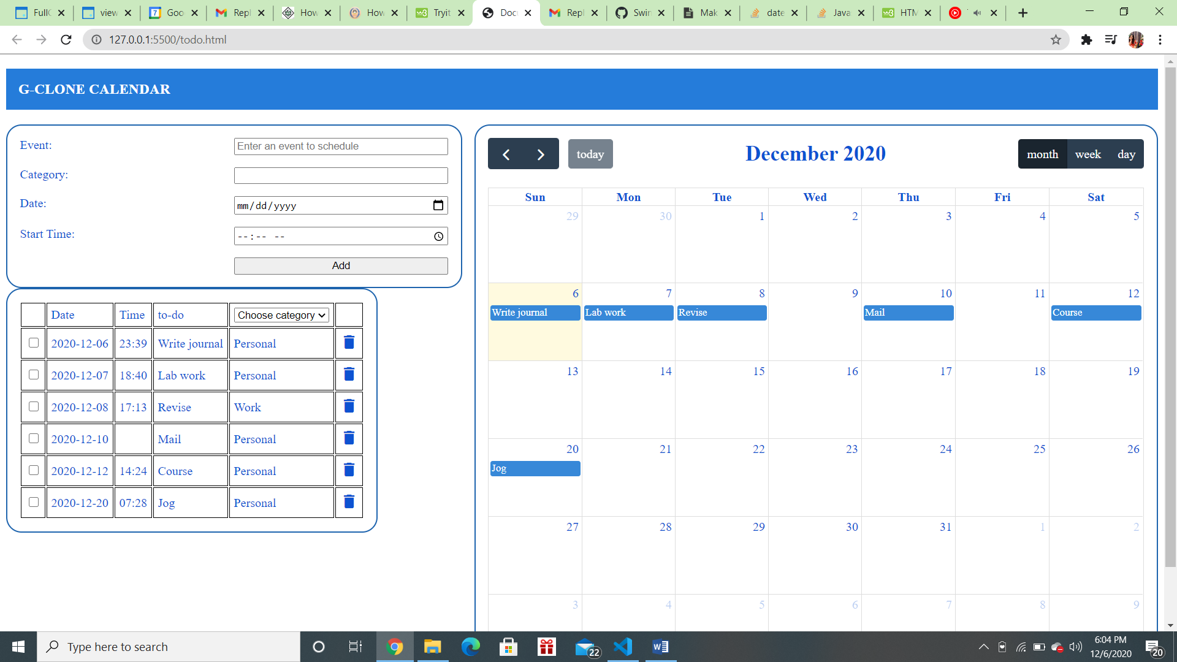

**WEEKLY VIEW**

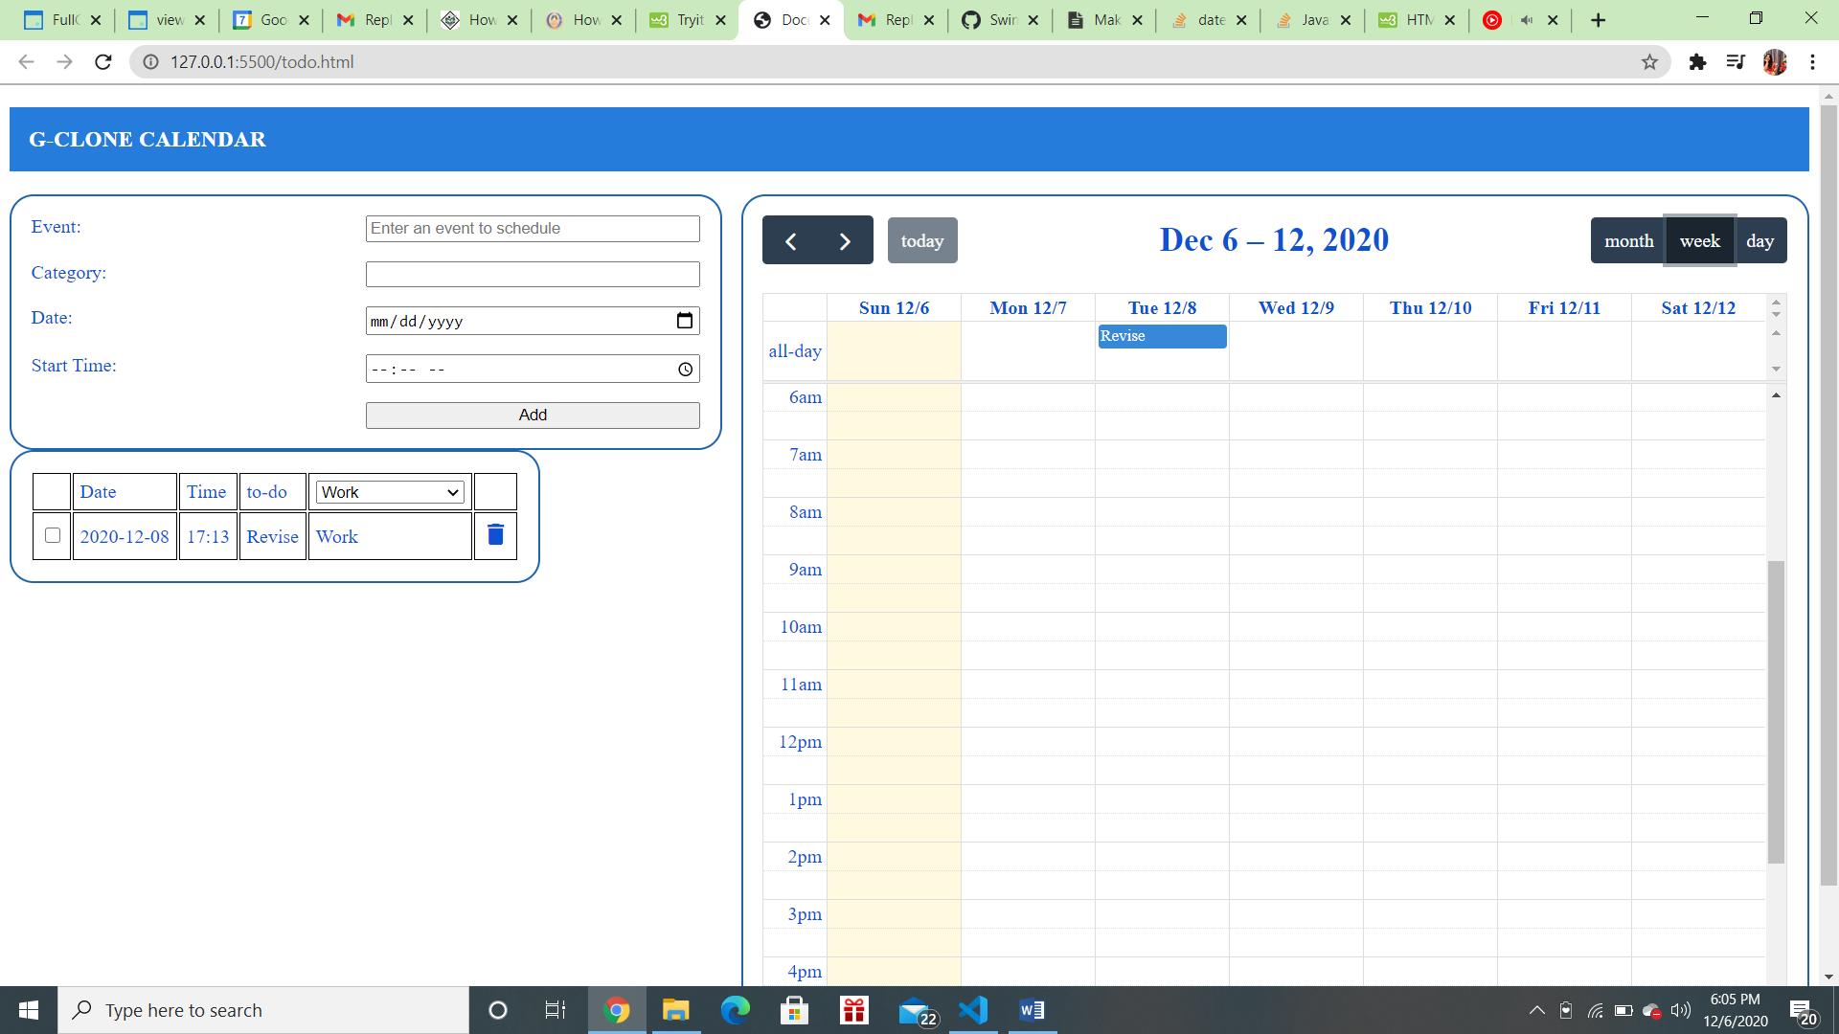

**SORT BY CATEGORIES**

By “Work” Category

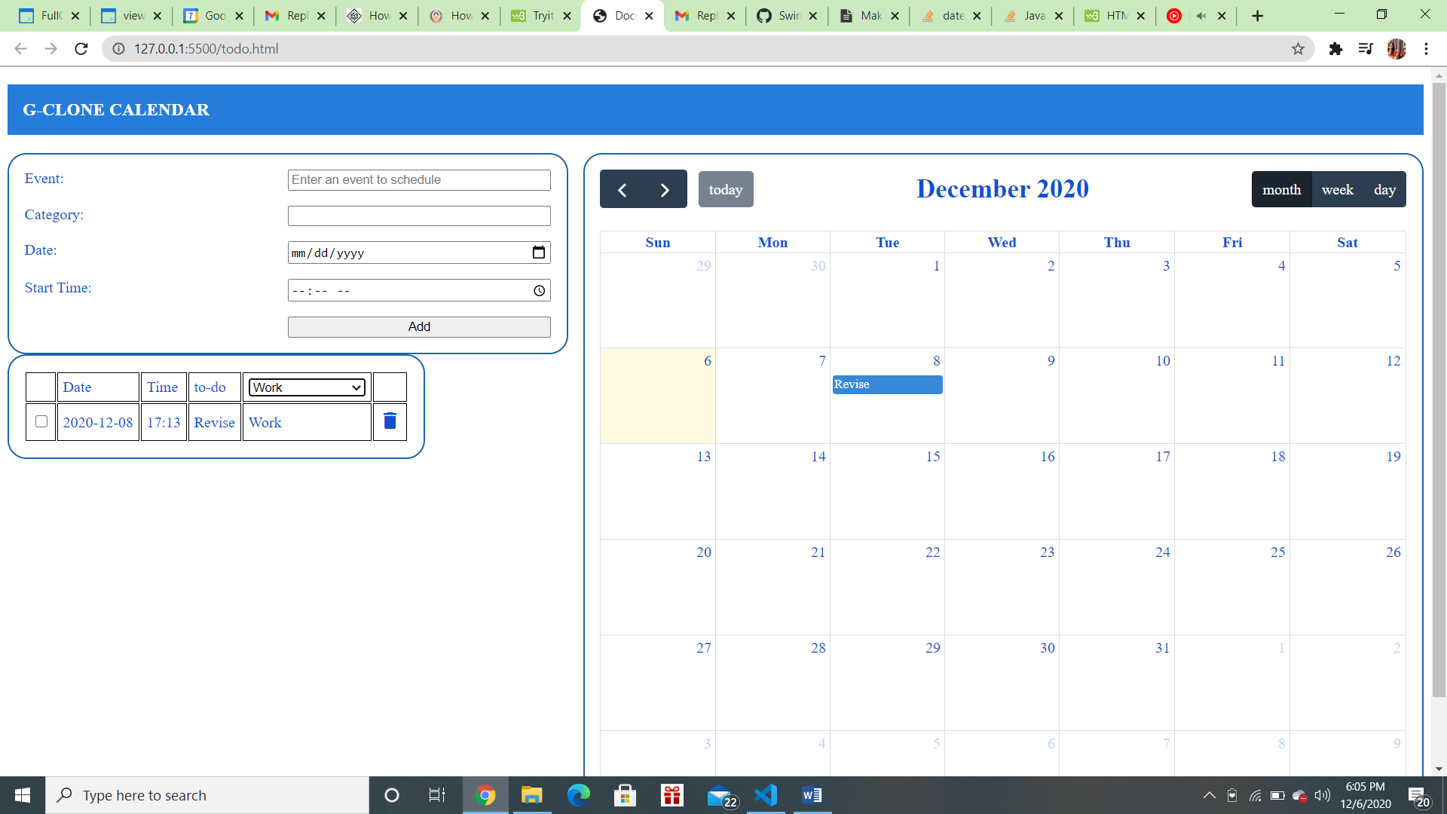

By “Personal” Category

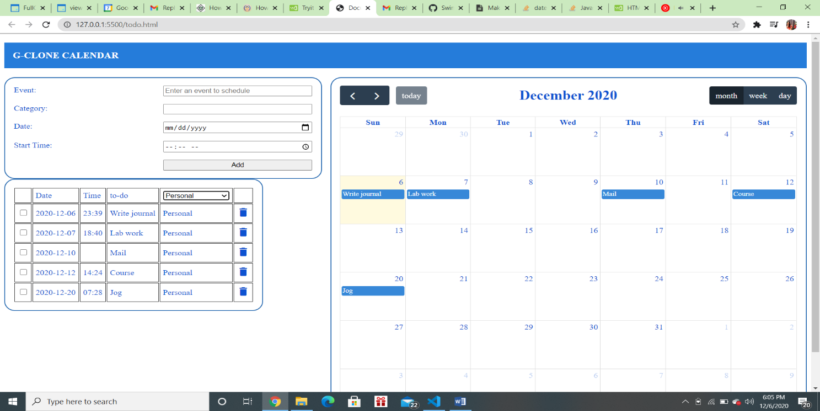

**DAILY VIEW**

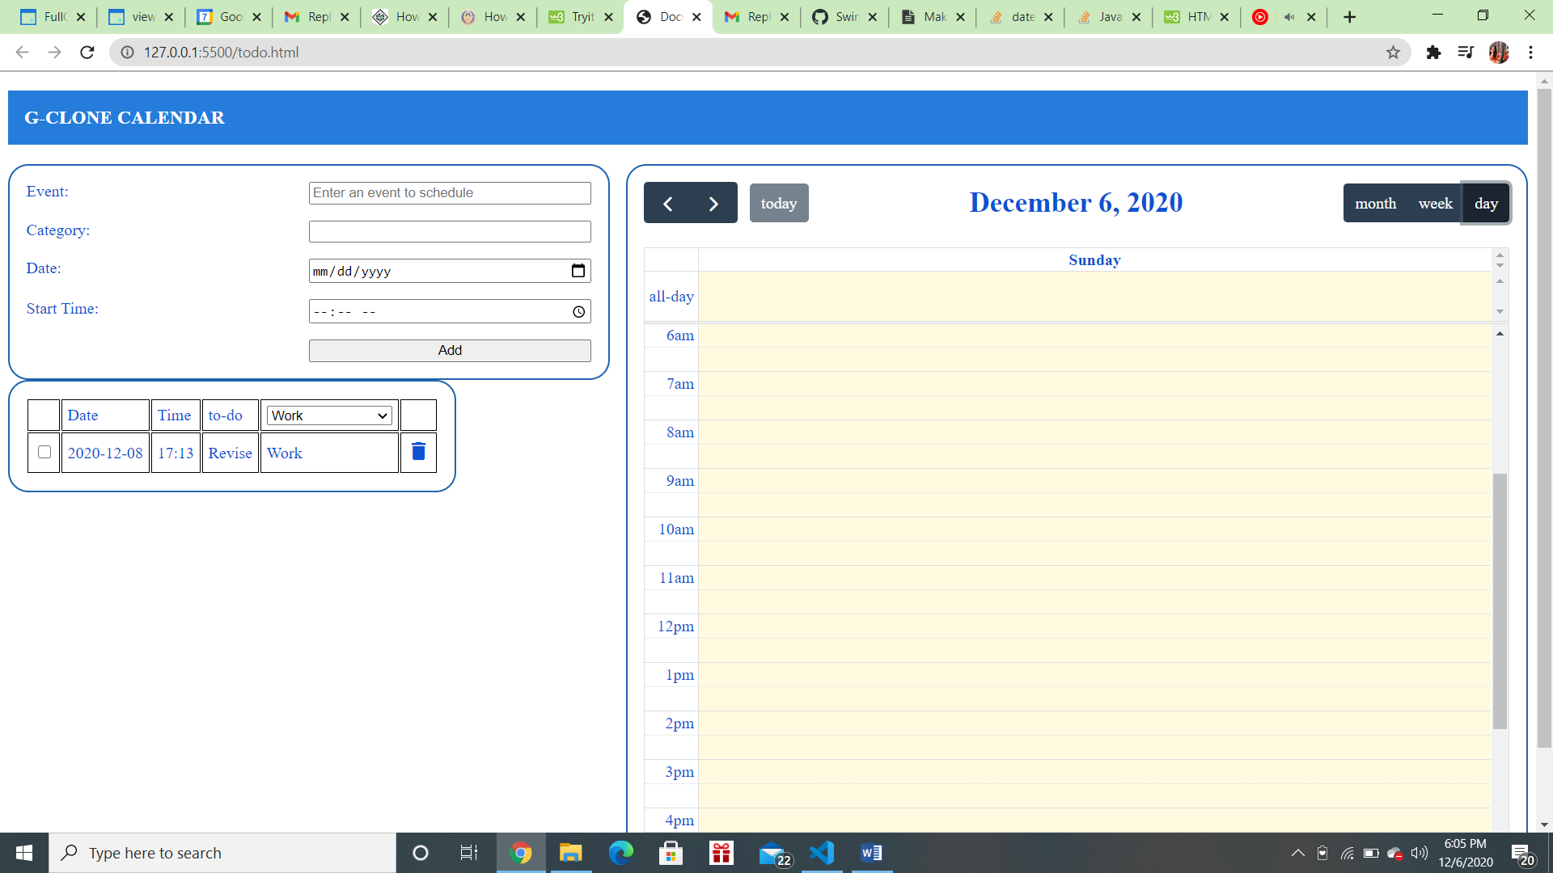

**DATA STORED AT THE BACK-END(localstorage)**

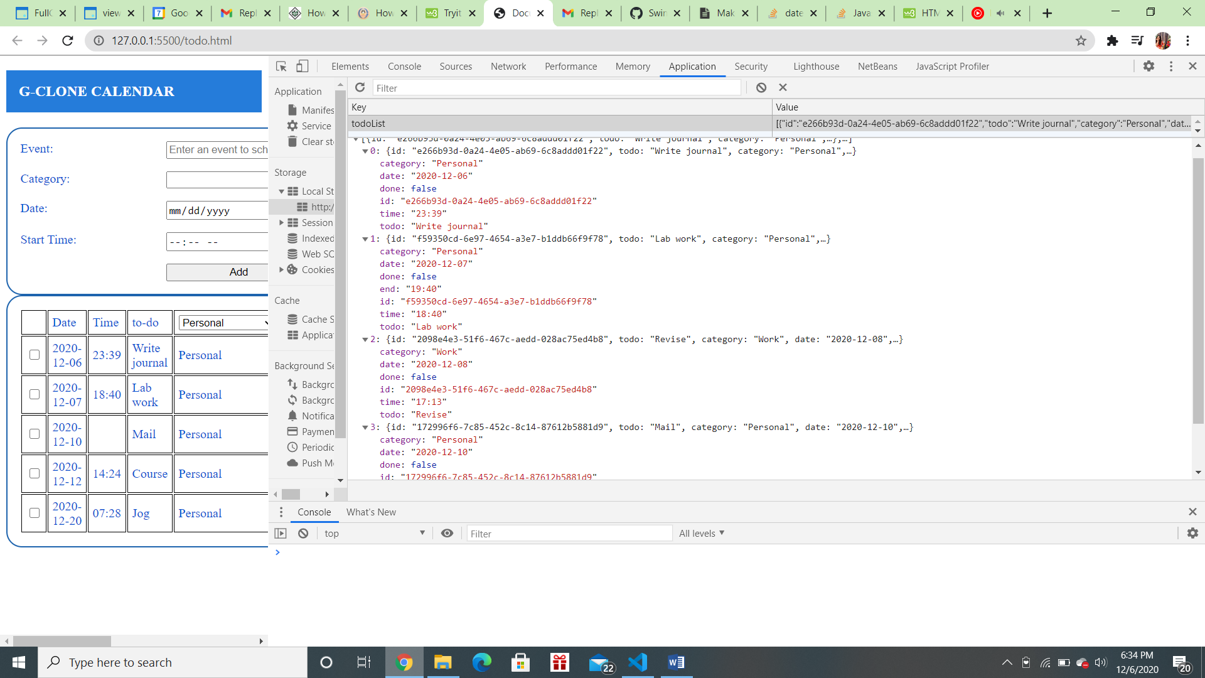

**Future Manipulations:**

* **Reminders** about the events can be included.
* Provision to add an **important note** about a certain event on the calendar can too be developed.