Heady System Architecture Overview

Introduction
Heady is a personal AI platform that functions like a small, fully automated company. It orchestrates more than 20 specialized AI services that cooperate to write code, review and validate changes, manage operations, create content, monitor security, and learn from experience. The system runs 24/7 across a network of connected AI services and websites.

AI Team Roles
Heady’s ecosystem is made up of several classes of agents, each covering a different aspect of the software lifecycle.
Category | Key Agents & Responsibilities
Thinkers | HeadyBrain (general reasoning), HeadySoul (deep alignment), HeadyVinci (pattern spotting)
Builders | HeadyCoder (orchestrator), HeadyCodex (hands-on coder), HeadyCopilot (pairing), HeadyJules (PM)
Researchers & Validators | HeadyPerplexity (web research), HeadyGrok (red team), HeadyBattle (quality gate), HeadySims (simulation)
Creatives | HeadyCreative (creative engine), HeadyVinci Canvas (design sandbox)
Operations | HeadyManager (control plane), HeadyConductor (monitor), HeadyLens (change microscope), HeadyOps (deploy), HeadyMaintenance (cleanup/health)
Personal Assistant | HeadyBuddy (browser-based assistant; triggers actions; remembers context)

Liquid Architecture & Auto-Success Engine
Heady employs a liquid architecture: services are dynamically allocated to wherever they are needed most. Under heavy load, the system scales up; under light load, it conserves resources. Some core components remain always-on (e.g., patterns, auto-success, streaming).
A key subsystem is the Auto‑Success Engine. It runs 135 background tasks organized into nine categories every 30 seconds. Errors are treated as learning events rather than fatal failures.
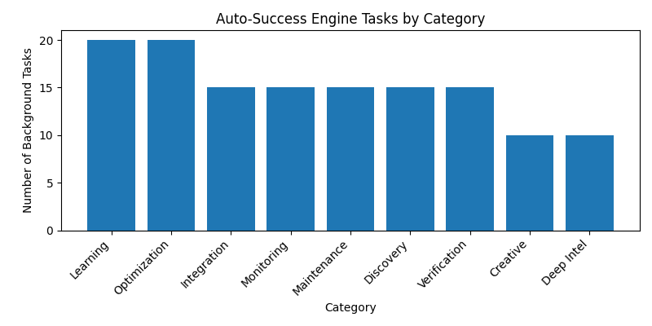
Figure 1: Number of tasks in each Auto‑Success Engine category.

Data Flow
Requests pass through an AI gateway (auth + rate limiting) into HeadyBrain for primary reasoning. HeadySoul can optimize/align decisions, then HeadyBattle validates changes and HeadySims runs Monte Carlo simulations. Arena Mode can evaluate competing solutions; winners are promoted to production automatically. HeadyVinci learns from outcomes.

Websites & Interfaces
The ecosystem spans multiple domains: headyme.com (personal dashboard), headysystems.com (infrastructure hub), headyconnection.org (community/social), headymcp.com (protocol portal), headyio.com (developer platform), headybuddy.org (assistant hub), and headybot.com (automation). Planned/active vertical expansions include headycreator.com, headymusic.com, headytube.com, headycloud.com, headylearn.com, headystore.com, headystudio.com, headyagent.com, headydata.com, and headyapi.com.

Custom Web-Based IDE
Heady includes a browser-based development environment (similar to a customized VS Code). It provides a file manager, live agent windows, service selection, an Arena Mode toggle, and real-time event streaming. The IDE is accessible at ide.headyme.com.

External AI Providers
Heady integrates multiple model providers via a unified routing layer, selecting the best model per task based on speed, cost, and quality, with automatic fallback. Providers include Anthropic Claude, OpenAI (Codex/GPT), Google Gemini, Perplexity, GitHub Copilot, and Groq.

Summary
Heady operates as a digital nervous system: autonomous software factory + operations center + research and creative suite. The liquid architecture, auto-success engine, and validation pipeline aim to maximize resilience and continuous improvement.

