PROVISIONAL PATENT APPLICATION

AI Tool Safety Gateway with Two-Phase Confirmation and Scoped Access
Patent Application 11: AI_Tool_Safety_Gateway

Applicant / Assignee | HeadySystems Inc.
Inventor | Eric Haywood
Correspondence Address | [To be provided]
Entity Status | Undetermined (select on filing)
Government Interest | None known
Attorney Docket | HS-PPA-11-AI-Tool-Safety-Gateway
Date | January 21, 2026

Note: This technical disclosure is intended to support a provisional filing. It is not legal advice.

Abstract
A security gateway system acts as an intermediary firewall between autonomous AI agents and external execution tools (e.g., file system access, API calls, command execution). The gateway enforces a deny-by-default policy and implements a two-phase confirmation protocol for high-risk actions. When an agent attempts a high-risk action, the gateway suspends execution and generates a cryptographic hash of the intent. Execution proceeds only upon receipt and verification of a digitally signed confirmation from an authorized human operator or policy engine. Additionally, the gateway enforces scoped access by restricting tool operations to specific ephemeral directories and least-privilege capability scopes, reducing system-wide contamination risk while producing audit-grade receipts for all mediated actions.

Field of the Invention
[0001] The invention relates to computer security and governance for autonomous or semi-autonomous AI agents, including mediation of external tool execution, risk-based authorization, cryptographic confirmation workflows, least-privilege sandboxing, and audit-grade evidence generation for regulated environments.

Background
[0002] Autonomous AI agents increasingly interact with external execution tools such as local file systems, shells, CI runners, and network APIs. While such tools amplify productivity, they also expand attack surface and create new failure modes, including unintended deletion, privilege escalation, prompt-injection-driven exfiltration, and irreversible configuration drift.
[0003] Traditional access control approaches often rely on static roles and long-lived credentials. Such approaches are insufficient for tool-driven agents because risk varies dramatically by action context (e.g., reading a file versus deleting a repository) and because the meaning of an action depends on parameters and environment state.
[0004] Further, conventional approval processes are typically informal and not cryptographically bound to the exact intent being approved, enabling approval replay, ambiguity, or disputes over what was authorized.
[0005] Accordingly, there is a need for a governance-grade execution gateway that (i) denies by default, (ii) classifies tool actions by risk, (iii) requires cryptographically verifiable confirmations for high-risk actions, (iv) enforces least-privilege scoping for approved actions, and (v) emits durable audit evidence.

Summary
[0006] In one embodiment, a safety gateway mediates all tool-use requests from an AI agent, canonicalizes each request into an intent record, and classifies the request into a risk level using policy and context.
[0007] In one embodiment, for high-risk requests the gateway suspends execution and generates a cryptographic intent hash. The action proceeds only after the gateway verifies a digitally signed confirmation receipt referencing the intent hash.
[0008] In one embodiment, the gateway enforces scoped access by mapping approved tool requests into an ephemeral sandbox, including dynamically created directory roots and short-lived credentials, thereby reducing blast radius.
[0009] In one embodiment, the gateway generates tamper-evident audit receipts binding identity, intent hash, risk classification, approvals, and outcomes, enabling compliance review and incident response.

Brief Description of the Drawings
[0010] FIG. 1 is a schematic block diagram illustrating a safety gateway positioned between an AI agent and external execution tools, including risk classification, two-phase confirmation, scoped sandbox execution, and audit receipt generation.

Detailed Description

System Overview
[0011] In an example implementation, an autonomous agent issues a tool-use request. The request is intercepted by a safety gateway that performs intent canonicalization, risk classification, and policy evaluation. Low-risk actions may be executed immediately within constrained scope. High-risk actions are suspended pending verification of a signed confirmation receipt that is cryptographically bound to the exact intent requested. All actions produce audit records suitable for later verification.

Intent Canonicalization and Hashing
[0012] A tool-use request may include a tool identifier, verb, arguments, target resources, and environmental context. The gateway converts the request into a canonical intent record to ensure stable hashing and consistent policy evaluation.
[0013] The gateway computes an intent digest (e.g., a cryptographic hash) over the canonical record. The digest uniquely identifies the requested action, preventing ambiguity about what is being approved or executed.
[0014] In some embodiments, the canonical record includes normalized paths, sorted argument maps, and explicit encoding of environment identifiers (e.g., repository, branch, container image digest) to prevent hidden differences.

Risk Classification and Policy Evaluation
[0015] The gateway classifies each intent into a risk tier using policy rules, historical context, and optional heuristics. Risk signals can include tool category, operation verb, sensitivity of target resources, and the magnitude of proposed changes.
[0016] Examples of high-risk intents include deleting files or directories, modifying access control rules, changing build/deployment configuration, disabling security controls, or writing to protected areas.
[0017] Policy evaluation may incorporate authorization claims (e.g., roles, scopes) and device or environment posture signals (e.g., attestation measurements, known-good build images) to determine whether execution is permissible.

Two-Phase Confirmation Protocol
[0018] For intents classified as high risk, the gateway suspends execution and emits a confirmation request containing the intent digest, a human-readable summary, and required approval conditions.
[0019] Execution proceeds only after the gateway receives a confirmation receipt that is digitally signed by an authorized human operator or deterministic policy engine. The receipt must reference the intent digest to prevent approval replay against a different request.
[0020] In some embodiments, the receipt includes a timestamp, approval reason code, and any evaluated evidence (e.g., test results hash), and the gateway verifies receipt freshness to prevent reuse.

Scoped Access and Ephemeral Sandboxing
[0021] Approved tool execution is constrained by least privilege. For file operations, the gateway can create an ephemeral directory tree (sandbox root) and map all file reads/writes to that root, denying access outside the allowed subtree.
[0022] For network operations, the gateway can enforce allowlists of endpoints, restrict methods, and apply short-lived credentials with limited scopes and expiration.
[0023] In some embodiments, each intent receives a fresh ephemeral scope (directory root, tokens, container namespace) that is destroyed after execution or upon timeout, thereby limiting contamination and reducing persistence of sensitive artifacts.

Audit Receipts and Evidence
[0024] The gateway emits audit events for each mediated intent, including the canonical intent record, intent digest, risk classification, authorization claims used, confirmation receipt identifiers (if any), and the outcome.
[0025] Audit records may be stored in an append-only ledger with hash chaining to provide tamper-evidence and support forensic analysis and compliance audit requirements.
[0026] In some embodiments, the gateway emits both a runtime log entry and a signed receipt artifact that can be attached to change management systems or CI/CD pipelines.

Example Use Cases
[0027] Autonomous refactoring: agent proposes code edits; low-risk writes are allowed only within a scoped repository subtree; deletions require two-phase confirmation.
[0028] CI operations: agent can run tests and read logs under low-risk policy, but cannot deploy or change pipeline credentials without signed approval.
[0029] Production incident response: agent can gather diagnostics under read-only constraints; any configuration change to production requires a signed confirmation receipt.

Alternative Embodiments
[0030] In some embodiments, the gateway runs as a local sidecar daemon on a developer workstation. In other embodiments, it runs as a remote proxy service mediating tool execution over a secure channel.
[0031] In some embodiments, high-risk approvals require multiple signatures (two-person integrity) or a combination of human signature and automated policy signature.
[0032] In some embodiments, the gateway integrates with JWT/OIDC identity providers and binds tool permissions to JWT claims that are verified on each request.

Drawings
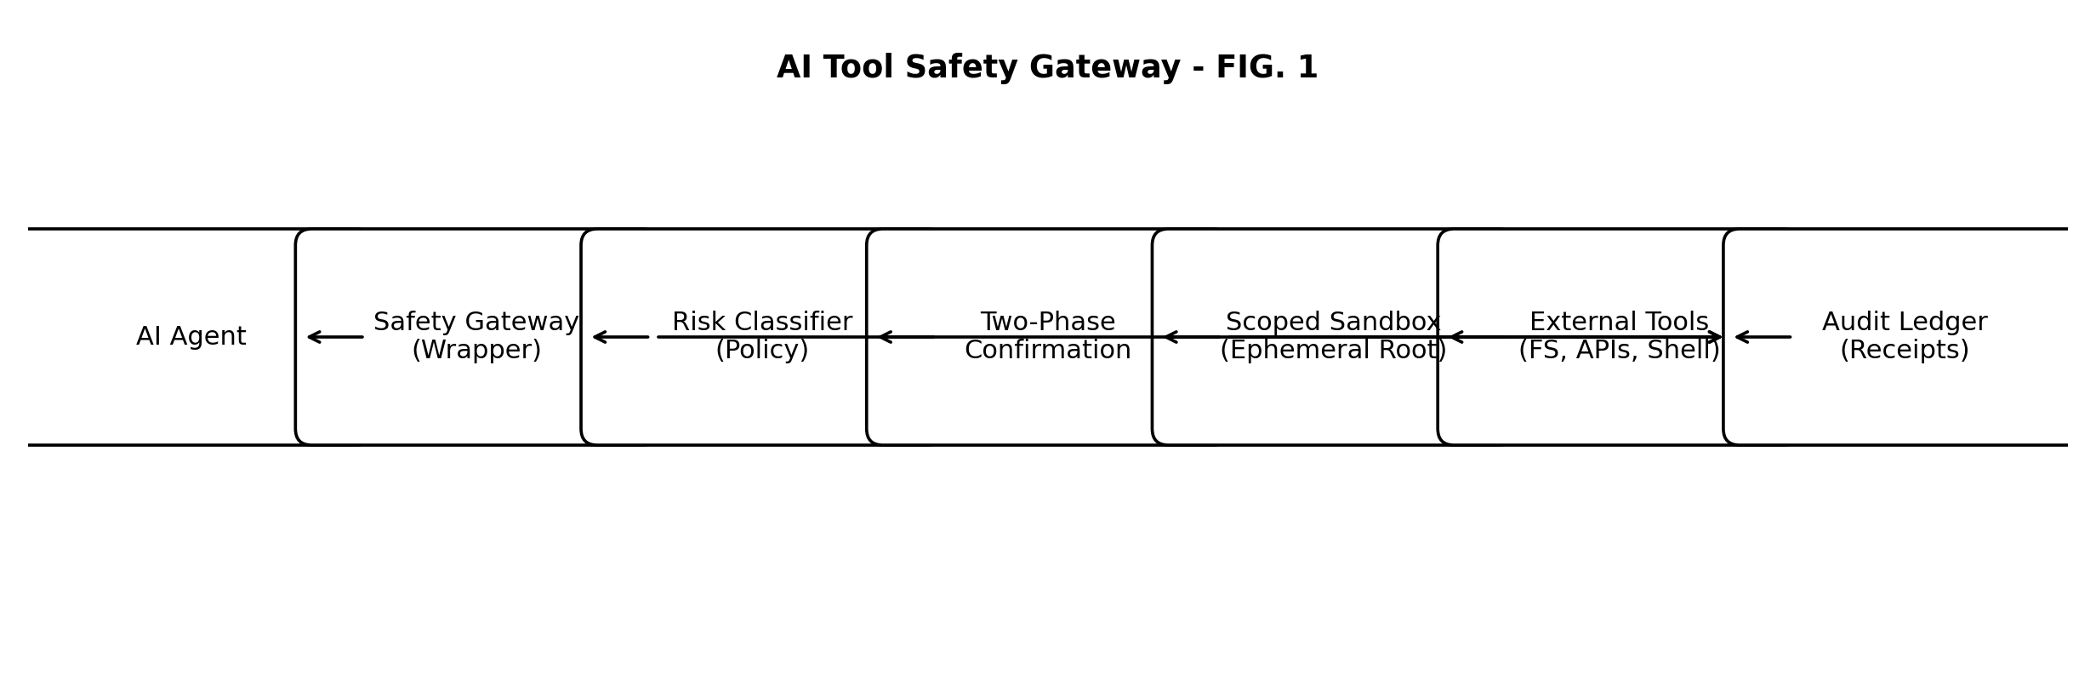
FIG. 1 - Safety gateway mediation of AI tool execution with risk classification, two-phase confirmation, scoped sandboxing, and audit receipts.

Example Claims
The following claims are provided as examples and may be revised for a later non-provisional filing.
1. A method for mediating AI tool execution comprising receiving a tool call request, classifying the risk level of the request, and suspending execution of high-risk requests until a cryptographically signed confirmation receipt is verified.
2. The method of claim 1, wherein file system access is restricted to a dynamically generated, ephemeral directory tree rooted in a non-system partition.
3. A system comprising a gateway server that validates JSON Web Tokens (JWT) minted by a trusted authority before routing any API traffic to external tools.
4. The method of claim 1, wherein the confirmation receipt references a cryptographic hash of a canonical intent record describing the tool call request.
5. The method of claim 2, wherein the ephemeral directory tree is destroyed after completion of the tool call or upon timeout.
6. The system of claim 3, wherein JWT claims encode tool scopes and resource roots and are evaluated per tool call request.

