COVER PAGE
PROVISIONAL PATENT APPLICATION

Hardware-Enforced Asymptotic Safety Limiter for Autonomous AI Inference
Patent Application 21: HeadyGuard

Applicant / Assignee | HeadySystems Inc.
Inventor | Eric Haywood
Correspondence Address | [To be provided]
Entity Status | Undetermined (select on filing)
Government Interest | None known
Attorney Docket | HS-PPA-21-HeadyGuard
Date | January 21, 2026
U.S. Provisional Application No. | [To be assigned]

Note: This technical disclosure is intended to support a provisional filing. It is not legal advice.

Abstract
A safety governance system integrates a non-bypassable asymptotic limiter into an autonomous AI inference and actuation pipeline. Before executing any external action, a safety oracle computes a harm potential vector representing predicted negative impact dimensions. The system evaluates an asymptotic cost function in which the computational cost of issuing or executing an action approaches infinity as the harm potential vector approaches a predefined limit. Actions that exceed the safety horizon become computationally infeasible within bounded time or compute budgets. In some embodiments, the safety logic is enforced by dedicated hardware that physically isolates external actuators from the AI processor, closing an actuation link only upon receipt of a safety capability signal produced when harm remains below the limit. Audit receipts bind action intents to harm evaluations and limiter decisions.

Field of the Invention
[0001] The invention relates to safety controls for autonomous and semi-autonomous artificial intelligence systems, including governed action execution, risk scoring, and hardware-enforced actuation gating. More particularly, it relates to an asymptotic safety limiter that makes harmful actions computationally infeasible and, in embodiments, physically isolates external actuators unless a safety capability signal is produced.

Background
[0002] Autonomous AI systems can propose and execute external actions through tools, APIs, robotic actuators, or other control interfaces. Such actions can have real-world consequences and may produce harm if mis-specified, adversarially induced, or executed under unsafe context.
[0003] Software-only safety filters and policy checks can be bypassed, disabled, misconfigured, or attacked. Systems that rely solely on software enforcement may fail open under compromise.
[0004] Risk and safety scoring approaches may produce probabilistic assessments, but organizations often require hard boundaries that prevent actions beyond a safety horizon from being executed.
[0005] Accordingly, there is a need for a safety mechanism that enforces a hard limit by design—making unsafe actions computationally or physically impossible to execute—while producing audit-grade evidence of safety decisions.

Summary
[0006] In one embodiment, the system computes a harm potential vector for each proposed action using a safety oracle. The vector represents multi-dimensional predicted negative impact such as physical harm risk, privacy harm risk, and regulatory harm risk.
[0007] In one embodiment, an asymptotic cost function maps the harm potential vector to a computation cost such that cost increases sharply as harm approaches a limit and approaches infinity at the limit.
[0008] In one embodiment, the system allocates bounded compute or time budgets for action issuance. Actions that would require cost beyond budget cannot be produced or executed, thereby enforcing a hard boundary.
[0009] In one embodiment, a hardware module physically isolates actuators from the AI processor and only enables actuation when a safety capability token is asserted, where the token is produced only when harm is below the limit.
[0010] In one embodiment, the system emits audit receipts binding action intent hashes to harm vector evaluations, limiter outputs, and actuation enablement decisions.

Brief Description of the Drawings
[0011] FIG. 1 is a schematic block diagram illustrating an autonomous AI inference pipeline with a safety oracle computing a harm vector, an asymptotic limiter producing a safety capability token, and a hardware actuator gate enforcing non-bypassable safety constraints with audit receipts.

Detailed Description

System Overview
[0012] In an example implementation, an AI model proposes an action intent. The intent is canonicalized and evaluated by a safety oracle that computes a harm potential vector. An asymptotic limiter evaluates a cost function that grows without bound as harm approaches a safety horizon. If the cost is within budget, the limiter produces a safety capability token that enables a hardware actuator gate to close the actuation link for the specific action context. If the cost exceeds budget or harm exceeds the limit, the capability token is not produced, and the actuator remains physically isolated.

Action Intents and Canonicalization
[0013] A proposed action is represented as an intent record including the operation verb, target resources or actuators, parameters, and context identifiers (e.g., environment, location, user clearance).
[0014] The intent record is canonicalized to a stable representation and hashed to produce an intent digest. The intent digest uniquely identifies the exact action being evaluated and is used to bind audit receipts and capability tokens.
[0015] Canonicalization may include normalized paths, sorted parameter maps, and explicit encoding of policy and model version identifiers.

Safety Oracle and Harm Potential Vector
[0016] The safety oracle computes a harm potential vector H for a candidate action. H may be multi-dimensional, including components for physical injury risk, property damage risk, privacy and data harm risk, financial harm risk, and regulatory or reputational harm risk.
[0017] H can be computed using rules, learned models, sensor fusion, environmental context, user intent, and policy constraints. The oracle can also compute uncertainty measures for each component.
[0018] In embodiments, the oracle outputs both H and a set of contributing factors, enabling human review and audit explanation without revealing sensitive internal model weights.

Asymptotic Cost Function
[0019] The asymptotic limiter evaluates a cost function C(H) that increases as harm approaches a limit L. In embodiments, C(H) is designed such that C(H) approaches infinity as any component of H approaches its corresponding limit component in L.
[0020] Example forms include reciprocal distance functions, barrier functions, or other convex penalties that diverge at the boundary. The limiter can incorporate multiple dimensions by applying the maximum component penalty, a weighted sum of penalties, or a norm-based barrier.
[0021] The system allocates a bounded compute or time budget B for action issuance or execution. If C(H) exceeds B, the action is not issued (or is issued too slowly to be actionable), thereby enforcing the safety horizon.

Hardware Enforcement and Actuator Isolation
[0022] In embodiments, a dedicated hardware module enforces the limiter decision by physically isolating the AI processor from external actuators. The actuation link is normally open (disconnected) and can be closed only by the hardware module.
[0023] The hardware module accepts a safety capability token from the limiter. The token is cryptographically bound to the intent digest, scope, and validity window. The hardware module verifies the token prior to enabling actuation.
[0024] If no valid token is presented, the actuation link remains open, preventing actuation regardless of software commands, thus making bypass by software compromise significantly more difficult.

Audit Receipts and Evidence
[0025] The system generates audit receipts that bind the intent digest, harm vector components, selected cost function parameters, budget values, and the limiter decision (allow/deny).
[0026] Receipts can be stored in an append-only ledger with hash chaining. Receipts provide evidence of why an action was allowed or denied and under what safety horizon settings.
[0027] In embodiments, receipt digests can be published to transparency logs and can include trusted timestamps to strengthen evidentiary value.

Example Use Cases
[0028] Autonomous tool execution: prevent AI agents from executing destructive filesystem operations by making risky operations exceed the compute budget and requiring safety tokens.
[0029] Robotics: prevent robotic actuators from moving into unsafe configurations by scoring physical harm risk and gating motor control lines through the hardware module.
[0030] Sensitive data handling: prevent actions that would exfiltrate protected data by scoring privacy harm components and enforcing hard limits.

Alternative Embodiments
[0031] In some embodiments, the limiter is implemented as a co-processor that must sign every actuator command, with signatures required to be fresh and bound to attestation state.
[0032] In some embodiments, the safety horizon L is parameterized by user clearance, operational mode, or environment state, and changes are governed by signed policy updates.
[0033] In some embodiments, the limiter integrates with a two-phase confirmation gateway such that high-risk actions require additional human approval even if below the limit.

Drawings
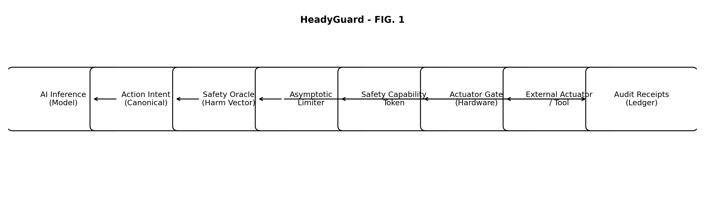
FIG. 1 - Asymptotic safety limiter with hardware actuator isolation and audit receipts.

Example Claims
The following claims are provided as example claims and may be revised for a later non-provisional filing.
1. A safety control system for AI utilizing an asymptotic cost function to enforce hard limits on the execution of potentially harmful actions.
2. The system of claim 1, wherein a safety oracle computes a harm potential vector for a candidate action based on context and predicted consequences.
3. The system of claim 1, wherein the asymptotic cost function increases computational cost as the harm potential vector approaches a predefined limit.
4. The system of claim 3, wherein the cost function approaches infinity at the limit, making actions beyond the limit computationally infeasible within a bounded time window.
5. The system of claim 1, wherein the safety logic is enforced by a dedicated hardware circuit physically isolating the AI processor from external actuators.
6. The system of claim 5, wherein the hardware circuit enables actuation only upon verification of a safety capability token bound to an intent digest and validity window.
7. The system of claim 1, further comprising generating an audit receipt binding the intent digest to the harm potential vector and limiter decision.
8. The system of claim 1, wherein harm dimensions include physical injury risk, property damage risk, privacy risk, and regulatory risk.
9. The system of claim 1, wherein the safety horizon limit is parameterized by user clearance or operational mode.
10. A non-transitory computer readable medium storing instructions to perform the method of claim 1.

