COVER PAGE
PROVISIONAL PATENT APPLICATION

Aggregate Visual Style Profiling via Latent Taste Vectorization
Patent Application 25: HeadyStyle

Applicant / Assignee | HeadySystems Inc.
Inventor | Eric Haywood
Correspondence Address | 149 Remington Street Unit 425, Fort Collins CO 80524
Entity Status | Small Entity
Government Interest | None known
Attorney Docket | HS-PPA-25-HeadyStyle
Date | January 21, 2026
U.S. Provisional Application No. | [To be assigned]

Abstract
A personalized recommendation system generates a user taste profile by analyzing an aggregate set of user-captured images. A computer vision encoder extracts latent embeddings that represent abstract aesthetic qualities such as color palette, texture, material cues, and form. The system aggregates embeddings into a latent taste vector (and optionally a covariance or multi-mode profile) that captures overall aesthetic preference across the collection. An inventory database of candidate items is encoded into the same latent space, and a recommendation optimizer selects items that minimize aesthetic distance to the taste vector while maximizing functional diversity, thereby favoring coherent style curation over simple nearest-neighbor similarity to a single image.

Field of the Invention
[0001] The invention relates to computer vision, latent representation learning, and personalized recommendation systems. More particularly, it relates to generating an aggregate aesthetic taste profile from multiple unstructured user images and selecting complementary recommendations by minimizing latent aesthetic distance while maximizing functional diversity.

Background
[0002] Recommendation systems for apparel, decor, and consumer goods commonly rely on item-to-item similarity, matching a single reference image or product. Such approaches often produce repetitive recommendations and fail to capture a user’s broader aesthetic expressed across a collection.
[0003] Users typically express taste through a set of inspirations and owned items. A system that optimizes only local similarity to one image can drift away from collection coherence and can overfit to one-off artifacts (e.g., lighting conditions or background clutter).
[0004] Additionally, recommendations optimized purely for similarity may lack functional diversity, repeatedly suggesting the same product type rather than a coherent set spanning categories.
[0005] Accordingly, there is a need for a recommendation engine that constructs an aggregate taste profile from many images and selects a set of complementary items that are coherent with the aggregate profile while remaining diverse in function and category.

Summary
[0006] In one embodiment, a vision encoder maps each user image to a latent embedding capturing aesthetic cues such as color palette, texture, and form.
[0007] In one embodiment, embeddings from a plurality of images are aggregated into a latent taste vector, optionally including covariance estimates or multi-mode clusters representing distinct style modes.
[0008] In one embodiment, inventory items are encoded into the same latent space, enabling computation of aesthetic distance between candidate items and the taste profile.
[0009] In one embodiment, a recommendation optimizer selects items that minimize aesthetic distance to the taste vector while maximizing functional diversity subject to constraints such as budget, availability, and category coverage.
[0010] In one embodiment, user feedback updates the taste profile using incremental vector updates and/or reweighting of embeddings, improving personalization over time.

Brief Description of the Drawings
[0011] FIG. 1 is a schematic block diagram illustrating aggregation of latent visual embeddings into a taste vector, scoring of inventory items by aesthetic distance and diversity, optimization of a curated set, and feedback-driven profile updates.

Detailed Description

System Overview
[0012] In an example implementation, a user supplies a set of images representing owned items or inspirations. A vision encoder computes a latent embedding for each image. An aggregator produces a taste profile comprising an aggregate vector and optionally a distribution model. Candidate inventory items are embedded into the same space. A scorer computes aesthetic distance and functional diversity metrics for candidates, and an optimizer selects a curated recommendation set that is coherent with the taste profile while remaining diverse in category and function. Feedback updates the profile iteratively.

Vision Encoder and Latent Embeddings
[0013] The vision encoder may be a convolutional network, vision transformer, or other learned model trained to embed images into a latent space where distances correspond to aesthetic similarity.
[0014] Embeddings can be computed from full images or from segmented regions to reduce background influence. In embodiments, the encoder normalizes for lighting, pose, and camera settings.
[0015] The latent representation can capture multiple aesthetic dimensions, including color palette distributions, texture/material cues, shape and silhouette, and composition patterns.

Taste Vector Aggregation
[0016] Given embeddings for multiple user images, an aggregation function produces an aggregate taste vector. In embodiments, the aggregate vector is a weighted mean of embeddings, where weights reflect image recency, user-provided importance, or inferred confidence.
[0017] The system may compute covariance or other dispersion measures to represent uncertainty or variation in taste. In embodiments, clustering yields multiple taste modes corresponding to different contexts.
[0018] Aggregation can include outlier rejection to prevent unusual or noisy images from dominating the profile.

Inventory Embedding and Candidate Retrieval
[0019] Inventory items are represented by images, metadata, and optionally text descriptions. The same vision encoder (or a paired encoder) computes embeddings for inventory items in the same latent space.
[0020] Candidate retrieval may use approximate nearest neighbor search to identify a superset of candidates near the taste vector prior to diversity optimization.
[0021] Constraints such as size, price range, availability, retailer exclusions, and shipping requirements filter candidates before scoring.

Aesthetic Distance and Complementarity
[0022] Aesthetic distance can be computed as cosine distance, Euclidean distance, Mahalanobis distance using taste covariance, or another metric defined in latent space.
[0023] Complementarity can incorporate alignment with secondary modes or intended use contexts, not only closeness to the mean taste vector.
[0024] In embodiments, the scorer penalizes redundancy by reducing score for items that are too similar to already-selected items, encouraging complementary variety within a coherent style envelope.

Functional Diversity Optimization
[0025] The optimizer selects a set of items that minimizes overall aesthetic distance while maximizing functional diversity across categories and subcategories.
[0026] Functional diversity can be quantified using taxonomy distances, category quotas, or coverage constraints. In embodiments, diversity is enforced using integer programming or greedy selection with diversity penalties.
[0027] Budget constraints and availability constraints can be integrated into the optimization objective and feasibility rules.

Feedback Updates
[0028] User feedback signals include clicks, saves, purchases, dwell time, explicit likes/dislikes, and returns. Feedback can update embedding weights and shift the taste vector toward accepted items.
[0029] In embodiments, feedback updates are bounded to avoid sudden drift. The system may maintain a stable long-term taste vector and a short-term session vector.
[0030] The system can also learn separate profiles for different contexts (work, travel, events).

Privacy and Data Handling
[0031] User images may contain sensitive content. In embodiments, embeddings are computed locally or in a secure environment and only embeddings are stored for recommendations.
[0032] The system can support user-controlled deletion, expiration policies, and encryption of stored embeddings.
[0033] In embodiments, the system maintains a provenance log for recommendations without storing raw user images, improving privacy while enabling audit and troubleshooting.

Alternative Embodiments
[0034] In some embodiments, the latent space is learned jointly from image and text, enabling recommendations that incorporate product descriptions and user prompts.
[0035] In some embodiments, the system optimizes for complementarity relative to a planned capsule set, using constraints for seasonal coverage and event-specific outfits.
[0036] In some embodiments, the system integrates with dynamic storefront generation, using the taste vector to curate a personalized storefront experience.

Drawings
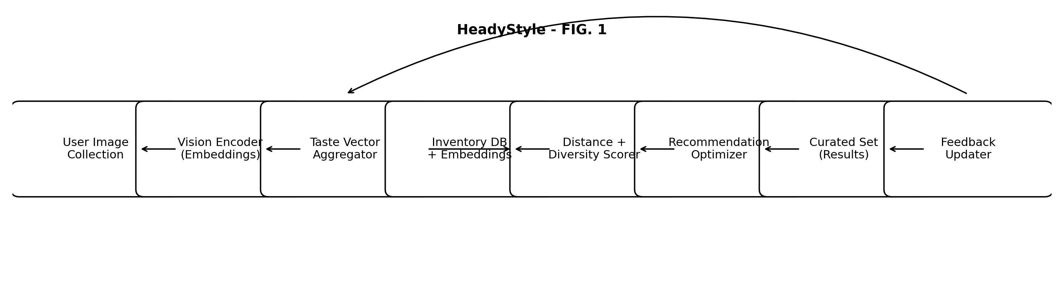
FIG. 1 - Aggregate taste vectorization and diversity-aware recommendation selection.

Example Claims
The following claims are provided as example claims and may be revised for a later non-provisional filing.
1. A method for generating a user taste profile by aggregating latent visual features from a plurality of unstructured user images.
2. The method of claim 1, wherein a vision encoder maps each user image to a latent embedding representing aesthetic attributes including color palette, texture, and form.
3. The method of claim 1, wherein the taste profile comprises an aggregate taste vector computed as a weighted mean of the latent embeddings.
4. The method of claim 3, further comprising computing a covariance or dispersion measure of the latent embeddings and using the measure to compute an aesthetic distance metric.
5. A recommendation engine that identifies items minimizing an aesthetic distance to a user's taste vector while maximizing functional diversity.
6. The recommendation engine of claim 5, wherein functional diversity is enforced using taxonomy constraints or category coverage quotas.
7. The method of claim 1, further comprising updating the taste vector based on user feedback signals including purchases and explicit accept/reject actions.
8. A non-transitory computer readable medium storing instructions to perform the method of claim 1.

