How to accept non-KYC bitcoin online with BTCPay Jungle and Electrum

by

Heady Wook

Published: 23 February 2021
Updated: 27 January 2022

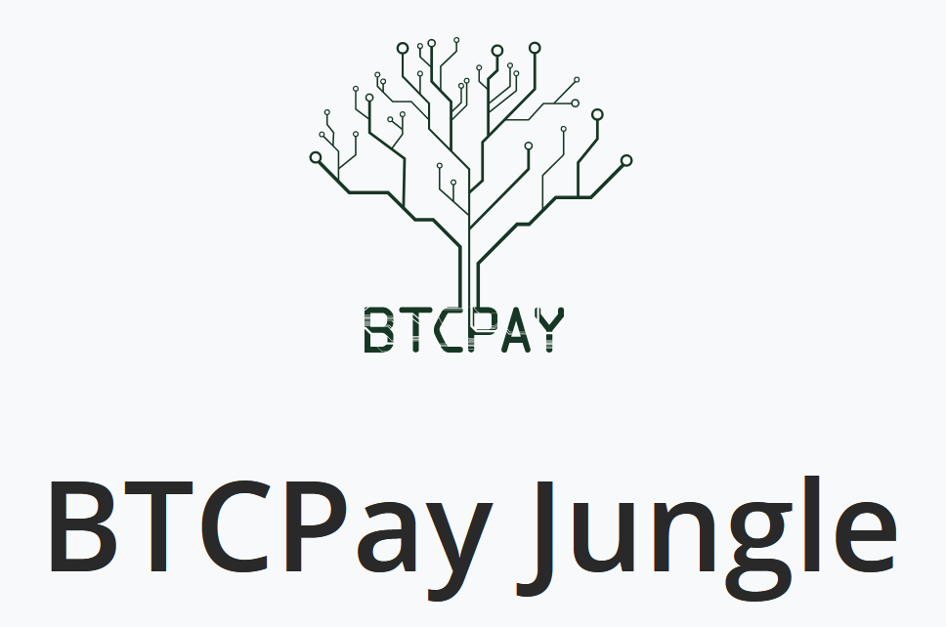


🄯 2022 Heady Wook

This work is licensed under CC BY 4.0. To view a copy of this license, visit http://creativecommons.org/licenses/by/4.0/
Introduction
This article discusses how to use an Electrum bitcoin wallet (i.e., mobile or desktop) to accept non-KYC bitcoin online with BTCPay Jungle. BTCPay Jungle is a fork of BTCPay Server, a full bitcoin payment processor, which offers free hosting services for anyone looking to start receiving bitcoin payments. Electrum is a bitcoin wallet that is open source, free, secure, and easy to use. This article is for users who have a product or service to offer in exchange for bitcoin and want to have an online presence. By the end of this article, a user should have set up an online store that accepts on-chain bitcoin as payment without giving any personally identifying information. Lightning payments will not be discussed here.

The trade-offs
By using BTCPay Jungle’s free third-party server, the xpub used will be exposed. This is why it is recommended to use a newly generated xpub from Electrum rather than using an existing xpub in the user’s control. Further, Electrum is a hot wallet and relies on third-party Electrum servers to verify transactions rather than one’s own node. With the proper mitigation strategies (i.e., keeping small amounts of bitcoin on the wallet, coinjoining the earned bitcoin, sweeping funds regularly, and/or deleting the old xpub and replacing it with a newly generated one), the benefits (i.e., an online store that accepts bitcoin) outweigh the risks.

Create a new account on BTCPay Jungle
Register a new account on https://btcpayjungle.com/Account/Register/ with a throw away email address. Also, BTCPay Jungle has an onion site for those that are interested. If the link is opened on Tor, a purple prompt will appear in the address bar reading “.onion available.” Select it and it will redirect to the onion site. Consider bookmarking the BTCPay Jungle login page for convenience. The quickest way to sign up with a throw away email address is to use https://www.guerrillamail.com/. After visiting Guerrilla Mail, open up the first email in the inbox and copy and paste the throwaway email into a text document for safekeeping. Also, remember the password. The email generated by Guerrilla Mail is what will be used to register on BTCPay Jungle. From here, wait for the confirmation email on Guerrilla Mail and continue to login to BTCPay Jungle. The confirmation email may take a few minutes but it will arrive.

Create a store on BTCPay Jungle
Once the new account is created, navigate to the “Stores” tab and select “+Create a new store.” Name the store and select “Create.” Once the new store is created it can later be found in the “Stores” tab. After the store is created, the user will need to enter an xpub in the “General settings” tab under “Wallet” by selecting “Setup” in the “BTC” field. Then select “Connect an existing wallet” and then “Enter extended public key.” As mentioned, an xpub from Electrum wallet will be used here.

Downloading Electrum
Download the desired Electrum wallet from https://electrum.org/#download (i.e., Linux, Windows, OSX, or Android). It is highly recommended that the user verify the PGP signature. This article does not cover how to verify signatures so the user must exercise their own due diligence. This link may be useful for those new to verifying signatures: https://www.wikihow.com/Verify-a-PGP-Signature.
After downloading and verifying the signature, Electrum wallet must be configured and the seed must be securely backed up before continuing with the store set up on BTCPay Jungle. Follow the prompts on Electrum (i.e., standard wallet, create new seed, secure and verify seed, and create password). Note, Electrum uses a few extra words on top of the BIP39 word list that overlap with the first four letters of other words so be sure to write out all the letters of each word when securing the seed phrase to avoid confusion in the future.
Whether initially downloaded on a desktop or mobile phone, the seed can be used to import on any one of available platforms. For example, if Electrum was downloaded and configured on a mobile phone, the user can import the wallet to Electrum’s desktop version with the seed.

Adding an xpub on to BTCPay Jungle
Now that Electrum has been downloaded, the xpub must be linked to BTCPay Jungle. To find the xpub in Electrum’s desktop wallet navigate to the “Wallet” tab, ”Information”, ”Master Public Key”. On Electrum’s mobile wallet, the xpub is found by selecting the wallet name on the top-left corner of the app. The xpub is found under ”Master Public Key.” Copy and paste the xpub into BTCPay Jungle’s “Extended public key” field and select continue.
Next, BTCPay Jungle will produce a series of bitcoin addresses. Verify that the first address listed matches the receive address produced in Electrum. To do this on the desktop app, navigate to the “Receive” tab in Electrum and then select ”New Address.” To do this on the mobile app, navigate to the “Receive” tab and select “Request.” Check that the address produced in Electrum matches the first one presented on BTCPay Jungle’s list. If they match, then proceed by selecting “Confirm” in BTCPay Jungle. At this point, the xpub has been successfully linked to BTCPay Jungle. Any funds received through the store created on BTCPay Jungle will be stored on the Electrum wallet that was just created.

New store settings
Now that an xpub has been linked with BTCPay Jungle, the store can now be set up. The following settings are recommended. Follow them as is for now but feel free to return later and experiment with alternative settings. If the user has been following up to this point, they should still be on the “My store” page where the xpub was added.
To continue, scroll down and select “Save Store Settings.” The settings in the “Payment” section should be good as is. Next, navigate to the “Checkout experience” tab and set the “Recommended fee confirmation target blocks” to 144. This setting adjusts the recommended miner fee for the buyer to low priority but still high enough to confirm in ~24 hours. Once set, select “Save.” The store’s main settings are now complete. The next step is to create a new app which will serve as the store’s Point-of-Sale (POS) web page.

Creating a new app
Navigate to the “Apps” tab and select “+Create a new app.” Next, give the store a name, leave the “App type” and “Store” settings as they are and select “create.” Use “my new app” for practice and follow through, then later a new app can be created after getting the hang of BTCPay Jungle. After the app is successfully created, scroll down to the bottom and select the button next to “View app” to preview the online store; it looks like a box with an arrow pointing to the top-right. This will open a new tab with the default “Tea shop” store settings. The URL in the address bar starting with “btcpayjungle.com/apps/…” is the URL that can be shared with others to lead them to the newly created store. Each new app will have a unique URL. Close the tab and return to the “Update Point of Sale” page.
Next, title the store and select “Default view.” “Static” allows purchases for one item at a time, “Cart” allows multiple purchases at a time, and “Light” allows a buyer to simply enter an amount to pay with no products displayed. Play around with these views by toggling between them and selecting “Save Settings” and then scrolling back down to the view app button mentioned above. This can be done throughout the set up process to preview changes in the store along the way as long as the user saves the settings. Select “Cart” for now and decide on one later when creating a new legitimate app.
The following recommendations are the authors preferences but these may be changed as the user sees fit. Change “Currency” from “USD” to “SATS.” Uncheck “User can input custom amount,” “User can input discount in %,” and leave “Enable tips” checked. The remainder of the settings before the “Products” section can be left as they are.
Creating a product. Next, in the Products section, delete all the automatically generated products by selecting the trash bin and select “+ Add” to list customized products and/or services. In “Create item” give it a title, set the price (in sats), and leave “Custom price” as is (i.e., no). Next add an item description and inventory (if applicable). For example, if the user has multiple of the same product, they may want to enter their inventory. If it is a service, leave it blank as these do not run out of inventory. The title of each item/service must be unique because BTCPay Jungle automatically uses the title to generate an ID and cannot list multiple items with the same ID.
Uploading an image to the product. To upload a product image go to https://postimages.org/ and upload an image by selecting “Choose images.” Once uploaded, select “Share” and copy the “Direct link.” This is what will be pasted into the “image” field for the product on BTCPay Jungle. Now save the changes and a product complete with name, price, image, and description should now be created. This process can be repeated for every product/service listed in the store.
Adding the page content. Next scroll down to the “Description” section located below the products section. This is where text can be added which is displayed above the products on the online store. Format it as desired with the menu bar. Those who are familiar with HTML can enter into HTML mode by selecting the “</>” button located in the menu bar. Keep the page content simple for now and return to it later to add embellishments. Once text has been added to the description section, select save settings at the bottom of the page and preview the store by selecting the view app button as mentioned above.

Testing the pay function
In the newly created store, select an item and proceed to pay. If the BTCPay Jungle store generated a bitcoin QR code, the store has been set up successfully. At this point the user should have a functioning online bitcoin store. Any bitcoin earned from this store will be secured in the Electrum wallet that was generated earlier. From here on it’s tinkering and formatting to get the web page to present as desired—this might require some HTML skills. See https://www.w3schools.com/html/ for a free HTML tutorial or see https://archive.org/details/webdevelopmentde0000felk_c1m7 to find an online text book one can rent for free.

Redirecting the BTCPay Jungle URL to a domain name
If a user owns a domain name, they can redirect the BTCPay Jungle URL to the domain name URL. For example, the author owns the domain HeadyTieDyes.com so anyone who types that into an address bar will be redirected to the BTCPay Jungle store. Those familiar with the process can go to their domain name provider’s settings and paste the BTCPay Jungle URL as the forward address.

Conclusion
This article walked through how to create an online store that accepts bitcoin with BTCPay Jungle and Electrum wallet. It discussed creating an account on BTCPay Jungle, connecting an Electrum wallet xpub, and creating an online store. With this article, a user should have been able to create a free online store that accepts bitcoin as payment without providing personally identifying information.

Donate
If this article was useful for acquiring non-KYC Bitcoin or Monero, please consider a donation by visiting:

https://btcpayjungle.com/apps/2NqQwXoB5ejGPqtHTefrsoE2oeyH/pos


Or connect via PayNym and donate:

+whitefirefly714

PM8TJeDuf5J3Xs16WxcHyMKDGas7fUjjJw49Vx1Vj9kFKURXwDBmDx78dUB9aQpvYQ8qrazSnPA4EkWNB8QLfN3X1s1qdUyuudSgKK1j2YR5ezxHPpPb

Or donate Monero (XMR):

8BCn19ApVcdMWYyNs3Xb1F8aWTcq79KSmhFSGEqcJQW85cT12pJYbr6bCrMmhqvTxNWWy7CLgKvegAKNVPd1AWXD2yH6TwJ


