How to use Text Verified to buy non-KYC bitcoin at a Bitcoin ATM

by

Heady Wook

Published: 27 November 2020
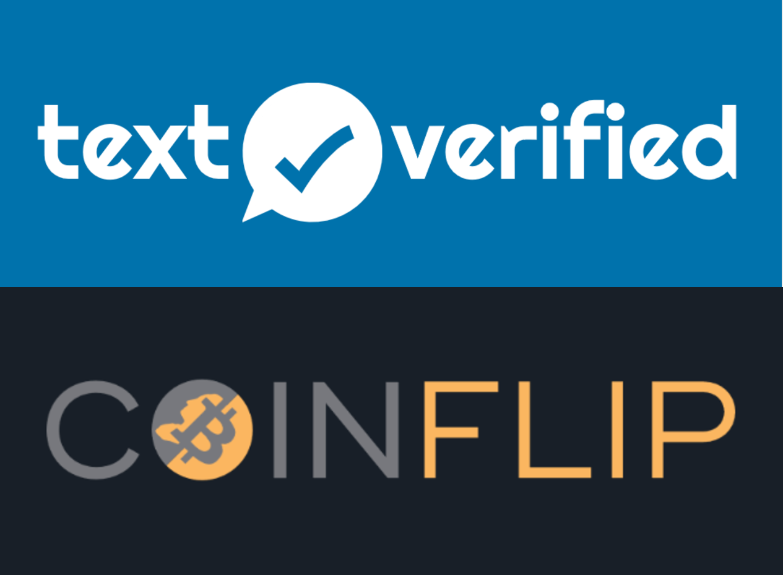

Updated: 25 January 2022

🄯 2022 Heady Wook

This work is licensed under CC BY 4.0. To view a copy of this license, visit http://creativecommons.org/licenses/by/4.0/

Introduction
This article discusses how to buy non-KYC bitcoin from a Bitcoin ATM (BATM), specifically CoinFlip BATM, using Text Verified. Text Verified is a non-VoIP phone number provider that accepts bitcoin. These phone numbers can be used to bypass SMS verification for services such as Twitter, Signal, and BATMs. Rather than give up a personal phone number, users can protect their personally identifying information by using Text Verified. CoinFlip is a BATM operator that takes cash for bitcoin. As of writing, they have 318 BATMs around the United States. To follow this guide, the user will need to own at least $10 worth of bitcoin, have a friend who can lend it to them, or buy a prepaid debit card with cash. There is also a $900 limit at these BATMs before KYC information is required. However, it is possible to execute multiple transactions back to back in the same day. By the end of this article, the user would have learned how to buy non-KYC bitcoin using Text Verified and CoinFlip BATM.

Selecting a Bitcoin ATM
As mentioned in the introduction, this guide is specifically meant for CoinFlip BATM. Although the method described in this article can be used with other BATMs, field tests indicate this method works best with CoinFlip. If the user decides to use a different BATM, or perhaps they don’t have a CoinFlip near them, then it is up to them to exercise due diligence. That is, determine the cost of the credits for using that given BATM and whether or not it will force KYC when using this method.
One way to check if the BATM will force KYC is to use https://coinatmradar.com/. On Coin ATM Radar, search for a nearby BATM and check the “limits and verifications” section to ensure no identification is required for at least a low level purchase tier.
To check the cost of credits for bypassing the SMS verification for that given BATM go to https://www.textverified.com/Verifications/#sms and search for the BATM. If the BATM is not listed, then SMS bypassing can still be accomplished but the default credit cost will be higher (i.e., 1.25 credits at the time of writing) compared to a BATM that is listed on Text Verified (i.e., 1.00 credit for CoinFlip).
According to field tests, most BATMs will force KYC on users when using this method. If there are no CoinFlip BATMs nearby, it would be wise for the user to fund the Text Verified account with about 5-10 credits to conduct field tests in an area near them. That is, go out to various BATMs and test whether or not they will force KYC when using this method.

Registering an account on Text Verified
The first step in using Text Verified to buy non-KYC Bitcoin from a BATM is to create an account on https://www.textverified.com/Account/Register/ with a throw away email address. The quickest way to do this is to use https://www.guerrillamail.com/. After visiting Guerrilla Mail, the user should open up the first email in the inbox and copy and paste the throwaway email into a text document for safekeeping. This is the email that will be used to register on Text Verified.
On the Text Verified registration page, use “n/a” for both the first and the last name, then paste the throw away email address into the respective field. Next, the user should generate a random password on https://www.random.org/strings/. On this webpage, enter “1” in the “generate” field and check off all three boxes (i.e., numeric digits, uppercase letters, and lowercase letters). Leave the string character length as is (i.e., 10) and select “get strings.” Examine the string that is generated and ensure that the string contains at least 1 uppercase (A-Z), 1 lowercase (a-z), and 1 number (0-9). If the string does not meet this criteria, it will not be accepted on Text Verified. If the string is missing one of these, select “again” until the string meets this criteria. Copy and paste this string into the text document with the throwaway email for safekeeping and paste it into the password fields on the Text Verified registration page.
Next, pass the reCAPTCHA and agree to the terms and conditions. From here, wait for the confirmation email on Guerrilla Mail and continue to login to Text Verified. The confirmation email may take a few minutes but it will arrive.

Adding credits on Text Verified
Once logged into the Text Verified account, it will need to be funded with bitcoin to buy credits. Ideally, the user should use a UTXO that is not tied to their identity via KYC records. A coinjoined UTXO or bitcoin lent to the user by a friend should do.
It is also possible for the user to buy a prepaid debit card with cash. With this however, the user will need to be sure it can be used for online purchases by reading the fine print and may be restricted to a minimum purchase, such as $25. The user may also need to “register” the card before it can be used online. When registering the prepaid debit card, follow the instructions on the card and use a semi-real name, the address of the place the card was purchased, and the phone number of that place too. For example, if the user bought the card at Ralphs, then use a semi-real name and Ralphs’ address and phone number to complete the registration. This is the information that will be needed when buying credits on Text Verified with a prepaid debit card.
To fund the Text Verified account, select the yellow “¢” symbol located in the menu. Select “buy with crypto” or “buy with USD.” Then use the toggle to determine how many credits to purchase or select from the menu options if paying with USD. For starters, purchasing about 5-10 credits is recommended. With this, a user can get about 4-8 SMS verifications depending on the cost for verification or number of field tests conducted. At the time of writing, each SMS bypass for CoinFlip costs 1.00 credit. If using a prepaid debit card, it may be best to max it out.
Once the credits are used up, it is good practice to throw away the old account. The user can then create and fund a new account complete with a whole new throw away email. This is ideal compared to funding the same account time and time again.

Finalizing the payment on Text Verified
Once the number of credits to be purchased has been determined, select bitcoin as the payment option and continue. Next, the user will be presented with a bitcoin payment address and QR code. Send the payment to the address provided within the allotted time frame (i.e., 15 minutes). The user should use a high priority miner fee if they wish to make a purchase as soon as possible. Otherwise send the payment with a low priority miner fee. Check the Bitcoin mempool at https://mempool.space/ to determine transaction fee priority. After a few on-chain conformations, the credits will be available to spend. If using a prepaid debit card to fund the account, continue on with the prompts and fill in the information that was used when the debit card was “registered” to be used online. Once the credits have been received on Text Verified, it is only a matter of going to the Bitcoin ATM.

Preparation before buying from a Bitcoin ATM
Given the times, it may be appropriate to wear a face mask as an increased measure of privacy. Adding sunglasses won’t hurt either. It should be noted that lower denominations of bills, such as $1 bills, may not be accepted. Therefore, come prepared with bigger bills, such as $20s. Search for any applicable discount codes (e.g., check CoinFlip’s Twitter or Instagram and on Coin ATM Radar) and have it loaded up or memorized. These discount codes help reduce the ATM fee.
Have Text Verified loaded up on a mobile device (i.e., ideally over Tor or VPN) and have the receiving bitcoin address ready on a wallet of choice. On Text Verified, navigate the menu and select “Verifications” and then “Text & Sms.” Then search and select the given BATM from the list. In this case, it would be CoinFlip. The user may be prompted by a pop-up message reading “Using A Proxy? Outside of the USA?” In this case, check the box “do not show again” and select “continue.” After selecting the given BATM, the user will be directed to the “Short-term SMS/Text verification” page which lists a temporary phone number. Use that phone number at the BATM within the allotted window of time. If the time runs out or the user decides to cancel the verification, the credits will not be used. The credits are only used after a verification is made. Once the timer starts, the user should walk up to the BATM. They should have plenty of time to perform the transaction.

Buying from a Bitcoin ATM
At the CoinFlip BATM select the bitcoin icon and enter a phony but semi-real name. Overtly fake names like “John Doe” will not work. These types of names may trigger a forced KYC, so avoid them. After entering a name, type in the phone number provided by Text Verified. Check the Text Verified tab on the mobile device for a confirmation code from the BATM. Type the confirmation code into the BATM. Next, scan the Bitcoin QR code, enter any applicable discount codes, and deposit the cash.
Before the transaction is finalized, the BATM will prompt for an email address to send a receipt to. This is optional. If a receipt is desired, then enter the throw away email address that was created earlier. Otherwise, ignore it and walk out. Within a few minutes, the incoming transaction will be seen in the bitcoin wallet and, if requested, the email receipt will be received too.

Pushing the limits
According to user feedback and first-hand experience, a user can make multiple purchases in one sitting using the upper limit of $900 per transaction. A new phone number will be generated for each transaction. Just repeat the process described above.
One user reported putting 3-5 transactions per sitting, per day at the upper limit until they fed $50,000 through the BATM. It took them about 2 weeks with 50 credits to buy $50,000 in non-KYC bitcoin.

Conclusion
This article discussed how to use Text Verified to buy non-KYC bitcoin at a Bitcoin ATM. Specifically, the author focused on CoinFlip given its reliability. The article covered how to register an account on Text Verified with a throw away email address, how to fund the account with credits, how to prepare, and how to navigate the BATM. A user following this guide should have been able to protect their personally identifying information by using Text Verified to buy non-KYC bitcoin from a BATM.

Donate
If this article was useful for acquiring non-KYC Bitcoin or Monero, please consider a donation by visiting:
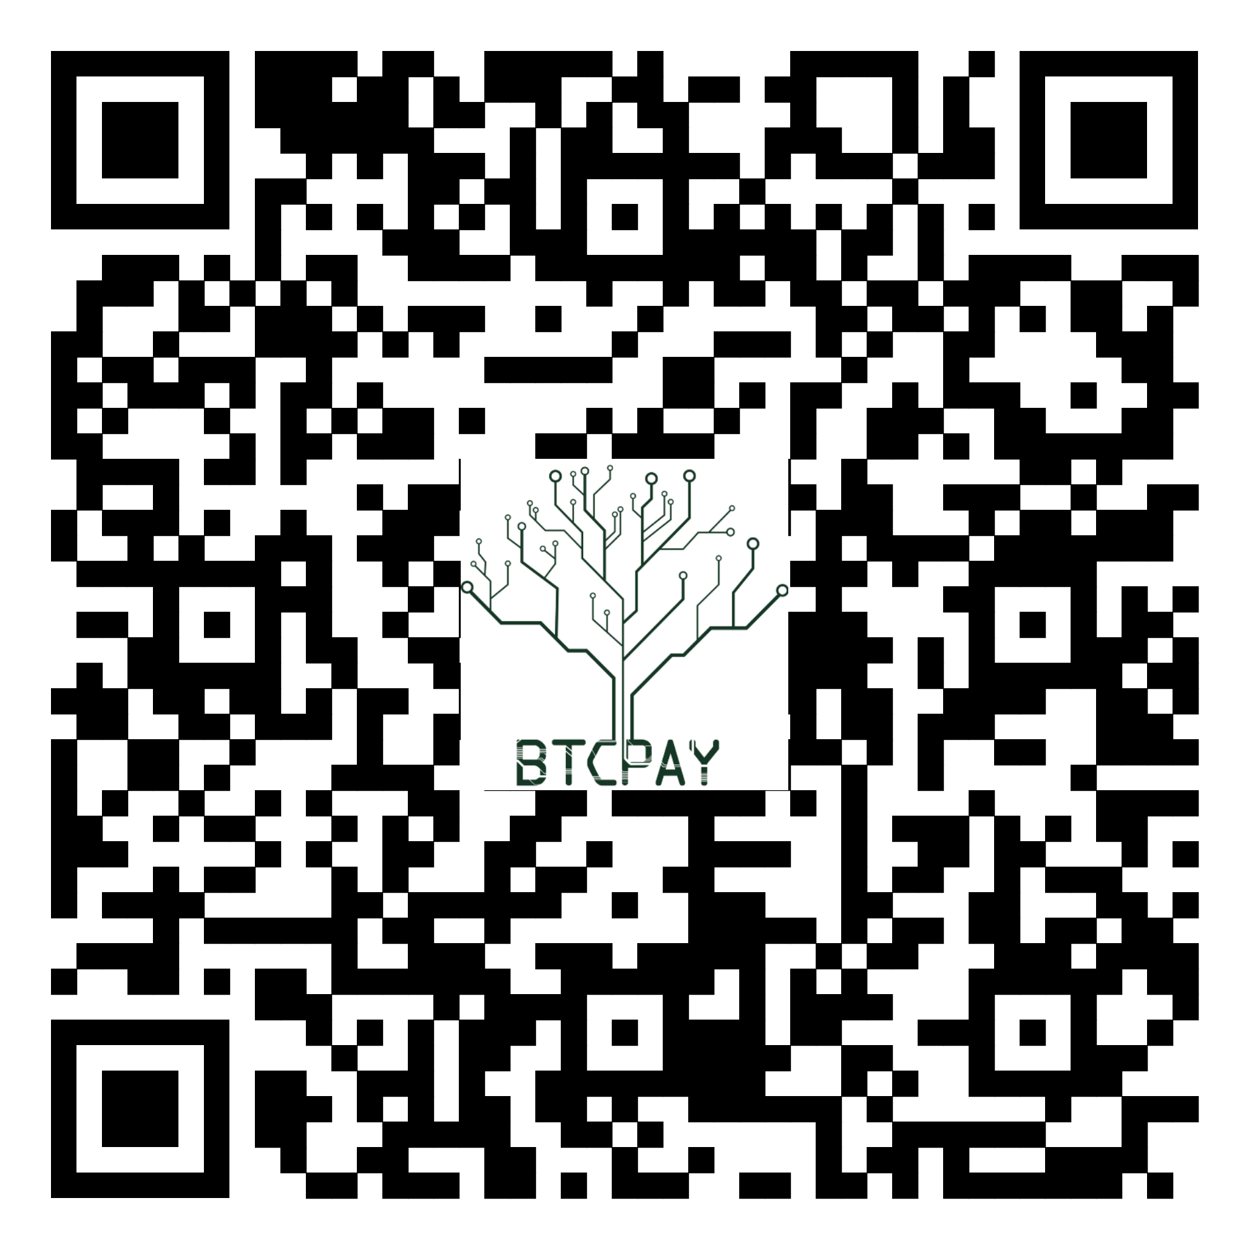
https://btcpayjungle.com/apps/2NqQwXoB5ejGPqtHTefrsoE2oeyH/pos

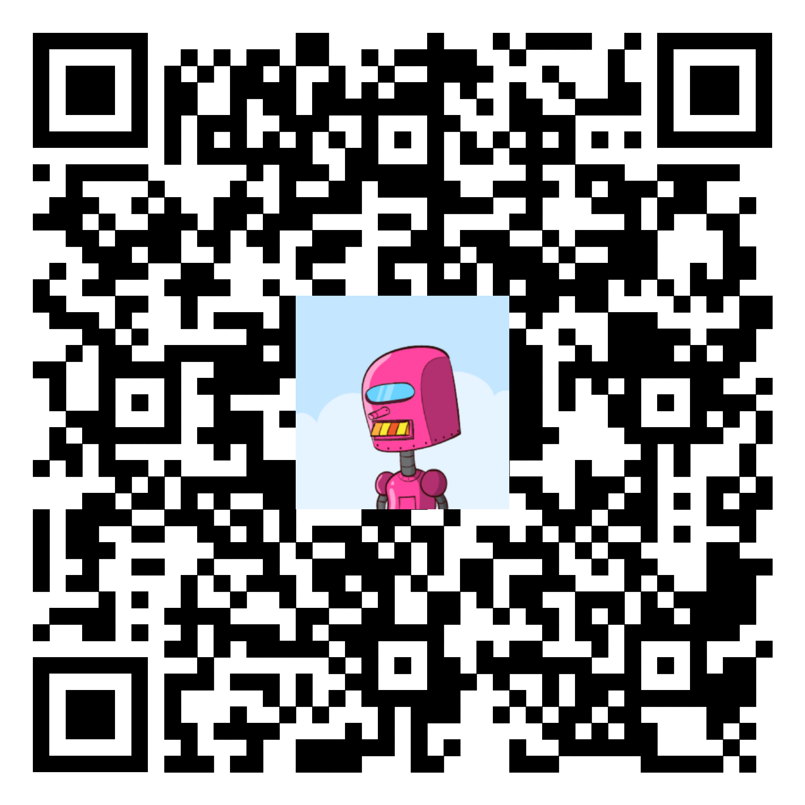
Or connect via PayNym and donate:

+whitefirefly714

PM8TJeDuf5J3Xs16WxcHyMKDGas7fUjjJw49Vx1Vj9kFKURXwDBmDx78dUB9aQpvYQ8qrazSnPA4EkWNB8QLfN3X1s1qdUyuudSgKK1j2YR5ezxHPpPb

Or donate Monero (XMR):

8BCn19ApVcdMWYyNs3Xb1F8aWTcq79KSmhFSGEqcJQW85cT12pJYbr6bCrMmhqvTxNWWy7CLgKvegAKNVPd1AWXD2yH6TwJ
