How to buy non-KYC Bitcoin with a US Postal Money Order on Bisq

by

Heady Wook

Published: 2020.07.07
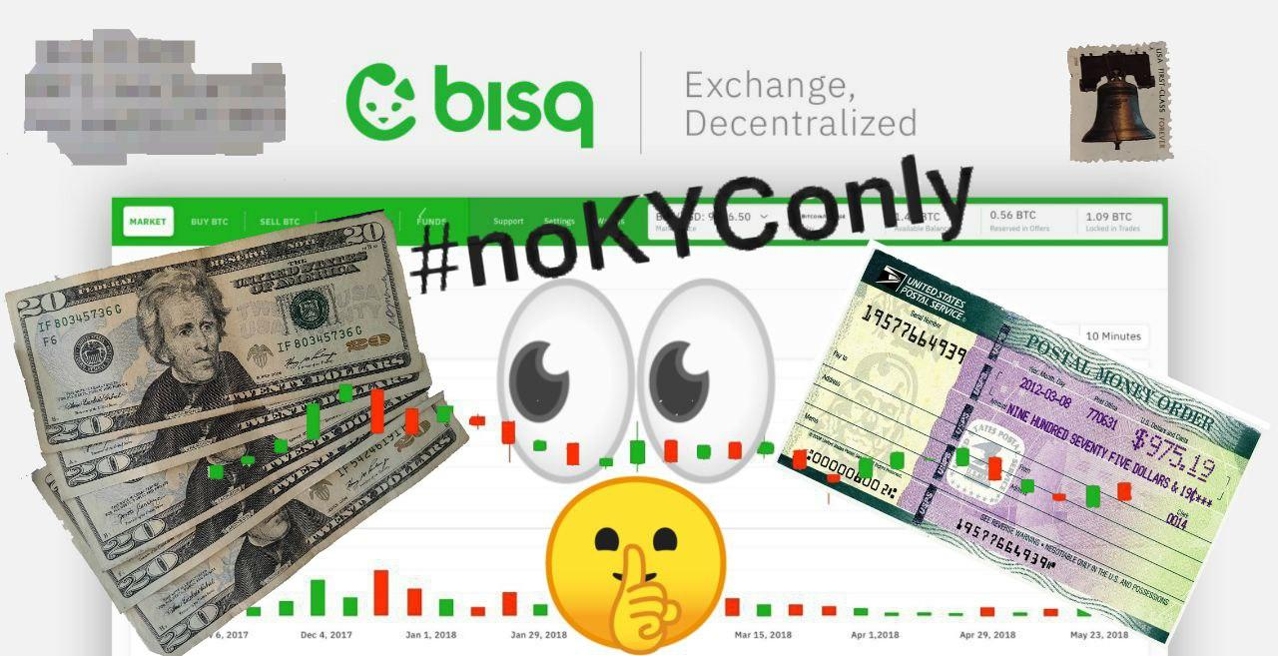
Updated: 2022.01.24

🄯 2022 Heady Wook

This work is licensed under CC BY 4.0. To view a copy of this license, visit http://creativecommons.org/licenses/by/4.0/

Table of contents

Page 4…………..Introduction
Adding “US Postal Money Order” as a payment method on Bisq
Page 5……………Taking an existing buy offer of Bisq
Page 7……………Creating a buy offer on Bisq with a US Postal Money Order
Page 9…………..Sending a US PMO via the US Postal Service
Supplies
Preparing the envelope
Page 10…………Certified Mailing Receipt
Page 11………….Buying the US Postal Money Order
Page 13…………Finalizing the trade on Bisq
Page 14…………Conclusion

Introduction
This article outlines how to buy non-KYC bitcoin Bisq with a US Postal Money Order (US PMO), one of the most private purchase methods available. The article covers how to create a US PMO payment account, how to take an existing buy offer, and how to create a buy offer on Bisq. It also covers how to buy and send a US PMO through the US Postal Service (USPS) using Certified Mail (i.e., tracking and signature confirmation). This article does not cover Bisq basics, such as downloading Bisq or app features. If this is what a buyer needs, then read Decentralized P2P exchange Bisq – How to buy and sell Bitcoin correctly? (ElkimXOC, 2021). Finally, this article is only meant for those looking to buy non-KYC bitcoin, not sell it.

Adding “US Postal Money Order” as a payment method on Bisq
The first step in buying bitcoin with a US Postal Money Order (US PMO) on Bisq is to create a new payment method. This is done in the “Account” tab and the “National currency accounts” tab. Select “Add new account” and use the “Select payment method” drop-down menu to scroll to “US Postal Money Order.”
The next two fields prompt for a name and address. The author recommends the buyer enter “n/a” in both these fields. By using “n/a” rather than coming up with a name, the buyer avoids injecting any bias into the generation of the name or address.
Lastly, the buyer can change the name of the payment account or use the one that is automatically generated. Once all the information is filled out, save the new account.
It should be mentioned that it is generally against Bisq trading policy to use fake information in any payment account. However, because a US PMO is a bearer instrument that works regardless of the name of the sender, it is okay to use a fake name and address only for accounts intended to buy bitcoin. This has been confirmed by a Bisq administrator.
The name and address on the Bisq payment account can only be seen by the seller and any mediators (i.e., should they be needed) so avoid using personally identifying information. The name and return address used when sending the payment though the Post Office will have nothing to do with the information used on this payment account.

Taking an existing buy offer of Bisq
After the buyer creates a US Postal Money Order (US PMO) payment account, they will be able to take existing buy offers. In order to do so, the buyer will already have to own some bitcoin to cover the security deposit, trading fee, and mining fee. If the buyer does not own any bitcoin, then read How to use Text Verified to buy non-KYC bitcoin at a Bitcoin ATM to learn how to use cash to buy bitcoin privately (Wook, 2022).
To take an existing buy offer, head to the “Buy BTC” tab and select the “Offers matching my payment accounts” button to filter out irrelevant buy offers. If there are US PMO buy offers posted on Bisq, then the buyer can select one to take. If there are no offers available, the buyer will need to create a buy offer (see the next section).
The price, percent premium, minimum and maximum BTC buy range, its USD equivalent, security deposit BTC amount, and account age are all listed for each available buy offer. Buy offers with a 0% premium are at market price. Positive percentages indicate a buy price above market value and negative percentages indicate a buy price below market value.
If there is a buy offer that the buyer wants to take, select “Take offer to buy BTC.” Read the prompt and continue. Next, enter the amount of BTC to buy if there is a range otherwise the buy amount will be preset. In “Advanced options,” leave it toggled on “BTC.” This guide does not cover using BSQ but it is covered by ElkimXOC.
Before continuing, it is important to note the “Amount in USD to spend” field when taking a buy offer. This is also discussed in the following section. At the Post Office, an individual can buy up to $2,999.99 in money orders per day before an ID is required of them. Each money order can only be made out to a max of $1,000. If a buyer wants to take an offer on Bisq at $3,000 or more without KYC, they would need to buy multiple money orders from the Post Office.
This can be done in a few ways. For example, if the “Amount in USD to spend” is $5,000, then the buyer would need to purchase five $1,000 money orders from the Post Office. The buyer can visit the Post Office on day one and buy up to $2,999.99 and then return the next day for the remainder, they can visit a few different Post Offices in a single day or across a couple days, or they can send in a few friends to help them acquire the money orders. Although it is a bit more work, taking a buy offer at $3,000 or more is possible without KYC.
To continue, select “next step” and deposit the funds (i.e., bitcoin) needed for the trade, which includes the security deposit, trading fee, and mining fee. Once this is done, the buy has been initiated. The reader can feel free to skip the following section (i.e., Creating a buy offer on Bisq with a US Postal Money Order) and jump to the remainder of the sections to learn how to prepare and buy the money order or the reader may continue to the next section to learn how to create a buy offer on Bisq.

Creating a buy offer on Bisq with a US Postal Money Order
Now that the new payment method has been created, a buyer can now create a buy offer with a US Postal Money Order (US PMO) on Bisq. To start, go to the “Buy BTC” tab, select “Create new offer to buy BTC with USD,” and select the correct trading account (i.e., the US PMO payment account that was just created) using the drop down menu. Next, enter the amount of Bitcoin to buy (e.g., 0.005 BTC). US PMO payment accounts are limited to a maximum purchase amount of 0.25 BTC. The minimum buy offer is 0.0001 BTC.
Next, enter the percent premium in “Below % from market price.” A percent premium of 0% would result in a buy at market value according to the Bisq Price Index. Positive percent premiums will result in a buy below market value and negative percent premiums will result in a buy above market value.
The percent premium a buyer decides on may depend on a couple factors such as market conditions (e.g., bear or bull markets) or the urgency at which one wants to buy bitcoin. When the bitcoin price is more volatile, such as during a bear or bull market, using a premium above market value will incentivize sellers to select that offer over others. Market value buy offers and especially buy offers below market value are less likely to be taken during times of volatility.
When the bitcoin price is less volatile, a buy offer at or below market value may be more likely to be taken. Additionally, if a buyer wants to purchase bitcoin quickly, then they may create a buy offer above market value to incentivize sellers to select that offer over others. If a buyer has no time frame to buy bitcoin, then they may create a buy offer at market value, or below, and wait for it to be taken. Buy offers below market value are the least likely to be taken. The percent premium can be edited at a later time at no cost.
Another thing to note here is the “Amount in USD to spend” field when creating a buy offer. At the Post Office, an individual can buy up to $2,999.99 in money orders per day before an ID is required of them. Each money order can only be made out to a max of $1,000. If a buyer wants to create an offer on Bisq at $3,000 or more without KYC, they would need to buy multiple money orders from the Post Office.
This can be done in a few ways. For example, if the “Amount in USD to spend” is $5,000, then the buyer would need to purchase five $1,000 money orders from the Post Office. The buyer can visit the Post Office on day one and buy up to $2,999.99 and then return the next day for the remainder, they can visit a few different Post Offices in a single day or across a couple days, or they can send in a few friends to help them acquire the money orders. Although it is a bit more work, creating a buy offer at $3,000 or more is possible without KYC.
After entering the buy amount and percent premium, the buyer will need to determine the security deposit percent. The security deposit is a collateral required of both the buyer and the seller to complete the trade. It acts as an escrow to protect both parties by holding the security deposit in a multi-sig wallet until the trade is complete. The security deposit is returned to each party after the seller confirms that they received the payment. The author typically uses a 50% security deposit but 15% is common on Bisq.
After all the fields are entered, select “Next step.” Follow the prompts and deposit the collateral to the address provided on Bisq. Once sent, confirmation is generally quick. Once the deposit has been confirmed, the buy offer is complete. The buyer can check on the offer under the “Sell” tab. This is also where the buyer can edit the percent premium or cancel the offer. If the buyer cancels the offer, they will forfeit the trading fee.
From here the buy offer is live on Bisq and ready to be taken by a seller. The offer will be live on Bisq as long as the app is open. Once the buyer closes the Bisq app, the offer will not be seen by sellers. Upon starting the Bisq app, the offer will again be live. To get an offer taken sooner than later, the buyer should run Bisq for at least a few hours a day, overnight, or a few days out of the week until the offer is taken. Based on the author’s experience, a buy offer is typically taken within a few days or within a couple weeks.

Sending a US PMO via the US Postal Service
Now that the buyer has an offer open (or has taken an existing offer) with a US Postal Money Order (US PMO) on Bisq and given the offer has been taken by a seller, the next thing to cover is sending a US PMO through the US Postal Service (USPS). This section reviews the supplies needed, how to prepare the envelope for delivery, and certified mailing. This section is discussed before buying the US PMO because the buyer can do these things before buying the money order.
Supplies. To send a US Postal Money Order (US PMO) in the mail, a buyer will need the following: An envelope, a blank sheet of printer paper, and a pen. Everything else (i.e., the money order and the Certified Mailing Receipt) can be obtained at the Post Office.
Preparing the envelope. Fill out the envelope in advance or in a private place at or near the Post Office. In the top-left corner of the envelope, write a pseudo-name and return “address.” Do not use a personally identifying address. Instead, use the address of the Post Office. This way, should the envelope be sent back, it will end up at the Post Office and be retrievable. It is unlikely that the envelope will be sent back because the envelope will be sent with Certified Mail, which is covered next.

The downside to using the address of the Post Office is that it reveals a snippet of information regarding the buyer’s location, such as state and city. However, this is also true when using tracking; the seller can see where the envelope was sent from. Another option would be to use a PO Box which also reveals a general location and requires identification to obtain. Therefore it is best to just use the address of the Post Office if the buyer does not have a PO Box.

If in a worst case scenario the envelope and US PMO gets lost and the trade goes into mediation, the buyer will be able to replace a lost or stolen money order but this may take anywhere from 30 to 60 days for the USPS to confirm and investigate the matter. It also comes with a $6.95 processing fee to replace the money order. A buyer can also check the status of the money order using the USPS’s status tool: https://tools.usps.com/money-orders.htm. Here a buyer can confirm whether the money order has been cashed or not. This will be useful information when in mediation with Bisq administrators and for the Post Offices investigation. If the buyer has done their due diligence, they will likely have a good case.

In the middle of the envelope write the name and address of the seller as provided on Bisq. It is strongly suggested to use the chat feature on Bisq to verify that the name and address of the seller is indeed correct.

Certified Mailing Receipt. It is highly recommended to buy (i.e., ~$5) a Certified Mailing Receipt, which includes tracking and signature confirmation. With tracking, the buyer will be better able to find the envelope should anything happen to it in transit. Additionally, it provides evidence that the buyer sent the payment and that the envelope was delivered to the correct address. With signature confirmation, it provides evidence that the seller indeed received the envelope. If no one is there to receive the delivery, then the Post Office will attempt another delivery. If no one is there to sign for it again, then the seller will likely have to go pick it up at the local Post Office.

A Certified Mailing Receipt can be obtained from the Post Office clerk or found somewhere in the Post Office, typically at a table, desk, or kiosk. The buyer does not need to pay for the mailing receipt until they are ready to send the payment.

Fill out the box located at the bottom of the mailing receipt (i.e., “Sent to”, “Street, Apt, No. or PO Box No”, and “City, State, Zip+4”; see appendix) using the information provided on Bisq. After the envelope and the Certified Mailing Receipt are filled out, the buyer is ready to purchase the money order which is covered in the following section.

Buying the US Postal Money Order
This section discusses the best practices on buying a US Postal Money Order (US PMO). Use the following suggestions to maximize privacy. Otherwise, the buyer should do what they are comfortable with.
For starters, get cash. This is a must because it does not leave an electronic trace and is not connected to an identity like a debit/credit card is. Get the exact amount of cash as listed on Bisq plus extra cash to cover any fees, such as the money order fee, certified mailing, and any applicable taxes. The fee is $1.45 for US PMO values of $0.01 to $500.00 and $1.95 for values of $500.01 to $1,000.00.
Next, when going to the Post Office, the buyer should intentionally leave their identification behind. Also, the buyer might consider wearing sunglasses and a mask to cover their face when buying the US PMO. In the days of COVID-19, wearing a mask has been normalized. This works great for protecting one’s identity—a collateral privacy benefit.
If this is the buyer’s first time using this method, the author would like to reassure them: It is easy as pie! It is one’s right to use the USPS money order service so exercise it! Simply, walk up to the cashier and order a US PMO for $XXX.XX amount. Complete the exchange and ask for a printed receipt (keep this until after the trade is completed). Should the clerk ask the buyer for identification, tell them nicely, “I do not have it on me and I am pretty sure I am not required to show identification for money orders under $3,000. I can show you on the USPS website, if you would like.” Alternatively, try a different USPS or return later.
Upon receiving the US PMO, find a private place to fill it out. At this point, the buyer should have already filled out their envelope and mailing receipt with the proper information. On the receipt portion of the US PMO, write the seller’s information, tear it off, and save it. Keep this, along with the printed receipt for documentation until the trade is complete.
Next, complete the “Pay to” portion with the seller’s information (i.e., left side of the money order; see appendix). Leave the memo blank. For the “From” side of the money order (i.e., right side of the money order), the buyer can simply write “n/a” for both fields (i.e., from and address) or omit it. Double check the seller’s information is accurate before packaging it up.
To package the money order in the envelope, take the blank sheet of printer paper and fold it hamburger style twice to form a “V” shape (see appendix). Place the folded sheet in the envelope with the opening of the “V” face up. Place the money order in between the “V” opening. Doing this adds an extra layer of thickness to prevent someone from looking in on the contents of the envelope. Finally, seal the envelope.

After doing so, the buyer is ready to complete the transaction. Give the sealed envelope and the filled-out mailing receipt to the clerk and pay with cash. The clerk will hand over a receipt and the stub from the mailing receipt which has the tracking number on it, keep these too. The buyer should have a stub for the money order, a stub for the mailing receipt, and the receipt from the overall purchase.

One can now be confident the envelope will be delivered securely and in a timely manner. With the tracking number provided, one can search the USPS webpage at: https://tools.usps.com/go/TrackConfirmAction!input.action. It will take a couple of days before any information can be seen. The web-page and tracking number can then be provided to the seller in the Bisq chat window. Doing so makes the seller aware the payment has been sent with tracking. From here, all that needs to be done is to wait for the delivery of the payment. When the payment is received by the seller and the funds are released, remember to properly dispose of the receipts and stubs. The author likes to burn them.

Finalizing the trade on Bisq
Lastly, on Bisq, buyers must select the “Payment started” button to continue with the trade. The seller will be notified the payment was sent. This is also a good time to use the chat feature to send the tracking number to the seller. Upon receiving the payment, the seller must then verify they received it by selecting “Confirm payment receipt.” With certified mailing, the seller should receive the payment within the eight-day trade window provided on Bisq. Once the seller verifies they received the payment, the funds will be released to the buyer.

Conclusion
This guide discussed how to buy non-KYC Bitcoin with a US Postal Money Order (US PMO) on Bisq, one of the most private purchase methods available. The article reviewed how to add a US PMO payment account, how to take an existing buy offer, and how to create a buy offer on Bisq. It also reviewed how to buy a US PMO and prepare it for delivery with Certified Mail.

Works Cited
ElkimXOC. “Decentralized P2P Exchange Bisq – How to Buy and Sell Bitcoin Correctly?” Alzashop, 5 Feb. 2021, www.alzashop.com/p2p-exchange-bisq-how-to-buy-and-sell-bitcoin-guide.
Wook, Heady. “How to Use Text Verified to Buy Non-KYC Bitcoin at a Bitcoin ATM.” Internet Archive, 25 Jan. 2022, archive.org/details/how-to-use-text-verified-to-buy-non-kyc-bitcoin-at-a-bitcoin-atm.

Appendix
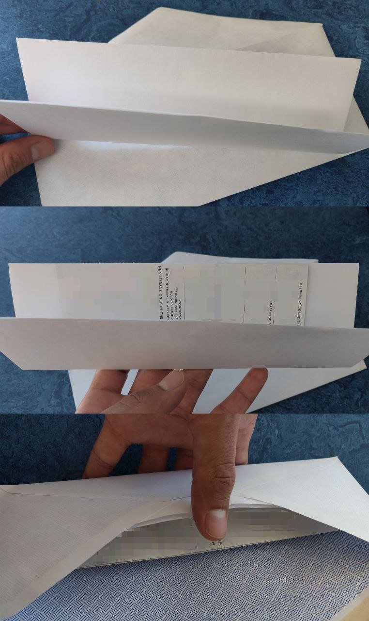Figure 2: Packaging the money order
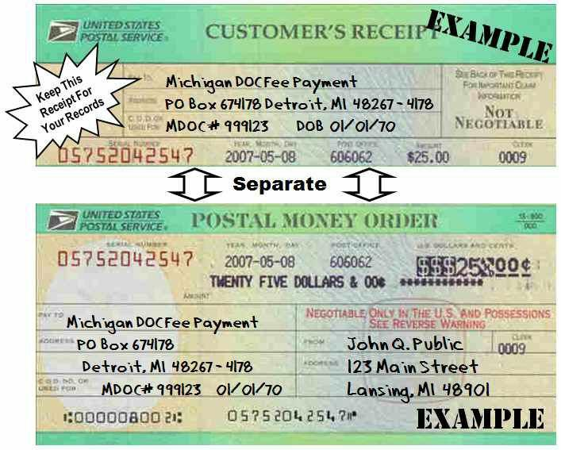Figure 3: US Postal Money Order
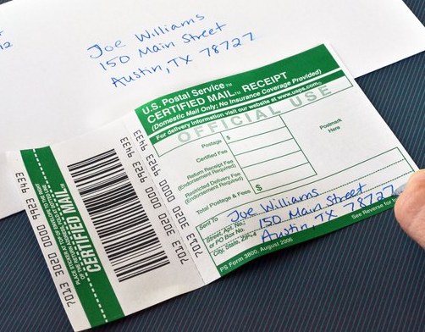Figure 1: Certified Mailing Receipt

Donate
If this article was useful for acquiring non-KYC Bitcoin or Monero, please consider a donation by visiting:
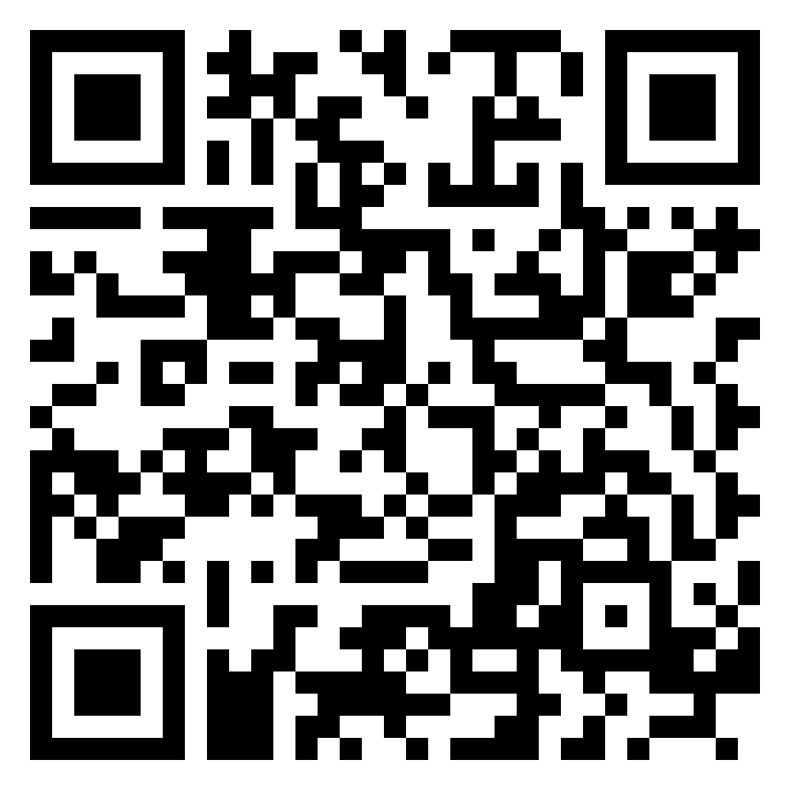
https://btcpayjungle.com/apps/2NqQwXoB5ejGPqtHTefrsoE2oeyH/pos

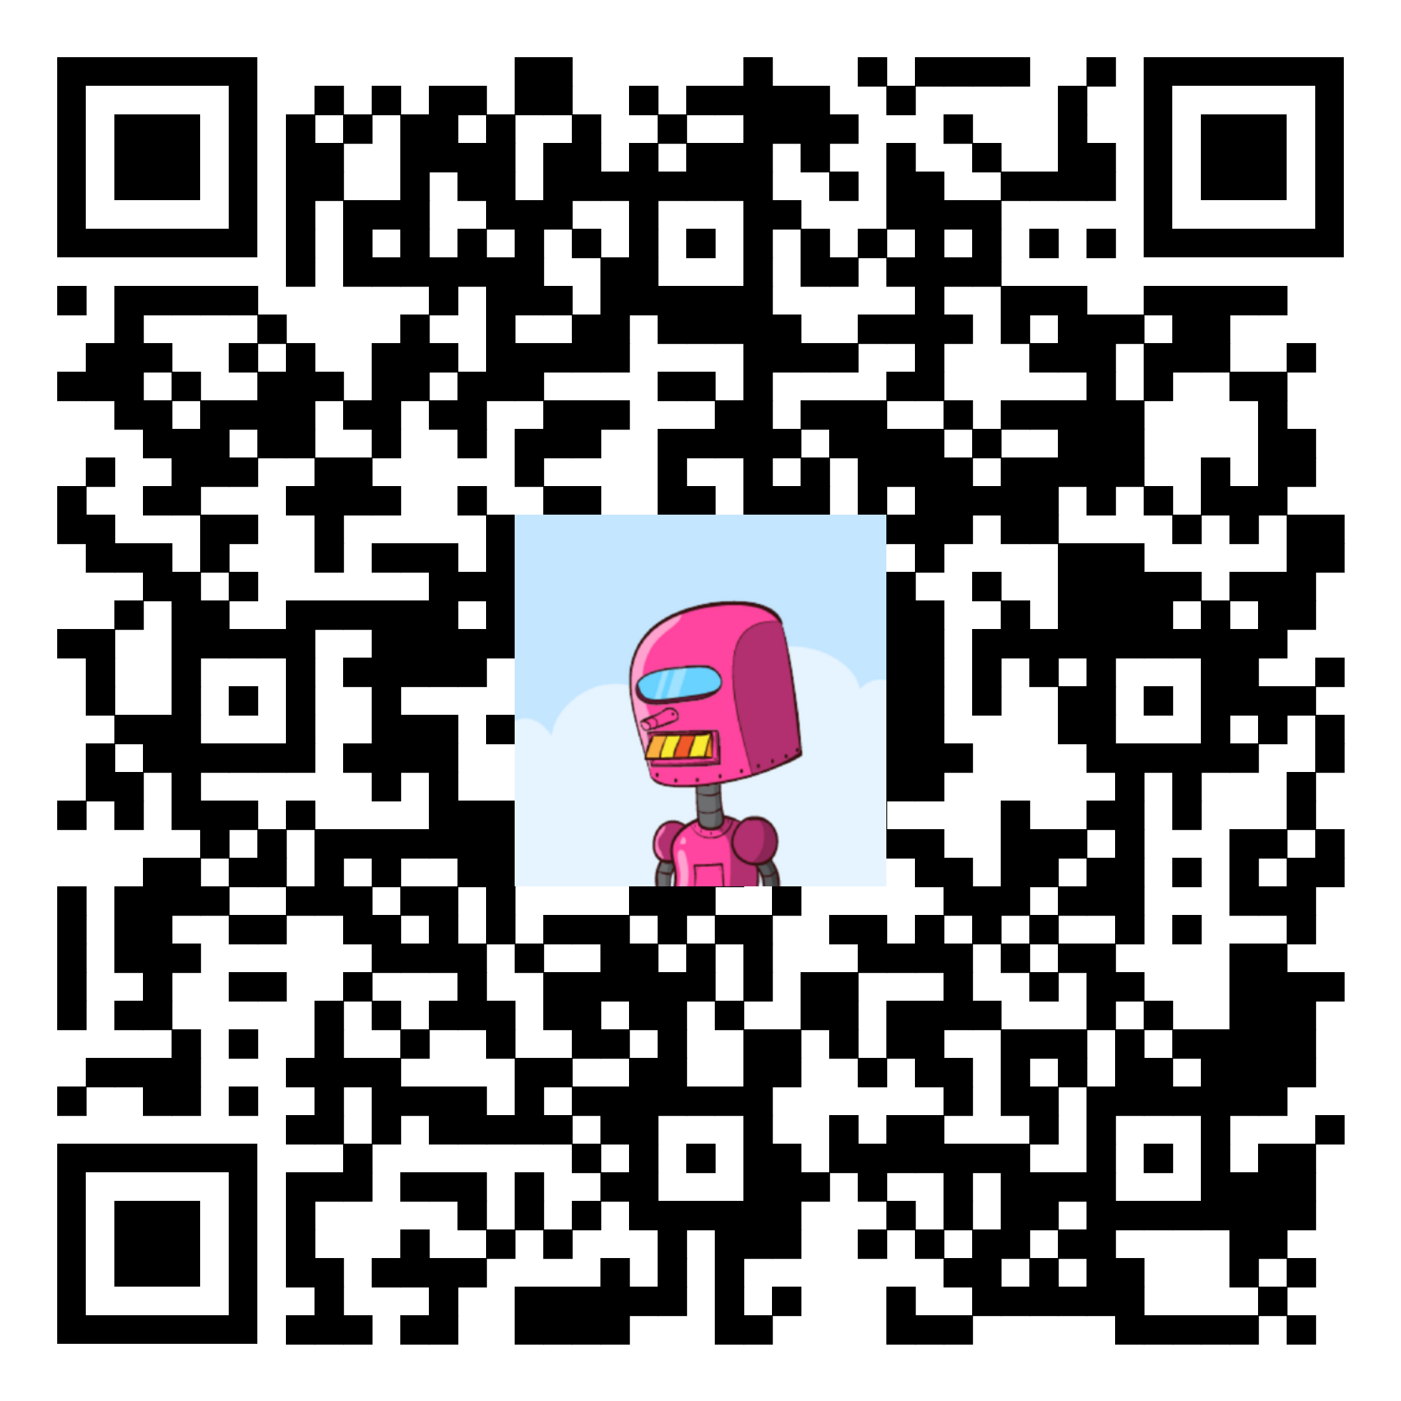
Or connect via PayNym and donate:

+whitefirefly714

PM8TJeDuf5J3Xs16WxcHyMKDGas7fUjjJw49Vx1Vj9kFKURXwDBmDx78dUB9aQpvYQ8qrazSnPA4EkWNB8QLfN3X1s1qdUyuudSgKK1j2YR5ezxHPpPb

Or donate Monero (XMR):

8BCn19ApVcdMWYyNs3Xb1F8aWTcq79KSmhFSGEqcJQW85cT12pJYbr6bCrMmhqvTxNWWy7CLgKvegAKNVPd1AWXD2yH6TwJ
