How to create a throw away email address

by

Heady Wook

Published: 2020.09.07

Updated: 2021.12.16


🄯 2022 Heady Wook

This work is licensed under CC BY 4.0. To view a copy of this license, visit http://creativecommons.org/licenses/by/4.0/
Introduction
This article is a prerequisite piece for a series of articles on non-KYC Bitcoin. It covers how to use https://cock.li/, https://protonmail.com/, and https://tutanota.com/ to create a throw away email address using random characters. In the original version of this article the focus was on using cock.li because they do not require email or SMS verification. However, cock.li has changed to an invite-only model. One must now contact a current cock.li user with available invites in order to create a cock.li email. Cock.li is ideal compared to the other services covered in this article because cock.li is absolutely no-KYC. Protonmail and Tutanota may prompt for some sort of information, such as SMS phone number or email verification, or may come with a time-delay limit before sending and receiving emails is allowed. In any case, by using a throw away email, a user can protect their personally identifying information when utilizing services across any platform. This comes in handy when acquiring non-KYC Bitcoin. This article provides a few examples on how a throw away email can be utilized, it discusses the use of Tor browser or a VPN, randomizing usernames and password strings, registering and accessing the respective throw away email addresses, and mentions a couple alternative throw away email services.

Use case examples
Example 1: Bob wants to create a Telegram account but does not want his phone number associated with it. He can create a throw away email address to register an account with https://textverfied.com/, a platform that will allow him to bypass using his real phone number on Telegram. Once Bob has created his throw away email and registered on Text Verified, he can proceed to create an account on Telegram as a pseudonymous user using a phony number.
Example 2: Alice created her Twitter account last year for networking at her new job. Recently, she has been posting some things that some of her colleagues do not agree with and it has caused some conflicts with her peers. Alice wants to maintain her networking account but also wants to be able to express her thoughts without upsetting her colleagues. Alice can create a throw away email to register a new pseudonymous account on Twitter. Now she can maintain her networking handle as strictly business and possess an alternative handle not associated with her work, with which she can express her personal thoughts.
Example 3: A live music festival is being streamed only on Twitch, but to watch it Jane needs to register on the platform. She has never needed a Twitch account before and never thought she would. Jane does not want to give up her real email to yet another third party, so she creates a throw away email. She registers it on Twitch and enjoys the show.

Tor and VPN
To get started, the best practice is to create a throw away email through Tor browser or over a VPN. By using Tor or a VPN, one can obfuscate their IP address, which enhances online privacy. Download Tor or Mullvad VPN. Once downloaded, open Tor browser or Mullvad VPN and connect. Next, visit the favored throw away email service, either over Tor or via a browser with the VPN activated. Once at the given email service website, register or sign up for an email address using the steps below. It is strongly recommended to randomize the username and password when signing up for a throw away email. Leave the current tab open for now. If anything during this process does not work due to some query issue (most likely via Tor browser), then close the browser and try again. Repeat this until there is no issue.

Randomizing email and password strings
In a new tab, visit https://www.random.org/strings/ and generate a random set of strings. By using random characters, one can avoid injecting personal biases into the username or password. On random.org, generate two random strings, each ten characters long. The length is arbitrary, however, some accounts have a minimum username or password length requirement, such as at least seven characters. Ten will do in most cases. Select “Numeric digits” and “Lowercase letters.” Avoid selecting “Uppercase letters” because it may cause some confusion when similar looking letters are generated in the same string, such as “I” and “l” or “0” and “O.” Select the option, “Each string should be unique” and then “Get Strings.” Random.org will produce the two random strings, such as:

k9aqrfvd22
mq0n38lorr

These are the strings that will be used to sign up for the throw away email address. Leave this tab open.

General tips
After creating a throw away email address, the user can utilize the email for whatever they want. For example, they can create an account on a given platform, use it once, and throw it away. Or they can save the login information to continue accessing the given account until they decide to throw it away. Either way, avoid using personal information, such as name, when creating an account on a third party platform to maintain anonymity. Also, use the randomly generated password for the platform account too. If the user will be saving the throw away email address for later access, it is recommended to copy and paste the username and password into a .txt file or to write it down on paper. The user should also leave themselves notes so they can remember what the throw away email was used for, like so:

Twitter account 2020.09.06
k9aqrfvd22@cock.li
mq0n38lorr

Remember, if the user does not save their login info, they will no longer have access to the email account.

Cock.li
Again, cock.li is ideal given they require no KYC information at all and have no time delays on sending or receiving emails. However, it may be difficult to find an invitation to register an email address. Despite this challenge, it is still covered in this article.
With the two randomly generated strings (i.e., username and password), go back to the cock.li registration tab. Copy and paste the username and password in their respective fields, enter the captcha, agree to terms and service, and register.
Congratulations to the user following this guide! They should now be the proud owner of a cock.li throw away email address.
To log back in on Tor, go back to the home https://cock.li/ page and scroll down to “Hidden Services.” Select the “webmail” .onion link to get to the login screen. At the login screen, enter the username and password which were just created. Remember to include “@cock.li” at the end of the username when logging in (i.e., k9aqrfvd22@cock.li). On an alternative browser over VPN, select the “Webmail” tab on the home screen to access the login screen.

Protonmail
Over Tor or in an alternative browser over a VPN, visit the protonmail.com webpage and select “sign up,” which is located in the menu at the top of the page. Select the “free plan” and, with the two randomly generated strings (i.e., username and password), copy and paste the username and password in their respective fields. Next, the user will be prompted to add a recovery method. This can be skipped. Again, select the “free” plan and then the user may be prompted to enter an existing email address or a phone number for SMS verification. If not, great; continue with creating the account. If so, then it is recommended that the user not associate this throw away email with any existing emails or phone numbers. Instead, the user can try a few things.
See the “Alternative throw away email services” section below and try providing an email with https://www.guerrillamail.com/ or https://www.throwawaymail.com/en to bypass the one-time verification. Sometimes Protonmail will not accept one or the other of these alternative email methods. Try both. If both do not work, then the user can try providing a bogus phone number via https://quackr.io/, a free SMS verification code bypass service. If the email did work, then check the respective alternative email and wait for the verification code to arrive. Once the user has the code, copy and paste it into Protonmail’s verification field and continue with creating the account.
Quackr.io has United Kingdom, United States, Australian, German, and Canadian phone numbers available, to name a few. Select a phone number and copy and paste it into Protonmail’s verification field. Protonmail may also reject these phone numbers. If this occurs and the alternative emails also fail, the user can try changing their VPN location, restarting the Tor browser, or signing up using the wifi at a local coffee shop without Tor or a VPN. If the phone number is accepted, then check quackr.io and wait for the verification code to arrive. Once the user has the code, copy and paste it into Protonmail’s verification field and continue with creating the account. If the email or SMS verifications never arrive, then troubleshoot as discussed earlier in this paragraph.
Congratulations! By now, the user following this guide should be the proud owner of a Protonmail throw away email address.
To log back in, go to Protonmail’s home page, select the menu at the top, and select “log in.”

Tutanota
Over Tor or in an alternative browser over a VPN, visit the tutanota.com webpage and select “sign up.” A new tab will open. Select the “free” version and agree to the terms. With the two randomly generated strings (i.e., username and password), copy and paste the username and password in their respective fields, agree to terms, select “next,” and then pass the captcha. The user will then be prompted to save a recovery code. This is optional if this email will be used for the mid- to long-term. Otherwise, it can be ignored if the email address will be disposed of sooner than later. Select “ok” to return to the login screen. Type in or paste the password to login.
Congratulations to the user following this guide! They should now be the proud owner of a tutanota throw away email address.
To log back in, go to Tutanota’s home page and select the login button at the top of the screen.
It should be noted that tutanota is pretty good about not asking for KYC information. However, this comes with a trade off. The user will not be able to send or receive emails for 48 hours after creation. Tutanota states that this time delay is necessary to “offer a privacy-friendly registration and prevent mass registrations at the same time.”

Alternative throw away email services
There are alternative services that can be used as a throw away email, such as https://www.guerrillamail.com/ and https://www.throwawaymail.com/en. However, one cannot rely on being able to access the same email at a later time or that it will be accepted by the given platform. The trade off here is convenience; it’s easy but not reliable. These are useful for quick throw away emails. If the platform does not accept these, then create a throw away email with the email providers mentioned above.

Conclusion
This article discussed how to create a throw away email using https://cock.li/, https://protonmail.com/, and https://tutanota.com/, along with the best practices. It also covered general tips and alternative throw away email providers. By using throw away emails, users can protect their personally identifying information from third parties. They can use the throw away email once and dispose of it or they can save it until no longer needed. Learning how to create a throw away email is a prerequisite skill for acquiring non-KYC Bitcoin, which is discussed further in other articles. The method described here, can be used to create as many throw away emails as needed, bitcoin related or not.

Donate
If this article was useful for acquiring non-KYC Bitcoin or Monero, please consider a donation by visiting:

https://btcpayjungle.com/apps/2NqQwXoB5ejGPqtHTefrsoE2oeyH/pos

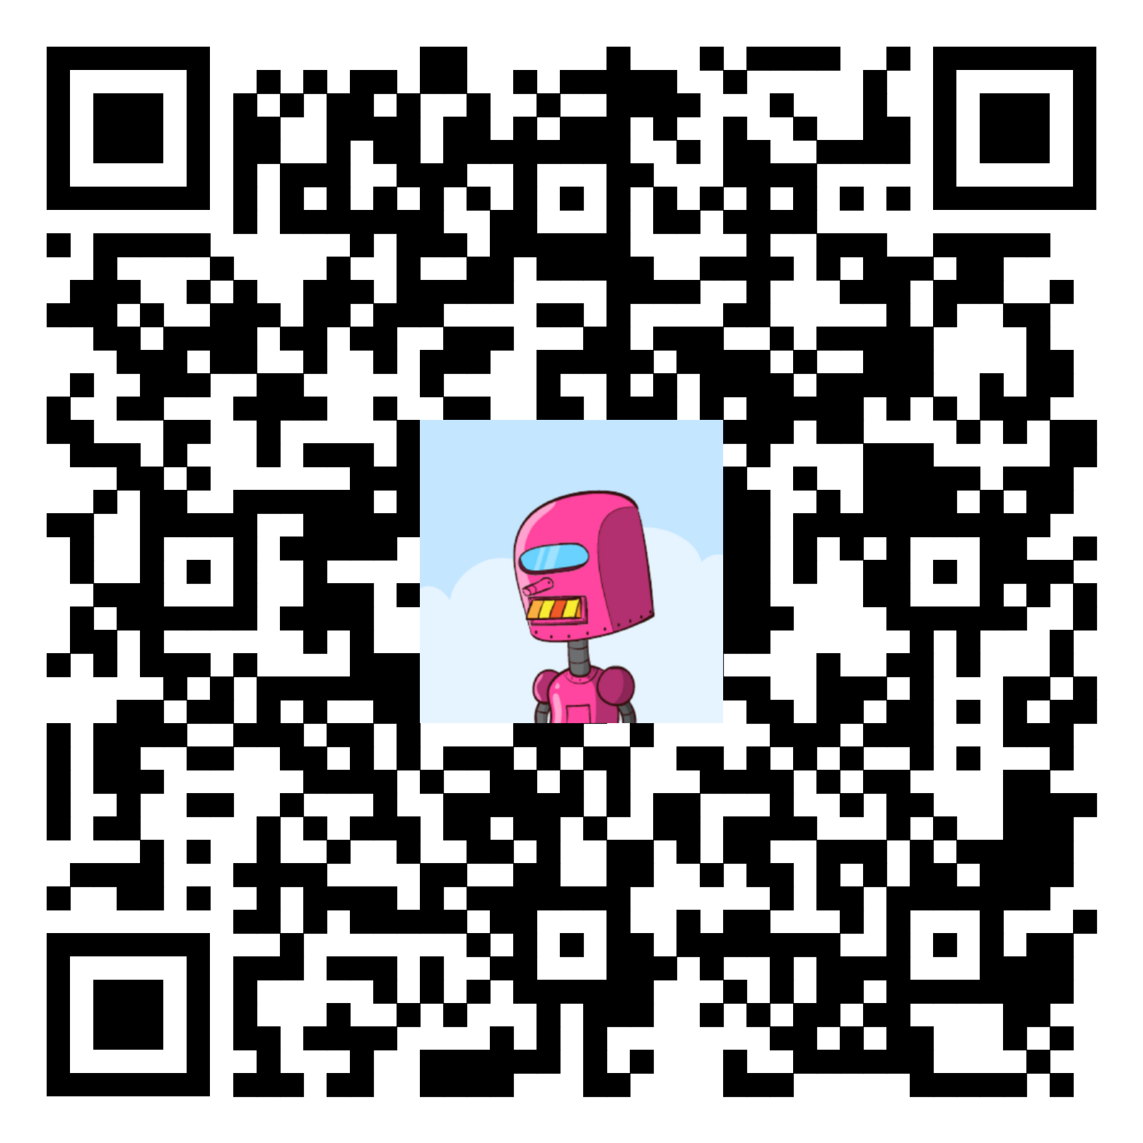
Or connect via PayNym and donate:

+whitefirefly714

PM8TJeDuf5J3Xs16WxcHyMKDGas7fUjjJw49Vx1Vj9kFKURXwDBmDx78dUB9aQpvYQ8qrazSnPA4EkWNB8QLfN3X1s1qdUyuudSgKK1j2YR5ezxHPpPb

Or donate Monero (XMR):

8BCn19ApVcdMWYyNs3Xb1F8aWTcq79KSmhFSGEqcJQW85cT12pJYbr6bCrMmhqvTxNWWy7CLgKvegAKNVPd1AWXD2yH6TwJ


