How to buy non-KYC Monero

by

Heady Wook

16 March 2022


🄯 2022 Heady Wook

This work is licensed under CC BY 4.0. To view a copy of this license, visit http://creativecommons.org/licenses/by/4.0/

Table of contents

Page 4 Introduction
Part 1
Selecting a Bitcoin ATM
Page 5 Registering an account on Text Verified
Adding credits on Text Verified
Paying with bitcoin
Paying with a prepaid debit card
Page 6 Preparation before buying from a Bitcoin ATM
Page 8 Buying from a Bitcoin ATM
Pushing the limits
Page 9 Part 2
Download a monero wallet
Bisq
Page 10 Taking a monero buy offer
Page 12 Making a monero buy offer
Page 14 Conclusion

Introduction
This article uses the method described in How to use Text Verified to buy non-KYC bitcoin at a Bitcoin ATM (Wook 2022) and builds on it by describing how to use bitcoin to buy non-KYC monero through Bisq. It will briefly reiterate some of the methods discussed in the article mentioned above, such as registering a Text Verified account and funding it with a prepaid debit card (Part 1), and describe the process for downloading a monero wallet and setting up a monero account on Bisq, including how to take offers and make offers (Part 2). Essentially, the user will use Text Verified to bypass SMS verification to buy non-KYC bitcoin at a Bitcoin ATM which could then be used to buy non-KYC monero through Bisq. Those already familiar with the methods discussed in the article cited above might skip to Part 2. By the end of this article, a user should be able to acquire monero without providing any personally identifying information.

Part 1

Selecting a Bitcoin ATM
Through user reports, it has been found that CoinFlip and RockItCoin Bitcoin ATMs (BATM) work with Text Verified to bypass SMS verification. However, users are encouraged to search for a local BATM and check the “limits and verifications” section through https://coinatmradar.com/. For example, one RockItCoin BATM currently lists “$0 - 750 SMS verification and pin” and a CoinFlip BATM lists “$20 - 900 SMS verification & Name Entry.” Any limits similar to those just mentioned (i.e., SMS verification/name) are worth a try with Text Verified.

Registering an account on Text Verified
Text Verified will be required in order to bypass the SMS verification at the BATM. Over Tor or VPN, register an account on Text Verified at https://www.textverified.com/Account/Register/ using a throw away email address from Guerrilla Mail at https://www.guerrillamail.com/. Save this email address and the password used during registration for later access to the Text Verified account. Avoid using personally identifying information when registering the account. For example, in the first and last name fields enter “n/a.” Text Verified will send a confirmation email to Guerrilla Mail. Once this is verified, the account is ready to be funded with credits.

Adding credits on Text Verified
If the user already owns some bitcoin, they will be able to fund the account with it. Ideally, the user should use a UTXO that is not tied to their identity via KYC records or use a coinjoined UTXO. If the user does not own bitcoin, they have a couple options: They can have a friend lend it to them or they can buy a prepaid debit card with cash to fund the Text Verified account.
Paying with bitcoin. To fund the Text Verified account, select the yellow “¢” symbol located in the menu and select “buy with crypto.” Then use the toggle to determine how many credits to purchase. Once the number of credits to be purchased has been determined, select bitcoin as the payment option and continue. Next, the user will be presented with a bitcoin payment address and QR code. Send the payment to the address provided within the allotted time frame (i.e., 15 minutes). After a few on-chain conformations, the credits will be available to spend.
Paying with a prepaid debit card. The first step in using a prepaid debit card is to buy one with cash. Bring extra cash to cover any fees and taxes. Go to a local grocery store and locate the prepaid debit cards. Some may have a minimum purchase, such as $25. This minimum is more than enough to get started. It is also important to verify that the given card can be used for online purchases by reading the fine print on the card. Typically, before the card is able to be used online, it will have to be “registered.”
To do this, follow the directions on the card but do not provide personally identifying information, such as name, address, zip code, phone number, or email. Instead use a semi-real psudo-name (i.e., avoid names such as “John Doe”), use the address, zip code, and phone number of the grocery store the card was purchased from or another local address, and use a throw away email to complete the registration. Make a note of the information provided because it will be needed when making an online purchase for Text Verified credits.
To fund the Text Verified account, select the yellow “¢” symbol located in the menu. Select “buy with USD” and pick the menu option which will max out the funds on the card. Continue on with the prompts and fill in the information (i.e., name and address) that was used when the prepaid card was first “registered.” Once the transaction goes through, the user will have the credits right away.
In either case, whether paying with bitcoin or a prepaid card, once all the credits are used up on Text Verified, it is best to throw away the account and create and fund a new one from scratch. This way account reuse is avoided.

Preparation before buying from a Bitcoin ATM
Given the times, it may be appropriate to wear a face mask as an increased measure of privacy when going to the ATM. Sunglasses help too.
Lower denominations of bills, such as $1 bills, may not be accepted. Therefore, come prepared with bigger bills, such as $20s.
The user will also need a bitcoin wallet downloaded on a mobile device or a pregenerated bitcoin address ready to scan. The author suggests Samourai Wallet for Android: https://samouraiwallet.com/download. While there are bitcoin wallets for iOS, the user will have to independently research the wallets. Remember to use due diligence. Next, secure the seed phrase. Finally, get familiar with the app’s functionality, such as producing a receive address. To do this in Samourai Wallet, login in with a pin, select the “+” on the bottom-right corner, and select “Receive” to generate a bitcoin address, along with a QR code. Every bitcoin address generated on Samourai Wallet will be different to prevent address reuse. This QR code is what will be scanned by the BATM.
Before walking up to the BATM, have Text Verified loaded up on a mobile device (i.e., ideally over Tor or VPN) and have the receiving bitcoin address ready on a wallet of choice. On Text Verified, navigate to the menu and select “Verifications” and then “Text & Sms.” Then search and select the given BATM from the list. In this case, it would be CoinFlip or “service not listed” for RockItCoin. The user may be prompted by a pop-up message reading “Using A Proxy? Outside of the USA?” In this case, check the box “do not show again” and select “continue.”
After selecting the given BATM, the user will be directed to the “Short-term SMS/Text verification” page which lists a temporary phone number. Use that phone number at the BATM within the allotted window of time. If the time runs out or the user decides to cancel the verification, the credits will not be used. The credits are only used after a verification is made. Once the timer starts, the user is ready for the BATM. They should have plenty of time to perform the transaction.

Buying from a Bitcoin ATM
At the BATM, select the bitcoin icon and enter a phony but semi-real name, if required. Overtly fake names like “John Doe” will not work. These types of names may trigger a forced KYC, so avoid them. After entering a name, type in the phone number provided by Text Verified. Check the Text Verified tab on the mobile device for a confirmation code from the BATM. Type the confirmation code into the BATM. Next, scan the bitcoin QR code and deposit the cash.
Before the transaction is finalized, the BATM will prompt for an email address for a receipt. This is optional. If a receipt is desired, then enter the throw away email address that was created earlier. Otherwise, ignore it and walk out. Within a few minutes, the incoming transaction will be seen in the bitcoin wallet and, if requested, the email receipt will be received too.

Pushing the limits
According to user feedback and first-hand experience, a user can make multiple purchases in one sitting using the upper limit of $900 per transaction. A new phone number will be generated for each transaction. Just repeat the process described above.
One user reported putting 3-5 transactions per sitting, per day at the upper limit until they fed $50,000 through the BATM. It took them about 2 weeks with 50 credits to buy $50,000 in non-KYC bitcoin.

Part 2

Download a monero wallet
At this point the user will need to download a monero wallet if they have not done so already. The author suggests Monerujo for Android (https://www.monerujo.io/#download) and, while there are monero wallets for iOS, the user will have to independently research the wallets. Remember to use due diligence. Next, secure the seed phrase. Finally, get familiar with the app’s functionality and learn to create sub-addresses. To do this in Monerujo, unlock the wallet, select the three-button menu icon located in the top-right corner, select “Subaddressess,” and select the “+” sign located at the bottom-right. One of these subaddresses will be used in a Bisq payment account.

Bisq
After downloading Bisq and securing the seed phrase, the user will need to create a new altcoin payment account under the “Account” tab. From there select “Add new account” and scroll down to select “Monero (XMR).”
The user can optionally select “Trade instant.” For instant trading, it is required that both trading peers are online to be able to complete the trade in less than 1 hour. The user can create one account of each; one with instant trade and one without, if they wish. Switching between trading accounts is discussed in the section below called “Making a buy offer.” However, this guide discusses the process without instant trade.
Next, in the “Monero address” field, the user will need to enter a monero receive address generated from the wallet discussed above. Finally, save the account, read the informational pop-up, and select “I understand.” The trade limits placed on this payment method are “Max. trade duration: 1 day / Max. trade limit: 2.00 BTC.” After creating this payment account, the user will be able to take offers or make offers to buy monero.
Taking a monero buy offer. To take an existing offer to buy monero on Bisq, go to the “Sell BTC” tab and change the “filter by currency” to “XMR Monero.” The user should then be able to see current offers to buy monero. If not already selected, turn on “Offers matching my accounts” to filter out irrelevant payment offers. Make sure to have enough bitcoin to cover the buy amount, the security deposit, trade fees, and miner fees. Offers with zero percent premium are at market price, negative values are below market price, and positive values are above market value.
Once the user has identified an offer they want to take (i.e., price premium and amount), select “take offer to buy XMR.” Review the conditions of the trade, enter the amount of BTC to sell if a buy range exists, and select “Next step.” On the following page, the transaction details are presented for review. A bitcoin address and QR code should be provided. The trade must be funded with bitcoin held in the present Bisq wallet or from an external wallet.
At this point the user will likely hold the bitcoin that was purchased from the BATM on a bitcoin wallet (i.e., external wallet). In this case, the user will need to access that wallet and fund the trade by scanning the QR code provided by Bisq with the wallet holding the bitcoin. To do this in Samourai Wallet, log in with a pin, select the square-shaped icon on the top-left corner, and scan the QR code provided on Bisq. Then, verify the address scanned by Samourai Wallet matches the address provided by Bisq and that the correct amount of bitcoin is being sent to fund the trade. Next, select “Review transaction” and set the desired transaction priority by sliding the green toggle right or left. A “low” to “normal” miner fee rate should be acceptable for this transaction.
After the trade is funded, a message will pop up indicating the trade was successfully funded. The user will then be able to review the order one last time before agreeing to the trade conditions by selecting “Review: Take offer to sell bitcoin.”
After doing so, a window opens displaying the offer, details, and contract terms. Review this one last time for accuracy and then select “Confirm: Take offer to sell bitcoin” to finalize the trade. A message reading “You have successfully taken an offer” will appear. Next, select “Go to ‘Portfolio/Open trades.’”
Now that the trade has been initiated, there must be sufficient blockchain confirmations before the trade process can proceed. The trade process includes: 1. Wait for blockchain confirmation, 2. Wait until payment has started, 3. Confirm payment received, and 4. Completed. All these stages must be completed within one (1) day. After the first block confirmation the trade period starts. If the trade period is exceeded, both traders can open a dispute. This is unlikely given that the trade partner is actively running their Bisq instance given that the trade was online. Be sure to periodically check back on Bisq before the trade period is over.
After at least one blockchain confirmation, the user will “need to wait until the BTC buyer starts the XMR payment.” After the trade peer sends the monero to the address provided when the payment account was first created, they will confirm they have started the payment. Once the trade peer confirms this, the user will receive a notification that the “BTC buyer has started the payment.” Next, the user will need to confirm they in fact received the monero in their wallet. If the funds are present in the wallet, then on Bisq select “Confirm payment receipt.” Finally, the trade is complete.
Making a monero buy offer. To make an offer to buy monero on Bisq, go to the “Sell BTC” tab, change the “filter by currency” to “XMR Monero,” and select “Create new offer to buy XMR (sell BTC).” Next, enter the amount in bitcoin to sell and the percent premium. Zero percent premium is at market price, negative values are above market price, and positive values are below market value.
Depending on the sell amount, the user may or may not get access to the “Advanced options.” If enabled, the user can decide on both traders’ security deposit (i.e., collateral). It will automatically populate as 34.98% but anything between 15% and 50% is typical for a security deposit. For example, if the sell amount is 0.01 BTC with a 15% security deposit, then the collateral each peer puts up is 0.0015 BTC. If not enabled, the security deposit will automatically be 0.001 BTC. All security deposits are returned at the end of the trade process.
Once the trade parameters are set, select “Next step.” Now the offer will need to be funded. One can do this with funds already held on Bisq (i.e., “Transfer funds from Bisq wallet”) or from an external wallet via the bitcoin address found under “Trade wallet address,” also presented as a QR code.
At this point the user will likely hold the bitcoin that was purchased from the BATM on a bitcoin wallet (i.e., external wallet). In this case, the user will need to access that wallet and fund the trade by scanning the QR code provided by Bisq with the wallet holding the bitcoin. To do this in Samourai Wallet, log in with a pin, select the square-shaped icon on the top-left corner, and scan the QR code provided on Bisq. Then, verify the address scanned by Samourai Wallet matches the address provided by Bisq and that the correct amount of bitcoin is being sent to fund the trade. Next, select “Review transaction” and set the desired transaction priority by sliding the green toggle right or left. A “low” to “normal” miner fee rate should be acceptable for this transaction.
After funding the trade, a notification will pop-up indicating success. Then, the user can review the order before finalizing it by selecting “Review: Place offer to sell bitcoin.”
After doing so, a window opens displaying the offer, details, and commitment terms. Review this one last time for accuracy and then select “Confirm: Place offer to sell bitcoin” to finalize the offer. A message reading “You have successfully placed an offer” will appear.
Next, select “Go to ‘Portfolio/Open trades’” to view the offer under the “My open offers” tab. The user can also see the offer live under the “Buy BTC tab.” This is where individuals looking to sell monero will see the offer. From either of these tabs a user can edit certain details, such as the trading account (i.e., this allows the user to switch between instant trade accounts and regular trade accounts) and the percent premium.
From here the buy offer is live on Bisq and ready to be taken by a monero seller. The offer will be live on Bisq as long as the app is open. Once the user closes the Bisq app, the offer will not be seen by sellers. Upon starting the Bisq app, the offer will again be live. To get an offer taken sooner than later, the user should run Bisq for at least a few hours a day, overnight, or a few days out of the week until the offer is taken. Make sure to periodically check in on the offer. Based on the author’s experience, a buy offer is typically taken within a few days or within a couple weeks.
Once the offer is taken, the user will be notified. After at least one blockchain confirmation, the trade process can proceed. The trade process includes: 1. Wait for blockchain confirmation, 2. Wait until payment has started, 3. Confirm payment received, and 4. Completed. All these stages must be completed within one (1) day. After the first block confirmation the trade period starts. If the trade period is exceeded, both traders can open a dispute. This is unlikely given both peers should be online.
After at least one blockchain confirmation, the user will need to wait for the monero seller to start the payment. After the peer sends the monero to the address provided when the payment account was first created, they will confirm they started the payment. Once the trade peer has done so, the user will receive a notification that the “BTC buyer has started the payment.” Next, the user will need to confirm they in fact received the monero in their wallet. If the funds are present in the wallet, then on Bisq select “Confirm payment receipt.” Finally, the trade is complete.

Conclusion
This article discussed how to buy non-KYC monero using methods described in How to use Text Verified to buy non-KYC bitcoin at a Bitcoin ATM (Wook 2022), such as registering a Text Verified account and funding it with a prepaid debit card (Part 1). It also walked through the process for downloading a monero wallet and setting up a monero account on Bisq, including how to take offers and make offers (Part 2). A user following this guide should have been able to acquire non-KYC monero.

Works cited

Wook, Heady. “How to Use Text Verified to Buy Non-KYC Bitcoin at a Bitcoin ATM.” Internet Archive, 25 Jan. 2022, archive.org/details/how-to-use-text-verified-to-buy-non-kyc-bitcoin-at-a-bitcoin-atm.

Donate
If this article was useful for acquiring non-KYC Bitcoin or Monero, please consider a donation by visiting:
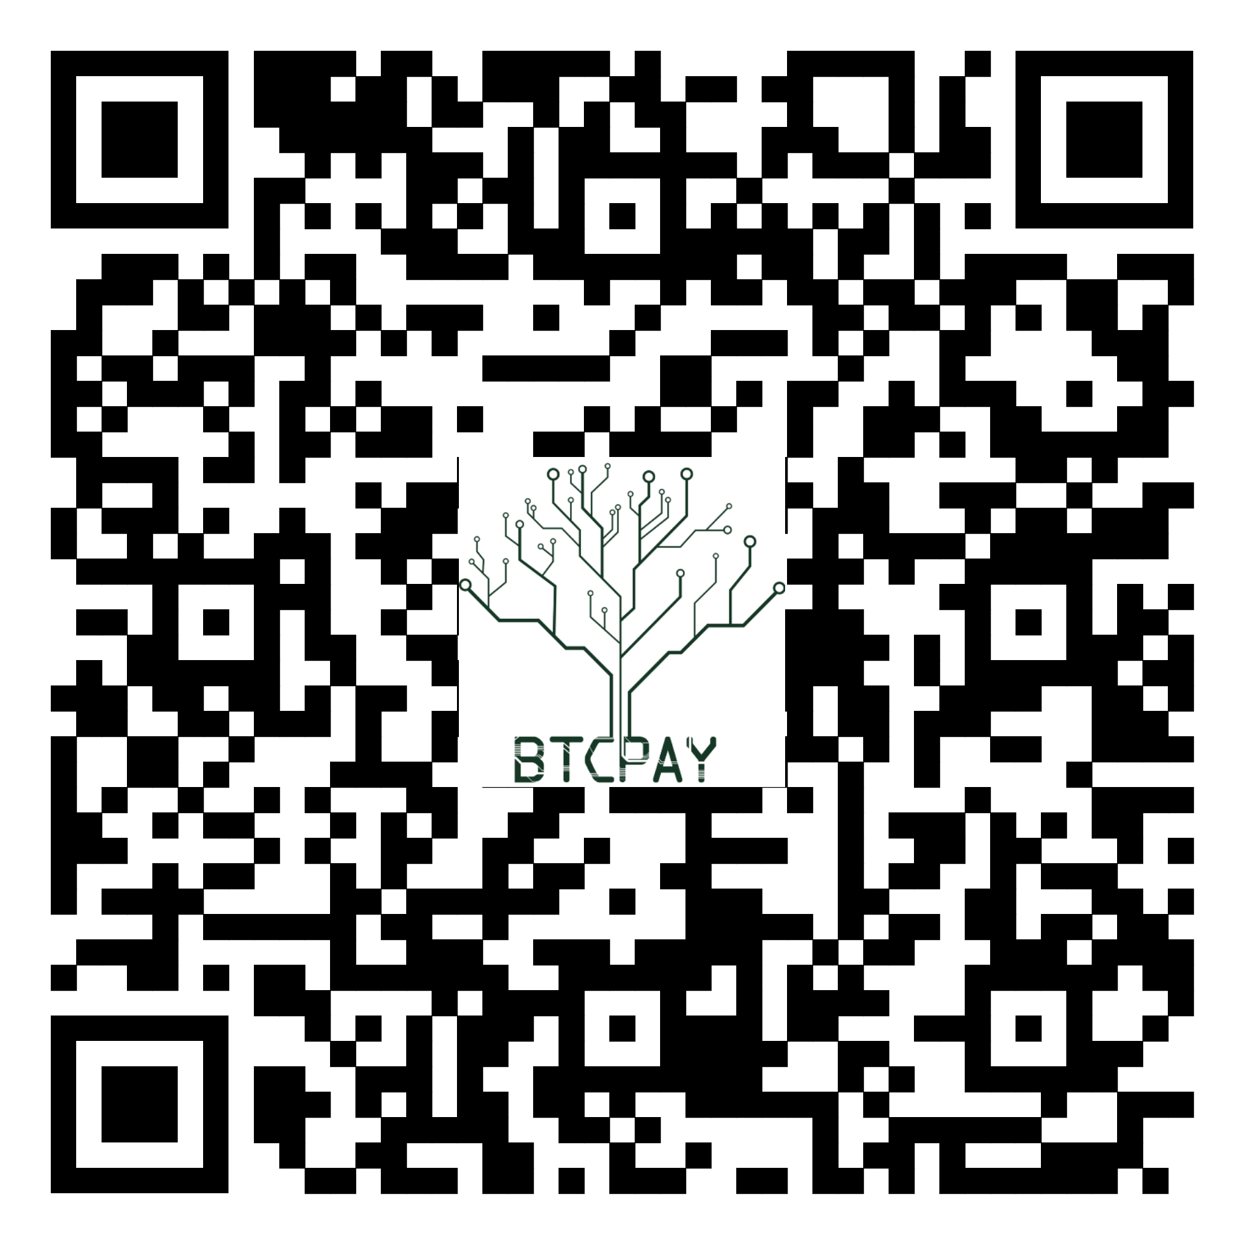
https://btcpayjungle.com/apps/2NqQwXoB5ejGPqtHTefrsoE2oeyH/pos

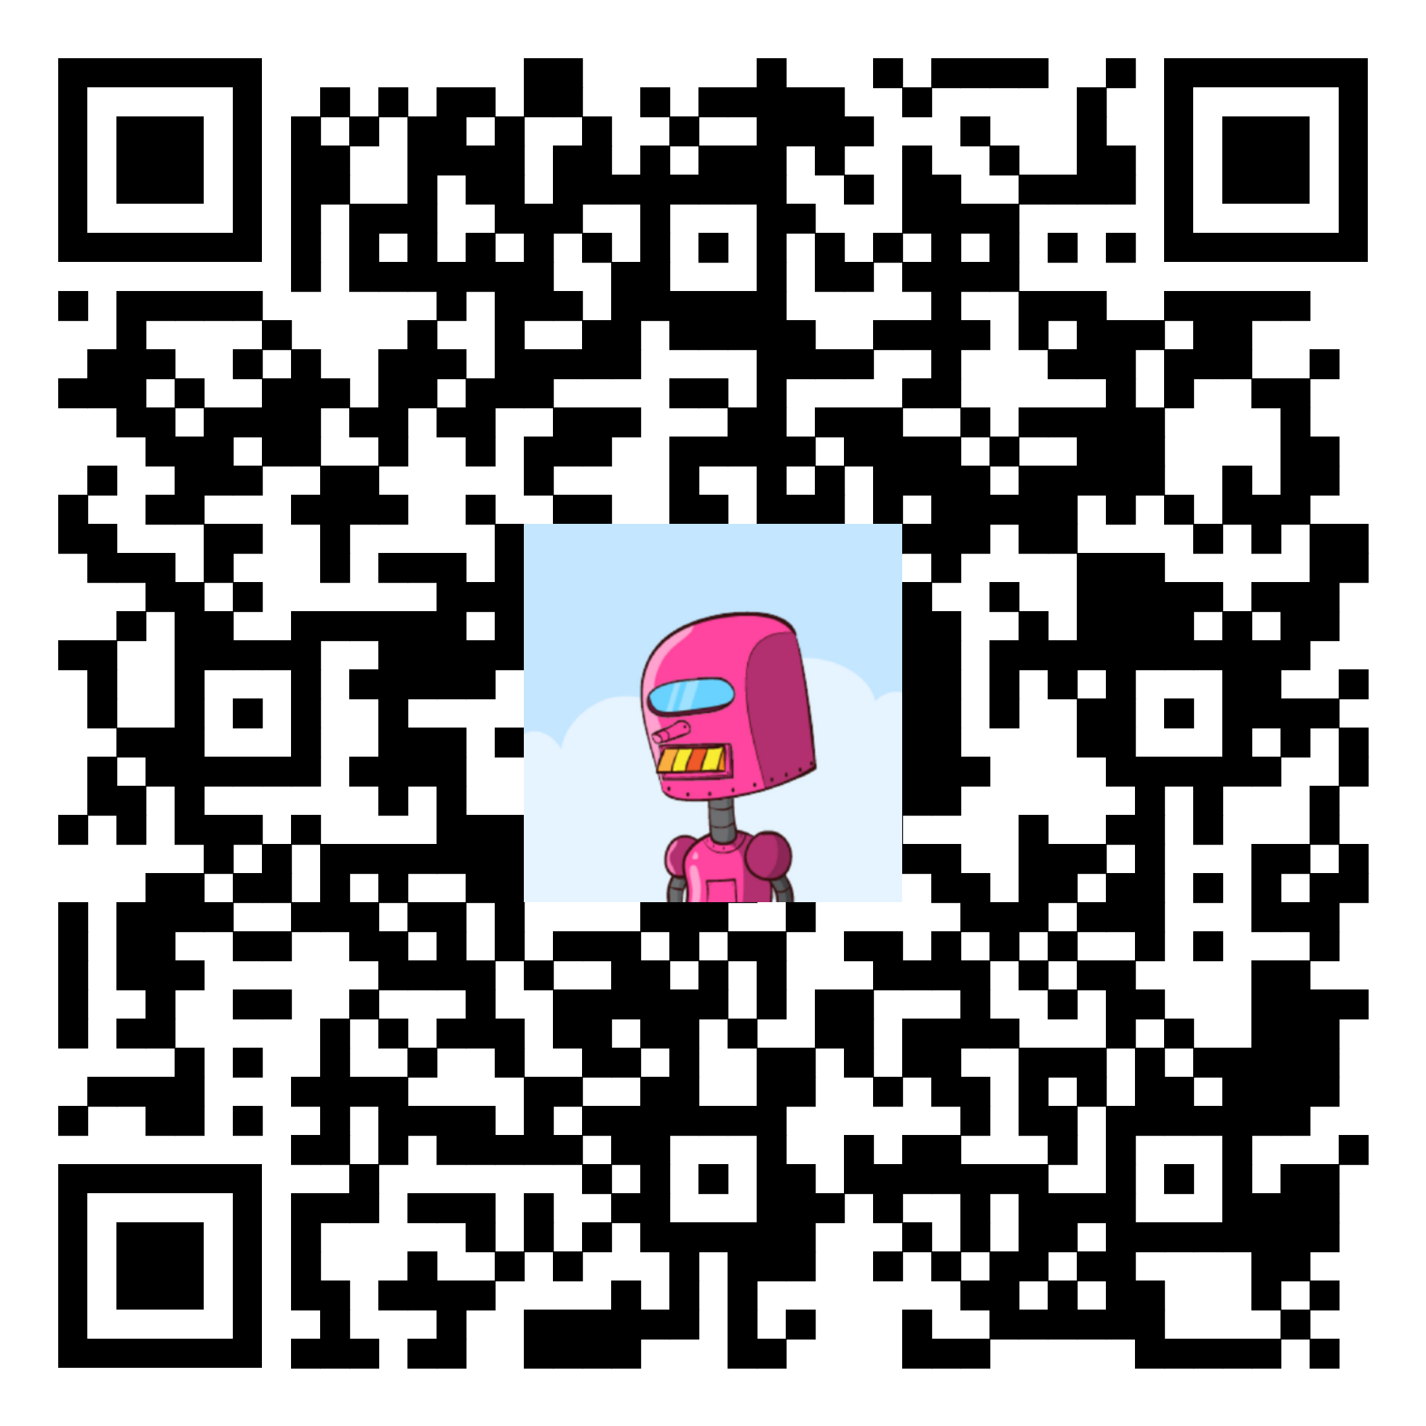
Or connect via PayNym and donate:

+whitefirefly714

PM8TJeDuf5J3Xs16WxcHyMKDGas7fUjjJw49Vx1Vj9kFKURXwDBmDx78dUB9aQpvYQ8qrazSnPA4EkWNB8QLfN3X1s1qdUyuudSgKK1j2YR5ezxHPpPb

Or donate Monero (XMR):

8BCn19ApVcdMWYyNs3Xb1F8aWTcq79KSmhFSGEqcJQW85cT12pJYbr6bCrMmhqvTxNWWy7CLgKvegAKNVPd1AWXD2yH6TwJ
