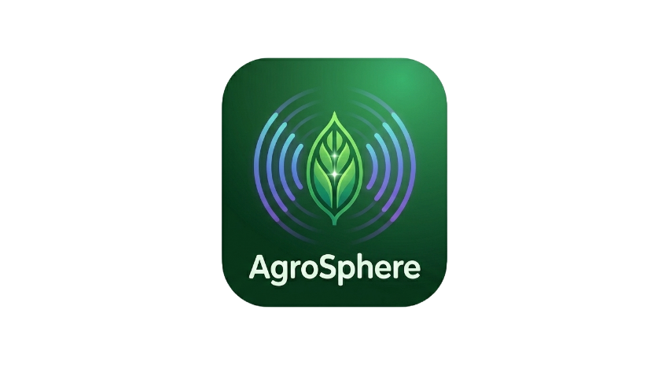
AgriSphere Smart
AI-Powered Digital Agronomist for Smallholder Farmers

HACKATHON PROJECT DOCUMENTATION
2026 | South Africa

"We are not replacing farmers — we are empowering them."
"This is not just an app. It's a digital agronomist in every pocket."

1. The Problem

Problem Statement
Millions of smallholder farmers in South Africa lack access to affordable agricultural expertise, causing preventable crop losses and unstable incomes.

The Farmer's Pain Points — Meet Thabo
Smallholder farmers like Thabo face these challenges every farming season:
- Lose up to 40% of crops due to late disease detection
- Use guesswork for watering and fertilizing
- Cannot afford agronomists — often located 50km away
- Face unstable income and food insecurity season after season

This happens every farming season and directly impacts millions of livelihoods across rural South Africa.

2. Our Solution — AgriSphere Smart

Simple Explanation
AgriSphere is a mobile platform that gives smallholder farmers the tools they need to farm smarter:
- Instant crop disease detection using AI
- A 24/7 farming assistant in their own language
- Real-time environmental data via IoT sensors
- Direct access to real agronomists when needed
- Automated robotic weeding powered by Machine Learning & Computer Vision

AgriSphere helps farmers make better decisions, faster — increasing yield and protecting livelihoods.

Unique Value Proposition (UVP)
AgriSphere is the only AI-powered farming assistant that delivers real-time crop diagnosis, personalized guidance, and expert support — even offline — for smallholder farmers.

3. How It Works

4-Step Farmer Journey
- Farmer takes a picture of their crop or asks a question via the mobile app
- AI analyzes the image and/or question to give instant, personalized recommendations
- Farmer receives specific guidance on watering, treatment, or fertilizing — in their language
- Optional: Connect directly to expert agronomists for additional human support when needed

Three Powerful Technology Layers
Our solution works in three integrated technology layers:

AI Vision | Detects crop diseases using the smartphone camera — early detection prevents crop loss
Smart Sensors (IoT) | Monitors soil moisture, temperature, humidity & pH in real time — no more guesswork
Predictive Intelligence | Uses AI to recommend actions and predict yields — farmers plan ahead and avoid losses

"Together, this gives farmers real-time, data-driven decisions without needing expensive experts."

4. Full Feature Breakdown

All Features at a Glance

Feature | How It Works | Value to Farmer
AI Disease Detection | Farmer takes a photo → AI detects disease instantly | Early detection prevents crop loss
IoT Smart Sensors | Measures soil moisture, temperature, humidity & pH in real time | No guesswork in watering or fertilizing
Location-Based Intel | Uses weather & regional data for localised advice | Advice specific to farmer's environment
Yield Prediction | AI models predict crop performance | Farmers can plan ahead & avoid losses
Robotic Weeding | Machine learning + computer vision automates weed extraction | Saves time & reduces labour costs
Multilingual AI Chat | 24/7 farming assistant in the farmer's own language | Breaks language barriers in rural areas

Spotlight: Robotic Weeding (New Feature)
AgriSphere Smart's newest innovation uses an automated robot to extract weeds from crops:
- Machine Learning — trains on crop vs. weed image data for accurate identification
- Computer Vision — real-time visual processing to detect weeds in the field
- Autonomous operation — robot physically removes weeds without manual labour
- Reduces labour costs and time spent on manual weeding

This feature makes AgriSphere Smart one of the first platforms to combine AI software with physical agricultural robotics for smallholder farmers in Africa.

5. Technical Architecture

Tech Stack Overview

Layer | Technology | Purpose
Mobile App | React Native (Expo) | Cross-platform iOS & Android
AI Backend | Python (Flask) + Google Gemini AI | Smart crop analysis & chatbot
IoT Sensors | ESP32 / ESP8266 | Real-time soil & environment monitoring
Database | Firebase (Firestore + Auth) | Real-time sync & user authentication
Robotic Weeding | Machine Learning + Computer Vision | Automated weed detection & extraction

Project Structure
Repository layout of the AgriSphere Smart codebase:
- IoT/ — IoT sensor firmware (ESP32/ESP8266)
- assets/Images/ — Application image assets & logo
- components/ — Reusable React Native components
- constants/ — Application-wide constants
- context/ — React Context providers for global state
- hooks/ — Custom React Native hooks
- models/ — Python Flask AI backend + Gemini integration
- screens/ — All mobile app screens
- services/ — API and service layer
- utils/ — Utility functions
- firebase.js — Firebase configuration
- App.js — Entry point

Getting Started (Developer Setup)
To run the project locally, follow these steps:
- Install dependencies: npm install
- Start the mobile app: npx expo start
- Navigate to models folder: cd models
- Install Python dependencies: pip install -r requirements.txt
- Start the AI backend: python app.py

6. Competitive Analysis

Alternatives in the Market
- Traditional agronomists — expensive & often located far from rural farmers
- Google / YouTube farming advice — generic, not personalized to the farmer's crop or location
- Basic farming apps — no AI capabilities, no offline support
- Farmers Agri-Care — professional consulting firm (detailed comparison below)

Head-to-Head: AgriSphere Smart vs. Farmers Agri-Care
Farmers Agri-Care is a professional farming consulting company that:
- Works mainly with commercial farmers
- Provides expert advice through human agronomists
- Uses data and research to improve yields
- Primarily operates in KwaZulu-Natal (KZN)

Feature | Farmers Agri-Care | AgriSphere Smart
Access | Physical / Consultants | Mobile App 📱
Cost | Expensive | Affordable (R49/month)
Availability | Limited hours | 24/7 AI Support
Target | Commercial farmers | Smallholder farmers
Location | Mostly KZN | Rural + anywhere in Africa
Internet | Required | Works OFFLINE ⚡
Speed | Slow consultations | Instant AI responses
Language | English/Afrikaans | Multilingual AI

"Unlike Farmers Agri-Care, which relies on physical agronomists and is primarily accessible to commercial farmers, AgriSphere Smart is designed for smallholder farmers — offering instant, affordable, and AI-powered farming support directly from a mobile device, even in low-connectivity areas."

Our Key Differentiators
- Works offline — massive advantage in rural, low-connectivity areas
- Multilingual AI assistant — supports farmers in their native language
- Combines AI + IoT + Human Experts + Robotics in a single platform
- Designed specifically for African smallholder farmers — not adapted from elsewhere
- Affordable pricing (R49/month) — accessible to low-income farmers

7. Market Opportunity & Validation

Target Customers
- Smallholder farmers in South Africa — millions of potential users
- Rural farming communities across sub-Saharan Africa
- Agricultural cooperatives and farming groups
- Government agriculture departments and NGOs

Market Validation
Research Backing | Studies show 15–30% yield increase when AI farming tools are adopted
Real-World Problem | Demonstrated through real farmer stories — as shown with Thabo's situation
Growing Market | African agri-tech market is rapidly expanding with smartphone penetration increasing

8. Revenue Model

Revenue Streams

Stream | Source | Price | Notes
Primary | Farmer Subscriptions | R49/month | Recurring, scalable income
Secondary | Agronomist Registration | R99 once-off | Expert network growth fee
Future | IoT Device Sales | TBD | Hardware revenue stream
Future | Data Insights | TBD | Analytics for agri-businesses
Future | Government & NGO Grants | TBD | Partnerships & funding

9. Growth Strategy

Expansion Plan
- Phase 1 — Penetrate South African smallholder farmer market
- Phase 2 — Expand to neighbouring southern African countries
- Phase 3 — Scale across sub-Saharan Africa and beyond

Strategic Partnerships
- Government agriculture programs and departments
- NGOs focused on food security and rural development
- Farming cooperatives and agricultural unions
- Agri-tech investors and accelerators

10. Hackathon Pitch Notes

Key Messages to Deliver
"We are not replacing farmers — we are empowering them."

"This is not just an app. It's a digital agronomist in every pocket."

Competitor Statement (Use This Word-for-Word)
"Unlike Farmers Agri-Care, which relies on physical agronomists and is primarily accessible to commercial farmers, AgriSphere Smart is designed for smallholder farmers — offering instant, affordable, and AI-powered farming support directly from a mobile device, even in low-connectivity areas."

Pitch Checklist
- Introduce the problem with a relatable farmer story (Thabo)
- Show the impact — 40% crop loss, inaccessible agronomists, food insecurity
- Demo the AI crop disease detection feature (most visual impact)
- Highlight offline functionality — critical differentiator for rural Africa
- Explain the 3 technology layers: AI Vision, IoT Sensors, Predictive Intelligence
- Introduce the Robotic Weeding feature as a bold, future-facing innovation
- Present the R49/month pricing vs. costly agronomist consultations
- Close with growth vision: from South Africa to all of Africa

AgriSphere Smart — A Digital Agronomist in Every Pocket
Empowering smallholder farmers across Africa with AI, IoT, and robotics.

