1、java曲线图统计

# 1、按照天数的曲线

## 1、曲线图的实体类相关类

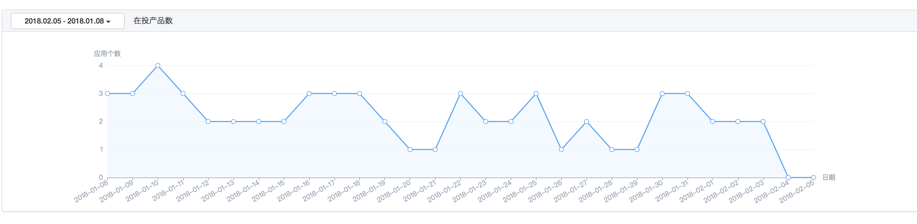

### 1、解释：如果下面的y2list 其实没有用到，因为上面只有一个曲线

public class UserAppsComplateData implements Serializable {  
 private List<String> xlist;  
 private List<Long> y1list;  
 private List<Long> y2list;  
  
 public List<String> getXlist() {  
 return xlist;  
 }  
  
 public void setXlist(List<String> xlist) {  
 this.xlist = xlist;  
 }  
  
 public List<Long> getY1list() {  
 return y1list;  
 }  
  
 public void setY1list(List<Long> y1list) {  
 this.y1list = y1list;  
 }  
  
 public List<Long> getY2list() {  
 return y2list;  
 }  
  
 public void setY2list(List<Long> y2list) {  
 this.y2list = y2list;  
 }  
}

## 2、js调用controller

/**  
 * 获取商务在投产品数量列表  
 * @return  
 */  
@RequestMapping("getAppPutInList")  
@ResponseBody  
public ResponseBean getAppPutInList(Long adminId,String startDate, String endDate){  
 try {  
 if(adminId == null) adminId = CasConfig.RemoteUserUtil.getRemoteUserId();  
 return ResponseBean.buildSuccess(saleService.getAppPutInList(adminId,startDate,endDate));  
 } catch (AppException e) {  
 return ResponseBean.buildFailure(e.getMessage());  
 }  
}

## 3、服务层开始实现吧，朋友

@Override  
public UserAppsComplateData getAppPutInList(Long adminId, String startDate, String endDate) {  
 UserAppsComplateData complateData = new UserAppsComplateData();  
 List<String> xlist = new ArrayList<>();  
 List<Long> y1list = new ArrayList<>();  
 List<Date> lDate = findDates(DateHelper.convertString2Date(startDate,DateHelper.***YYYY_MM_DD***), DateHelper.convertString2Date(endDate,DateHelper.***YYYY_MM_DD***));  
 for (Date date : lDate) {  
 xlist.add(DateHelper.convertDate2String(date, DateHelper.***YYYY_MM_DD***));  
 String sdate = DateHelper.convertDate2String(date, DateHelper.***YYYY_MM_DD***) + " 00:00:00";  
 String edate = DateHelper.convertDate2String(date, DateHelper.***YYYY_MM_DD***) + " 23:59:59";  
 Date stime = DateHelper.convertString2Date(sdate, DateHelper.***YYYY_MM_DD_HH_MM_SS***);  
 Date etime = DateHelper.convertString2Date(edate, DateHelper.***YYYY_MM_DD_HH_MM_SS***);  
 List<UserAppsSpreadData> spreadIdsList = userAppMapper.getSpreadIdsList(4l, stime, etime);  
 y1list.add(Long.valueOf(spreadIdsList.size()));  
 }  
 complateData.setXlist(xlist);  
 complateData.setY1list(y1list);  
 return complateData;  
}

### 2、获取一段时间内的日期

/**  
 * 获取一段时间之内的日期  
 * @param dBegin  
 * @param dEnd  
 * @return  
 */  
private List<Date> findDates(Date dBegin, Date dEnd) {  
 List lDate = new ArrayList();  
 lDate.add(dBegin);  
 Calendar calBegin = Calendar.getInstance();  
 calBegin.setTime(dBegin);  
 Calendar calEnd = Calendar.getInstance();  
 calEnd.setTime(dEnd);  
 // 测试此日期是否在指定日期之后  
 while (dEnd.after(calBegin.getTime()))  
 {  
 // 根据日历的规则，为给定的日历字段添加或减去指定的时间量  
 calBegin.add(Calendar.***DAY_OF_MONTH***, 1);  
 lDate.add(calBegin.getTime());  
 }  
 return lDate;  
}

# 2、按照月份的曲线

## 1、曲线图

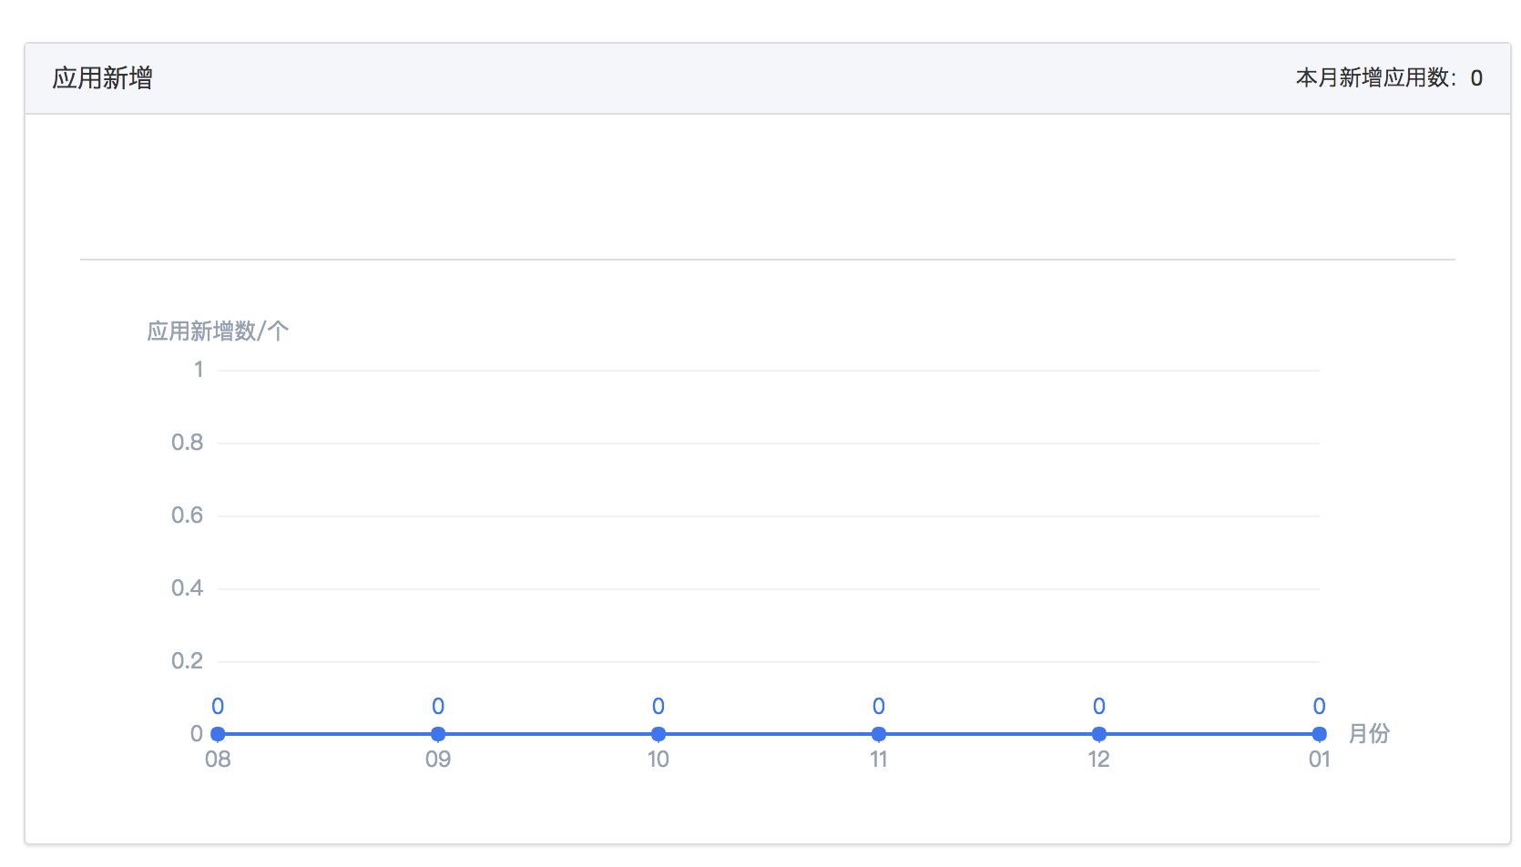

## 2.、设置曲线实体类

public class UserAppsData implements Serializable {  
 private List<AppsAppData> appDataList;  
 private List<String> xlist;  
 private List<Integer> ylist;  
 private String ym; //当月月份  
  
 public List<AppsAppData> getAppDataList() {  
 return appDataList;  
 }  
  
 public void setAppDataList(List<AppsAppData> appDataList) {  
 this.appDataList = appDataList;  
 }  
  
 public List<String> getXlist() {  
 return xlist;  
 }  
  
 public void setXlist(List<String> xlist) {  
 this.xlist = xlist;  
 }  
  
 public List<Integer> getYlist() {  
 return ylist;  
 }  
  
 public void setYlist(List<Integer> ylist) {  
 this.ylist = ylist;  
 }  
  
 public String getYm() {  
 return ym;  
 }  
  
 public void setYm(String ym) {  
 this.ym = ym;  
 }  
}

## 3、controller

/**  
 * 获取商务新增应用列表  
 * @return  
 */  
@RequestMapping("getNewAddAppList")  
@ResponseBody  
public ResponseBean getNewAddAppList(Long adminId){  
 try {  
 if(adminId == null) adminId = CasConfig.RemoteUserUtil.getRemoteUserId();  
 return ResponseBean.buildSuccess(saleService.getNewAddAppList(adminId));  
 } catch (AppException e) {  
 return ResponseBean.buildFailure(e.getMessage());  
 }  
}

## 4、服务层真正实现

@Override  
public UserAppsData getNewAddAppList(Long adminId) {  
 List<String> xlist = new ArrayList<>();  
 List<Integer> ylist = new ArrayList<>();  
 UserAppsData appsData = new UserAppsData();  
 Date startDate = DateHelper.convertString2Date(getMonthFirstDay(),DateHelper.***YYYY_MM_DD***);  
 List<AppsAppData> list = userAppMapper.getUserAppAddList(adminId, startDate,new Date());  
 appsData.setYm(DateHelper.convertDate2String(new Date(),DateHelper.***YYYY_MM***));  
 appsData.setAppDataList(list);  
 for (int i = 6; i > 0 ; i--){  
 xlist.add(StringUtils.substringAfter(getYm(-i),"-")); 2017-08 取出08

List<AppsAppData> appAddListLast = userAppMapper.getUserAppAddList(adminId, getFirstYMDHMS(-i-1),getLastYMDHMS(-i-1));  
 List<AppsAppData> appAddListNew = userAppMapper.getUserAppAddList(adminId, getFirstYMDHMS(-i),getLastYMDHMS(-i));  
 int sum = 0;  
 appAddListNew.remove(appAddListLast);  
 ylist.add(appAddListNew.size());  
 }  
 appsData.setXlist(xlist);  
 appsData.setYlist(ylist);  
 return appsData;  
}

### 1、getYm(-i)当前月份的接触上减去（6，5，4，3，2，1） 也就是显示8，9，10，11，12，1 月的曲线

private String getYm(int num) {  
 Date date = new Date();  
 Calendar calendar = Calendar.getInstance();  
 calendar.setTime(date);  
 calendar.add(Calendar.***MONTH***, num);  
 return DateHelper.convertDate2String(calendar.getTime(), DateHelper.***YYYY_MM***);  
}

## 2、取得上个月的第一天，和上个月的最后一天（这里是28号，不过也差不多就是个这） 减去几就是上几个月的值

private Date getFirstYMDHMS(int num) {  
 Calendar calendar = Calendar.getInstance();  
 calendar.set(Calendar.***DAY_OF_MONTH***,  
 calendar.getActualMinimum(Calendar.***DAY_OF_MONTH***));  
 calendar.add(Calendar.***MONTH***, num);  
 String time = DateHelper.convertDate2String(calendar.getTime(), DateHelper.***YYYY_MM_DD***)+" 00:00:00";  
 return DateHelper.convertString2Date(time, DateHelper.***YYYY_MM_DD_HH_MM_SS***);  
}  
  
private Date getLastYMDHMS(int num) {  
 Date date = new Date();  
 Calendar calendar = Calendar.getInstance();  
 calendar.set(Calendar.***DAY_OF_MONTH***,  
 calendar.getActualMaximum(Calendar.***DAY_OF_MONTH***));  
 calendar.add(Calendar.***MONTH***, num);  
 String time = DateHelper.convertDate2String(calendar.getTime(), DateHelper.***YYYY_MM_DD***)+" 23:59:59";  
 return DateHelper.convertString2Date(time, DateHelper.***YYYY_MM_DD_HH_MM_SS***);  
}