1、添加详情

## 1、整理附件弹出的页面代码

<aside class="right-sidebar" ng-class="{'control-sidebar-open': isActive }">  
  
 <div class="flex-wrap">  
 <div class="list">  
 <div class="title">详情</div>  
 <p class="info">  
 <label>主题</label>  
 <span class="des">{{currItem.title}}</span>  
 </p>  
 <p class="info">  
 <label>公司名称</label>  
 <span class="des">{{currItem.customerName}}</span>  
 </p>  
 <p class="info">  
 <label>对方联系人</label>  
 <span class="des">{{currItem.contactName}}</span>  
 </p>  
   
 <div ng-repeat="itemattach in currItem.attachmentList">  
 <p class="info" ng-if="itemattach.fileName!=undefined && itemattach.fileName!=''">  
 <label>附件</label>  
 <span class="des">  
 <a href="${oss_host}{{itemattach.fileUrl}}"

target="_blank">

<img src="${oss_host}/{{itemattach.fileUrl}}" style="height: 100px;"/>

</a>  
 </span>  
 </p>  
 </div>  
  
 </div>  
 <div class="close" ng-click="closeRight()">×</div>  
 </div>  
 <div class="processing text-center adParseInfo margin-top-3" style="display: none;">  
 数据加载中 <i class="glyphicon glyphicon-refresh spin"></i>  
 </div>  
 <div class="btn-check">  
 <a class="handle refuse" ng-click="closeRight()">关闭</a>  
 </div>  
</aside>

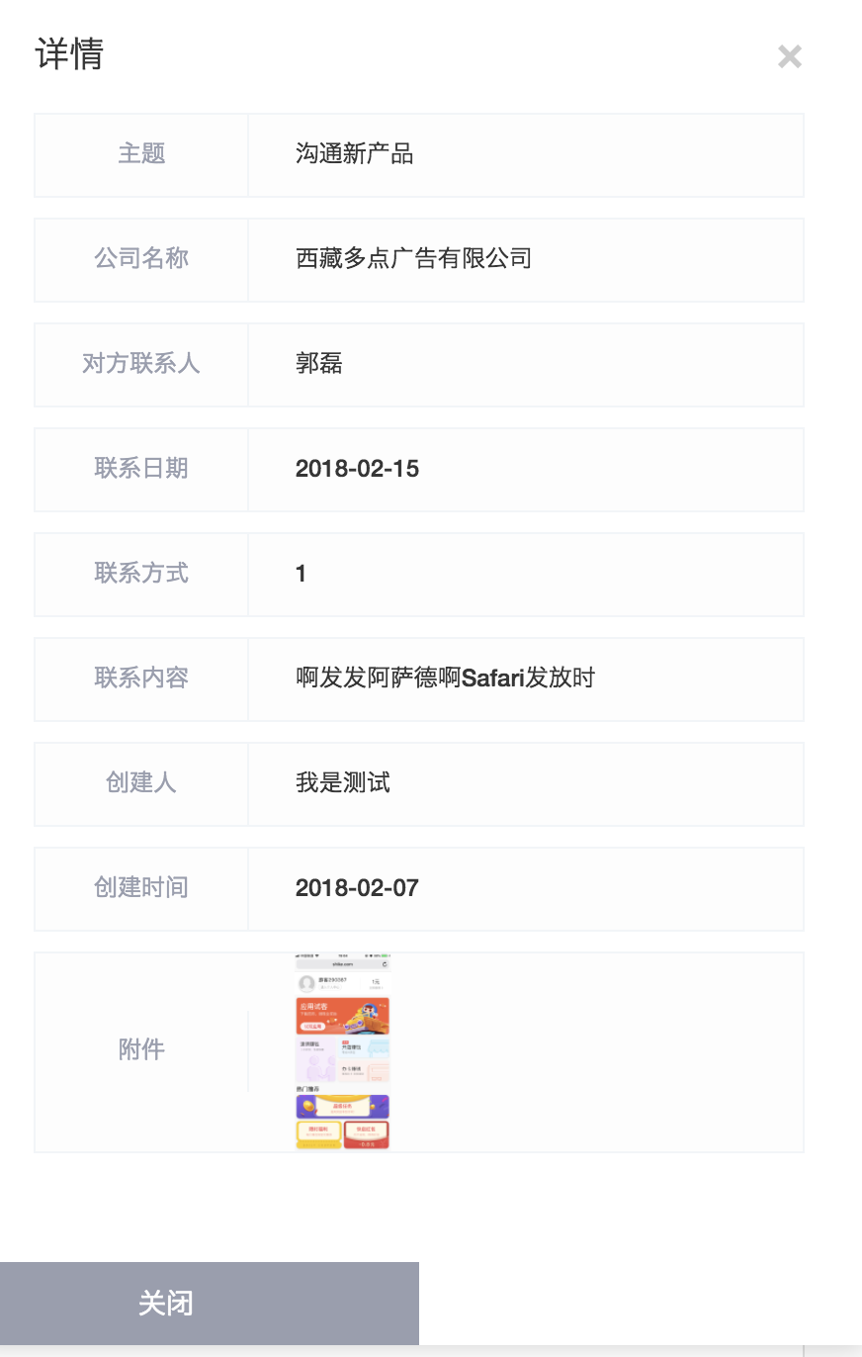

## 2、点击详情 和js控制弹出上面的菜单

<a ng-click="check(item)">详情</a>

/**  
 * 详情页  
 * @param item  
 */  
$scope.check=function (item) {  
 $scope.currItemDetails = {};  
 $scope.currItem = item;  
 $scope.isActive=true;  
  
  
  
};  
  
$scope.closeRight=function () {  
 $scope.isActive=false;  
}

## 3、上面的详情，其实在取得list分页数据的时候就已经加载了（注意下面的附件）

### 1、controller

@RequestMapping("data")  
@ResponseBody  
public Page<Contact> data(@RequestParam(defaultValue = "0")Integer page, String name, Integer type,  
 @RequestParam(defaultValue = "15")Integer pageSize){  
 Long adminId = CasConfig.RemoteUserUtil.getRemoteUserId();  
 Pageable pageable = new PageRequest(page,pageSize);  
 return contactService.findContactList(pageable,name,type,adminId);  
}

### 2、service （因为在保存的时候，不管有没有图片附件，都会设置一个附件的id值，所以我们在展示要不要显示附件的时候，不能通过判断附件是否为null就判断附件是否存在，而应该看看附件里面的内容是不是存在的，比如fileName）

@Override  
public Page<Contact> findContactList(Pageable pageable, String name, Integer type, Long adminId) {  
 List<Contact> list = customerMapper.findContactList(name, type, pageable.getOffset(), pageable.getPageSize());  
 if(adminId != null){  
 for (Contact contact : list){  
 List<ContactRecordAttachment> attachmentList = contactRecordAttachmentDAO.findByContactId(contact.getId());  
 contact.setAttachmentList(attachmentList);  
 SysAdminUser adminUser = sysAdminUserDAO.findOne(adminId);  
 if(adminUser != null){  
 contact.setAdminName(adminUser.getName());  
 }  
 }  
 }  
 Long count = customerMapper.countContactList(name, type);  
 return new PageImpl<>(list,pageable,count);  
}

### 3.、附件的实体类

@Entity  
@Table(name = "crm_contact_record_attachment")  
public class ContactRecordAttachment implements Serializable {  
  
 @Id  
 @GeneratedValue(strategy = GenerationType.***IDENTITY***)  
 private Long id;  
 private Long contactId;  
 private String fileName;  
 private String fileUrl;

## 4、前端控制附件的显示 （存在的时候，显示附件，不存在的时候，附件的名字都不会显示出来）

<div ng-repeat="itemattach in currItem.attachmentList">  
 <p class="info" ng-if="itemattach.fileName!=undefined && itemattach.fileName!=''">  
 <label>附件</label>  
 <span class="des">  
 <a href="${oss_host}{{itemattach.fileUrl}}" target="_blank"><img src="${oss_host}/{{itemattach.fileUrl}}" style="height: 100px;"/></a>  
 </span>  
 </p>  
</div>