# 1.制作html

<html>

<head>

<meta http-equiv=*"Content-Type"* content=*"text/html"*; charset=*"gb2312"*>

<title>Insert title here</title>

</head>

<body>

<form enctype=*"multipart/form-data"* method=*"post"* action=*"uploadprocess.php"* name=*"myform"*>

<table>

<tr><td align=*"center"* colspan=*"2"*><font style="font-size: *40px*;font-family: *华文彩云*;">文件上传</font></td></tr>

<tr><td>请填写用户名:</td><td><input type=*"text"* name=*"username"* /></td></tr>

<tr><td>请简单介绍该文件</td><td><textarea name=*"fileintro"* rows=*"10"* cols=*"80"*></textarea></td></tr>

<tr><td>请选择你要上传文件:</td><td><input type=*"file"* name=*"myfile"* /></td></tr>

<tr><td><input type=*"submit"* value=*"上传文件"* /></td><td></td></tr>

</table>

</form>

</body>

</html>

# 2.然后测试接收

//1.接收提交文件的用户

$username=$_POST['username'];

$fileintro=$_POST['fileintro'];

**echo** $username.$fileintro;

//我们这里需要使用到 $_FILE

**echo** "<pre>";

print_r($_FILES);

**echo** "</pre>";

## 2.2测试结果

、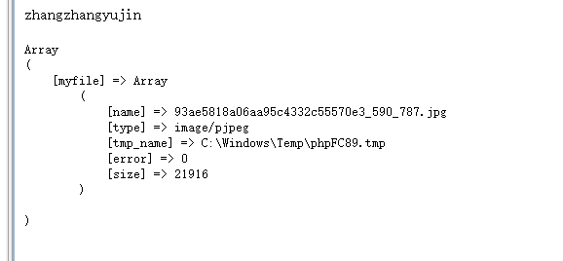

# 3.开始上传

//1.接收提交文件的用户

$username=$_POST['username'];

$fileintro=$_POST['fileintro'];

**echo** $username.$fileintro;

//我们这里需要使用到 $_FILE

**echo** "<pre>";

print_r($_FILES);

**echo** "</pre>";

//判断是否上传ok

**if**(is_uploaded_file($_FILES['myfile']['tmp_name'])){

//把文件转存到你希望的目录

$uploaded_file=$_FILES['myfile']['tmp_name'];

$move_to_file=$_SERVER['DOCUMENT_ROOT']."/File/ScXz/file/".$_FILES['myfile']['name'];

**echo** $move_to_file;

//开始上传文件

**if**(move_uploaded_file($uploaded_file,$move_to_file)){

**echo** $_FILES['myfile']['name']."上传ok";

}**else**{

**echo** "上传失败";

}

# 4.文件上传Apache是有限制的，

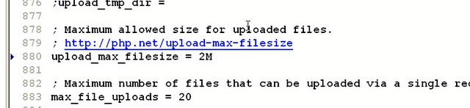

# 5.开始解决中文上传的问题

## 1.在保存的时候 对上传的路径进行编码为gb2312

**if**(move_uploaded_file($uploaded_file,iconv("utf-8","gb2312",$move_to_file))){

**echo** $_FILES['myfile']['name']."上传ok";

}**else**{

**echo** "上传失败";

}

# 6.文件上传的大小的限制

//获取文件的大小

$file_size=$_FILES['myfile']['size'];

**if**($file_size>2*1024*1024){

**echo** "文件过大,不能上传大于2m文件";

**exit**();

}

# 7.文件类型的限制

//获取文件的类型

$file_type=$_FILES['myfile']['type'];

**if**($file_type!='image/jpg' && $file_type!='image/pjpeg'){

**echo** "文件类型只能是 jpg的";

**exit**();

}

# 8.防止名字重复被覆盖

## 1.我们给每个用户动态的创建一个文件夹

//我们给每个用户动态的创建一个文件夹

$user_path=$_SERVER['DOCUMENT_ROOT']."/File/ScXz/file/".$username;

//判断该用户是否已经有文件夹

//解决中文乱码

$user_path=iconv("utf-8","gb2312",$user_path);

**if**(!file_exists($user_path)){

mkdir($user_path);

}

$move_to_file=$user_path."/".$_FILES['myfile']['name'];

**echo** $move_to_file;

# 9.同一个用户上传的文件名字相同的问题

$file_true_name=$_FILES['myfile']['name'];

// 取得后缀名 substr($file_true_name,strrpos($file_true_name,".")

$move_to_file=$user_path."/".time().rand(1,1000).substr($file_true_name,strrpos($file_true_name,"."));

# 10最终代码

<?php

//1.接收提交文件的用户

$username=$_POST['username'];

$fileintro=$_POST['fileintro'];

**echo** $username.$fileintro;

//我们这里需要使用到 $_FILE

**echo** "<pre>";

print_r($_FILES);

**echo** "</pre>";

//获取文件的大小

$file_size=$_FILES['myfile']['size'];

**if**($file_size>2*1024*1024){

**echo** "文件过大,不能上传大于2m文件";

**exit**();

}

//获取文件的类型

$file_type=$_FILES['myfile']['type'];

**if**($file_type!='image/jpg' && $file_type!='image/pjpeg'){

**echo** "文件类型只能是 jpg的";

**exit**();

}

?>

//判断是否上传ok

**if**(is_uploaded_file($_FILES['myfile']['tmp_name'])){

//把文件转存到你希望的目录

$uploaded_file=$_FILES['myfile']['tmp_name'];

// $move_to_file=$_SERVER['DOCUMENT_ROOT']."/File/ScXz/file/".$_FILES['myfile']['name'];

//echo $move_to_file;

//开始上传文件//我们给每个用户动态的创建一个文件夹

$user_path=$_SERVER['DOCUMENT_ROOT']."/File/ScXz/file/".$username;

//解决中文乱码

$user_path=iconv("utf-8","gb2312",$user_path);

//判断该用户是否已经有文件夹

**if**(!file_exists($user_path)){

mkdir($user_path);

} //下面的这行不能解决 同一个用户上传相同的文件名

// $move_to_file=$user_path."/".$_FILES['myfile']['name'];

//.time().rand(1,1000).substr($file_true_name,strrpos($file_true_name,"."));

$file_true_name=$_FILES['myfile']['name'];

// 取得后缀名 substr($file_true_name,strrpos($file_true_name,".")

$move_to_file=$user_path."/".time().rand(1,1000).substr($file_true_name,strrpos($file_true_name,"."));

**echo** $move_to_file;

**if**(move_uploaded_file($uploaded_file,iconv("utf-8","gb2312",$move_to_file))){

**echo** $_FILES['myfile']['name']."上传ok";

}**else**{

**echo** "上传失败";

}

}**else**{

**echo** "上传失败";

}