# 1.md5加密

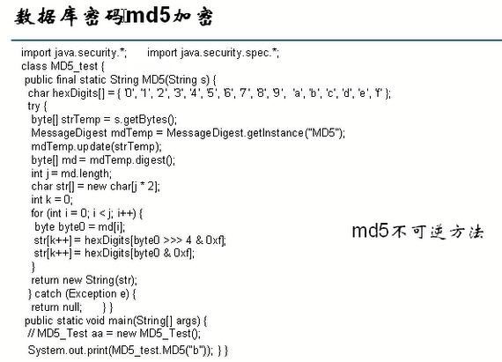

# 2.获取文件的前后名

**public** **class** TestUUID {

**public** **static** String getUUIdName(String filename){

String uuid = UUID.*randomUUID*().toString();

// System.out.println(uuid);

//现在考虑 将文件名filename.jpg 变为 uuId.jpg

// String filename= "abcdefghijklmn.jpg";

**int** begainName = filename.lastIndexOf(".");

//取得文件的前面的名字

// String newName = filename.substring(0, filename.lastIndexOf("."));

// 获取后缀名 因为是包头不包尾所以就直接length

// String newName = filename.substring(begainName, filename.length());

//制作新名字

String newName = uuid+filename.substring(begainName, filename.length());

System.*out*.println(newName);

**return** newName;

}

}

# 2.String 用法

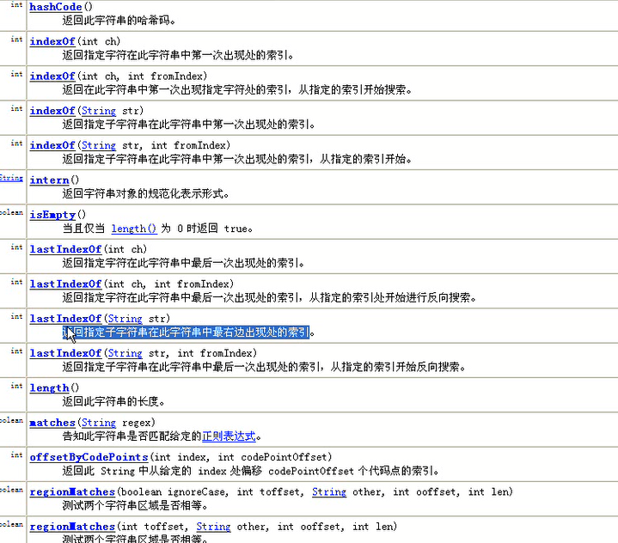

# 3.中解决img文乱码

## 3.1java.net.URLEncoder.*encode*(

String newName = java.net.URLEncoder.*encode*(user.getPhotoBefore(),"utf-8"));

## 3.2对内容进行转码

content=new String(content.getBytes("iso-8859-1"),"utf-8"); //

## 3.3进行base64解码

content=new String(decoder.decodeBuffer(content),"utf-8");

# 4.在sql语句中一定要注意使用‘’

# 5.userForm一定要严格把关，就是连setName都要一样