1.

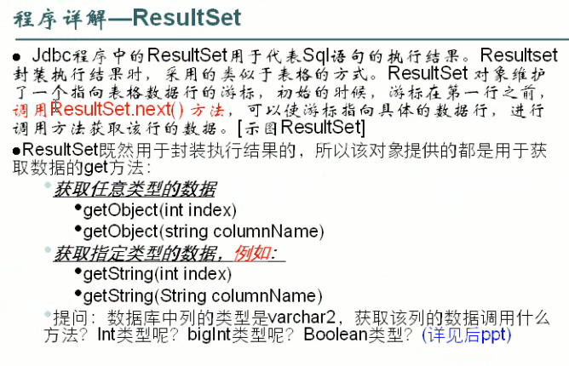

2.

/加载驱动

Class.forName("com.mysql.jdbc.Driver");

**try**{

//得到连接

ct = DriverManager.getConnection("jdbc:mysql://localhost:3306/shouru","root","147094");

//相数据库提交sql的statement对象

st = ct.createStatement();

//将事物设为不自动提交

ct.setAutoCommit(**false**);

ResultSet rs = st.executeQuery("select * from shouru ");

**while**(rs.next()){

out.println(rs.getInt(1));

out.println(rs.getInt(2));

}

}**catch**(Exception e){

}

%>