# 1、新建一个maven的activemq的web项目（spring集成）

## 1、web.xml重配置activemq的相关监听

|  |
| --- |
| <context-param>  <param-name>brokerURI</param-name>  <param-value>/WEB-INF/activemq.xml</param-value>  </context-param>  <listener>  <listener-class>org.apache.activemq.web.SpringBrokerContextListener</listener-class>  </listener> |

## 2、WEB-INF目录下建立activemq.xml

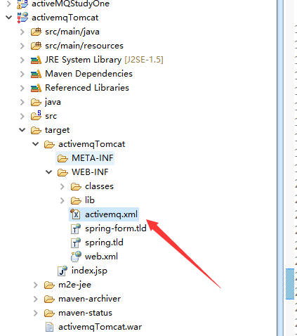

|  |
| --- |
| <beans  xmlns=*"http://www.springframework.org/schema/beans"*  xmlns:amq=*"http://activemq.apache.org/schema/core"*  xmlns:xsi=*"http://www.w3.org/2001/XMLSchema-instance"*  xsi:schemaLocation=*"http://www.springframework.org/schema/beans*  *http://www.springframework.org/schema/beans/spring-beans-2.0.xsd*  *http://activemq.apache.org/schema/core*  *http://activemq.apache.org/schema/core/activemq-core-5.2.0.xsd*  *http://activemq.apache.org/camel/schema/spring http://activemq.apache.org/camel/schema/spring/camel-spring.xsd"*>    <broker xmlns=*"http://activemq.apache.org/schema/core"* brokerName=*"localhost"*>    <persistenceAdapter>  <kahaDB directory=*"/usr/local/activemq5.12.1/data/kahadb"*/>  </persistenceAdapter>    <transportConnectors>  <transportConnector  name=*"openwire"*  uri=*"tcp://localhost:61616"*  </transportConnectors>  </broker>  </beans> |

## 3、拷贝activemq lib下面的jar包到tomcat项目下面，也就是我们的activemqTomcat的项目中

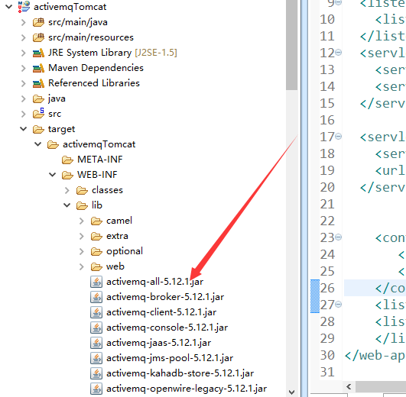

## 4、然后启动tomcat，就可以 运行生产者和消费者了