14、CentOS下搭建DNS服务器

## 1. 安装bind

### # yum -y install bind*

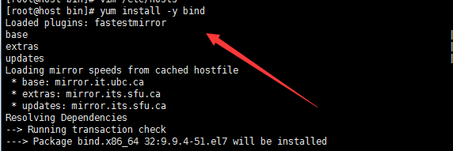

## 2. 修改/etc/named.conf配置文件

### vi /etc/named.conf

|  |
| --- |
| //  // named.conf  options {  listen-on port 53 { any; }; //开启监听端口53，接受任意IP连接  listen-on-v6 port 53 { ::1; }; //支持IP V6  directory "/var/named"; //所有的正向反向区域文件都在这个目录下创建  dump-file "/var/named/data/cache_dump.db";  statistics-file "/var/named/data/named_stats.txt";  memstatistics-file "/var/named/data/named_mem_stats.txt";  allow-query { 0.0.0.0/0; }; //允许任意IP查询  recursion yes;    dnssec-enable yes;  dnssec-validation yes;  dnssec-lookaside auto;    /* Path to ISC DLV key */  bindkeys-file "/etc/named.iscdlv.key";  managed-keys-directory "/var/named/dynamic";  };    logging {  channel default_debug {  file "data/named.run";  severity dynamic;  };  };    zone "." IN {  type hint;  file "named.ca";  };    include "/etc/named.rfc1912.zones"; //主要配置文件  include "/etc/named.root.key"; |

## 3. 修改/etc/named.rfc1912.zones文件，添加realhostip.com的正向和反向区域

我的vps ip和域名为：



|  |
| --- |
| //realhostip.com的正向区域  zone "realhostip.com" IN {  type master;  file "named.h.healerjean.top";  allow-update { none; };  };  //realhostip.com的反向区域  zone "155.122.176.in-addr.arpa" IN {  type master;  file "176.122.155.arpa";  allow-update { none; };  }; |