## -1-创建一张新表，并且添加一个字段 下面的函数就是表示字段uuid

SELECT uuid_generate_v4() as uuid_accid, t_account.* INTO tn_account from t_account;

## 3.直接根据字段导入另一张表

INSERT INTO "public"."tb_student"(id,created_on,email,mobile,pwd,real_name,source,updated_on) SELECT tn_account.uuid_accid,create_date,email

,mobile,pwd,real_name,source,modify_date from tn_account;

## 1.具有json的数据导入另一张表

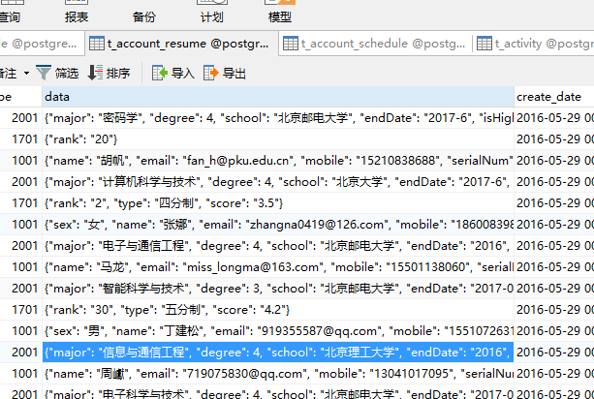

INSERT INTO "public"."tb_stu_basic_info"(id,birthday,city,created_on,email,gender,mobile,political,province,realname,updated_on)

SELECT DISTINCT

t1.uuid_accid,

t1."data" ->> 'birthday' as "birthday",

t1."data" ->> 'city' as "city",

t1.create_date as "created_on",

t1."data" ->> 'email' as "email",

t1."data" ->> 'sex' as "sex",

t1."data" ->> 'mobile' as "mobile",

t1."data" ->> 'political' as "political",

t1."data" ->> 'province' as "province",

t1."data" ->> 'name' as "name",

--t1."data" ->> 'serialNum' as "serialNum",

t1.modify_date as "updated_on"

FROM

tn_account_resume t1

WHERE

t1.type = '1001';

# 4.模糊查询

@Query(value = **"from JobRequistion j where j.recruiter=?1 and ( audit.status=?2 or ?2=null) and (j.title like (%?3%) or ?3=null) and ( jobCategory=?4 or ?4=null) and ( jobArea in ?5 or ?5=null) and j.status=null and (j.department.name in ?6 or ?6=null)"**)  
**public** Page<JobRequistion> findListByConditionForAuditStatusNoDate(RecruiterInfo recruiter,

# 5.判断某个字段是不空的

**WHERE r.end_date LIKE ?1% AND graduate_destination.ID = r.ID AND graduate_destination.rec_name IS NOT NULL "**,nativeQuery = **true**)  
**int** updateUderemployed(String graduateDate);