My IT Manager advised that he deployed the LibKey browser extension via Group Policy Objects (GPO)
- He used administrative templates to do this – one for Google Chrome and one for Edge - I’ve enclosed screen shots of what he showed me
- He said that once you have the templates, you can customise elements with these - and then specify the plug in (the very, very long string of alphanumeric text)
- And then to go the website to check it works
- He advised that it took a very short amount of time to do this
- He also mentioned that the instructions sent by HEE were helpful (also enclosed for completeness)
In Chrome
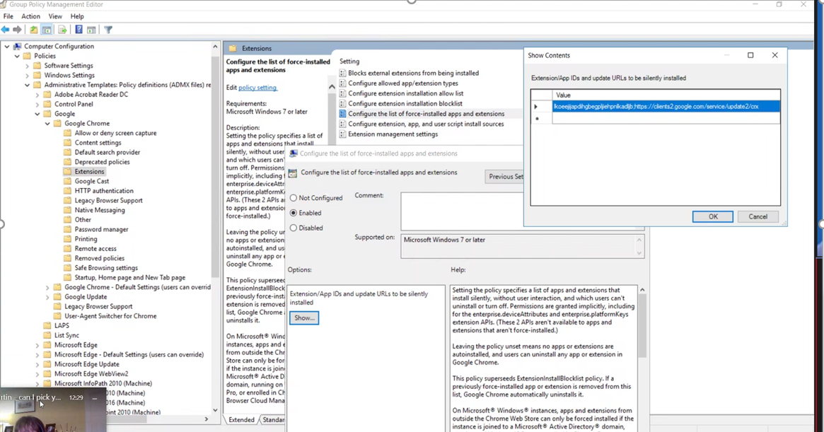

In Edge
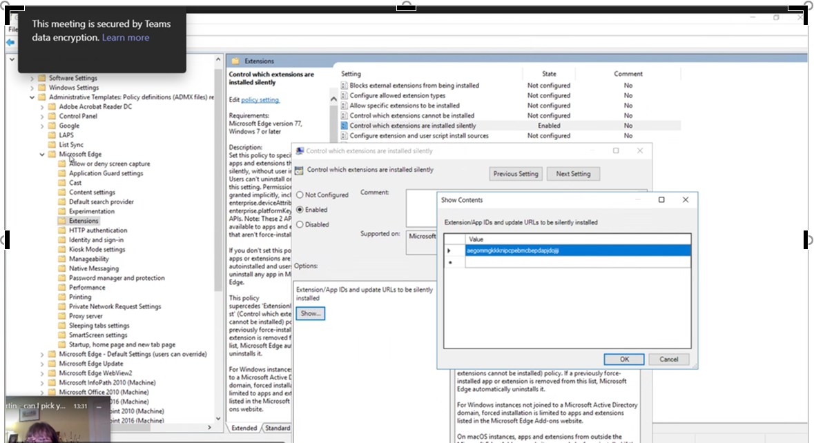
Instructions from HEE
LibKey Nomad from Third Iron is a browser extension which automatically provides full-text links to NHS-subscribed/licenced ejournal articles when browsing the web, greatly streamlining access to evidence and saving staff time.
Please see https://thirdiron.com/products/libkey-nomad/ for a general overview, and https://support.thirdiron.com/knowledgebase/articles/1920796-libkey-nomad-for-it-professionals for information specifically for IT professionals.
LibKey Nomad can be installed on individual devices (https://thirdiron.com/downloadnomad/) but for maximum benefit we strongly recommend deploying once for your whole organisation through Group Policy deployment. For full instructions please see:
LibKey Nomad Group Policy Deployment (Chrome)
LibKey Nomad Group Policy Deployment (FireFox)
Libkey Nomad Group Policy Deployment (Edge)

