User tidy – SirsiDynix
Why?
- Membership records which have empty fields that can affect statistics
- A useful set of reports can be used to check the health of your user records.
Remember
- User lists are protected
- More than 1 library? Create a separate set of reports for each library.
- User list templates cannot be copied so you have to create each time (Not too tricky)
How?
Location = Reports / Schedule New Reports 
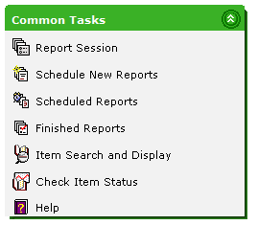
Select – ‘User’ Tab
Select – ‘List users’ from list
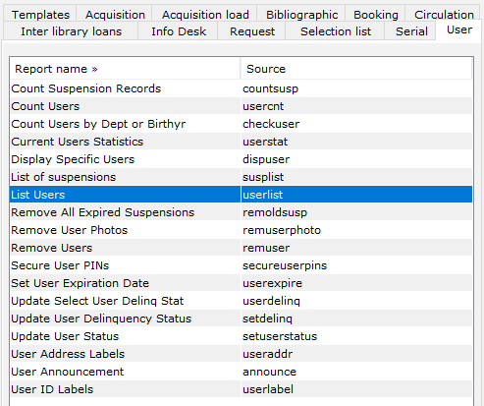

Name Report
- Template will open in the ‘Basic tab’
- Give it a recognisable ‘Report Name’ e.g. ES List users No Trust
- Description and title can be amended but don’t forget the ‘Report Name’
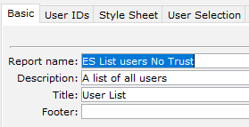
Select – ‘User Selection’ tab
Select – Your library under using the 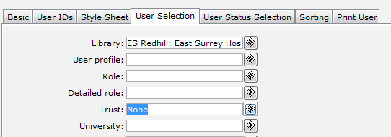button
- Use the: role / detailed role / trust & university as appropriate
Select – ‘Trust’ using the button
Select – ‘Contains no policy’ (This finds records with empty key fields, when it should be populated)
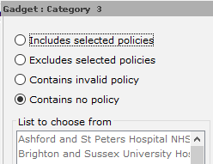
Example
This is an example of ES wanting to identify users with No Employing Trust.

Select – ‘Save as Template’ and then run.
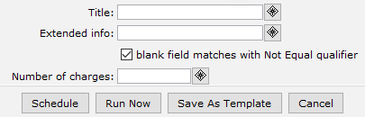
Location – ‘Schedule New Reports’
Select – Select your report
Select – ‘Run Now’ Tab
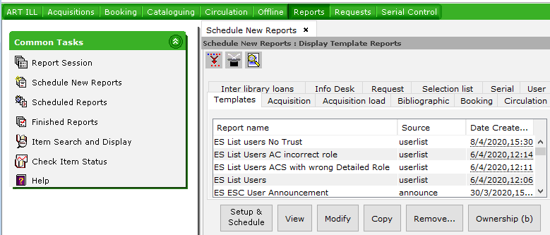
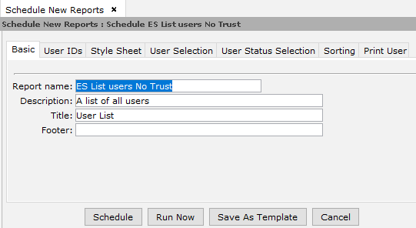
This would cover the following 4 reports.
- List users with No Trust
- List Users with No role
- List Users with No detailed role
- List Medical and nursing students with no university
Please note
- If you prefer you can exclude users who have expired by typing D0: into privilege expiry.
- These records may yield a lot of other checks so if users have expired you can check Athens and NHS mail plus current awareness services such as Knowledgeshare.
Users with inaccurate data in Detailed Role
The next reports are concerned with incorrect detailed roles which are often of interest in local statistics
Location = Reports / Schedule New Reports / Users
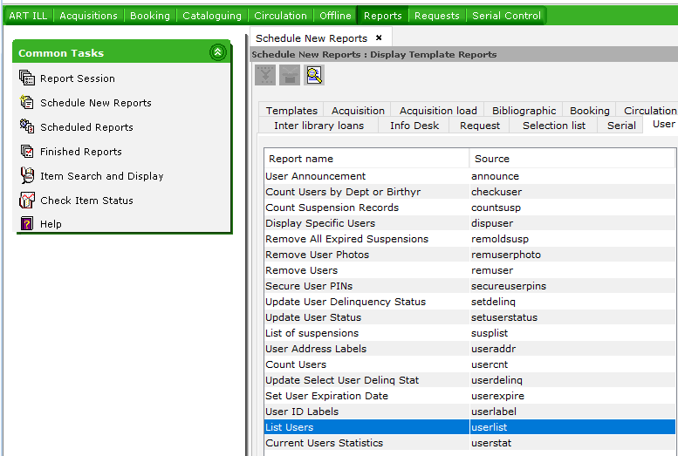

- Provide a name to the report eg ES List of AC users incorrect detailed role
- In User selection select Library, Role (AC) and then exclude all AC detailed roles)
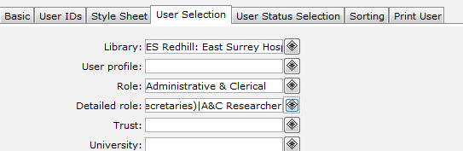
- List AC users with incorrect role
- List ACS users with incorrect role
- List AHP users with incorrect role
- List APST users with incorrect role
- List E&A users with incorrect role
- List HSCI users with incorrect role
- List M&D users with incorrect role
- List N&M users with incorrect role
- List Student users with incorrect role
You can save one report as a template then adjust the role and detailed role dynamics each time.
Run the reports and check results in Finished.
This can identify old memberships which may have expired or it can identify regular mistakes.

