How to run an HDAS search in Ovid in 3 Parts

Part 1: Locate your search strategy and export in simple text format

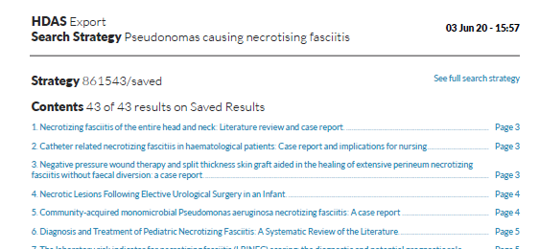
Example HDAS Report

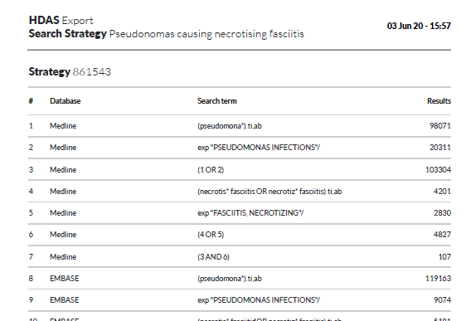
Example: HDAS Report / Search Strategy
Example: Extract the Search Strategy from the original document
Number | Database | Search Strategy | Number of Results
1 | Medline | (pseudomona*).ti,ab | 98071
2 | Medline | exp "PSEUDOMONAS INFECTIONS"/ | 20311
3 | Medline | (1 OR 2) | 103304
4 | Medline | (necrotis* fasciitis OR necrotiz* fasciitis).ti,ab | 4201
5 | Medline | exp "FASCIITIS, NECROTIZING"/ | 2830
6 | Medline | (4 OR 5) | 4827
7 | Medline | (3 AND 6) | 107
8 | EMBASE | (pseudomona*).ti,ab | 119163
9 | EMBASE | exp "PSEUDOMONAS INFECTIONS"/ | 9074
10 | EMBASE | (necrotis* fasciitis OR necrotiz* fasciitis).ti,ab | 5181
11 | EMBASE | exp "FASCIITIS, NECROTIZING"/ | 6190
12 | EMBASE | (10 OR 11) | 7210
13 | EMBASE | (8 OR 9) | 122100
14 | EMBASE | (12 AND 13) | 160

Example: Extract the Search Strategy from the table.
Trainer Tip: Copy and Paste, but Paste, selecting the Keep Text Only (T) option.

(pseudomona*).ti,ab
exp "PSEUDOMONAS INFECTIONS"/
(1 OR 2)
(necrotis* fasciitis OR necrotiz* fasciitis).ti,ab
exp "FASCIITIS, NECROTIZING"/
(4 OR 5)
(3 AND 6)
(pseudomona*).ti,ab
exp "PSEUDOMONAS INFECTIONS"/
(necrotis* fasciitis OR necrotiz* fasciitis).ti,ab
exp "FASCIITIS, NECROTIZING"/
(10 OR 11)
(8 OR 9)
(12 AND 13)

Part 2: Go to the Ovid Search History Launcher Tool

Go to https://tools.ovid.com/ovidtools/launcher_athens.html

Example: Standard appearance
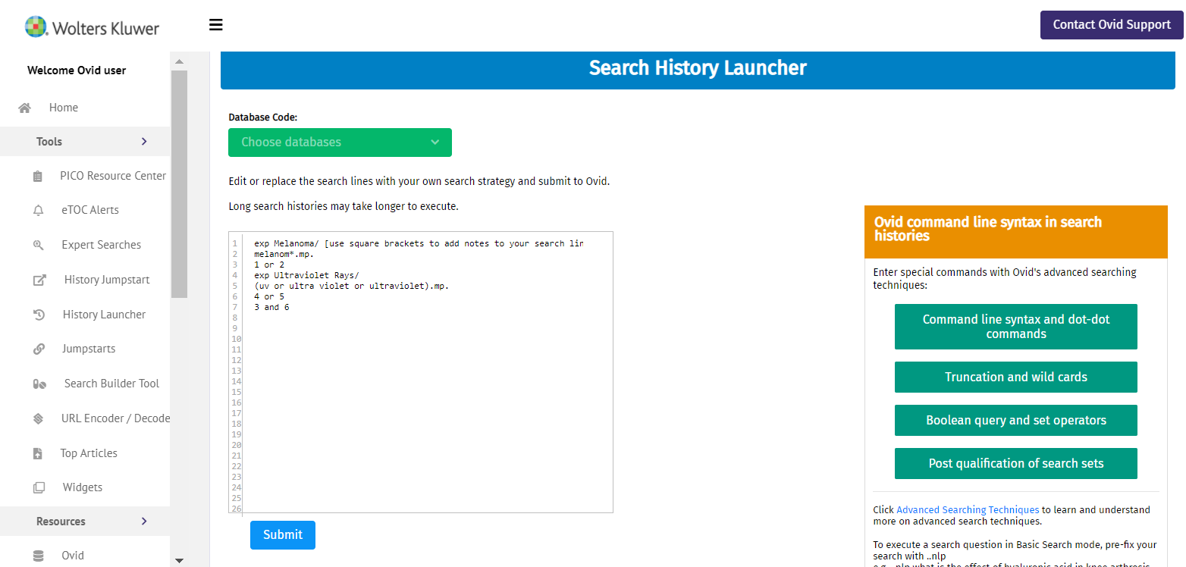

Insert your search history, select a database, and click on Submit.

Part 3: Run, re-run, use and re-use your search in Ovid.

Confirm your search history has run successfully in Ovid.

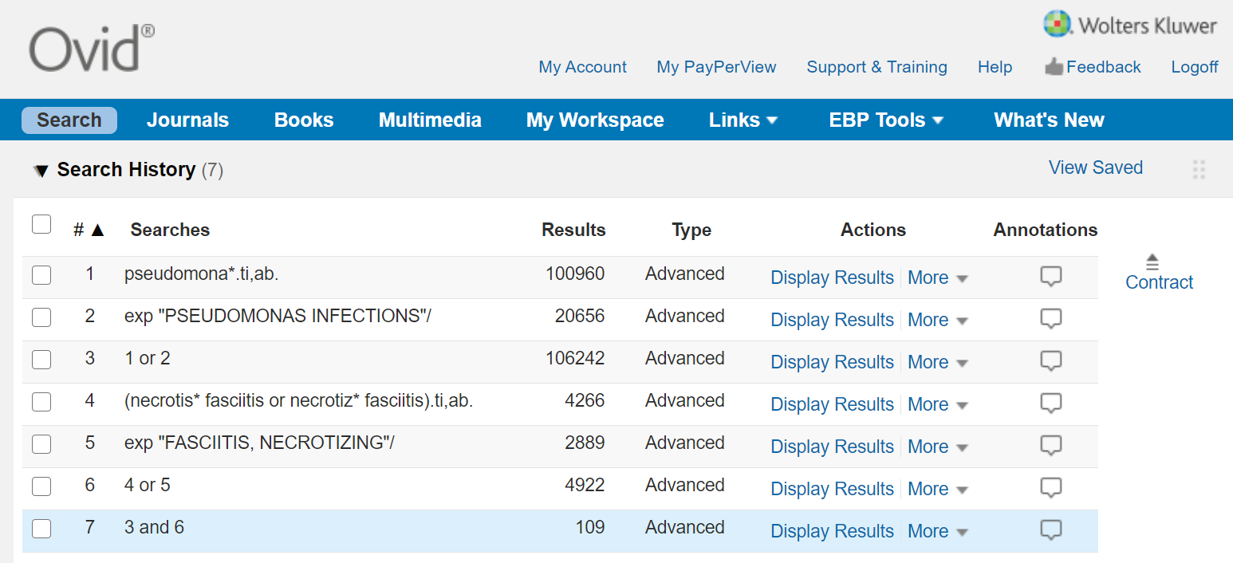

Edit and amend your search history, save it and/or set as an Autoalert.

