NHS Course 1 Ovid Native Interface
Questions and Answers

[10:32] THOMAS, Sarah (SHERWOOD FOREST HOSPITALS NHS FOUNDATION TRUST) (Guest)
For a free text phrase search do we not need to use quote marks?
Ovid Training Dept: No need to use quotation marks in Ovid. In the Advanced Search Mode, the Ovid platform automatically searches for your terms as a phrase. [see screenshot below].
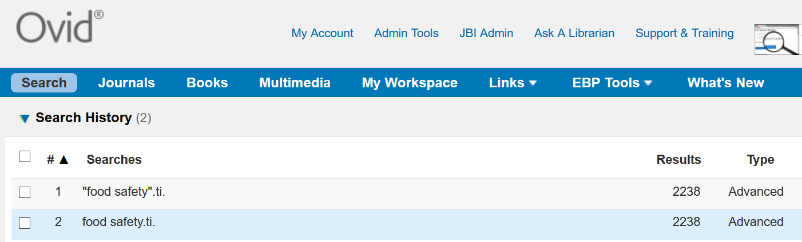
​
[10:33] ROPER, Tom (BRIGHTON AND SUSSEX UNIVERSITY HOSPITALS NHS TRUST) (Guest)
How customisable is deduplication as you've just demonstrated? If I take out results from individual databases and dedup in EndNote I can make several passes at the records, with different settings....e.g choosing which fields to use
Ovid Training Dept: It is important to remember that research platforms such as Ovid, Ebsco, Proquest etc.. specialize in their search capabilities. It is true that many of these platforms integrate other tools such as a dedupe function. Being an aggregator Ovid provides dedupe to it users that wish to search across multiple subscribed databases. The dedupe feature in Ovid does have some limitations, for example you can only dedupe when you have less than 6,000 records. However, it is possible to personalize your database preference as well as your field preference, you can also review duplicates when you have used the feature. It is also possible to activate the dedupe option within multi-database auto alerts. This would allow users to remove duplicates from the last 90 to 180 days of results. A professional reference manager such as Endnote, Refworks, Procite, Zotero etc… will undoubtedly provide a more complete service. Not all customers have a reference manager facility, so Ovid’s integrated dedupe feature is a welcome touch.

[10:33] WILLIAMS, Christine (DARTFORD AND GRAVESHAM NHS TRUST) (Guest)
Can you deduplicate within my projects?
Ovid Training Dept: No, it is not possible to dedupe within My Projects. Users should dedupe before transferring results to this space.
​
[10:34] LAWRENCE, Lisa (UNIVERSITY HOSPITALS OF DERBY AND BURTON NHS FOUNDATION TRUST) (Guest)
If you run a search in more than one database, how does Ovid handle different controlled vocabulary? Can you see what headings are used for each database - how they've been translated across the databases - e.g. from Medline to Embase?
Ovid Training Dept: This is a very valid point. Users have the option to always determine how they wish to search. Some researchers welcome the option to search in various databases in one platform. Imagine searching in PubMed, Embase.com and then Cochrane? It would be necessary to be familiar with three different interfaces, functionality, syntax etc… That is a challenge, although not an impossible one. Searching for all the databases subscribed in 1 interface will have its advantages and disadvantages. The disadvantage as you said is knowing whether the subject heading entered is recognized by the second database. These challenges can be overcome by first being aware of the databases’ differences and having a plan on how to proceed. We do provide training to cover multi-database searching. I have attached the following video tutorial which you are welcome to watch and see how we deal with precisely your question in Ovid.
Video Multi Database Searching in Ovid – Useful also for Systematic Reviewers https://www.brainshark.com/1/player/wkovid?pi=zFTzVIQDOz34XJz0&r3f1=&fb=0

[10:38] REY, Patricia (QUEEN VICTORIA HOSPITAL NHS FOUNDATION TRUST) (Guest)
Why can't I have a single log in using OpenAthens? Why do I have to create a personal account? This is adding another username & password for our users to forget.
Ovid Training Dept: As a colleague on the call mentioned, many providers including Ovid provide the personal account to identify the individual user that wishes to Customize their Ovid Session, use My Projects, Create Alerts and Save Searches etc…I agree that this is yet another ID/PWD to remember. I could enquire to find out whether your Athens ID/PWD can be mapped automatically but, this would be a development and there is no guarantee that it would be easy or be feasible. Have a go trying to use your Athens credentials in the Ovid setup for the Personal Account.
​
[10:45] ROPER, Tom (BRIGHTON AND SUSSEX UNIVERSITY HOSPITALS NHS TRUST) (Guest)
Do you have a view on the relative merits of using .mp, .af. .ti,ab. etc?

Ovid Training Dept: These particulars fields are available in all your Ovid databases. For more information simply browse the database field guide [Fields] to see the specific explanation for each option. http://ospguides.ovid.com/OSPguides/medline.htm MP is a range of default fields selected for each database. AF is the option to search across all the databases fields in one search, inevitable that search would produce more results. TI and AB are searches in the title and abstract, respectively. When searched they would provide a more focused search than MP or AF. I believe one of your colleagues also responded to this question by stating that MP is a very useful for searches when not many results are expected for a specific term (this is also true).
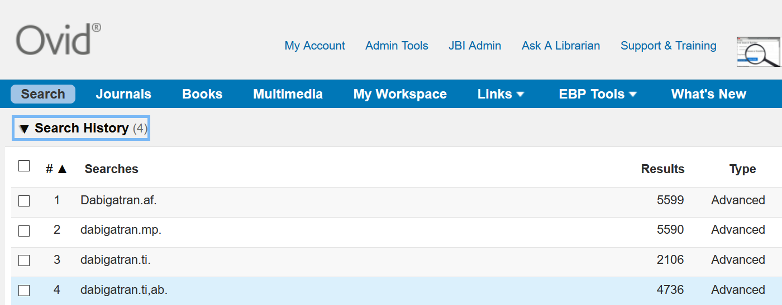

N/A: If the database selection screen is limited to five databases, can we still access the other segments if we need to?
Ovid Training Dept: Yes, from the Ovid Limits section it is possible to limit to the different database segments. So, no functionality is lost. The idea of reducing the number of segments I to make the selection much easier for all Ovid users irrelevant of their experience.

N/A: Can the wild card [?] be used at the beginning of a word eg ?esethetic
Ovid Training Dept: During the training I mentioned the truncation is provided at the beginning of a word in Ovid. Ovid only provides truncation in the middle or end of terms in Ovid. So, for the ?esethetic query you can see below that the most comprehensive search would be to search for both terms in full (set 4). Truncation could be used at the end of each term to further increase and recall additional variants (set 5).
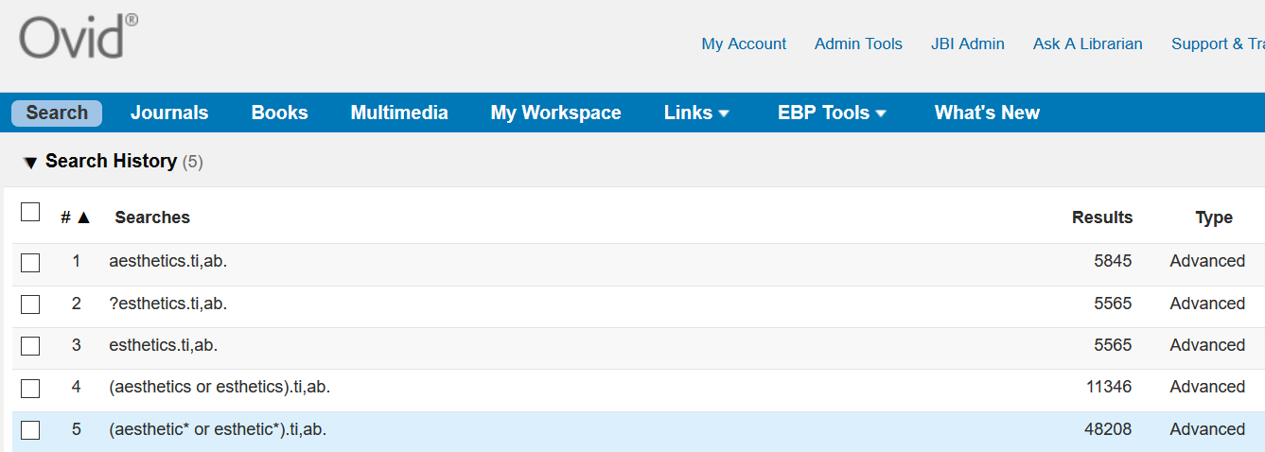
​​
N/A: Is it possible to limit records more than once, and then combine with Boolean Operators AND, OR, NOT?
Ovid Training Dept: Yes, Ovid is flexible enough to do this. See the screenshot below to see a completed example highlighting an outcome. Please contact us at customersuccessemea@wolterskluwer.com should you wish to ask us further questions about this.
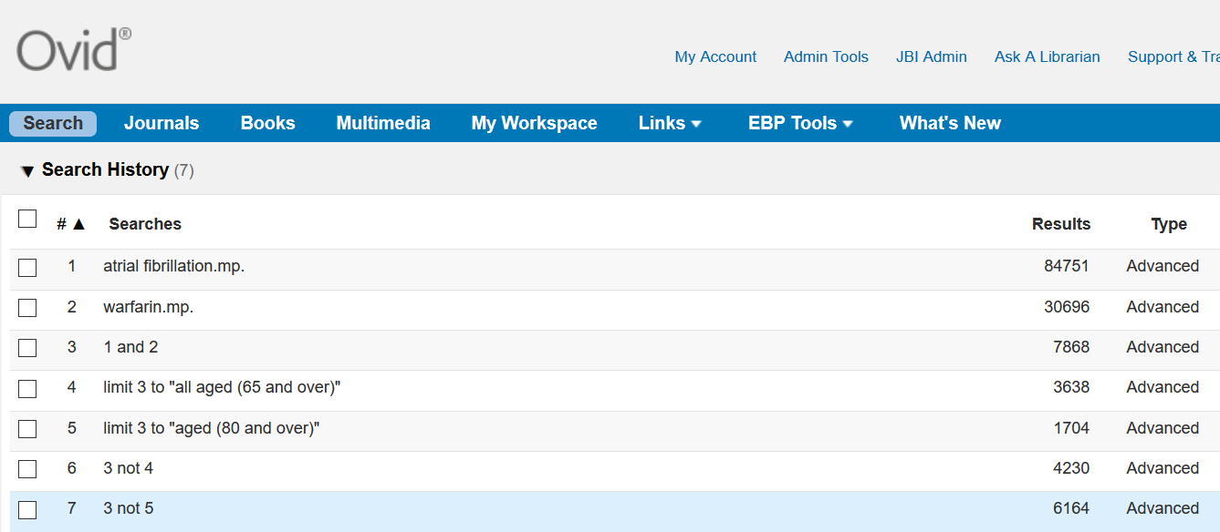

[10:48] Roberts Samantha - Head of Knowledge Services
In the term finder do you have the option to add the field codes you want to search other than mp or do you have to go and edit the lines.
Ovid Training Dept: The MP is the default setting in the Term Finder. As you correctly say, you simply launch the search in Term Finder first then, go the to Search History and make the necessary edits.
​​
[10:53] Lepley, Deborah
Will the term finder feature be added to the other databases at some point?
Ovid Training Dept: Ovid Term was launched at the end of October 2020; it is very new. In this first version Medline has been selected to work with Term Finder. I know the product Management Team are looking to add new Databases soon especially those that use a similar hierarchy of controlled vocabulary terms, such as Cochrane Central. As I showed in the demonstration, to search in other databases with your keywords you simply select CHANGE database and select any number of Ovid databases from your list. Please do provide your own personal feedback and suggestions for Term Finder from the tool itself. See “We would like your feedback on Term Finder” to provide your suggestions.
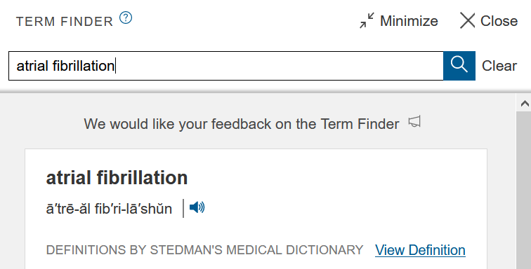
​[10:55] Susan Merner (Guest)
Is there an option to cancel or stop a search that is taking a long time?
Ovid Training Dept: Yes, you can always click on the x in the top corner of the dialogue box “with the spinning wheel”. Today I had a case of Murphy’s law, and my session was particularly slow for which I apologies. Normally, my access is much quicker at loading pages for short as well as lengthy searches.
​
[10:58] REY, Patricia (QUEEN VICTORIA HOSPITAL NHS FOUNDATION TRUST) (Guest)
From the search history how can I see which database I've used?
Ovid Training Dept: In a single database session, you would see the database (highlighted in bold text). In a multi database session you will also see the databases in bold, at the same time in the Search History you would also see small arrows allowing users to open each search result per database. [See screenshot]
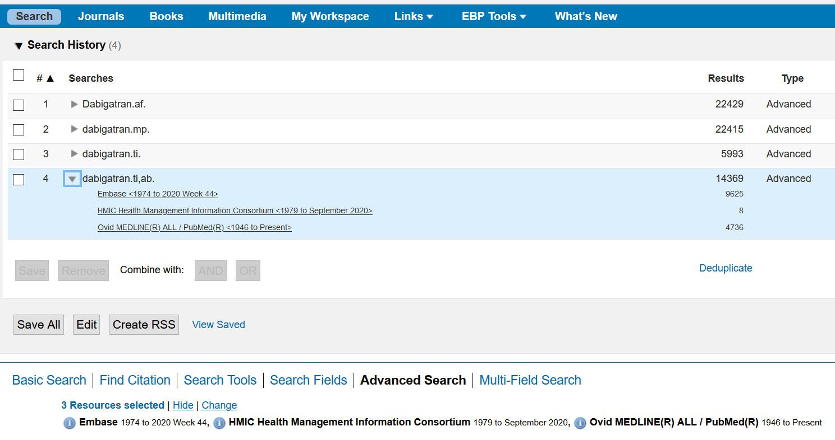
​​
[11:02] REY, Patricia (QUEEN VICTORIA HOSPITAL NHS FOUNDATION TRUST) (Guest)
Can I rearrange search lines to make my strategy more logical or delete lines? If I do this will the search steps be renumbered?
Ovid Training Dept: Yes, the Search History can be rearranged, you can add sets up and below, make the terms more logical, add new booleans, brackets, truncation etc… By adding new sets and renumbering the strategy can still be focused and valid (without errors). I welcome you to play around with the edit feature in the Search History as it is a recent edition for Ovid users.
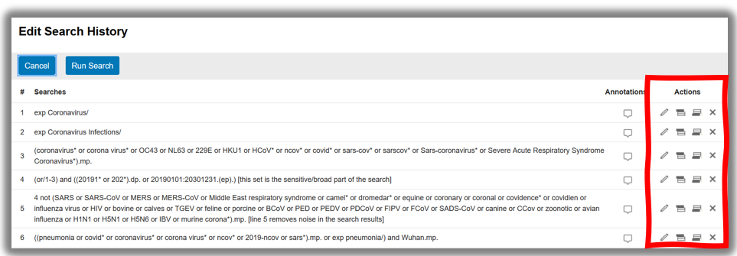

[11:02] Harte Alison - Clinical Information Specialist
How many searches can it store?
Ovid Training Dept: We have many expert searches that can be directly imported into the Ovid Database. Some of these strategies are extensive and very lengthy so, although I can not provide a specific number to your question, you should find no issue with creating very large strategies for your own searches.
Covid-19 and PPE Personal Protective Equipment on Ovid MEDLINE and Journals@Ovid
1 exp Coronavirus/
2 exp Coronavirus Infections/
3 (coronavirus* or corona virus* or OC43 or NL63 or 229E or HKU1 or HCoV* or ncov* or covid* or sars-cov* or sarscov* or Sars-coronavirus* or Severe Acute Respiratory Syndrome Coronavirus*).mp.
4 (or/1-3) and ((20191* or 202*).dp. or 20190101:20301231.(ep).) [this set is the sensitive/broad part of the search]
5 4 not (SARS or SARS-CoV or MERS or MERS-CoV or Middle East respiratory syndrome or camel* or dromedar* or equine or coronary or coronal or covidence* or covidien or influenza virus or HIV or bovine or calves or TGEV or feline or porcine or BCoV or PED or PEDV or PDCoV or FIPV or FCoV or SADS-CoV or canine or CCov or zoonotic or avian influenza or H1N1 or H5N1 or H5N6 or IBV or murine corona*).mp. [line 5 removes noise in the search results]
6 ((pneumonia or covid* or coronavirus* or corona virus* or ncov* or 2019-ncov or sars*).mp. or exp pneumonia/) and Wuhan.mp.
7 (2019-ncov or ncov19 or ncov-19 or 2019-novel CoV or sars-cov2 or sars-cov-2 or sarscov2 or sarscov-2 or Sars-coronavirus2 or Sars-coronavirus-2 or SARS-like coronavirus* or coronavirus-19 or covid19 or covid-19 or covid 2019 or ((novel or new or nouveau) adj2 (CoV on nCoV or covid or coronavirus* or corona virus or Pandemi*2)) or ((covid or covid19 or covid-19) and pandemic*2) or (coronavirus* and pneumonia)).mp.
8 COVID-19.rx,px,ox. or severe acute respiratory syndrome coronavirus 2.os.
9 ("32240632" or "32236488" or "32268021" or "32267941" or "32169616" or "32267649" or "32267499" or "32267344" or "32248853" or "32246156" or "32243118" or "32240583" or "32237674" or "32234725" or "32173381" or "32227595" or "32185863" or "32221979" or "32213260" or "32205350" or "32202721" or "32197097" or "32196032" or "32188729" or "32176889" or "32088947" or "32277065" or "32273472" or "32273444" or "32145185" or "31917786" or "32267384" or "32265186" or "32253187" or "32265567" or "32231286" or "32105468" or "32179788" or "32152361" or "32152148" or "32140676" or "32053580" or "32029604" or "32127714" or "32047315" or "32020111" or "32267950" or "32249952" or "32172715").ui. [Articles not captured by this search when created in April 2020, pending further indexing by NLM]
10 or/6-9 [Lines 6 to 9 are specific to Covid-19]
11 5 or 10
12 (11 and 20191201:20301231.(dt).) use medall
13 (((pneumonia or covid* or coronavirus* or corona virus* or ncov* or 2019-ncov or sars*) adj5 Wuhan) or (SARS coronavirus* and Wuhan)).mp.
14 (2019-ncov or ncov19 or ncov-19 or 2019-novel CoV or sars-cov2 or sars-cov-2 or sarscov2 or sarscov-2 or Sars-coronavirus2 or Sars-coronavirus-2 or coronavirus-19 or covid19 or covid-19 or covid 2019 or "novel coronavirus" or "new coronavirus" or "nouveau coronavirus" or CoV or nCoV or covid or covid19 or covid-19 or "coronavirus 2" or ((novel or new or nouveau) adj1 (CoV or nCoV or covid or coronavirus* or "corona virus" or Pandemi*2)) or ((covid or covid19 or covid-19) and pandemic*2)).mp. [mp=ti, ab, ot, nm, hw, fx, kf, ox, px, rx, ui, sy, tx, ct]
15 (COVID-19 or "severe acute respiratory syndrome 2" or 2019 pandemic or 2020 pandemic).mp. or SARS-like coronavirus*.ti,ab,ct.
16 or/13-15
17 (16 and 2020:Current.(yr).) use ovft
18 12 or 17
19 exp "Protective Clothing"/ or gown*.mp. or coverall*.mp. or "protective layer".mp. or "protective layers".mp. or "surgical toga".mp. or apron*.mp. or "smock".mp. or "smocks".mp. or "hazmat suit".mp. or (hazmat and suit).mp. or exp "Gloves, Protective"/ or "glove".mp. or "gloves".mp. or "Respiratory Protective Devices"/ or "Masks"/ or "mask".mp. or "masks".mp. or "N95".mp. or "air-purifying respirator".mp. or "PAPR".mp. or "enhanced respiratory and contact precautions".mp. or "respiratory protection".mp. or "transparent panel".mp. or "surgical mask".mp. or "surgical masks".mp. or "filtering face piece".mp. or "filtering facepiece".mp. or "Eye Protective Devices"/ or goggle*.mp. or "visor".mp. or "facial protection equipment".mp. or "safety glass".mp. or "safety glasses".mp. or "safety spectacles".mp. or "personal protective equipment".mp. or "PPE".mp. or "protective equipment".mp. or overshoe*.mp. or "shoe cover".mp. or "shoe covers".mp. or "rubber boot".mp. or "rubber boots".mp. or "head cover".mp. or "head covering".mp. or "face shield".mp. or "face shields".mp. or "surgical hood".mp. or "hood".mp. or exp Equipment Contamination/pc or exp "Infection Control"/ or "infection control".ti,ab. or "gloving".mp. or "donning".mp. or "doffing".mp.
20 ((("Protective Cloth$3" or gown* or coverall* or "protective layer$1" or "surgical toga" or apron* or "smock" or "smocks" or "hazmat suit" or (hazmat and suit) or PPE or glove$3 or Respiratory Protective Device$ or "Mask$1 or N95 or air-purifying respirator or PAPR or enhanced respiratory") and "contact precautions or respiratory protection or transparent panel or surgical mask or surgical mask$1 or filtering face piece or filtering facepiece or Eye Protective Devices or goggle* or visor or facial protection equipment or safety glass or safety glasses or safety spectacles or personal protective equipment or PPE or protective equipment or overshoe* or shoe cover$1 or rubber boot$1 or head cover$5 or face shield$3 or ace shield$1") or "surgical hood" or "hood" or Contamination equipment or decontamination equipment or "Infection Control" or "gloving" or "donning" or "doffing").ti,ot,ab,kw.
21 18 and (19 or 20)
22 remove duplicates from 21

Additional Information
Ovid Self Service portal for NHS users – We have recently created this page where you can find Video Tutorials, Documentation, and Knowledge Base…
https://tools.ovid.com/nhs/resourcecenter/

Remember to contact us with your training or technical questions to the Ovid Training Department at: customersuccessemea@wolterskluwer.com

