Ovid Training – COURSE 2 - Q&A Follow-Up

REFERENCE:
COURSE 2: https://www.brainshark.com/wkovid/vu?pi=zF9zsd330z34XLz0 (Recording)

QUESTIONS:
[11:24 AM] SNELL, Lindsay (UNIVERSITY HOSPITALS OF DERBY AND BURTON NHS FOUNDATION TRUST) (Guest)
Do these changes stay between sessions or are you making the edit for a single session only?
Ovid Training Department: The changes remain for the session only. However, where you find you are returning to a regular My Fields selection of fields or also of Limits these can be permanently connected to your User ID and/or group account. We can advise you further on these options. Alternatively please contact our colleagues at Support@Ovid.com for details concerning implementation.

[11:25 AM] REY, Patricia (QUEEN VICTORIA HOSPITAL NHS FOUNDATION TRUST)
We run searches on institution so that we can set up an alert for articles authored by people at our own hospital. What's the best way to do that?
Ovid Training Department: The best way to do this would be - having composed your search for authors at your institution - to then set up an Autoalert. Setting up the Autoalert assumes you are logged into your personal working area on Ovid: My Workspace. Autoalert settings will enable you to set the time interval for delivery of the updated information as well as the means of delivery, i.e. via e-mail and/or an RSS feed. For a practical overview of how to set up Autoalerts on Ovid, please refer to the 4 minute video tutorial, Creating Autoalerts for Current Awareness on Ovid.

[11:27 AM] Hendron Elizabeth (Medical & Teaching)
in my fields if you select all fields will it search just the selection you have moved into my fields
Ovid Training Department: The All Fields group index as ticked below is present in the two fields’ collection options highlighted below, namely My Fields and All Fields and is fixed in these two fields’ collection options. Irrespective of under which option is used, Ovid runs a <Term>.af. search across the target database.
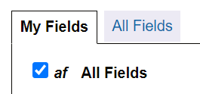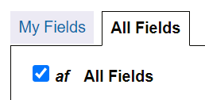

[11:28 AM] BRBRE, Igor (BRIGHTON AND SUSSEX UNIVERSITY HOSPITALS NHS TRUST)
Is there a list of preprint sources for Medline? (smile)
Ovid Training Department: On Ovid MEDLINE the preprint sources are BioRxiv, MedRxiv, ArRxiv, Research square, SSRN and ChemRxiv. Although a specific listing has been difficult to find from either Ovid or the NLM, a series of searches (#2-#7 in the screen shot below) using the field NLM Journal Name (NJ) to identify the sources of the references yielded by the search Publication Type equals “preprint”(#1), produces the list.
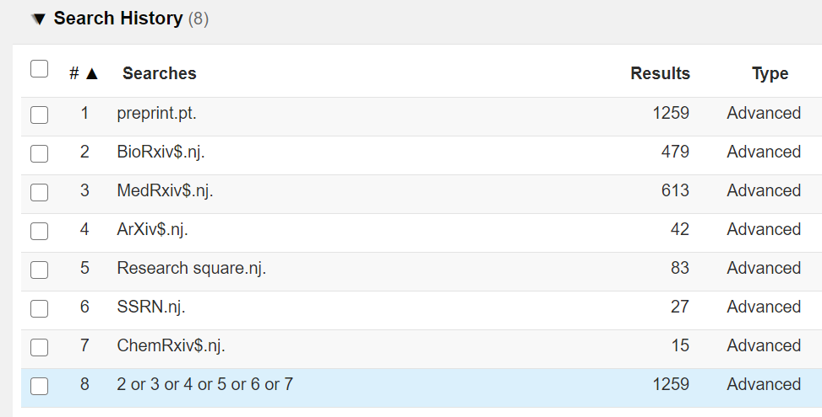
For more on the NIH Preprint Pilot, see https://www.ncbi.nlm.nih.gov/pmc/about/nihpreprints/ .

[11:29 AM] SNELL, Lindsay (UNIVERSITY HOSPITALS OF DERBY AND BURTON NHS FOUNDATION TRUST) (Guest)
"complete parity" - does that mean we no longer need to check PubMed for the most recent literature as a supplement to Medline? Ie that PubMed has no additional more recent content?
Ovid Training Department: “Complete parity” means that Ovid MEDLINE is 100% equivalent in content to PubMed. It is the case however that PubMed and Ovid MEDLINE are likely to show daily variations given that although Ovid MEDLINE is updated daily, it is so with a 1-day delay (and 2-day delay on Mondays) compared to PubMed. For a detailed assessment of the differences between Ovid MEDLINE and PubMed, as well as recommendations on comparing the two databases, the following reference prepared by the Ovid Product Development Team is highly recommended,

How to Compare Ovid MEDLINE and PubMed
https://tools.ovid.com/ovidtools/pdf/Ovid_MEDLINE_and_PubMed_compared.pdf

[11:31 AM] REY, Patricia (QUEEN VICTORIA HOSPITAL NHS FOUNDATION TRUST)
I'd like more Embase examples. I usually search Embase first as it's so good for drugs.
Ovid Training Department: Thank you for the feedback. We will certainly plan in more training sessions that specifically look at Embase. In the meantime, following on from the COURSE 2 focus on Search Fields the following suggestions are hopefully useful.

Re. Fields specific to Embase: Conferences, Drugs and Devices
The Search Fields mode is a very useful means of highlighting as well as of accessing the special fields specific to that database. In the case of Embase such special fields relate to conference information as well as information on drugs and devices.
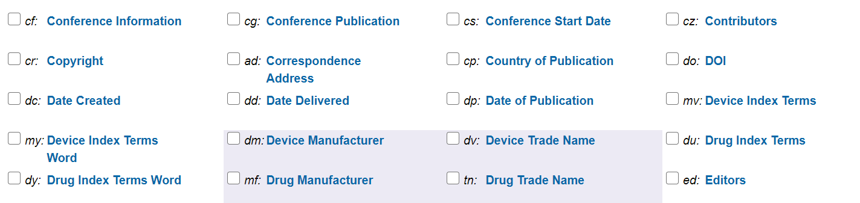

Re. Fields specific to Embase: Triple Subheading
One such special field, available only on Embase, is the Triple Subheading field. The Triple Subheading field is phrase indexed whereas its neighbour the Triple Subheading Word is word indexed.
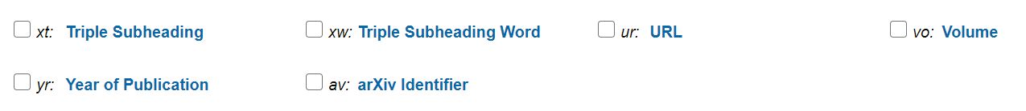
The Triple Subheading field on Embase allows you to search for a drug in a context and in a very targeted and precise way. For example, using the anesthetic propofol as an example, you would need to simply enter propofol adverse drug reaction into the index search box and you will obtain results that indicate not only an adverse drug reaction, but specifically what the adverse reaction actually is, i.e. amnesia, anaphylaxis, bronchospasm etc.

By way of contrast the example below looks at propofol combined with other drugs.
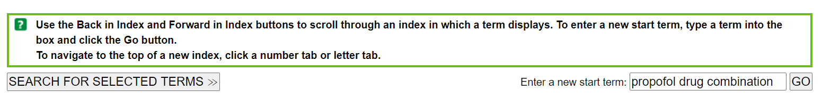
Navigating to propofol drug combination fentanyl yields 869 very targeted results.
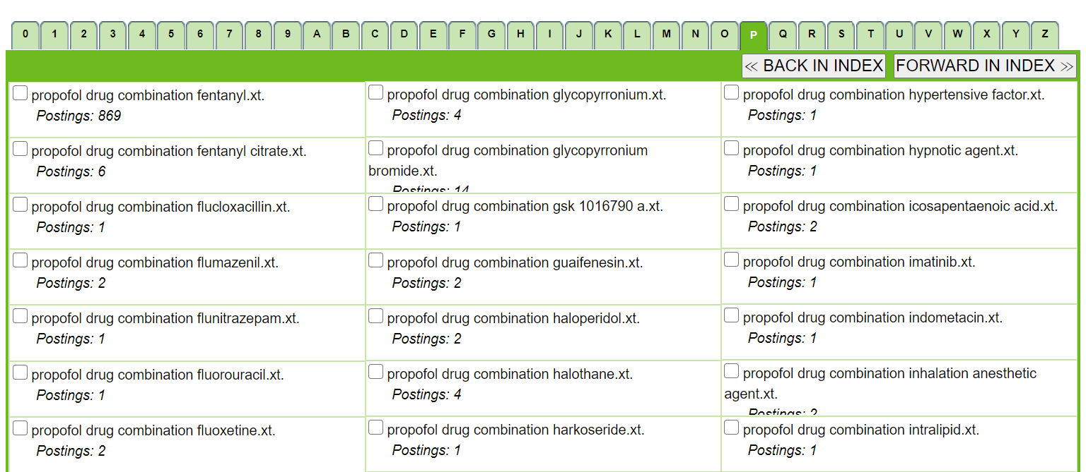

Until we schedule some specific Embase related training the two video tutorials Embase as well as Embase Advanced Techniques offer background as well as more detailed information on Embase on Ovid.

[11:33 AM] SNELL, Lindsay (UNIVERSITY HOSPITALS OF DERBY AND BURTON NHS FOUNDATION TRUST) (Guest)
I don't think I've ever met a librarian who uses thesaurus terms only, but several database supplier trainers have warned against over the years. Just wondered where the idea of thesaurus only searches comes from? Or am I just very uninformed?

[11:34 AM] Roberts Samantha - Head of Knowledge Services
me neither

[11:34 AM] REY, Patricia (QUEEN VICTORIA HOSPITAL NHS FOUNDATION TRUST)
Lindsay I totally agree with you. It's a bit patronising really.
Ovid Training Department: With respect to the points made above, I do apologise if anyone felt irked or vexed by assumptions made or implied during the training session. From a training point of view, it is often the case that we are addressing a heterogeneous audience with a mixture of needs and different requirements and that we are not as clear as we would ideally like to be about just how our audience(s) actually use the databases. And that irrespective of whether they are a beginner, intermediate user or expert. These two kick-off courses were arranged to get the ball rolling - so to speak - and hopefully in the future, as we all get to know each other better, we will be able to refine and perfect the mix, content and approach.

[11:41 AM] SNELL, Lindsay (UNIVERSITY HOSPITALS OF DERBY AND BURTON NHS FOUNDATION TRUST) (Guest)
Can you access search history launcher if you log in to Ovid first or only from this URL / the portal?
Ovid Training Department: The Ovid Search History Launcher Tool is directly available from the Ovid Tools & Resources Portal (https://tools.ovid.com/ovidtools/index.php). As it is available outside the Ovid platform there are no log on requirements to use it. A point to note here however, is that where Ovid access is through OpenAthens, a specific Ovid Search History Launcher Tool URL is required. This is
https://tools.ovid.com/ovidtools/launcher_athens.html
The steps involved in using the Ovid Search History Launcher Tool to convert HDAS search strategies into Ovid strategies are outlined in the accompanying document:

[11:45 AM] REY, Patricia (QUEEN VICTORIA HOSPITAL NHS FOUNDATION TRUST)
So how would we use this? Do we get an Ovid log on?
Ovid Training Department: Please see the previous answer, and the links and references therein.

[11:46 AM] REY, Patricia (QUEEN VICTORIA HOSPITAL NHS FOUNDATION TRUST)
How can I tell which database I've done my search in? The search line doesn't seem to show that?
​Ovid Training Department: Ovid does not automatically indicate the database used on a line by line basis. The database used and any other additional information can be appended to the search using an annotation as shown in the screen shot below. Any information in square brackets, i.e. [ ] following a search is regarded as being for informative purposes only and is not included in the search.
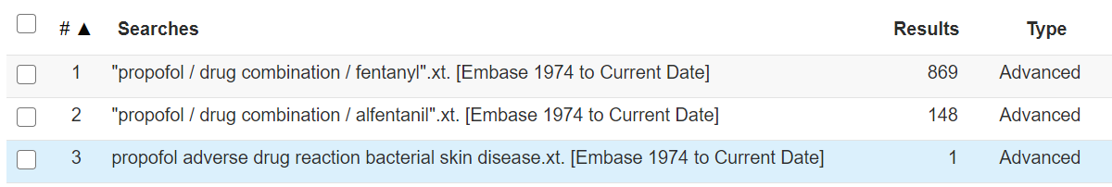
When using the Print command, where the option Include Search History is selected, the search history subsequently displayed, automatically includes the database used in the search.
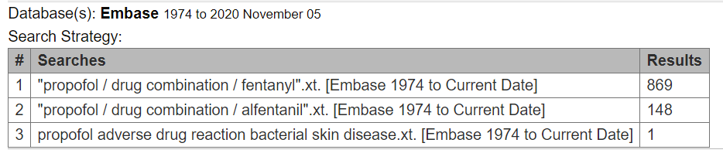

[11:47 AM] REY, Patricia (QUEEN VICTORIA HOSPITAL NHS FOUNDATION TRUST)
What parts of the entries does it use to deduplicate?
Ovid Training Department: For a detailed answer to this question, please see the relevant entry in the Ovid Knowledge Base also available via the Ovid Tools & Resources Portal.
How does the Ovid deduplication work? (Version: 29th June 2020)
https://wkhealth.force.com/ovidsupport/s/article/How-does-the-Ovid-deduplication-work

[11:49 AM] BRBRE, Igor (BRIGHTON AND SUSSEX UNIVERSITY HOSPITALS NHS TRUST)
is it possible to reorder lines in the search strategy?
(2 liked)
Ovid Training Department: Yes. This can be achieved by using the Inline Editor (navigate to via Actions / More / Edit). Also, when lines are removed Ovid will additionally remove the lines the previous lines were subsequently involved in.

[11:50 AM] SNELL, Lindsay (UNIVERSITY HOSPITALS OF DERBY AND BURTON NHS FOUNDATION TRUST) (Guest)
Multi-database searching - I never do this as the thesauruses vary. How does cross-database searching work for (a) thesurus terms which appear in one database only with no equivalent in the other and (b) thesaurus terms which are the same concept but use different terms?
Ovid Training Department: It is indeed the case that care must be taken when running multi-database searches that use thesaurus terms. In kindred databases (so to speak) such as Ovid MEDLINE and Embase there is a degree of connection and compatibility between MeSH and Emtree thesauri that a proportion of thesaurus-based searches do work. Also re. point (b) above, searches can work where the concept is expressed by different terms. Consider the term “stroke” which maps to Stroke in MeSH but cerebrovascular accident in Embase.
Also worth noting is that care needs to be taken too with Limits when conducting multi-database searches. For example, controlled trials and their phases can be located in Ovid MEDLINE using the Publication Type limit. In Embase this is not the case as there is an additional Limit called Clinical Trials dedicated to these types of publications.
The screenshots below illustrate the difference between Ovid MEDLINE and Embase.
In Ovid MEDLINE: The Publication Type Limit covers clinical trials.
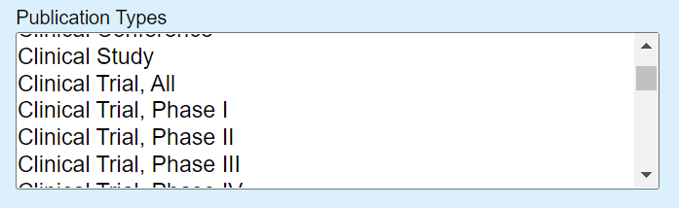
In Embase: The Clinical Trials Limit covers clinical trials.
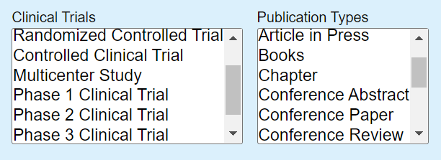

CONTACT:
For questions on any of the above please do not hesitate to contact either Michael Fanning via michael.fanning@wolterskluwer.com or Ovid Customer Support via Support@Ovid.com.

