Registering to use the Accent Course Manager System

What is Accent?
Accent is a course management and booking system. It has been used by Health Education England for many years to coordinate bookings onto a range of HEE events.
The HEE KLS team has arranged to use the system to manage course bookings onto knowledge and library staff training and development offers provided through the Knowledge for Healthcare Learning Academy. Accent will replace a web-based bookings system used in the north of England, and a process used in London and the South.

Why would I register to use it?
During 2022 the HEE Knowledge and Library Services Team will be transitioning to use Accent for all course booking relating to our learning and development offers.
All knowledge and library staff will need to register for an account on Accent to book onto these events. We would recommend that all team members register individually as managers will not be able to book their staff onto events through this system.
In addition to booking onto events, the system will record the training you have undertaken which may be useful for the appraisal / professional development review / professional registration and revalidation process. You will also be able to access certificates of attendance for the events you have attended.

How do I register?
To register
- go to https://accent.hicom.co.uk/CourseManager/Live/HEE/Web/

- Click on “Register” in the column on the left
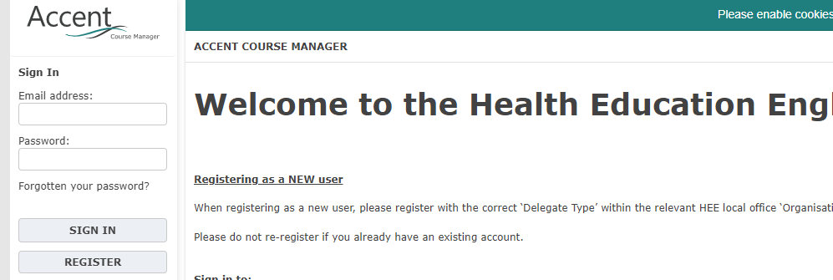

- Add your email address to the email address field and confirm
- Create a password (which should include a combination of letters and numbers) and confirm
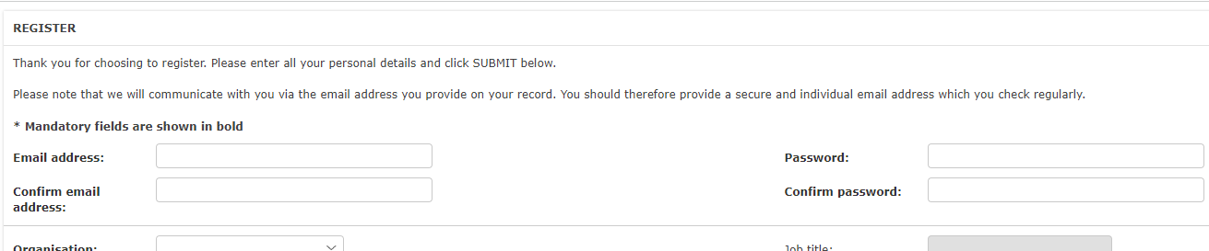

- In the organisation field choose “Knowledge and Library Service”
DO NOT CHOOSE THE REGION OPTIONS - this will prevent you booking on KLS events
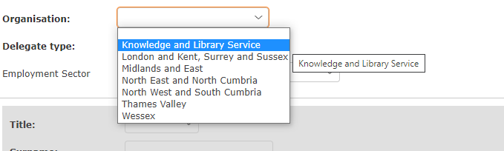
[Please note: it is important that you do not choose the region you belong to rather than “Knowledge and Library Service” – this would prevent you having access to the development opportunities added for our knowledge and library teams]

- In the delegate type field please choose, from the three delegate types, the description which most closely matches your role. Do not worry that the type may not exactly match your role. This fields is used to loosely monitor the roles of colleague accessing the learning opportunities.

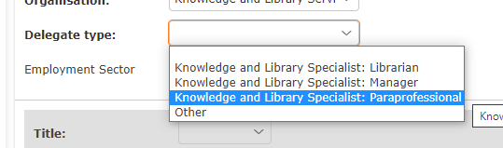

- In “Employment Sector” please choose the type of organisation you are employed by.
In most cases this is likely to be “NHS Trust”
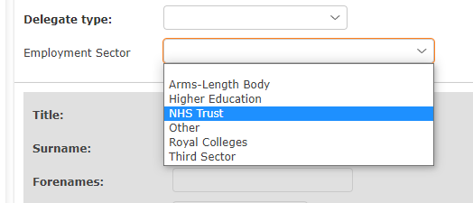

- Once the above fields have been completed you will be provided with further fields to complete as below:

- Job Role – enter your job title
- Title
- Surname
- Forename
- Telephone (we request this so that we can contact you at short notice in case of any problems with the course on which you have registered)
- Registration Number – please ignore this field – you do not need to complete
- Trust Name
- Band – these are NHS bands – Non-NHS please choose the one which most closely matches your salary or leave blank

- Please tick to confirm acceptance of terms and conditions (you can read these following the “Terms and Conditions” link at the foot of the screen)
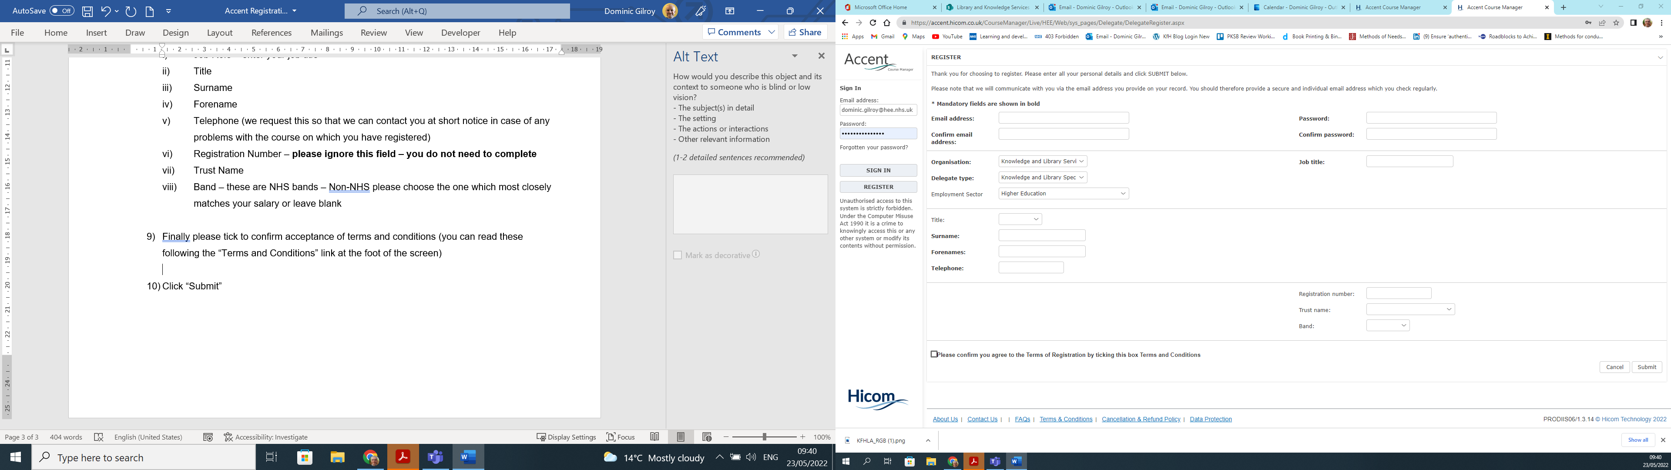

- Finally Click “Submit”
You should receive a confirmation message confirming success

Booking on an Event
You can only book on an event once you have registered to use the Accent system (see above). Once registered you may follow the process below.

- Go to https://accent.hicom.co.uk/CourseManager/Live/HEE/Web/

- Sign in with your login details

- Under “Events by Organisation” click on “Knowledge and Library Service”
- At the bottom of the page the available courses will be listed

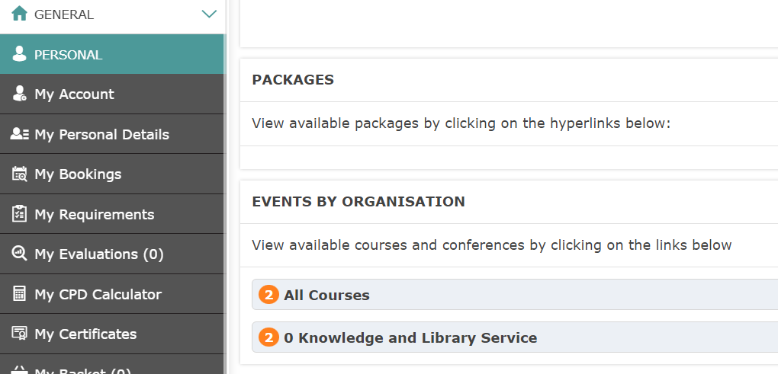

- At the bottom of the page the available courses will be listed
Click on the name of the course you are interested in for more information

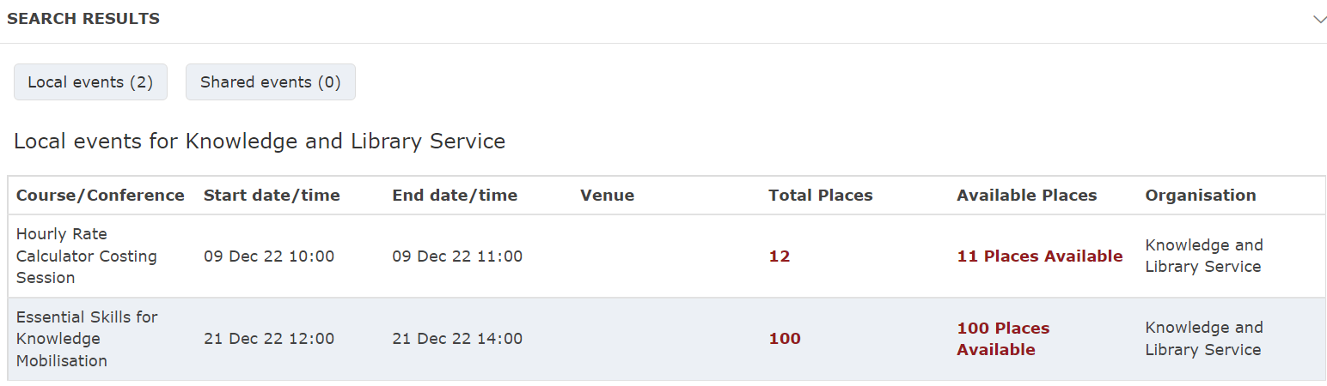

Please be patient if the page takes a few moments to load

- The details of the course are shown including the target audience
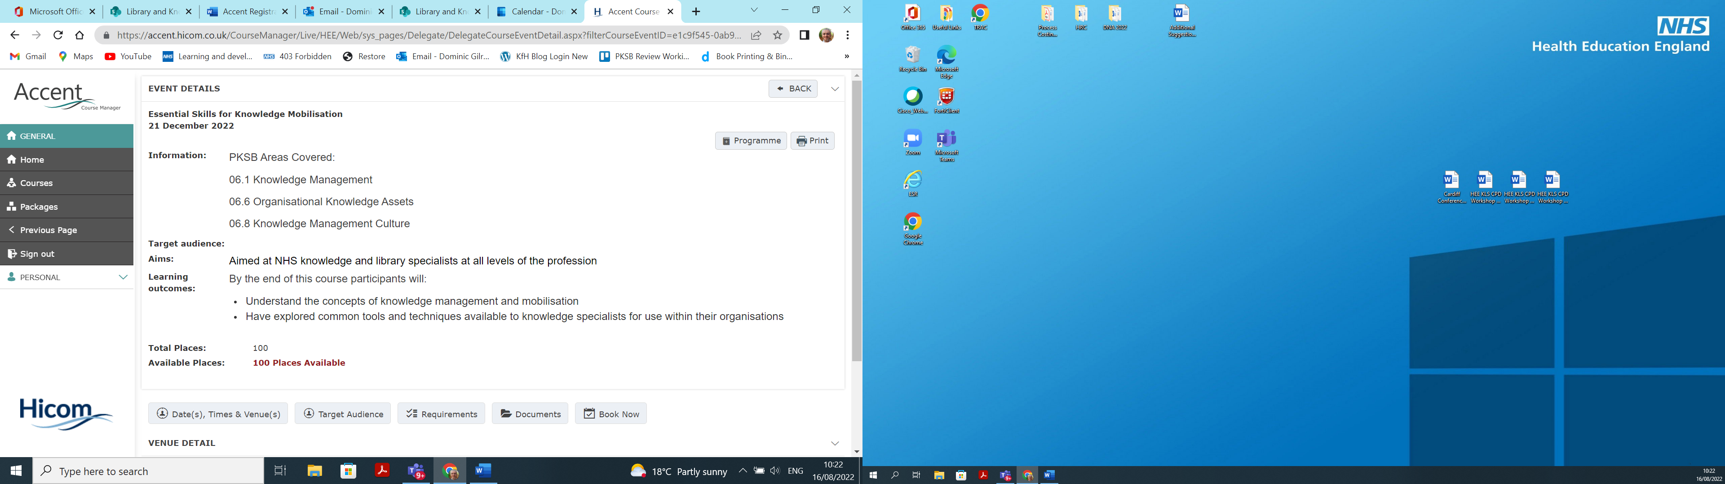

- To book on the event scroll down to the bottom of the page and click “Book Now” - the button to the right of the screen (as above)

- Booking options should now appear at the foot of the screen.
Scroll down to view the details
This page confirms the cost of the event (KLS events are zero cost to delegates)
Tick to confirm the terms and conditions
Click “Book” to confirm the booking

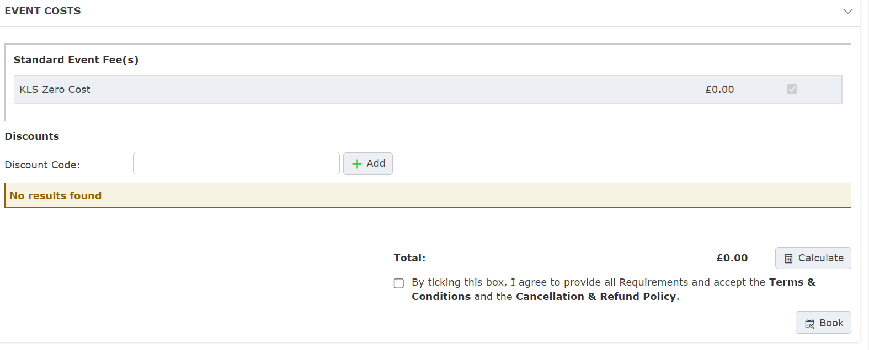

- Your booking will be confirmed
There is the option of downloading a confirmation PDF

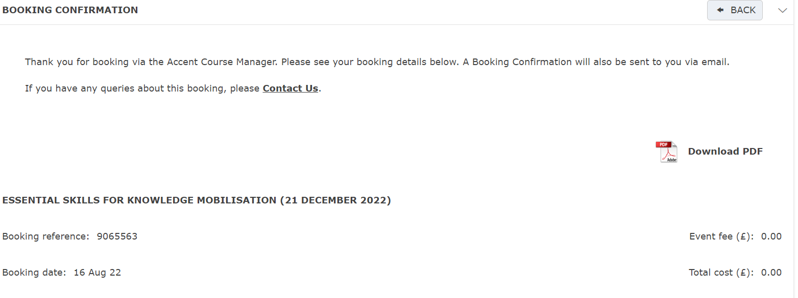

- Please reserve the date in your calendar
You will receive further details from the HEE team nearer the time

If you find yourself unable to attend for any reason please let the HEE Team know as soon as possible so that your place can be offered to another delegate kfh.england@hee.nhs.uk

