Action Learning Sets:
Coaching Using the GROW Model
Knowledge and Library Services

- Use open questions where possible
- Let the coachee come up with ideas – coach is not there to solve the problem
- The coachee should be the one doing most of the talking
- Coach may wish to reflect back to coachee to clarify or encourage coachee to expand e.g. “So you’re feeling…”
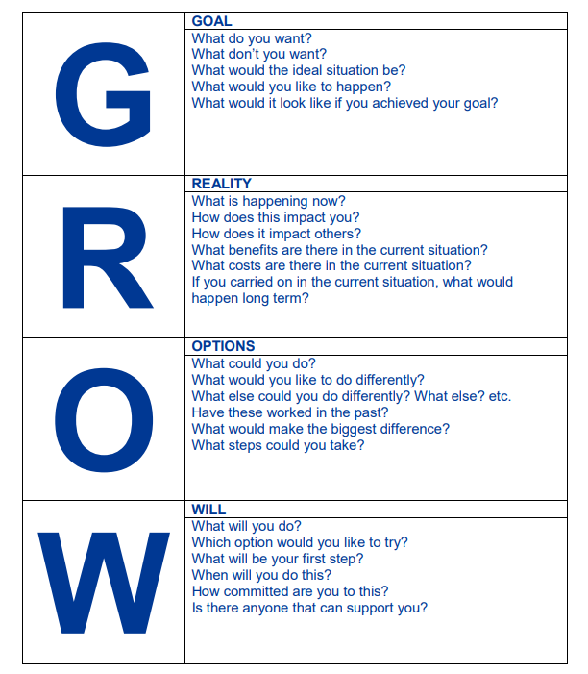
Reproduced with permission from Jo Walley, Coaching https://jowalley.co.uk/

