Connecting its workforce to corporate knowledge & best practice: how the Royal Liverpool & Broadgreen University Hospitals NHS Trust (RLBUHT) Library Service is utilising clinicalskills.net
NHS Library and Knowledge Services in England policy states that Health Education England is committed to developing NHS library services that are proactive and focussed on the knowledge needs of the NHS and its workforce.1 The Carter review identiﬁes the need for Trusts to identify opportunities to achieve productivity, realise efﬁciency savings and improve the quality of care.2 Health Education England’s ‘Knowledge for Healthcare’ strategic development framework states that librarians and knowledge specialists have a pivotal role to play through mobilising knowledge and evidence effectively while transforming the way we deliver library and knowledge services.3
Building on the success of its involvement in the Royal Liverpool Emergency Medicine Handbook App (see http://kfh.libraryservices.nhs.uk/knowledge-management/knowledge-management-story/emergency-medicine-handbook-app/), the library team at RLBUHT have ‘stepped up to the plate’ once again to further increase their involvement in organisational knowledge management activities, ensuring that the service is fully embedded in the business of the organisation, ‘making the provision of knowledge and evidence a business-critical healthcare intervention’.4
Early in 2016, the RLBUHT Library subscribed to clinicalskills.net including all procedures and test assessments, not realising that it would create an additional significant role for library staff within the organisation.
clinicalskills.net contains over 300 fully illustrated step-by-step guidelines on clinical skills covering Adult Nursing, Children’s Nursing, Primary Care, Moving & Handling and Healthcare Assistants. With each procedure comes a test assessment. The library agreed to fund the resource. As we had few resources to offer clinical skills or Bands 2-4, we thought the subscription would, in the long term, be more beneficial to staff (and ultimately patient care) than the purchase of additional textbooks.

Having promoted the resource, in the first instance, to our Clinical Skills & Simulation Department, they began using it as pre-training material for bands 3 & 4 HCA workforce before commencing the ‘practicals’ in the laboratory, helping them to bridge the knowledge–practice gap. Pre-course tests allowed them to significantly shorten training sessions. Health care assistants, for example, could complete the relevant module and assessment at their own pace; and only those staff who had passed the test were allowed to attend the training. Reference to the e-learning modules has been embedded into the RLB programme—an in-house training programme for registered nurses, dental nurses, allied health professionals, assistant practitioners, healthcare assistants and volunteers.

We knew that the resource was popular, with 74,670 page views within our account in the last 12 months. We also knew that it was fully customisable, with administrators being able to:
- Add new users and teams;
- Edit existing question banks or devise question banks from scratch;
- Add organisational notes to each procedure, for example direct links to Trust policies;
- Allocate tests and procedures to individuals or teams; and
- View all candidates’ progress/scores.

What we didn’t fully appreciate was how it could be used as a highly flexible e-learning tool, allowing the RLBUHT Library Service to play a vital role in improved patient care and at the same time delivering significant time and cost savings for the Trust as demonstrated below.
I was approached by the Head of Clinical & Practice Development and a Consultant in Diabetes to see if we could use clinicalskills.net to host ‘Use Insulin, Save Lives’, an e-learning module written by the Consultant, which is part of our Trust’s Clinical Core Skills Programme. ‘Use Insulin’ had been previously hosted on our existing Electronic Staff Record (ESR), but some users were unable to access it despite apparently having the correct software (e.g. JAVA). As a result, few people had completed the module online.

‘Use Insulin’ was in the form of an interactive PowerPoint show and a question bank of 105 questions. The Consultant sent us the PPT, the introduction to the module and the question bank and we decided to try putting it on clinicalskills.net. While the ESR cannot currently be accessed off-site, clinicalskills.net can, using Athens authentication.

The first step was to create and name the assessment ‘Use Insulin, Save Lives’. We added our own Trust logo to the template, highlighting to our users that this assessment was linked to our organisation. We set the desired percentage pass rate at 90% and the number of allowed attempts to unlimited. We could have set a time limit, but this was not required. The Consultant wanted learners to be able to view feedback on the answers and have the ability to download a certificate. All these options were set. Next, we created the question banks. All 105 questions were split into 5 sections or chapters, so that we could ‘cherry pick’ 7 questions from each section, forming a test of 35 randomised questions in all. We were able to load all the questions, using the question types available on clinicalskills.net: True/False, Multiple answers: only one is correct, Multiple answers: several can be correct or Free text.

Having completed setting up the test, we began to promote it to all managers and clinicians involved in prescribing or administering insulin, explaining that staff could access it with their existing Athens accounts. On logging in via Athens, for the first time, users have to complete first-name and last-name fields and agree to the terms and conditions. This ensures that the learner’s name appears on the certificate of test completion. Library contact details were added to address any queries. The test has been very successful: during the 2 years that the ‘Use Insulin, Save Lives’ test was hosted on the ESR, only 75 staff completed it, but in the 45 days since it has been available on clinicalskills.net, 70 staff have passed the module! At present, the scores are exported and forwarded to the Learning & Development Department monthly, for them to upload to the ESR. As the resource is SCORM compliant with any Learning Management System (LMS) via SSO (single sign-on), it will in my view be essential to integrate clinicalskills.net into our ESR so that we can seamlessly and automatically record users’ scores.
Following this success, the Gastroenterology Nurse Consultant asked us whether clinicalskills.net could provide a solution to the dwindling numbers of doctors attending the face-to-face training on ‘Safe placement of Nasogastric Tubes’, which is part of the Trust’s ‘Essential Skills’ Training Programme. A Patient Safety Alert5 issued in July 2016 stated that, despite the guidance from the National Patient Safety Agency (NPSA), issued in 2011 and aimed at reducing the harm caused by misplaced nasogastric feeding tubes in adults, children and infants, there have since been 95 incidents reported to the National Reporting & Learning System (NRLS) where fluids or medication were introduced into the respiratory tract via a misplaced nasogastric tube. A study by NHS Improvement found that the most common type of error was misinterpretation of X-rays by medical staff who had not received the required competency-based training. Again, clinicalskills.net lent itself well to this type of test, which involved interpretation of chest X-rays, as the questions can also incorporate images for viewing with each question.

We now plan to host a whole series of e-learning modules and test assessments tailored to the needs of our organisation. The subject areas below form part of either the ‘Clinical Core Skills Programme’ or ‘Essential Skills Training Programme’. Hosting these on clinicalskills.net will enable our staff to complete them both on and off site. These are currently being delivered ‘face to face’ at induction and as part of mandatory training. The essential learning modules will be integrated into the appraisal process, with managers identifying which staff need to do particular learning.

Clinical Core Skills Programme | Essential Skills training Programme
Acute Kidney Injury (AKI) | Anticoagulation
Aseptic Non-Touch Technique (ANTT) | Clostridium Difficile
Care of Vascular Access Devices (COVAD) | Consent
Enteral Nutrition | Cardiology – 4 part module ECGs & ACS
Falls | End of Life Care
IV Therapy | Last Offices
Malnutrition Screening Tool (MUST) | Pneumonia
Managing Clinically Challenging Behaviours | Tracheostomy care
Medicines Management
Oral Care
Pain Management
Sepsis
Venous Thromboembolism (VTE)

Library staff have met with several of these subject specialists to complete a template for uploading content to clinical skills.net and decide who the course will be aimed at. We normally receive the content in PowerPoint and utilize our skills to make the test as interactive as possible.
Everyone who has an individual account on clinicalskills.net can view a record of their performance: which tests they have taken, the pass mark, their score, and, if they have started a test, there is a link to allow them to continue with it. Managers can see who has started or completed their tests, whether they have passed and at what mark, and how many times a user has taken a test. They can also see what answers users gave to the most recently taken test. Nurses can record their CPD activity online. In addition, reflective accounts in preparation for revalidation can automatically be generated within the Nursing and Midwifery Council-approved form, which also adds up the hours automatically.
In a recent CILIP Update article concerning HEE’s ‘knowledge for Healthcare’ strategic development framework, Lacey Bryant et al. state that ‘the challenge is to flex to meet priorities, design and deliver services that make a positive impact on patient care and give value for money, managing electronic and physical resources to optimum effect’. I feel that this challenging project has called on the Library team at the Royal to do just that—as well as reflecting HEE’s ‘Knowledge for Healthcare’ strategic development framework, which advocates library staff to be ‘flexible, multi-skilled knowledge specialists, able to work at pace and deliver under pressure, taking opportunities to enhance their skills in leadership, networking, partnership working, problem solving and in many other areas as they deliver projects”.
The Carter review ident iﬁes the need for
national capability and capacity to help trusts
identify the opportunities to achieve productivity,
realise ef ﬁciency savings and improve the quality
of care.
4
Librarians and knowledge specialists
have a pivotal role to play through mobilising
knowledge and evidence effectiv
ENDS

References
1 Health Education England. The NHS Library and Knowledge Services in England Policy. Available from:https://hee.nhs.uk/sites/default/files/documents/Knowledge%20for%20Healthcare%20Policy%20Statement%20Nov%202016.pdf [Accessed 17th May 2017]
2 Lord Carter of Coles. Operational productivity and performance in English NHS acute hospitals: Unwarranted variations: An independent report for the Department of Health. Available from:
https://www.gov.uk/government/publications/productivity-in-nhs-hospitals [Accessed 17th May 2017]
3Health Education England. Knowledge for Healthcare: A Development Framework for NHS Library and Knowledge Services in England. Available from: https://hee.nhs.uk/sites/default/files/documents/Knowledge%20for%20healthcare%20-%20a%20development%20framework.pdf [Accessed 17th May 2017]
4 Bryant, SL, Stewart, D, Young, G. Knowledge for Healthcare – Workforce Planning and Development. CILIP Update. 2016 (December/January): 33-35. Available from: https://hee.nhs.uk/sites/default/files/documents/CILIP%20article%20-%20workforce%20planning%20and%20development.pdf [Accessed 17th May 2017]
5 NHS Improvement. Patient Safety Alert NHS/PSA/RE/2016/006 – Nasogastric tube misplacement: continuing risk of death and severe harm. Available from:
https://improvement.nhs.uk/uploads/documents/Patient_Safety_Alert_Stage_2_-_NG_tube_resource_set.pdf [Accessed 17th May 2017]
Images to incorporate throughout text?
Categories
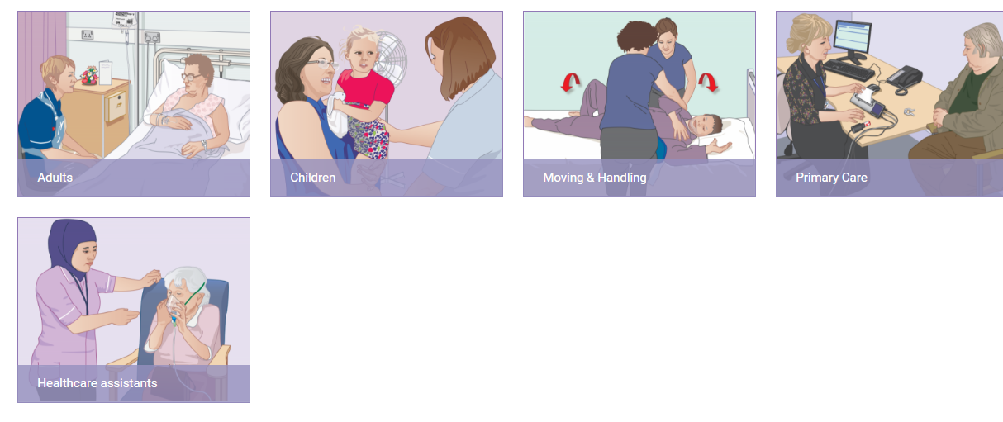

Dashboard
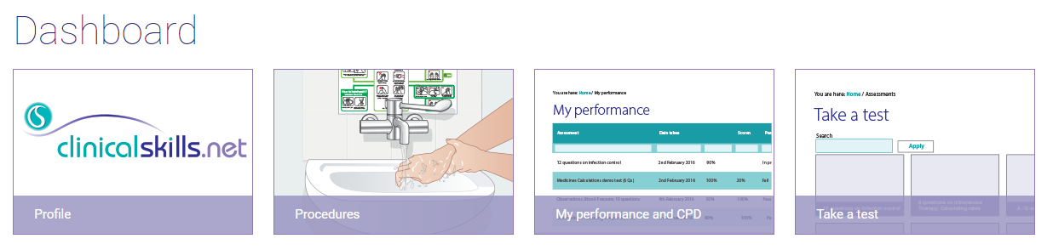
Embedding RLBUHT Logo within Test Assessments
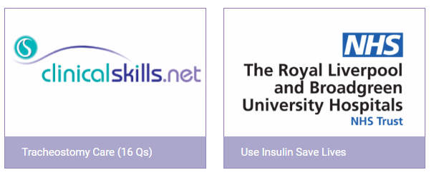
Embedding RLBUHT Logo on Homepage when logged in
