Knowledge Retention & Transition  Quick Tips for  Leavers & their Managers | 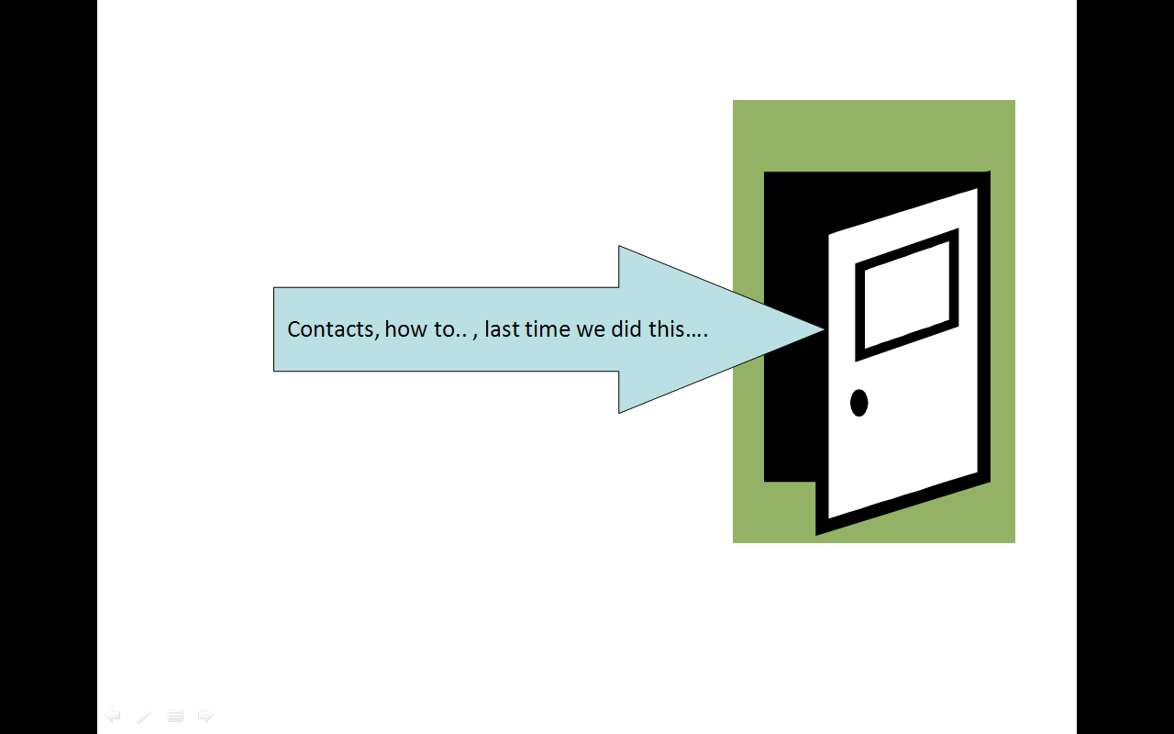
Getting Started

Start thinking about your knowledge transfer as early as possible and get dates for activities/events in diaries with colleagues early on.
- Identify what you think are the key knowledge areas you are taking with you when you leave.
- Ask team/colleagues what they think they would like to know from you before you go – it may be different!
- Agree with line manager the priorities to focus on.
- Agree with line manager reasonable actions for each priority. These activities may include a combination from the toolbox below.
- If possible, identify a key colleague to help and to facilitate your knowledge transfer activities.
- Create your ‘legacy’. Capture output from the activities and store in a central area accessible to all the team.

A toolbox of knowledge transfer activities:
(Select as appropriate don’t try and do them all!)

What do others need to know about my job? – create a table of the key priorities relating to your job and identify who needs to know this information and how you are going to give it to them.
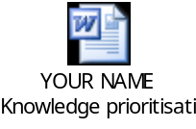

Create a physical handover folder which you can put a copy of all key documents (with file path added in the footer) and a printed copy of any of the documents you created from the list below.

Emails 75% of organisational knowledge is transferred via email and is lost when your email account is deleted when you leave. Go through your mailbox thoroughly and collate the ones you know will be useful to colleagues, save as actual document.

My Key Contacts – draft a key contacts list, who you use to get your job done, internally, externally. Annotate with useful background/context. | 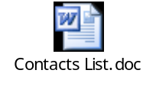
Calendar of my job – create table of activities/events that take place during a standard year and note what must happen when and who is involved etc. | 
Electronic documents/files transfer to your team’s shared drive. Prune and organise. You could also leave colleagues a guide to your unique file structure. The guide could be added to your prioritisation plan (above)

‘Work in hand’ – draft a brief position statement for each on going/unfinished area of work.
The position statement could be added to your prioritisation plan (above).

Useful resources – draft a’ list (not too long) of the resources you use to get your job done (favourite databases, websites, books etc.) | 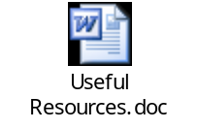
Handover guides – write up ‘How to’, ‘Best practice’ and procedure guides.

My FAQs – write up the Top 5 questions you are always/repeatedly asked by colleagues.

Elicitation interview – 1:1 with line manager or other appropriate colleague on specific area of knowledge to draw out tacit knowledge (what’s in your head).  You may find the questions in the facilitation tool helpful. | 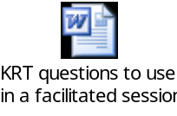
‘Audience with…’ – this is a Q&A session with your immediate (and sometimes wider) team, and can be linked to a last team meeting. Colleagues get to ask you anything they want to know. Prepare the team in advance to think of questions. Works best if made an informal social event – i.e. over tea & cakes.

Knowledge Exchange – quick and dirty transfer of essential knowledge. You and the team, in a room, for an hour. Team draft ‘top 10 things we want to know about X’. You simultaneously draft ‘Top 10 things you need to know about X’. Bring lists together, work through and answer questions there and then. Ensures the crucial knowledge is exchanged in a short space of time, no lengthy documenting. Team members are responsible for capturing their own notes.

Masterclass – in-depth training for a group of people in a specific area of knowledge. Prepare an annotated PowerPoint presentation to leave for colleagues reference after the event.

Coaching/Baton passing – arrange 1:1 sessions with key colleague.

