Innovation Case Study

Title of innovation

Awards bulletin

Please provide a very brief description of your innovation?
One or two sentences about the innovation.
A collaborative approach to create and maintain a list of awards for service recognition. A shareable spreadsheet categorising all awards options and a monthly bulletin of open entry submissions was created.

During which period did you implement your innovation?
Please state which year (and month if possible).
June 2015 – April 2017

What was the driver for your innovation?
Please describe the issue or challenge that your innovation addresses

(100 words max)
We became aware that several library services in the North West were receiving requests for information about awards that recognised new services or initiatives. We knew, from the experiences of a few services, that it was time-consuming to find and maintain such information, and so decided to try a ‘do once and share’ project.

There was no readily accessible source for this information and we thought the end product would not only save considerable time and duplication of effort, within and outside library services, but it could play an important role in raising the profile and impact of library services.
What did you do?
Please describe your aims and objectives and how you implemented these

(200 words max)
Aim: To create a comprehensive list of recognition awards appropriate to the health sector, which library & knowledge services could share across their organisation.

Objectives:
- Create a collaborative approach
The Library & Knowledge Service Leads were contacted to test the idea and check that no similar projects were in the pipeline. A discussion was held on the LIHNN network to identify existing work and seek out volunteers to form a project group. To support remote working a shared work platform was created on Yammer.

- Create a comprehensive list of awards
Previous work of the group was compared and standardised and an updated search completed. The group ran a number of Plan, Do, Study, Act scenarios to find the best way to monitor and update the list, in a way which share the workload and minimise individual time commitments. This included monitoring how awards change over time.

- Create a monthly bulletin for distribution
Once the spreadsheet was finalised a mail merge template was created to create a bulletin of open submissions. The bulletin could then be adapted locally and distributed across email lists.

What methods were used to evaluate your innovation?

In the first quarter of 2017, once the processes were refined and finalised, the bulletins have been shared with libraries nationally via the lis-medical and LIHNN email distribution lists.
Feedback was received from the local networks and identified as something which may be of value for Knowledge Hub (unfortunately never created). The bulletins were shared and tested locally within the organisation and user feedback received. In 6 months the team will carry out a formal evaluation of the project, but in the meantime, some feedback is outlined below:

“I think this is an excellent resource Sue and needs to be shared and publicised.” Sarah Coombs, Head of Integrated Governance, Mid Cheshire Hospitals NHS Foundation Trust.

“I like the brief intro and the notes around who it’s relevant for, really useful thanks” Mandy Davis Blended Learning Manager Lancashire Teaching Hospitals NHS Foundation Trust

The bulletin has been well received by libraries across the country.

“I am part of the team which keeps the Knowledge Management Toolkit up to date and I think this piece of work would make an excellent KM Story, would you consider writing it up using our simple template?” Laura Wilkes, Library and Knowledge Services Manager, West Suffolk NHS Foundation Trust.

What were the outcomes and key learning points?
(200 words max)
- A monthly bulletin listing upcoming awards, made available to NW NHS library services for them to adapt and customise to meet the needs of their host organisations.
- A shared spreadsheet of information, created and updated on a collaborative basis.
- Shared responsibility for maintaining the project on an on-going basis.
- A shared understanding of the complexities of the production process.
- Technical and Information Governance issues, relating to the use of information technology within the NHS, meant that we had to source and explore a range of options to enable us to work together effectively and not duplicate information and effort. We had to develop and refine our processes, to fit with the technology we were using and also realised that we would need to develop written guidance, to ensure consistency of approach.
- The next steps are to create a blog where the monthly bulletins will be housed.

Further information
Please use this field to enter any relevant further information, such as links, references or associated innovations
Recently NHS Employers have started a similar project: http://www.nhsemployers.org/your-workforce/need-to-know/calendar-of-national-health-and-care-award-events

The group has contacted them to share additional information and offer support.

Screenshot of email to distribution lists:

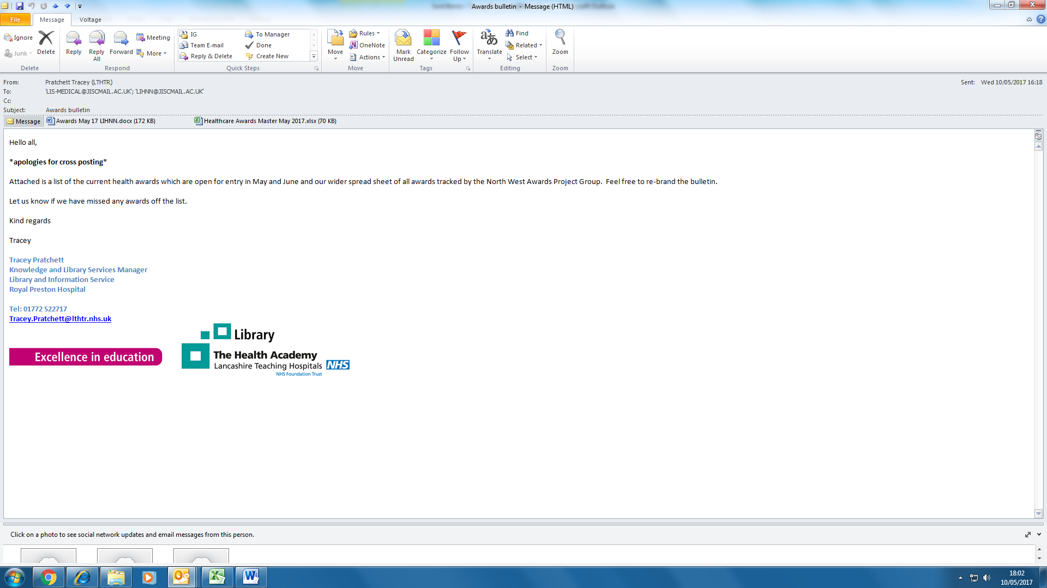
Your name and job title

Susan Smith, Senior Librarian1; Tracey Pratchett2; Bernie Hayes3; Steve Collman4; Annabel Leinster5; Lynda Cotterill4
location within HEE
Your Library & Knowledge Service & Organisation
Please provide the name of your service and organisation in which it is based
JET Library, Mid Cheshire Hospitals NHS Foundation Trust1 Lancashire Teaching Hospitals NHS Foundation Trust2; North West Boroughs Healthcare NHS Foundation Trust3; East Cheshire NHS Trust4; Wirral University Teaching Hospital NHS Foundation Trust5

Your email address

Contact: susan.smith@chester.ac.uk;

Your phone number

Contact: 01270 273172

