Innovation Case Study

Title of innovation

Facilitating research amongst radiographers through information literacy workshops

Please provide a very brief description of your innovation?
One or two sentences about the innovation.
This project is a collaboration between a clinical librarian and a research nurse, tailoring and delivering information skills workshops to radiographers to help them engage with research. The project was funded by a research bursary from the CILIP Information Literacy Group.

During which period did you implement your innovation?
Please state which year (and month if possible).
May 2016-February 2017

What was the driver for your innovation?
Please describe the issue or challenge that your innovation addresses

(100 words max)
Despite a strong research presence in our Trust, Allied Health Professionals are under-represented in developing and publicising “home grown” research.
Library and Knowledge Services (LKS) and Research and Innovation (R&I) wanted to work together to enable staff to develop the knowledge and skills they needed to access information and create new evidence. The project helps to:
- ‘…build the capacity and capability of our current and future workforce to embrace and actively engage with research and innovation’. (Health Education England)

- ‘…Expand UK radiography research capacity through development of skilled and motivated research-active members of the profession’. (Society and College of Radiographers)

What did you do?
Please describe your aims and objectives and how you implemented these

(200 words max)
Aims: To develop a set of Information Literacy workshops that seek to facilitate an increase in research output in a profession-specific group in an NHS Trust. To explore how the workshops impact on the participants’ information literacy self-efficacy.

Objectives:
- To increase collaboration between LKS and R&I within the Trust
- To create a set of workshop plans and support resources that are transferable between professional groups within health
- To measure levels of information literacy self-efficacy, library usage and any research output within the chosen profession-specific group, before and after the delivery of workshops

Participants: The radiography department was selected as there was management support and a desire to develop the skill sets within the workforce, as well as increase the visibility and recognition of the department. We ran two awareness raising sessions introducing the project.

Tailoring of workshops: Via an online survey the participants chose the following workshops:

- Overcoming barriers to starting research
- What to do with your research idea
- Planning your research project
- Introduction to critical appraisal
- An overview of e-journals and databases
- Creating a poster

Content and delivery was tailored for a radiography audience. Workshops were an hour long and were delivered twice.

What methods were used to evaluate your innovation?

Data Collection:
Before and after workshop delivery:
- Measured library usage and research outputs throughout the project and will continue for 12 months after final workshop delivery.
- Utilised the Information Literacy Self Efficacy Scale (Serap Kurbanoglu et al.) to measure participants’ self-efficacy in relation to information literacy.

Other impacts:
- One participant successfully submitted a poster to UKRCO.
- Another has been accepted on the Trusts’ new Clinical Academic Trainees programme, and will be released from her role one day a week to carry out a service improvement project.
- Two participants created a poster to share the results of a patient satisfaction survey.
- Participants and stakeholders were filmed outlining some of the benefits of the project: https://youtu.be/iWiSRom6a7g

What were the outcomes and key learning points?
(200 words max)
23 members of staff completed the initial ILSES. 14 of those then went on to attend at least one of the six workshops delivered. Ten then completed the final ILSES after all of the workshops had been delivered.
- All participants had an increased ILSES score.
- The increases ranged from 10 to 89.
- The top three biggest increases in scores were for: Use library catalogue, locate useful information sources in the library, and evaluate www sources.

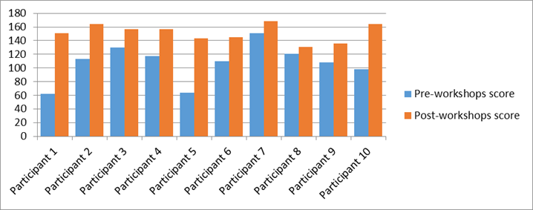

Dissemination – presented on the initial stages of the project at Health Libraries Group Conference, and the completed project at Librarian’s Information Literacy Annual Conference, with a poster successfully submitted for UK Radiological and Radiation Oncology Congress in June.

The workshop plans and support resources are freely available for others to use. This will save other librarians time and provide them with robust materials to use when it comes to delivering this training. These will be hosted on the LTHTR library website.

LKS and R&I are continuing to work together and are planning to roll the workshops out to a new department in September this year.

Further information
Please use this field to enter any relevant further information, such as links, references or associated innovations
Health Education England, Developing a flexible workforce that embraces research and innovation: research and innovation strategy, 2015. Available at: https://www.hee.nhs.uk/sites/default/files/documents/HEE_Research_and_Innovation_Strategy.pdf

Society and College of Radiographers, 2016-2021 society and college of radiographers research strategy, 2015. Available at: https://www.sor.org/sites/default/files/document-versions/research_strategy_final_4.pdf

Serap Kurbanoglu, S., et al. “Developing the Information Literacy Self‐efficacy Scale.” Journal of Documentation, vol. 62, no. 6, Nov. 2006, pp. 730–743

HLG Presentation: https://www.cilip.org.uk/sites/default/files/documents/emily_hurt.pdf

LILAC Presentation: https://www.slideshare.net/infolit_group/facilitating-research-amongst-radiographers-through-information-literacy-workshops-hurt-mcloughlin

Your name and job title

Emily Hurt, Clinical Librarian
location within HEE
Your Library & Knowledge Service & Organisation
Please provide the name of your service and organisation in which it is based
Library, Lancashire Teaching Hospitals NHS Foundation Trust

Your email address

Emily.hurt@lthtr.nhs.uk

Your phone number

01772 524763 / 07875 152562
xxxxxxxxxxxxxxxxxxxxxxxxxxxxxxxxxxxxxxxxxxxxxxxxxxxxxxxxxxxx

