Innovation Case Study

Title of innovation

Creating a health and wellbeing room in the library

Please provide a very brief description of your innovation?
One or two sentences about the innovation.
This was a collaborative project with the Health & Wellbeing team to expand the Health and Well-being (H&W) offer to Trust staff at Chorley. A Library office was converted into a H&W room providing access to resources, a drop-in space for reflection and the delivery of H&W initiatives e.g. mindfulness sessions, smoking cessation, book clubs etc.

During which period did you implement your innovation?
Please state which year (and month if possible).
Funding was secured from HCLU towards the end of 2016 and the room was opened late 2016/early 2017.

What was the driver for your innovation?
Please describe the issue or challenge that your innovation addresses

(100 words max)
There are a number of drivers for this innovation:

1. Patient/Public Health Information – providing a space for staff at Chorley to use H&W resources, provide a reflective space and sessions to improve their health.
2. Library Plans – to improve use of Chorley Library; partnering with H&W team enabled us to host activities e.g. mindfulness, health checks and connect with new users.
3. CQUIN indicators – providing a dedicated room directly supports staff mental, psychological and general health needs enabling the trust to satisfy a significant portion of the CQUIN requirements.
What did you do?
Please describe your aims and objectives and how you implemented these

(200 words max)
In 2016 the H&W Centre opened at Preston, the library team proactively identified an underused office in Chorley Library and transformed it into a H&W space. This means that staff at Chorley now have access to a H&W space similar to staff at Preston.

The Library manager is a member of the H&W Strategy Group; this project helped us to strengthen links with the H&W team. It also increased visibility of Chorley library across the trust. The H&W team worked closely with us transform and promote the space. We champion and advocate for each other, pooling our resources to increase reach e.g. using social media.

The room was transformed using funding received from the HealthCare Libraries Unit, with matched funding from the staff lottery. Library staff and H&W staff also donated items to improve the ambience of the room. We worked together to discuss the best use of the funds and various resources were purchased, particularly for mindfulness and yoga activity.

The room was soft launched in the trust Connect magazine and the room is now being used by H&W staff for specific sessions and increasingly used by trust staff on an ad-hoc basis.

What methods were used to evaluate your innovation?

The room has only been in use for a short period of time, but has benefitted the library service in a number of ways. It is difficult to completely quantify use of the room as it is available as a drop-in space and has not yet been formerly evaluated.

We have received the following anecdotal feedback and will be undertaking a larger launch and evaluation later in the year.

“Just wanted to say how great the resources are now in the H&W room at Chorley. The stools and cushions are fab and we have been using them today on the intensive mindfulness course. Just wanted to thank you for doing the funding application and sharing your space with us. It’s a fantastic space for staff and I’m sure it will get used more and more as news of it spreads.” Mindfulness Practitioner, Feb 2017

“The Health and Wellbeing Room is of huge value to the staff of our Trust. It provides a dedicated, pleasant, comfortable, well-resourced and quiet area where groups or individuals can focus on their physical and psychological wellbeing. The room is equipped for meditation, mindfulness, yoga, quietly relaxing, or browsing the many wellbeing resources available to staff via the library service. Many staff have also had an NHS Health Check in the room too, and we regularly get comments on how lovely the room is and that is a great place to relax.

“The importance of this space for staff cannot be underestimated; chiefly, it is where growing numbers of people are learning and practising the mindfulness techniques that are building their psychological resilience to the continuing daily pressures and demands of NHS work - helping to keep them well. Without the room a significant amount of health and wellbeing work would need to be done within work areas, which are often full of noise, bustle and interruptions. In contrast, the Health and Wellbeing Room provides a much more therapeutic environment for staff.

“In addition, the fact that the library team has made the Health and Wellbeing Room available and developed it to such an excellent standard shows the holistic thinking of the library service: it’s not just about health education, it’s about being at the forefront of vital health improvement and health development work too.” Health and Wellbeing Project Coordinator, May 2017
What were the outcomes and key learning points?
(200 words max)
The room was used by the H&W team for short mindfulness sessions (see below for numbers), providing a tranquil and relaxing space to practice mindfulness, informal discussions relating to intensive mindfulness, one to one support following a traumatic incident, traumatic incident emotional de-brief, meetings with external stakeholders in relation to mindfulness, focus groups in relation to the workplace wellbeing charter accreditation, Health checks (see below for numbers) and some adhoc usage by students for yoga.

- 45 staff attended 10 mindfulness sessions
- 46 staff attended free NHS health checks

We have seen a 21% increase in the use of our well-being stock from 797 issues in 2015-2016 to 966 in 2016-2017.

The room at Chorley was used during the Workplace Wellbeing Charter accreditation visits, where the trust was successful in attaining accreditation.

This space has raised the profile of the Library at Chorley and given it a new identity as a space for people to take time out of their busy day.

The next steps will be to plan a larger launch with the H&W team and to increase the range of activities which are carried out in the room.

Further information
Please use this field to enter any relevant further information, such as links, references or associated innovations
Examples of tweets and engagement

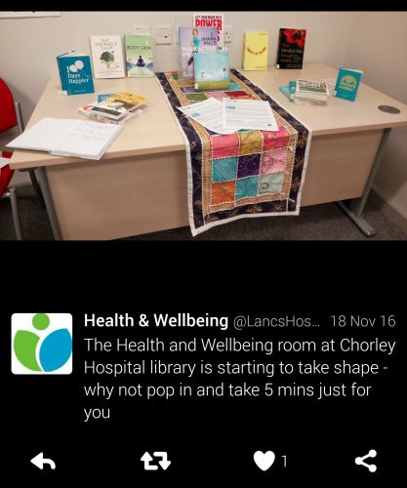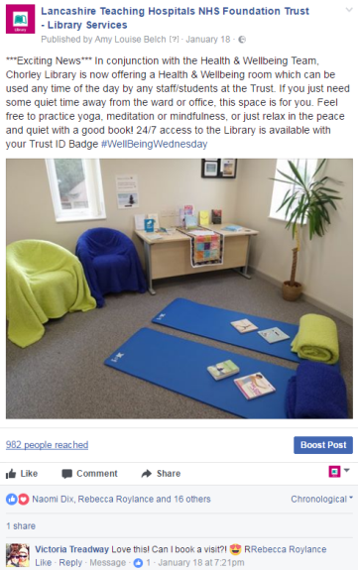

Launch article published in Trust connect magazine Winter 2016

Your name and job title

Tracey Pratchett, Knowledge & Library Services Manager
location within HEE
Your Library & Knowledge Service & Organisation
Please provide the name of your service and organisation in which it is based
Library, Lancashire Teaching Hospitals NHS Foundation Trust
Your email address

Tracey.pratchett@lthtr.nhs.uk
Your phone number

01772 522717
xxxxxxxxxxxxxxxxxxxxxxxxxxxxxxxxxxxxxxxxxxxxxxxxxxxxxxxxxxxx

