Innovation Case Study

Title of innovation

Shh wall art in the library

Please provide a very brief description of your innovation?
One or two sentences about the innovation.
The use of wall art around the theme of “Shh” as a means of reducing the level of noise in the library
During which period did you implement your innovation?
Please state which year (and month if possible).
November 2017

What was the driver for your innovation?
Please describe the issue or challenge that your innovation addresses

(100 words max)
We were receiving more and more complaints (junior doctors forum, annual survey responses, medical student feedback, complaints directly to library staff) about noise in the library. People were using the library study areas to talk on their mobile phones, meet with colleagues, or to work together. We had tried a number of approaches to reduce the noise, e.g. putting notices on the tables, asking people to be quiet or to move to an area of the library where it didn’t matter if they talked, but nothing seemed to have an impact, instead the problem seemed to be getting worse.
What did you do?
Please describe your aims and objectives and how you implemented these
(200 words max)
To reduce the amount of talking and use of mobile phones in the library study areas, by creating large pieces of wall art that expressed the need for quiet in the library in an eye catching but friendly way.

Having explored a number of different approaches we had a discussion at a team meeting and came up with the idea of having some wall art painted directly onto the walls around the theme of Shh, We commissioned an artist to design come up with some drawings, from these we selected three designs which the artist painted directly onto the walls of the library, two of the painting include the word Shh and the third is a quote about studying by Doctor Seuss (Cat in the Hat). The largest drawing is painted onto the back wall of the library and is visible as people enter the library.

What methods were used to evaluate your innovation?

Observational: the library team noticed the difference immediately:
- As people entered the library they reduced the level of their conversations.
- Instead of daily having to ask people to stop talking they had to do this less than once a week
- The library team felt less uncomfortable asking people to stop talking as they could point to the art work and also felt that it was quite clear that people shouldn’t be talking
- The study areas were much quieter

Informal feedback:
- Comments from users about how much better the study areas now were as people were no longer talking

Student feedback
- No complaints in formal student feedback about the library being noisy

Soundings at the Junior doctors forum:
- When asked if they now found the library was a quieter place to work? They confirmed that people were no longer talking in the study areas.

Annual survey responses
The annual survey is sent out in June, so unfortunately it has not yet been possible to measure impact via the survey.

What were the outcomes and key learning points?
(200 words max)
That the Shh wall art did what it set out to do ie reduce the amount of talking in the library study areas to a minimum.
That it is always worth asking team members for suggestions as to how to resolve a problem, rather than rushing to a solution.

Please provide a short quote from a member of staff who has benefitted from the innovation
Please include name and job title
(100 words max)
At SASH, the CEO meets the Doctors in Training every 6 weeks to discuss how the Trust is meeting their educational needs.

The Doctors were raising concerns about the noise in the library, and the impact that this was having on their study time.

The Library Service organised an artist to come in and draw some eye catching Shhh signs.

The feedback since then from the doctors is that the library area is now much more quiet, and they are enjoying being able to take time out of their busy days to study there.

Tina Suttle-Smith
Strategic Medical Education Manager

Further information
Please use this field to enter any relevant further information, such as links, references or associated innovations
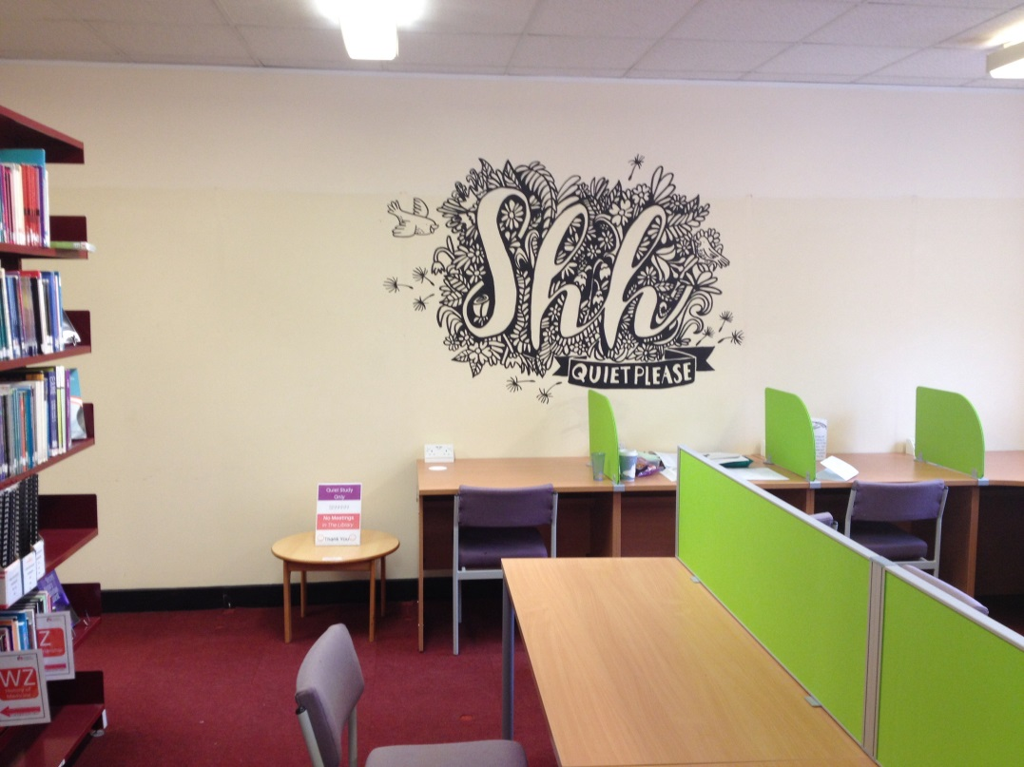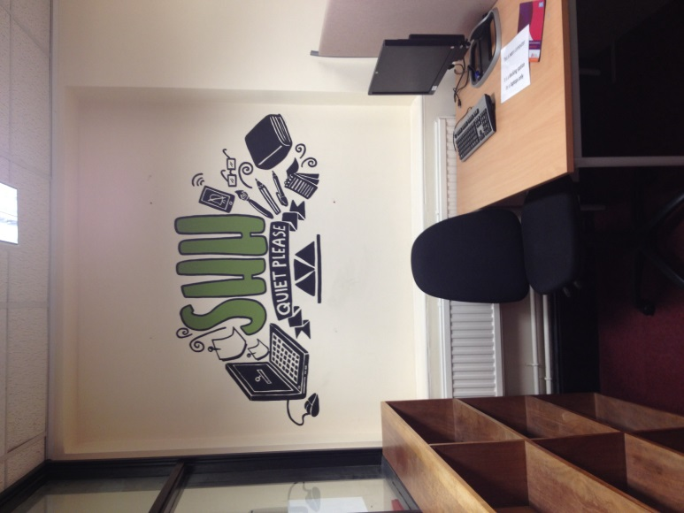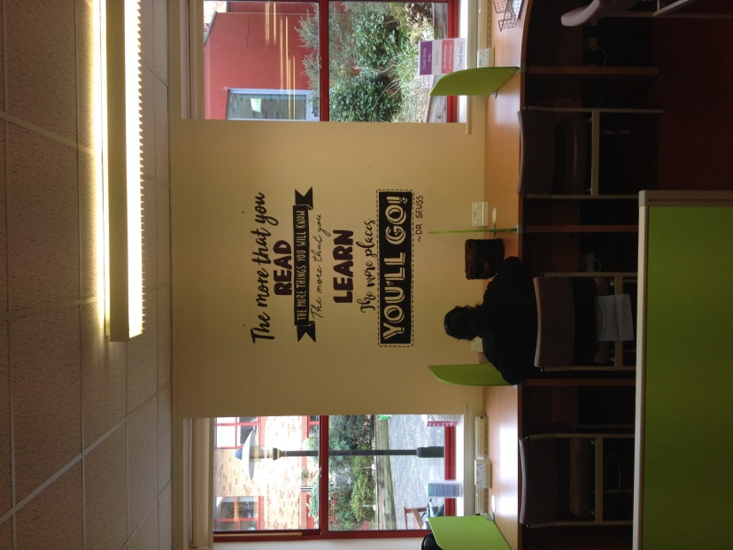

Your name and job title

Rachel Cooke, Head of Library Services & Knowledge Management
in HEE
Your Library & Knowledge Service & Organisation
Please provide the name of your service and organisation in which it is based
Surrey and Sussex Library and Knowledge Services
Surrey and Sussex Healthcare NHS Trust

Your email address

Rachel.cooke1@nhs.net

Your phone number

01737 768511 ext 6054

