Innovation Case Study

Title of innovation

Dismantling the silos - Sharing and celebrating good practice @ RJAH

Please provide a very brief description of your innovation?
One or two sentences about the innovation.
A Poster event providing an opportunity for staff throughout the organisation to share good practice and learn from each other.

During which period did you implement your innovation?
Please state which year (and month if possible).
May 2017

What was the driver for your innovation?
Please describe the issue or challenge that your innovation addresses

(100 words max)
A culture change programme has been ongoing at the Trust since September 2016, with members of the Executive team and Trust Board undertaking to meet and talk and listen to staff about their concerns. One of the overwhelming issues raised by staff throughout the Trust was that they wanted other staff to recognise and value the work that was going on within their departments, and their contribution to the organisation and also to know more about what other wards and departments were doing .The Library Services team created and facilitated this event which offered the opportunity to learn from each other and to celebrate and share good practice.

What did you do?
Please describe your aims and objectives and how you implemented these

(200 words max)
We wanted to create a comparatively easy way for staff to share their work, which meant that they could demonstrate what they did in what would be perceived as a safe environment.

All staff were invited to create a poster to be displayed as part of an exhibition in the hospital. Posters could demonstrate the work of their department, a particular project, or an area of good practice which would give both staff and patients an opportunity to see the diversity of work which goes on within the organisation. A template and guidance for creating posters was provided and the library team were on hand to offer help to all staff in the design and layout of their posters.

The Library Services Manager met with managers and team leaders across the Trust, both clinical and non-clinical to ask for their support for this event. An Invitation was sent to all staff, and the template and guidance was made available on the Trust intranet. A deadline of two weeks prior to the event was set for the submission of posters, and regular reminders to staff were communicated via the Trust electronic noticeboard and Facebook and Twitter. The Chief Executive Officer also lent his support to the event at his monthly staff forum.

What methods were used to evaluate your innovation?

As part of the event all staff were given stickers which they were asked to use to vote for the poster that they felt had the most impact. Hundreds of stickers were used with the posters with most impact having over 70 stickers.

Since the original event the posters have been used to demonstrate the work done within the Trust at the Trust AGM, recruitment events and most recently as part of the judging for the HSJ Provider Trust of the Year.

We are exploring ways of utilising the posters and the learning from the Poster Exhibition to capture the enthusiasm of staff to share information in this way. A second event is planned for 2018.

What were the outcomes and key learning points?
(200 words max)
Our expectation for support for this event had been around 30 to 40 posters at the most. The response that we had was totally overwhelming; as the deadline approached it was becoming clear that we had really struck a chord with staff. The final number of posters submitted was over 100, way beyond our most optimistic expectations.

Support and interest from both staff and patients during the event was immense, and the energy and enthusiasm as people viewed the posters was amazing. This exhibition, by showcasing the huge variety of work which goes on, gave us a chance to share what we do. It also demonstrated the value the library service brings to the organisation; it brought people together, and captured and shared knowledge and good practice. In addition it raised the profile of the library service and our accessibility to staff.

Please provide a short quote from a member of staff who has benefitted from the innovation
Please include name and job title
(100 words max)
“This exhibition gave us a chance to break out of our individual silos and engage in meaningful and thought-provoking conversations with our colleagues. Staff from across the Trust have really embraced the concept of this event, and have shared learning and good practice from their area of work. It offered a unique opportunity for us all to learn from each other and about the work which goes on. “
Kerry Robinson
Director of Strategy & Planning
RJAH

Further information
Please use this field to enter any relevant further information, such as links, references or associated innovations
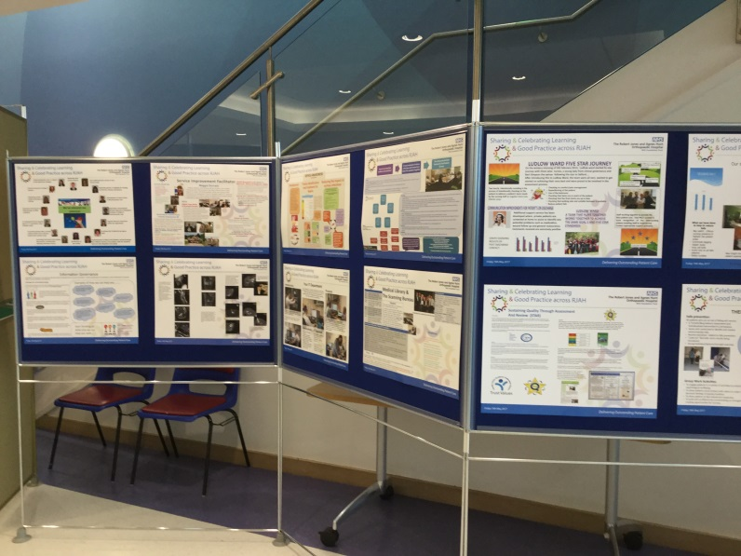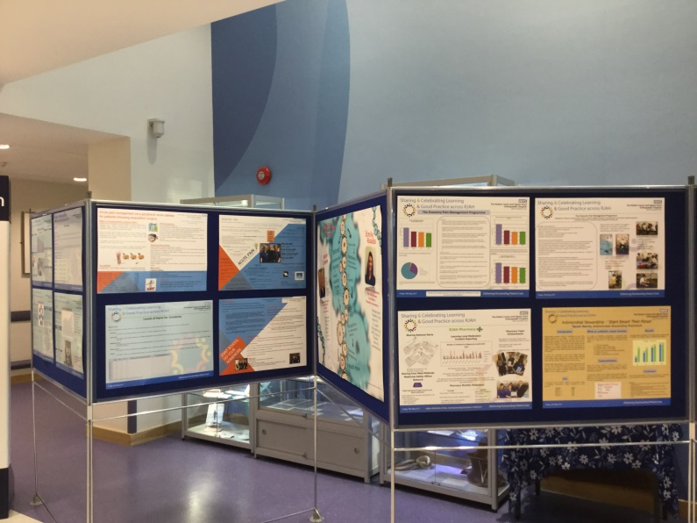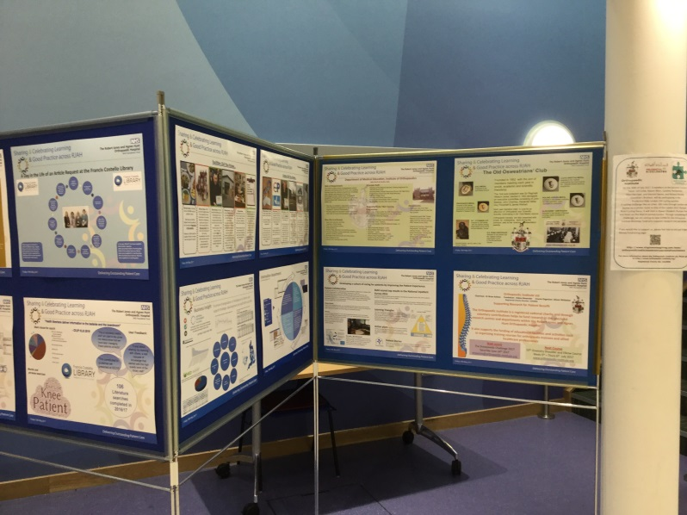

Your name and job title

Lis Edwards
Library Services Manager
in HEE
Your Library & Knowledge Service & Organisation
Please provide the name of your service and organisation in which it is based
Francis Costello Library
Robert Jones & Agnes Hunt Orthopaedic Hospital NHS Foundation Trust
Oswestry
SY10 7AG

Your email address

lis.edwards@rjah.nhs.uk

Your phone number

01691 404287

