How to embed evidence in an MS Word document
We recommend you PDF all MS Office documents to reduce the size of the individual files.
We advise that you use the FILE, PRINT, PRINT TO PDF facility for Microsoft Office documents. Scanned documents can also be inserted.

The embedding process
- Open your LKS Quality Assessment template in MS Word and click in the relevant cell in the Evidence table
- Go to the INSERT tab on the ribbon

- Go to the TEXT section of the ribbon and select OBJECT

- Choose the CREATE FROM FILE option.
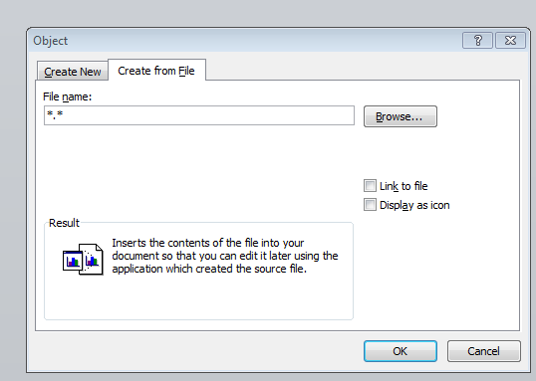
- BROWSE your computer to find your PDF version of the evidence and select the file.

- Tick the DISPLAY AS ICON box.

- Edit the FILE NAME to remove any references to your Trust network e.g. From
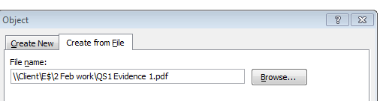

To this
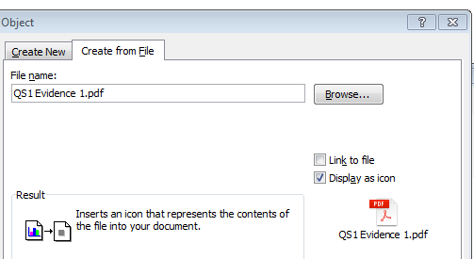

- And hit enter and your file will be where you want it to be e.g. see below
To note: this is an image so the PDF won’t open.
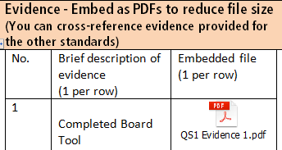

Created 2 February 2018

