Name of library and knowledge service
Library and Knowledge Service Sector  (The organization which employs the LKS staff) | Choose an item.
Organisation(s) served
In this section please list only organisations served which have an LDA with HEE– if unsure check with your local HEE LKS Lead
Details of any additional organisations served may be included in the “notes” section below.
Organisation name | WTE Staffing*1 | Organisation type | Level of service provided  Full or Partial: Please give brief details of levels of service provision. (Expand text areas as required)
 |  | Choose an item.
 |  | Choose an item.
 |  | Choose an item.
List of service points  (Provide additional rows if required) | Accessible hours  (State 24/7 if accessible with swipe card) |  | Staffed Opening Hours  (State “0” if never staffed)
Library and knowledge staffing  You may upload an organogram or organizational chart to the notes section in addition, or as an alternative, to completing this section. | Numbers (WTE) |  | Notes  For example: library staff working in embedded roles or in innovative or non-traditional roles. Any redeployment during the Covid-19 pandemic.  (Guidance one sentence per staff member)
Professional Staff
Band 8a and above
Band 7
Band 6
Band 5
Paraprofessional / Administrative Staff
Band 4
Band 3
Band 2
Apprentices
Notes
Use this section to tell us anything which you think we need to know about your service and the organization(s) it serves.
Key partnerships, relationships, strengths, weaknesses. Include any recent significant changes or challenges affecting your service including any impact on the service during the COVID-19 pandemic.
Guidance 500 words (expand as required)
Please embed the following documents (see notes below)

Strategy | Implementation Plan | Annual Report | Service Level Agreements  (Where relevant)

*1 WTE staffing numbers for NHS Organisations may be found here
https://digital.nhs.uk/data-and-information/publications/statistical/nhs-workforce-statistics

Embed documents in the following way:

- Insert
- Object (may resemble the below on your insert menu)
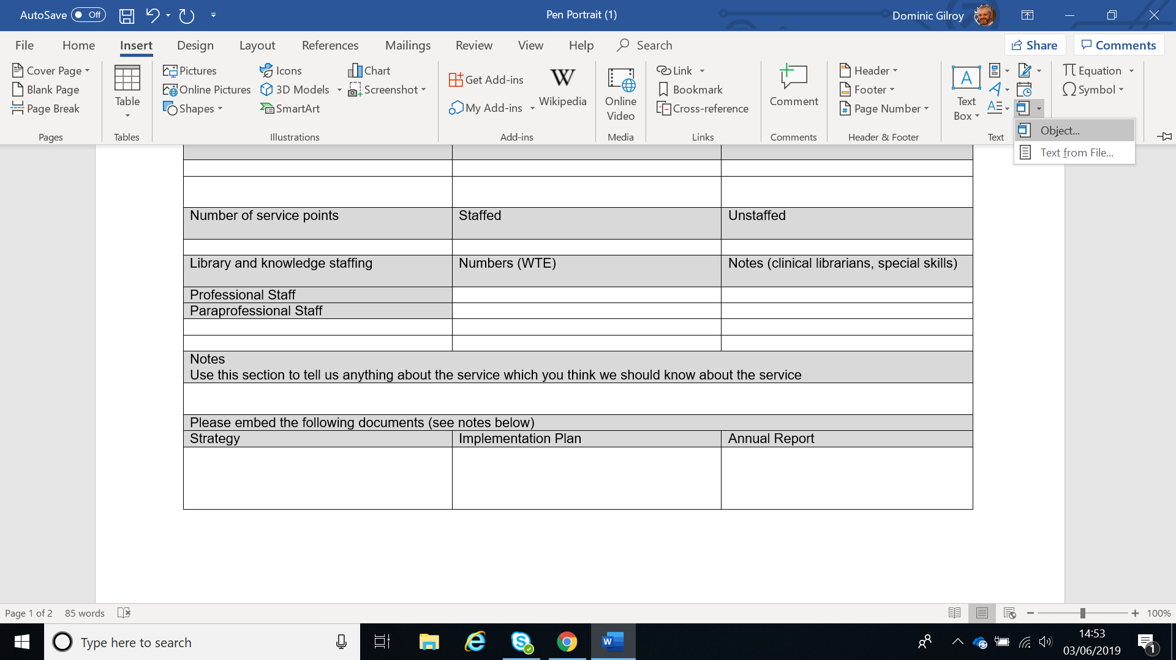
- Create from file
- Browse and select document from your drive
- Tick “Display as Icon”
- Change Icon (if necessary for long filenames)
- Click “OK”
- Save

